Odyssey Yamdrok Oxygen Hotel is a luxury themed hotel under Asia Odyssey Travel Group. Nestled by Yamdrok Lake in Shannan City, the birthplace of Xizang culture, it stands right next to Retuo Temple, known as "the loneliest temple in the world", and has become a newly popular must-visit spot in Xizang.
The hotel is designed to offer guests an all-new experience, allowing you to immerse yourself in the beauty of Yamdrok Lake, one of the three sacred lakes in Xizang.
For a long time, most tourists visited Yamdrok Lake in the same way: stopping briefly at windy mountain passes, taking a few panoramic photos, and then hurrying away. Stunning as the scenery is, such encounters always feel fleeting. The opening of Odyssey Yamdrok Oxygen Hotel has completely changed this situation.
Here, you can sit comfortably indoors and admire the lake scenery up close through full-length floor-to-ceiling windows, enjoying warmth and comfort. Free from strong winds and cold air, you are surrounded by peace and serenity.
What’s more, you can slow down and savor a leisurely lakeside lunch in our scenic restaurant.
Highlight 1: Full-view Floor-to-ceiling Windows
The hotel has only 6 boutique lake-view guest rooms, all fitted with full-view floor-to-ceiling windows facing the crystal-blue lake directly.
Deluxe Twin Rooms-4 Rooms
Basic Facilities
- Area: 42 square meters
- Bed type: Two 1.5-meter single beds
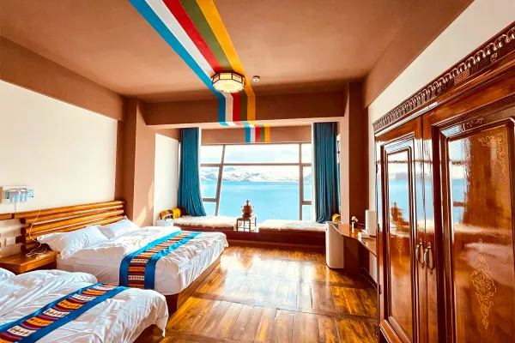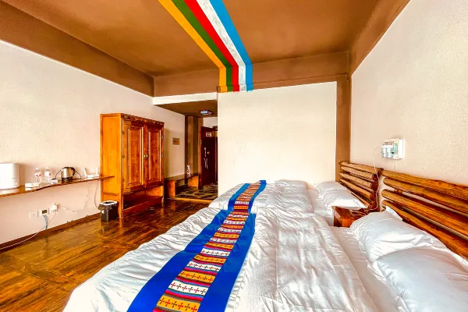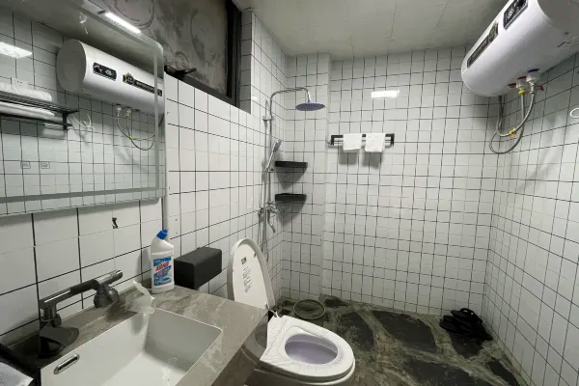
Restroom area: Toilet
Wash area: Vanity counter and faucet
Bath area: Shower set, floor drain and storage shelves
General amenities: Anti-slip floor tiles, ventilation system, towel racks and more
Panoramic View King Rooms-2 Rooms
Basic Facilities
- Area: 38 square meters
- Bed type: One 1.8-meter king-size bed
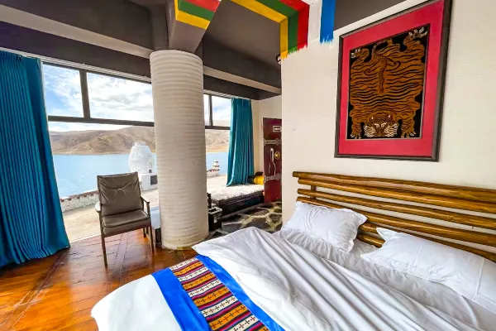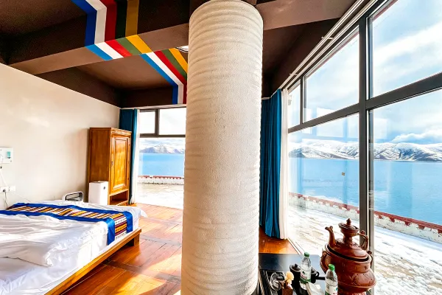
Lying in bed, you can watch the shimmering lake water and drifting clouds over the mountains, and catch the breathtaking view of the sunset reflecting on the lake. On clear nights, you can gaze up at the vast starry sky over the Qinghai-Xizang Plateau.
Highlight 2: On-site Oxygen Supply System for a More Comfortable Stay
We aim to make your stay by Yamdrok Lake not only memorable, but also relaxing and pleasant.
To help you rest soundly after a day of touring the plateau, every guest room is equipped with an independent medical-grade oxygen supply system, constant underfloor heating and air purifiers.
These thoughtful facilities keep you warm throughout the night for a sound sleep, letting you fully unwind and enjoy your time by the lake. You no longer need to worry about altitude sickness, and can indulge in the one-of-a-kind views outside the windows.
Premier Viewing Spot of Yamdrok Lake — Exclusive Serenity Away from Crowds
Apart from the indoor scenic restaurant with superb views, the hotel features a spacious outdoor viewing platform that offers a full panoramic vista of Yamdrok Lake.
Private Platform for Undisturbed Photography
Public viewing platforms along scenic roads are usually crowded with limited shooting spots. In contrast, our platform is spacious, quiet and laid-back.
No pushing or scrambling for angles is needed. Every view is like a painting, and every shot you take turns out wonderful. You can also take distinctive cultural travel photos here: pose with yaks, Tibetan mastiffs and flocks of sheep, or take pictures at the iconic stone stele of Yamdrok Lake. Capture unique Xizang-style travel memories all in one place.
Unobstructed Full Panorama
The platform is merely about 30 meters away from the lake, delivering an immersive sightseeing experience.
Beneath your feet lies the clear emerald lake, while rolling snow-capped mountains on the opposite bank form a magnificent backdrop. With boundless views, a tranquil environment and complete landscapes, this is an ideal place for photography, aerial shooting, watching sunsets or simply sitting by the lake to relax your mind.

