5 Days Kyrgyzstan Group Tour: Bishkek to Issyk-Kul Lake (Tianshan Mountain View)

Tour Code: CAGT-02
Travel Route: Bishkek - Burana Tower - Cholpon-Ata - Bishkek
Features: national park, mountains, lakes, square, museums, history, bazaars, local life, silk road
Tour Type: Small Group of maximum 16 travelers, guaranteed departures;
Guide & Driver: English-speaking guide, experienced driver with regular tourist vehicle
Accommodation: 4 Nights at 4-Star Hotel & Guest House

Itinerary at a Glance

Bishkek (2 Days)
Ala-Archa National Park, Ala-Too Square (Statue of Manas), Oak Park, State Historical Museum, Osh Bazaar

Burana Tower (0.5 Day)

Cholpon-Ata (1 Day)
Issyk-Kul Lake (Boating), Petroglyphs Museum

Bishkek (1.5 Day)
Depart from Bishkek

Itinerary Day by Day

Day 1 Bishkek (Kyrgyzstan) Arrival | Airport Pick-up & Hotel Check-in

Dear friends, welcome to Kyrgyzstan! Often called the “Switzerland of Central Asia,”
Kyrgyzstan is famous for its breathtaking natural beauty and nomadic culture. Bishkek, the capital, is filled with Soviet-era charm and lush greenery.
Today, the group will make its way to Bishkek. Upon landing at Manas International Airport (FRU) in Bishkek, our local driver will be waiting to transfer you to your downtown hotel. (Tip: The airport is about 32 km northwest of Bishkek, 40-minute to 1-hour drive.)
Check in to your hotel. The rest of the day is yours to explore the capital city. (Tip: If you arrive early, you can ask our travel advisors for “free-time suggestions”.)
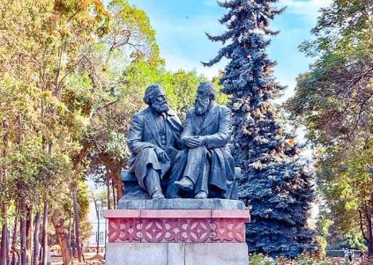  Oak Park |  |  | 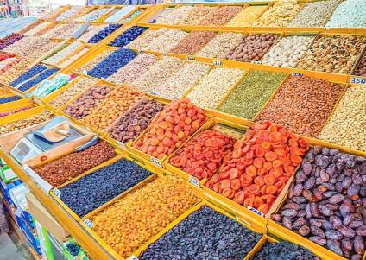  Osh Bazaar
 | Attractions  none  Dining  None |  Transportation  vehicle  Accommodation  Bishkek

Day 2 Bishkek Tour | Ala-Archa National Park, Ala-Too Square
(Statue of Manas), Oak Park, State Historical Museum, Osh Bazaar

After breakfast, your local guide and driver will pick you up from your hotel. Your group will then head out of Bishkek for a hike in Ala-Archa National Park, located 30 km (about 40-60 minutes) southwest of the city. Known as Bishkek’s “backyard park,” this alpine valley in the Tian Shan Mountains offers scenery reminiscent of Switzerland - majestic snow-capped
peaks, clear blue skies, dense pine forests, wildflower meadows, and scenic river valleys. It’s ideal for light hiking. You can follow the riverside trail for a leisurely walk while enjoying the

fresh mountain air. Keep an eye out for wildlife such as squirrels, red deer, wild goats, and even the elusive snow leopard (rare but possible!). (Route Tip: There are three hiking routes; we recommend the easy riverside path for the best views.)
In the afternoon, return to Bishkek for a city highlights tour. Begin at the main square, Ala- Too Square, where you’ll see the impressive statue of Manas, the legendary national hero, along with the Government House and the national flagpole. At certain times, you may also catch the changing-of-the-guard ceremony.
From the square, take a pleasant walk to Oak Park, a peaceful spot filled with centuries-old oak trees and various sculptures.
Nearby, visit the State Historical Museum, an excellent introduction to Kyrgyzstan’s rich
culture and heritage. Inside, you’ll find more than 80,000 artifacts, including a full-scale
Kyrgyz yurt, traditional felt and leather crafts, embroidered clothing, horse gear, and exhibits covering the Russian Empire and Soviet eras.
Next, head to Osh Bazaar, one of the liveliest markets in the city. Explore stalls offering fresh produce, spices, nuts, dried fruits, local clothing, handicrafts, and beautifully woven carpets.
AOT Special Welcome Dinner:
This evening, enjoy a welcome dinner hosted by Asia Odyssey Travel at a renowned local restaurant. Experience a warm Kyrgyz atmosphere with modern comfort as you savor
authentic Kyrgyz dishes and Central Asian fusion cuisine.

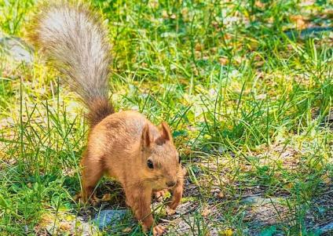
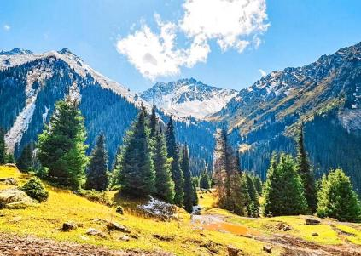
Ala Archa National Park
Ala Archa National Park

Attractions

5 sites

Dining
Breakfast, Dinner

 Transportation
vehicle

Accommodation
Bishkek

Dining
Accommodation
Cholpon-Ata
Breakfast
Day 3 Bishkek - Burana Tower - Cholpon-Ata | Issyk-Kul Lake (Boating)

After breakfast, your guide and driver will take the group east from Bishkek toward Issyk- Kul, the world’s second-largest high-altitude lake.
On the way, you’ll stop at the Burana Tower, an 11th-century minaret that once marked the ancient city of Balasagun, capital of the Kara-Khanid Khanate. Climb to the top for sweeping views of the surrounding plains and distant snow-capped mountains. On the ground, stroll among the Balbals - medieval stone figures used as Turkic nomadic gravestones—offering a fascinating glimpse into the region’s early history.
Continue driving to Cholpon-Ata (about 3 hours), located on the northern shore of Issyk-Kul. After checking in to your hotel, enjoy the rest of the afternoon relaxing by the lake. Known as the “Pearl of Central Asia,” Issyk-Kul Lake sits at an elevation of 1,607 meters. Its slightly
salty water keeps it from freezing in winter, and its clear blue surface gives the impression of a calm seaside.
Activities at Issyk-Kul Lake:
· Boat Trip: Head to the pier for a scenic boat ride and take in panoramic views of the lake and surrounding mountains.
· Relax or Swim: Enjoy the golden sandy beaches - sunbathe or take a refreshing swim in the warm, crystal-clear water.
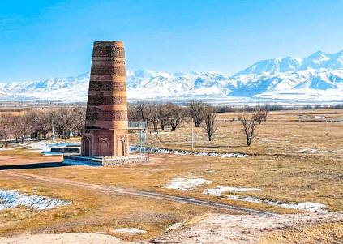  Burana Tower |  |  | 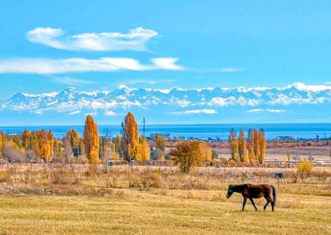  Issyk K ul Lake
 | Attractions  2 sites |  Transportation  vehicle

Day 4 Cholpon-Ata - Petroglyphs Museum - Bihskek

Enjoy breakfast at your hotel. After that, you'll visit the Petroglyphs Museum. This open-air museum (42 hectares) is set on vast land with the majestic Tianshan Mountain range as
backdrop. Here, you'll find ancient petroglyphs carved on massive black basalt stones,
which are dated from the 2nd millennium BC until the 4th century AD. These carvings depict animals like wolves and snow leopards, as well as hunting and sacrificial scenes.
After the visit, your group will be driven back to Bishkek (about 4 hours).
Upon arrival in Bishkek, you'll have some free time to visit a local market to buy souvenirs. Enjoy a relaxing evening in Bishkek.
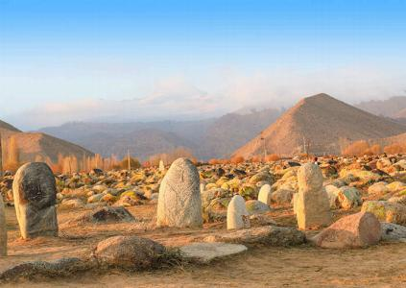  Petroglyphs Museum |  |  | 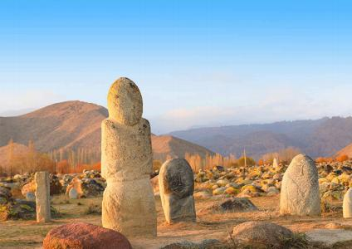  Petroglyphs Museum
 | Attractions  1 site  Dining  Breakfast |  Transportation  vehicle  Accommodation  Bihskek

Day 5 Bishkek Departure | Hotel Check-out & Airport See-off

After breakfast, you will have some free time to explore Bishkek. Afterward, your group will be transferred to the airport for your flight to your next destination or return home. Your 5- day Kyrgyzstan group tour ends. (Tip: Please inform us of your flight details so we can
arrange your airport transfer accordingly.)
Central Asia Trip Extension:
Kyrgyzstan is only one part of “Five Stans” tour. If you have more time, you are welcome to join group tours to Uzbekistan, Kazakhstan, Turkmenistan, and Tajikistan. More landscapes

and adventures await you.
 | Attractions  None | Transportation  vehicle
 | Dining  Breakfast |  | Accommodation  /

Month  Apr | Available Date  Apr.10, 2026
Month  Apr | Apr.21, 2026
Month  Apr | Apr.25, 2026
May | May.02, 2026
May | May.13, 2026
May | May.17, 2026
May | May.24, 2026
Jun | Jun.04, 2026
Jun | Jun.08, 2026
Jun | Jun.15, 2026
Jun | Jun.26, 2026
Jun | Jun.30, 2026

Jul | Jul.07, 2026
Jul | Jul.18, 2026
Jul | Jul.22, 2026
Jul | Jul.29, 2026
Aug | Aug.09, 2026
Aug | Aug.13, 2026
Aug | Aug.20, 2026
Aug | Aug.31, 2026
Sep | Sep.04, 2026
Sep | Sep.11, 2026
Sep | Sep.22, 2026
Sep | Sep.26, 2026
Oct | Oct.03, 2026
Oct | Oct.14, 2026
Oct | Oct.18, 2026
Oct | Oct.25, 2026
Nov | Nov.05, 2026

Price: What’s Included & What’s Excluded

What's Included:

 Guide Service: Professional English-speaking tour guide.
Attraction Tickets: Entrance fees for all sites listed in the itinerary.
 Transportation:
- Airport transfers upon arrival and departure.
- Private tourist vehicle for all city sightseeing tours and overland travel.
- All flights and overland border crossings between countries, as well as all local transfers within the Five Stans.
Accommodation:
- Hotels as listed in the itinerary (primarily 4-star standard).
- In remote areas (e.g., Darvaza Gas Crater), accommodation will be in traditional guesthouses or yurt camps.
Meals:
- Daily breakfast at the hotel.
- Lunch and Dinner where specifically listed in the day-by-day itinerary.
- Special Meal Arrangements (One featured dining experience per country):
- Tashkent: Dinner featuring traditional dance and live music.
- Darvaza (Turkmenistan): Desert Barbecue Dinner with views of the burning gas crater.
- Ashgabat: Dinner at the TV Tower restaurant with city night views.
- Bishkek or Issyk-Kul (Kyrgyzstan) dinner
- Charyn Canyon (Kazakhstan): Picnic Lunch after hiking.
- Almaty: Featured Dinner featuring Kazakh cuisine and music/dance.
Logistics & Support:
- Cross-Border Assistance: Guide assistance for land border crossings.
- Turkmenistan LOI: Includes the fee for the Letter of Invitation required for the Turkmenistan visa.
Service Fees: All planning, handling, operational, and communication charges.

What's Excluded:
- Visa Fees: Cost of tourist visas (if required), depending on the traveler’s nationality.
- Travel Insurance: Comprehensive travel insurance is not included but is strongly recommended.
- Optional Tours: Costs for any optional activities or tours not explicitly listed in the itinerary.
- Unlisted Meals: Lunches and dinners not specified in the itinerary (your guide can provide recommendations for local restaurants).

- Single Supplement: Additional charge for travelers requesting a private room.
- Tips & Gratuities: Gratuities for tour guides and drivers are optional and at the traveler’s discretion.
- Overtime Service Fees: Additional charges may apply for services requested beyond scheduled itinerary hours.
- Personal Expenses: Shopping, alcohol, snacks, laundry, and other beverages outside of those specified in the itinerary.


Your Central Asia Group Tour Experience: What You Need to Know

01 | Small Group Size (1–16 Pax)  Our small group tours welcome 1–16 travelers, ensuring comfort and a friendly atmosphere. Departures are guaranteed even with one traveler. The group size will not exceed 16.
02 | Solo Travelers Welcome  We accept individual bookings. One person can join freely—just confirm your date with our Central Asia travel experts.
03 | Rooming & Single Supplement  Prices are based on double occupancy. Solo travelers or guests requesting a private room must pay a single supplement.
04 | Booking & Payment  A deposit is required to secure your seat. The remaining balance is due no later than 30 days before departure.
05 | Best Travel Season  Tours operate from late March to early November. The ideal months to visit the Five Stans are spring and autumn.
06 | About Visa  Visa required. We will need to apply for your Letter of Invitation (LOI) in  advance. The Turkmenistan visa can be obtained at the border upon arrival, based on the approved LOI. PCR test and Visa on arrival Fee need to pay on spot.

 | - If you need to obtain a Uzbekistan visa, it should be a multiple-entry e-visa.
07 | Accommodation Standards  Enjoy comfortable 4-star hotels in major cities.  Note: At the Darvaza Gas Crater, conditions are basic—private yurts, shared toilets, no showers, and limited water supply.
08 | Border Crossings  Usually require 1–2 hours. Your local guide will assist with forms and entry procedures.
09 | Luggage Policy  Each traveler may bring 1 suitcase (max 26 inches) + 1 carry-on backpack. Excess luggage may affect comfort during transfers.
10 | Travel Insurance  Comprehensive insurance (medical, accident, cancellation, property) is strongly recommended.
11 | Non-Participation Policy  Skipping any activity is considered voluntary abandonment. No refunds will be provided for unused services.
12 | Amendments After Booking  Changes after confirmation may incur amendment fees and depend on availability and supplier conditions.
13 | Itinerary Integrity  For the safety and convenience of all travelers, deviations from the group itinerary cannot be accommodated during the tour.
14 | Cancellation & Rescheduling Policy  30–60 days before departure: 10% of the tour fee  15–29 days before departure: 30% of the tour fee 8–14 days before departure: 80% of the tour fee  0–7 days before departure: 100% of the tour fee

