Uzbekistan Group Tour: 5-Day Bukhara & Samarkand Essential Silk Road Route

Tour Code: CAGT-03
Travel Route: Bukhara - Samarkand
Features: Silk Road, World Heritage, Mausoleum, Mosque, Square, Minaret, Fortress, Palace, Bazaar, Museum, Tomb, Food, History, Local Life
Tour Type: Small Group of maximum 16 travelers, guaranteed departures;
Guide & Driver: English-speaking guide, experienced driver with regular tourist vehicle
Accommodation: 4 Nights at 4-Star Hotel & Guest House

Itinerary at a Glance

Bukhara (2.5 Days)
Chor Minor Madrasah (Four Minarets), Lyabi Hauz Ensemble (Afandi Statue),
Magoki Attori Mosque, Trading Domes, Po-i-Kalyan Complex (Kalyan Minaret), Ark of Bukhara (Ark Fortress), Bolo Hauz Mosque

Samarkand (2.5 Days)
Gur Emir Mausoleum (Timur’s Tomb), Registan Square, Bibi Khanim Mosque, Siyab Bazaar, Shahi Zinda Necropolis, Farewell Dinner

Itinerary Day by Day

Day 1 Bukhara (Uzbekistan) Arrival | Pick-up & Hotel Check-in

Dear friends, welcome to Bukhara, Uzbekistan! Called “Open-Air Museum”, ****Bukhara is
UNESCO World Heritage city, located in south-central Uzbekistan, with over 2,500 years of history. During the 9th-10th centuries (Samanid Dynasty), Bukhara was the center of Persian civilization and was known as the “Pillar of the Islamic World.” From the 16th century to the early 20th century, it served as the capital of the Bukhara Khanate.
Today, your group will travel to Bukhara. Upon arrival at either Bukhara International
Airport or Bukhara Railway Station, our local driver will be waiting to transfer you to your hotel in the city center. (Tip: The railway station is about 11 km southeast of downtown - around 30-minute drive.)
After check-in, the rest of the day is yours to freely explore Bukhara.
(Tip: If you arrive early, feel free to ask our travel advisors for “free-time suggestions.”)
Arrival Ideas:
Bukhara is accessible by both flights and trains. Travelers can fly from Tashkent to Bukhara, or take high-speed trains connecting Bukhara with Tashkent and Khiva.

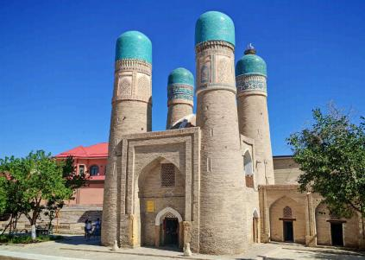
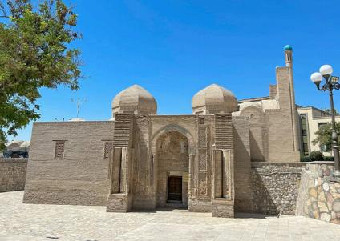
Chor Minor Madrasah, Bukhara
Magoki Attori Mosque & Carpet Museum



Attractions

none

Dining

None

 Transportation
tourist vehicle

Accommodation
Bukhara

Day 2 Bukhara Tour | Chor Minor Madrasah (Four Minarets), Lyabi Hauz Ensemble (Afandi Statue), Magoki Attori Mosque, Trading
Domes, Po-i-Kalyan Complex (Kalyan Minaret), Ark of Bukhara (Ark Fortress), Bolo Hauz Mosque

Today, follow our guide to fully explore Bukhara, one of the most atmospheric cities along the Silk Road. Often called the “Second Mecca,” Bukhara has been a center of Islamic
learning for centuries and is famous for its 2,500-year-old history as a Silk Road hub, from the era of the Samanids to the Timurids. This legendary city is also tied to the tales of One Thousand and One Nights and is the home of the beloved folk character Afandi.
Bukhara is wonderfully walkable - most of its landmarks are within a compact 6 km stretch - making it easy to immerse yourself in its living history, lively bazaars, and warm local
atmosphere.
Your exploration begins at Chor Minor Madrasah, the four-towered gem that once graced the cover of Lonely Planet Central Asia. Built in 1807 by the wealthy merchant Khalif
Niyazkul, its four unique minarets are believed to represent the four major religions of the world, with decorations that some interpret as Buddhist prayer wheels, Christian crosses, Zoroastrian motifs, and Islamic patterns. This charming structure is all that remains of a once-grand madrasa complex.
Continue to Lyabi Hauz Ensemble, the beating heart of Bukhara since the 17th century. Built around a peaceful pool shaded by mulberry trees, this square was once a lively Silk Road
trading hub. Its three surrounding monuments - the Nadir Divan-Beghi Madrasah, the Nadir Divan-Beghi Khanaka (Sufi hospice), and the Kukeldash Madrasah - are masterpieces of
Central Asian architecture. Today, Lyabi Hauz remains the social center of the city, lined with cafes where locals sip tea and travelers watch the world go by. Don’t miss the playful statue of Khodja Nasreddin (Afandi), the wise fool of Sufi legend, riding his donkey.
Nearby is the Magoki Attori Mosque, Bukhara’s oldest surviving mosque, dating back to the 9th–10th centuries. Situated 4.5 meters below ground level, this mosque is a true
archaeological wonder, displaying ancient brickwork and terracotta ornamentation. It now houses a small carpet museum (admission self-pay).
From there, stroll through Bukhara’s famous Trading Domes, a network of 16th-century domed bazaars - Toki-Zargaron, Toki-Sarrofon, Telpak-Furushon, and Tim Abdullah Khan.
Once bustling hubs for jewelers, money changers, and silk merchants, they still sell
traditional crafts, carpets, and souvenirs, allowing you to experience Bukhara’s mercantile spirit firsthand.
Next, reach the Po-i-Kalyan Complex, the iconic centerpiece of Bukhara’s skyline. Here you will admire the 47-meter-high Kalyan Minaret - so magnificent that Genghis Khan spared it from destruction. The adjacent Kalyan Mosque, with its 288 domes and capacity for 10,000 worshippers, and the Mir-i-Arab Madrasah, with its turquoise domes and active Islamic
school, together form one of Central Asia’s most stunning architectural ensembles.
Your final stop is the Ark of Bukhara, the ancient fortress that served as the royal residence for centuries, and the nearby Bolo Hauz Mosque, known as the “Mosque of Forty Columns” for its 20 exquisitely carved wooden pillars reflected in the pool in front. Inside the Ark,
explore its throne room, coronation mosque, and museums, or climb to the top for sweeping views over the city.

After the tour, be escorted back to your hotel in Bukhara.

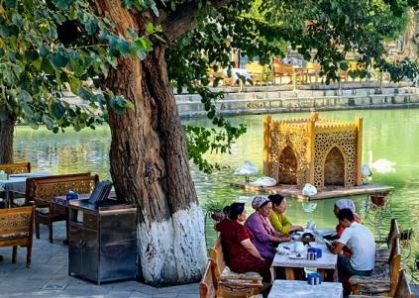
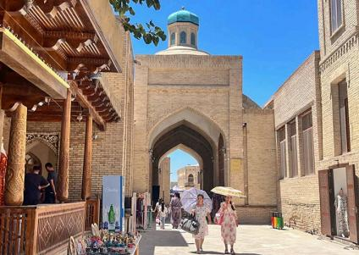
Toki-Sarrofon, Trading Domes Bukhara
Lyabi Hauz Ensemble, Bukhara

Attractions

7 sites

Dining
Breakfast

Transportation
tourist vehicle

Accommodation
Bukhara

Day 3 Bukhara - Samarkand | Scenery on the Way, Samarkand Hotel Check-in

After breakfast, your group will leave Bukhara and drive toward Samarkand. The journey takes about 4.5-5 hours (about 278km).
Shortly after departing Bukhara, you’ll enter a vast, flat landscape - a semi-desert steppe painted in soft gray-yellow tones, dotted with drought-tolerant shrubs and camel-thorn
bushes. Around the halfway point, the scenery shifts to endless cotton fields stretching to the horizon. In harvest season (September–October), you may see fluffy white cotton bolls opening across the fields and local farmers hand-picking the crop - an iconic sight of
Uzbekistan.
As you get closer to Samarkand, the land becomes greener and more fertile. Orchards of apricot and mulberry trees, vineyards, and well-kept farmlands line the road, signaling your approach to one of the Silk Road’s greatest cities.
Upon arrival in Samarkand, check in to your hotel and enjoy a comfortable stay in this legendary Silk Road destination.

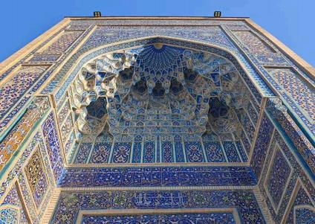

Attractions

none

Dining
Breakfast

 Transportation
tourist vehicle

Accommodation
Samarkand

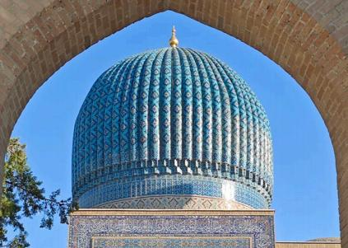
Day 4 Samarkand Tour | Gur Emir Mausoleum (Timur’s Tomb),
Registan Square, Bibi Khanim Mosque, Siyab Bazaar, Shahi Zinda Necropolis, Farewell Dinner

Today, immerse yourself in Samarkand, a UNESCO World Heritage Site and the former
capital of the Timurid Empire (14th–15th centuries). Known as Uzbekistan’s cultural heart and second-largest city, Samarkand dazzles visitors with its monumental architecture, Silk Road legends, and vibrant bazaars. From the majestic Gur-e Amir Mausoleum to the iconic Registan Square, the grand Bibi Khanim Mosque, the breathtaking Shahi Zinda Necropolis, and the lively Siyab Bazaar, you will discover a city that celebrates the glory and power of the Timurid dynasty.
Begin at Gur-e Amir Mausoleum, the final resting place of Amir Timur (Tamerlane),
completed in 1404. This striking monument, crowned with a ribbed azure dome, served as a prototype for later Mughal architecture, including India’s Taj Mahal. Step inside to marvel at its gilded interior, intricate jade tombstones, and delicate calligraphy. Look for Timur’s
legendary grave marker, said to carry a warning: “Whosoever disturbs my tomb will unleash an invader more terrible than I.” When Soviet archaeologists opened the tomb in June 1941, Nazi Germany invaded the USSR days later - a story that adds an air of mystery to your visit.
Next, head to Registan Square, the heart of Samarkand and one of the Silk Road’s most
magnificent sights. Once a sandy gathering place for royal decrees, military parades, and
festivals, it is now flanked by three resplendent madrasahs: Ulugh Beg Madrasa (1420), with its starry celestial mosaics; Sher-Dor Madrasa (1619), famed for its unique lion mosaics;
and Tilya-Kori Madrasa (1660), with a dazzling gold-leaf dome that graces the cover of

many guidebooks. By day, Registan is a masterpiece of symmetry and tilework; by night, it transforms under magical illuminations - a perfect spot for photography.
Continue to the monumental Bibi Khanim Mosque, one of the largest in the Islamic world. Built in 1404 to honor Timur’s wife, the mosque is steeped in legend - including the tale of the architect who dared to kiss Bibi Khanim and met Timur’s wrath. Step inside to admire gilded decorations inspired by local embroidery traditions.
Right nearby lies Siyab Bazaar, where you can sample Samarkand’s famous round bread, dried fruits, and spices while mingling with locals - a lively reminder that Samarkand was once a key Silk Road trading hub.
End your day with a stroll through Shahi Zinda Necropolis, an extraordinary “avenue of
mausoleums” climbing a hillside. This necropolis, dating from the 11th to 15th centuries,
contains some of the finest examples of Timurid-era tilework and the tombs of Timur’s
female relatives and high-ranking nobles. The site is also believed to house the grave of
Qutham ibn Abbas, cousin of Prophet Muhammad, making it a revered pilgrimage site. With its brilliant turquoise domes and intricate mosaics, Shahi Zinda is not just a spiritual
landmark but also one of Samarkand’s most photogenic spots.

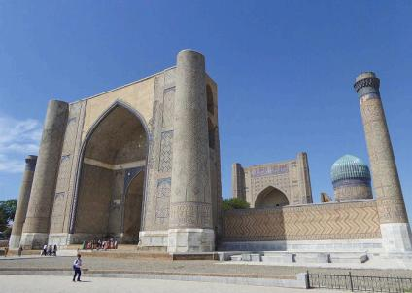
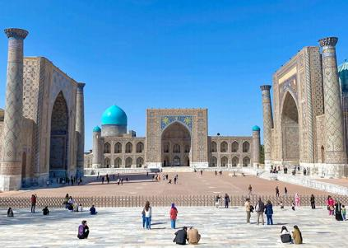
Bibi Khanim Mosque, Samarkand
Registan Square, Samarkand

Attractions

5 sites

Dining
Breakfast, Dinner

 Transportation
tourist vehicle

Accommodation
Samarkand

Day 5 Samarkand Departure | Hotel Check-out & See-off

After breakfast, it’s time to conclude your 5 days Uzbekistan group tour. Our local driver in
Samarkand will escort you to the airport or train station for your departure to your next
destination. (Travel Tip: Please share your flight or train details with us in advance so we can arrange your transfer smoothly.)
Additional Transfer Service (Extra Fee Required):
If you need transfer services from Samarkand to Tashkent, please let us know in advance. While the tour officially ends in Samarkand (as it has its own airport and train station), we’ll be happy to help you book train tickets to Tashkent and arrange transfers in Tashkent.
Central Asia Trip Extension:
Uzbekistan is only one part of “Five Stans” tour. If you have more time, you are welcome to join group tours to Kyrgyzstan, Kazakhstan, Turkmenistan, and Tajikistan. More landscapes and adventures await you.
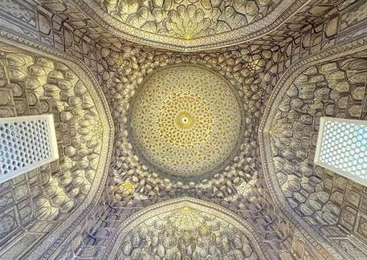  Shahi Zinda Necropolis, Samarkand |  |  | 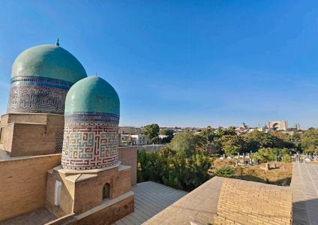  Shahi Zinda Necropolis, Samarkand
 | Attractions  none  Dining  Breakfast | Transportation  tourist vehicle  Accommodation  /

Month  Apr | Available Date  Apr.13, 2026
Month  Apr | Apr.20, 2026
May | May.01, 2026
May | May.05, 2026
May | May.12, 2026
May | May.23, 2026
May | May.27, 2026
Jun | Jun.03, 2026
Jun | Jun.14, 2026
Jun | Jun.18, 2026
Jun | Jun.25, 2026
Jul | Jul.06, 2026
Jul | Jul.10, 2026
Jul | Jul.17, 2026
Jul | Jul.28, 2026
Aug | Aug.01, 2026
Aug | Aug.08, 2026
Aug | Aug.19, 2026

 | Aug.23, 2026
 | Aug.30, 2026
Sep | Sep.10, 2026
Sep | Sep.14, 2026
Sep | Sep.21, 2026
Oct | Oct.02, 2026
Oct | Oct.06, 2026
Oct | Oct.13, 2026
Oct | Oct.24, 2026
Oct | Oct.28, 2026
Nov | Nov.04, 2026

Price: What’s Included & What’s Excluded

What's Included:
 Guide Service: Professional English-speaking tour guide.
Attraction Tickets: Entrance fees for all sites listed in the itinerary.
 Transportation:
- Airport transfers upon arrival and departure.
- Private tourist vehicle for all city sightseeing tours and overland travel.
- All flights and overland border crossings between countries, as well as all local transfers within the Five Stans.
Accommodation:
- Hotels as listed in the itinerary (primarily 4-star standard).
- In remote areas (e.g., Darvaza Gas Crater), accommodation will be in traditional guesthouses or yurt camps.

Meals:
- Daily breakfast at the hotel.
- Lunch and Dinner where specifically listed in the day-by-day itinerary.
- Special Meal Arrangements (One featured dining experience per country):
- Tashkent: Dinner featuring traditional dance and live music.
- Darvaza (Turkmenistan): Desert Barbecue Dinner with views of the burning gas crater.
- Ashgabat: Dinner at the TV Tower restaurant with city night views.
- Bishkek or Issyk-Kul (Kyrgyzstan) dinner
- Charyn Canyon (Kazakhstan): Picnic Lunch after hiking.
- Almaty: Featured Dinner featuring Kazakh cuisine and music/dance.
Logistics & Support:
- Cross-Border Assistance: Guide assistance for land border crossings.
- Turkmenistan LOI: Includes the fee for the Letter of Invitation required for the Turkmenistan visa.
Service Fees: All planning, handling, operational, and communication charges.

What's Excluded:
- Visa Fees: Cost of tourist visas (if required), depending on the traveler’s nationality.
- Travel Insurance: Comprehensive travel insurance is not included but is strongly recommended.
- Optional Tours: Costs for any optional activities or tours not explicitly listed in the itinerary.
- Unlisted Meals: Lunches and dinners not specified in the itinerary (your guide can provide recommendations for local restaurants).
- Single Supplement: Additional charge for travelers requesting a private room.
- Tips & Gratuities: Gratuities for tour guides and drivers are optional and at the traveler’s discretion.
- Overtime Service Fees: Additional charges may apply for services requested beyond scheduled itinerary hours.
- Personal Expenses: Shopping, alcohol, snacks, laundry, and other beverages outside of those specified in the itinerary.


Your Central Asia Group Tour Experience: What You Need to Know

01 | Small Group Size (1–16 Pax)  Our small group tours welcome 1–16 travelers, ensuring comfort and a friendly atmosphere. Departures are guaranteed even with one traveler. The group size will not exceed 16.
02 | Solo Travelers Welcome  We accept individual bookings. One person can join freely—just confirm your date with our Central Asia travel experts.
03 | Rooming & Single Supplement  Prices are based on double occupancy. Solo travelers or guests requesting a private room must pay a single supplement.
04 | Booking & Payment  A deposit is required to secure your seat. The remaining balance is due no later than 30 days before departure.
05 | Best Travel Season  Tours operate from late March to early November. The ideal months to visit the Five Stans are spring and autumn.
06 | About Visa  Visa required. We will need to apply for your Letter of Invitation (LOI) in  advance. The Turkmenistan visa can be obtained at the border upon arrival, based on the approved LOI. PCR test and Visa on arrival Fee need to pay on spot.  - If you need to obtain a Uzbekistan visa, it should be a multiple-entry e-visa.
07 | Accommodation Standards  Enjoy comfortable 4-star hotels in major cities.  Note: At the Darvaza Gas Crater, conditions are basic—private yurts, shared toilets, no showers, and limited water supply.
08 | Border Crossings  Usually require 1–2 hours. Your local guide will assist with forms and entry

 | procedures.
09 | Luggage Policy  Each traveler may bring 1 suitcase (max 26 inches) + 1 carry-on backpack. Excess luggage may affect comfort during transfers.
10 | Travel Insurance  Comprehensive insurance (medical, accident, cancellation, property) is strongly recommended.
11 | Non-Participation Policy  Skipping any activity is considered voluntary abandonment. No refunds will be provided for unused services.
12 | Amendments After Booking  Changes after confirmation may incur amendment fees and depend on availability and supplier conditions.
13 | Itinerary Integrity  For the safety and convenience of all travelers, deviations from the group itinerary cannot be accommodated during the tour.
14 | Cancellation & Rescheduling Policy  30–60 days before departure: 10% of the tour fee  15–29 days before departure: 30% of the tour fee 8–14 days before departure: 80% of the tour fee  0–7 days before departure: 100% of the tour fee

