8 Days Kazakhstan Kyrgyzstan Tour: 2
Stans with Nature, Hiking & Nomadic Life (Small Group)

Tour Code: CAGT-04
Travel Route: Kazakhstan (Almaty - Charyn Canyon) - Kyrgyzstan (Bishkek - Burana Tower - Issyk-Kul Lake - Bishkek)
Features: gorges, lakes, museums, mosque, tower, nature wonders, nomadic culture, bazaars, local life, hikes, capitals
Tour Type: Small Group of maximum 16 travelers, guaranteed departures;
Guide & Driver: English-speaking guide, experienced driver with regular tourist vehicle
Accommodation: 7 Nights at 4-Star Hotel & Guest House

Itinerary at a Glance

Almaty, Kazakhstan (2 Days)
28 Panfilov Guardsmen Park (Ascension Cathedral), Military History Museum, Museum of Folk Musical Instruments, Green Bazaar, Kok-Tobe Hill (Cable Car)

Charyn Canyon, Kazakhstan (1 Day)
Day trip to Charyn Canyon. About 2-hour Hiking, Picnic Lunch

Almaty - Bishkek, Kyrgyzstan (1 Day)
Flight from Almaty to Bishkek in Kyrgyzstan

Bishkek (1 Day)
Ala-Archa National Park, Ala-Too Square (Statue of Manas), Oak Park, State Historical Museum, Osh Bazaar

Burana Tower (0.5 Day)

Cholpon-Ata (1 Day)
Issyk-Kul Lake (Boating), Petroglyphs Museum

Bishkek (1.5 Day)
Depart from Bishkek

Itinerary Day by Day

Day 1 Almaty (Kazakhstan) Arrival | Airport Pick-up & Hotel Check in

Hello travelers! Welcome to Almaty, Kazakhstan’s Old Capital & Largest City! Upon your
arrival at Almaty International Airport, our local driver will greet you at the arrival gate. From there, it's about 20 km drive to the downtown area. Check in your hotel. The rest of today is free on your own in Almaty.
Nestled at the foot of the majestic Trans-Ili Alatau mountain range, Almaty enchants
travelers with its breathtaking natural setting, where snow-capped peaks are always in view. Known as the “Father of Apples” & “City of Apples”, it’s believed to be the genetic birthplace of modern apples. Spot whimsical apple art dotted all over Almaty - sweet, playful, and
totally Instagram-worthy!
Once a pivotal city on the Silk Road, Almaty is celebrated for its relaxed, friendly vibe, making it a haven for hikers, foodies, and culture lovers. As Kazakhstan’s former
capital (1929-1997), it retains a distinct Soviet-era charm, with leafy streets, grand avenues, and impressive cultural landmarks.
Almaty feels like a blend of European and Asian influences - clean, safe, and vibrant, with a multi-ethnic population of Kazakhs, Russians, Uyghurs, and Koreans. Be sure to try local delicacies like beshbarmak (a hearty meat and noodle dish) and shubat (fermented camel milk) for an authentic taste of nomadic heritage.
Arrival Ideas:
1. For Flights: Almaty International Airport (ALA) is Kazakhstan’s busiest hub, offering direct flights from major cities like Istanbul, Dubai, Frankfurt, Seoul, Beijing, and Moscow. Check
airlines like Lufthansa, Turkish Airlines, or Air Astana for the latest schedules and connections.
2. For Visas: Kazakhstan offers visa-free entry for citizens of over 80 countries, including the U.S., EU nations, the UK, Canada, Australia, and most of Asia. Others apply for an e-visa

online - fast, simple, and ready for your adventure! Always confirm requirements with official government sources before your trip.
Almaty Travel Tip: If you arrive in Almaty early and have some free time, you or your group can explore the city on your own. The following ideas have been compiled foryour
reference:
· Almaty Metro Experience: It is 18-meter-deep Soviet-era marvel. Ride affordable,
scenic lines: Abay Station’s cultural murals, Zhibek Zholy’s art. See uniquely themed stations adorned with beautiful mosaics, murals & ornate chandeliers. It’s an artistic underground museum & a functional transit hub.
· 2.Abay Opera House: Watch evening performance (affordable) at one of Central
Asia's oldest opera houses. It showcases world-class ballet & opera productions. Its elegant, Soviet-era architecture & grand interior provide a truly memorable cultural experience.
· 3. Night Life at Arbat Street:** It is a vibrant pedestrian zone. Enjoy street
performers, browse local art and crafts, and relax at one of its many cozy cafes. It's the perfect place to soak up the local culture.

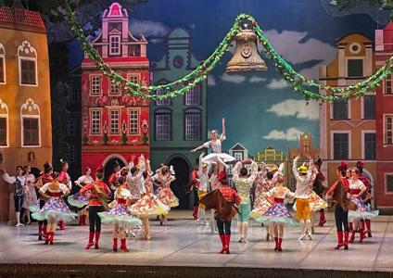
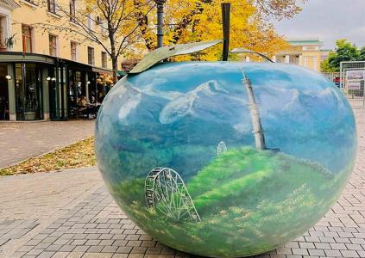
Abay Kazakh State Academic Opera and
Apple art dotted all over Almaty
Ballet Theater



Attractions

none

Dining

None

 Transportation
tourist vehicle

Accommodation
Almaty

Day 2 28 Panfilov Guardsmen Park (Ascension Cathedral, Military History Museum), Museum of Folk Musical Instruments, Green
Bazaar, Kok-Tobe Hill (Cable Car), Welcome Dinner

Today, your group will enjoy a full-day tour of Almaty’s essential city highlights. For first-time visitors, you will get perfect introduction to the city’s “historical memory, ethnic culture,
vibrant local life, and panoramic city views”.
After breakfast, your tour begins at 28 Panfilov Guardsmen Park, a peaceful green oasis named after General Ivan Panfilov and his 28 soldiers who heroically defended Moscow during World War II. Their legendary last words - “Great Russia, but nowhere to retreat.
Moscow is behind us.” - echo through history. Stroll along the shaded paths, pause at the Memorial of Glory and Eternal Flame, and honor the bravery that symbolizes the
preciousness of peace.
Move to the center of the park, you will see Almaty’s most iconic landmarks - the Ascension Cathedral (Zenkov Cathedral). Designed by architect Andrei Zenkov and completed in 1907, this 56-meter-tall architectural gem is the second-tallest wooden church in the world, built entirely without nails. Remarkably, it survived the devastating 1911 earthquake with almost no damage. Step inside to admire its colorful murals, gilded iconostasis, and serene
atmosphere - a memorable stop for reflection and photography.
After leaving the park, you will visit the Military History Museum, which presents the story of Kazakhstan’s warriors - from the ancient Saka and Turkic nomads to the modern Kazakh
armed forces. Spend some time in the World War II section, where precious photographs, letters, uniforms, and medals are displayed. Here, you will gain a deeper understanding of the 28 Panfilov Heroes and other Kazakh soldiers who showed extraordinary bravery during the war.
Next, take a short walk to the Kazakh Museum of Folk Musical Instruments, also designed by Zenkov. This charming wooden building houses more than 1,000 traditional instruments, including wooden harps, horns, bagpipes, the two-stringed dombra, and the bowed kobyz - each carrying the spirit of Kazakhstan’s nomadic heritage. If timing allows, you may even enjoy a short live performance that brings the sounds of the steppe to life.
Later, your group will visit the lively Green Bazaar (Zeleny Bazar), a bustling marketplace that offers a true taste of local life. Browse colorful stalls filled with spices, dried fruits, and
handmade crafts, or sample regional delicacies like juicy samsa (meat pies), tangy kurt (dried cheese), kazy (horse sausage), and traditional dairy sweets.
In the afternoon, be transferred and ascend to Kok-Tobe Hill, a symbol of Almaty at 1,100 meters above sea level. Ride the scenic cable car for panoramic views of the city and the
snow-capped Shymbulak Mountains. Visit the famous Beatles monument, admire the 372- meter TV Tower, and enjoy attractions like the Ferris wheel, mini-zoo, or cozy cafés. It’s a
perfect spot for sunset photography and relaxation amidst nature. After your visit, get down the hill and get back to Almaty.

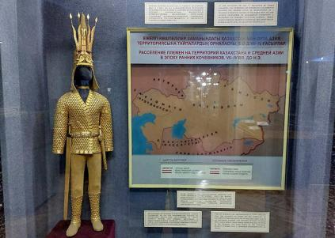
Central State Museum of Kazakhstan,
Almaty

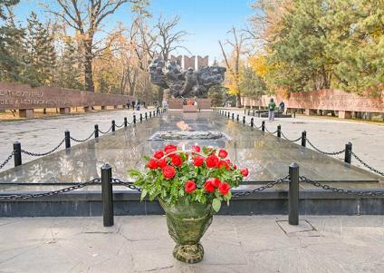
28 Panfilov Guardsmen Park, Almaty

 Attractions

5 sites

Dining
Breakfast, Dinner

 Transportation
tourist vehicle

Accommodation
Almaty

Day 3 Almaty - Charyn Canyon - Almaty | About 2-hour Hiking, Picnic Lunch

This morning, leave Almaty behind and set off on a scenic drive to Charyn Canyon National Park (about 210 km, 4-5 hours). Often called the “Grand Canyon of Central Asia,” this awe- inspiring natural wonder has been carved by wind and the Charyn River over the past 12
million years. Layers of colorful sedimentary rock reveal the Earth’s deep geological history - from ancient lake beds to long-vanished river systems.
The highlight of the park is the Valley of Castles (Dolina Zamkov), a stunning section where wind-sculpted cliffs and pillars resemble ancient fortresses and magical towers. Enjoy a
leisurely 2–3 km walk along the canyon floor, surrounded by glowing walls of red, orange, and gold. At the end of the trail, the path opens up to the Charyn River, where you can relax, enjoy your packed lunch, or simply take in the serenity of this incredible landscape.
Charyn Canyon stretches over 150 km along the river, featuring a surprising diversity of
terrain - from semi-desert cliffs to lush riverbanks dotted with small groves of ash trees, all framed by the distant, snow-capped Tian Shan Mountains. With a bit of luck, you may spot wildlife such as foxes, eagles, hares, or lizards along the way.
Travel Tips:
· Best Time to Visit: Spring (April-June) and autumn (September-October) offer the most pleasant weather. In summer (July-August), temperatures can exceed 40°C at the canyon floor - avoid hiking at midday if possible.

· Hiking Advice: The trail is mostly flat but exposed; wear comfortable, non-slip hiking shoes and carry plenty of drinking water.
· Picnic Lunch: As there are no restaurants within the canyon, we will provide a picnic or simple lunch box for your group, typically including sandwiches, fruit, and bottled water.
After a day of exploring one of Kazakhstan’s most spectacular natural sites, return to Almaty in the late afternoon.

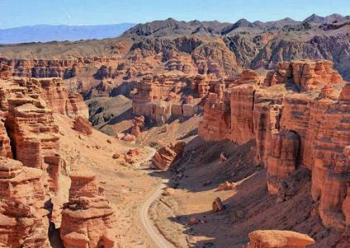
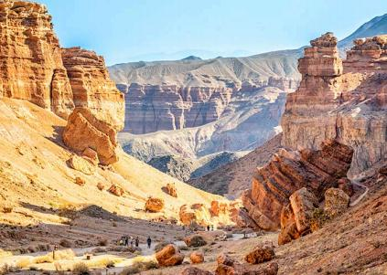
Charyn Canyon National Park
Charyn Canyon National Park

Attractions

1 site

Dining
Breakfast, Lunch

Transportation
tourist vehicle

Accommodation
Almaty

Day 4 Almaty Flight to Bishkek (Kyrgyzstan) | Airport Pick-up & Hotel Check-in

Today, you will enjoy some free time in Almaty. You can either rest at your hotel or wander around the city at your leisure. Then, your group will be transferred to the airport in Almaty for your flight to Bishkek, Kyrgyzstan. (Note: There are typically one to two daily flights on this route. We will book the best available option based on the current schedule.)
Welcome to Kyrgyzstan! Often referred to as the “Switzerland of Central Asia,” this country is renowned for its breathtaking natural beauty and rich nomadic culture. Its capital, Bishkek, offers a unique blend of Soviet-era charm and lush, green parks.
Upon arrival at Manas International Airport (FRU), our local driver will greet you and provide a private transfer to your downtown hotel. (Note: The airport is located approximately 32 km from the city center; the drive takes 40 to 60 minutes.)

Check in to your hotel. The rest of the day is yours to explore the capital city. (Tip: If you arrive early, feel free to ask our travel advisors for “free-time suggestions.”)

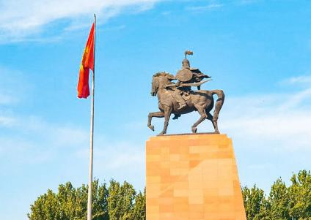
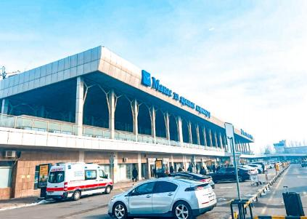
Bishkek Airport
Ala Too Square

Attractions

none

Dining
Breakfast

 Transportation
tourist vehicle

Accommodation
Bishkek

Day 5 Bishkek Tour | Ala-Archa National Park, Ala-Too Square
(Statue of Manas), Oak Park, State Historical Museum, Osh Bazaar, Welcome Dinner

After breakfast, your local guide and driver will pick you up from your hotel. Your group will then head out of Bishkek for a hike in Ala-Archa National Park, located 30 km (about 40-60 minutes) southwest of the city. Known as Bishkek’s “backyard park,” this alpine valley in the Tian Shan Mountains offers scenery reminiscent of Switzerland - majestic snow-capped
peaks, clear blue skies, dense pine forests, wildflower meadows, and scenic river valleys. It’s ideal for light hiking. You can follow the riverside trail for a leisurely walk while enjoying the fresh mountain air. Keep an eye out for wildlife such as squirrels, red deer, wild goats, and
even the elusive snow leopard (rare but possible!). (Route Tip: There are three hiking routes; we recommend the easy riverside path for the best views.)
In the afternoon, return to Bishkek for a city highlights tour. Begin at the main square, Ala- Too Square, where you’ll see the impressive statue of Manas, the legendary national hero, along with the Government House and the national flagpole. At certain times, you may also catch the changing-of-the-guard ceremony.

From the square, take a pleasant walk to Oak Park, a peaceful spot filled with centuries-old oak trees and various sculptures.
Nearby, visit the State Historical Museum, an excellent introduction to Kyrgyzstan’s rich
culture and heritage. Inside, you’ll find more than 80,000 artifacts, including a full-scale
Kyrgyz yurt, traditional felt and leather crafts, embroidered clothing, horse gear, and exhibits covering the Russian Empire and Soviet eras.
Next, head to Osh Bazaar, one of the liveliest markets in the city. Explore stalls offering fresh
produce, spices, nuts, dried fruits, local clothing, handicrafts, and beautifully woven carpets.

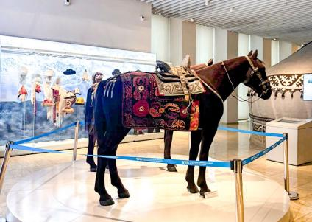
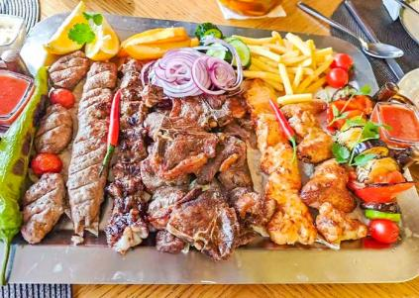
State Historical Museum
Kyrgyzstan Food

Attractions

5 sites

Dining
Breakfast, Dinner

Transportation
tourist vehicle

Accommodation
Bishkek

Day 6 Bishkek - Burana Tower - Cholpon-Ata | Issyk-Kul Lake (Boating)

After breakfast, your guide and driver will take the group east from Bishkek toward Issyk- Kul, the world’s second-largest high-altitude lake.
On the way, you’ll stop at the Burana Tower, an 11th-century minaret that once marked the ancient city of Balasagun, capital of the Kara-Khanid Khanate. Climb to the top for sweeping

views of the surrounding plains and distant snow-capped mountains. On the ground, stroll among the Balbals - medieval stone figures used as Turkic nomadic gravestones - offering a fascinating glimpse into the region’s early history.
Continue driving to Cholpon-Ata (about 3 hours), located on the northern shore of Issyk-Kul. After checking in to your hotel, enjoy the rest of the afternoon relaxing by the lake. Known as the “Pearl of Central Asia,” Issyk-Kul Lake sits at an elevation of 1,607 meters. Its slightly
salty water keeps it from freezing in winter, and its clear blue surface gives the impression of a calm seaside.
Activities at Issyk-Kul Lake:
· Boat Trip: Head to the pier for a scenic boat ride and take in panoramic views of the lake and surrounding mountains.
· Relax or Swim: Enjoy the golden sandy beaches - sunbathe or take a refreshing swim in the warm, crystal-clear water.

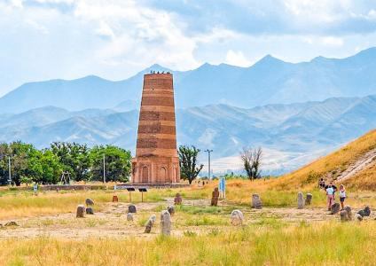
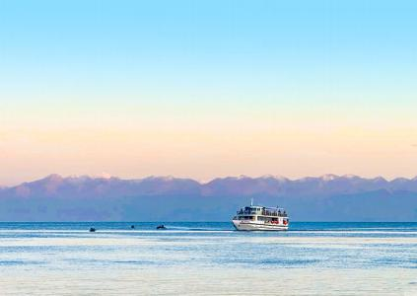
Issyk K ul Lake
Burana Tower

Attractions

2 sites

Dining
Breakfast

Transportation
tourist vehicle

Accommodation
Cholpon-Ata

Day 7 Cholpon-Ata - Petroglyphs Museum - Bihskek

Enjoy breakfast at your hotel. After that, you'll visit the Petroglyphs Museum. This open-air museum (42 hectares) is set on vast land with the majestic Tianshan Mountain range as backdrop. Here, you'll find ancient petroglyphs carved on massive black basalt stones,

which are dated from the 2nd millennium BC until the 4th century AD. These carvings depict animals like wolves and snow leopards, as well as hunting and sacrificial scenes.
After the visit, your group will be driven back to Bishkek (about 4 hours).
Upon arrival in Bishkek, you'll have some free time to visit a local market to buy souvenirs. Enjoy a relaxing evening in Bishkek.

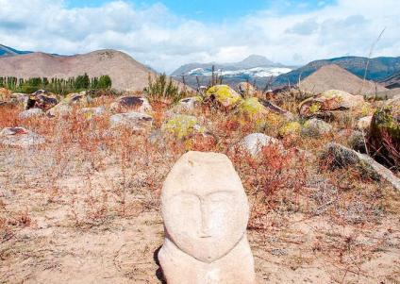
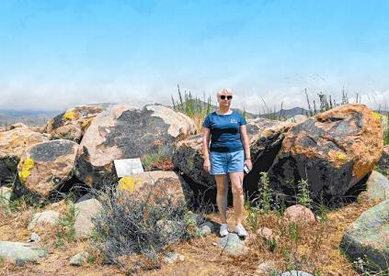
Petroglyphs Museum
Petroglyphs Museum

Attractions

1 site

Dining
Breakfast

Transportation
tourist vehicle

Accommodation
Bihskek

Day 8 Bishkek Departure | Hotel Check-out & Airport See-off

After breakfast, you will have some free time to explore Bishkek. Afterward, your group will be transferred to the airport for your flight to your next destination or return home. Your 8- day Kazakhstan Kyrgyzstan group tour ends. (Tip: Please inform us of your flight details so we can arrange your airport transfer accordingly.)
Central Asia Trip Extension:
Kazakhstan and Kyrgyzstan are part of “Five Stans” tour. If you have more time, you are
welcome to join group tours to Uzbekistan, Turkmenistan, and Tajikistan. More landscapes and adventures await you.

Attractions

none

Dining
Breakfast

Transportation
tourist vehicle

Accommodation
/

Month  Mar | Available Date  Mar.31, 2026
Apr | Apr.07, 2026
Apr | Apr.18, 2026
Apr | Apr.22, 2026
Apr | Apr.29, 2026
May | May.10, 2026
May | May.21, 2026
Jun | Jun.01, 2026
Jun | Jun.05, 2026
Jun | Jun.12, 2026
Jun | Jun.23, 2026
Jun | Jun.27, 2026
Jul | Jul.04, 2026

 | Jul.15, 2026
 | Jul.19, 2026
 | Jul.26, 2026
Aug | Aug.06, 2026
Aug | Aug.10, 2026
Aug | Aug.17, 2026
Aug | Aug.28, 2026
Sep | Sep.01, 2026
Sep | Sep.08, 2026
Sep | Sep.19, 2026
Sep | Sep.23, 2026
Sep | Sep.30, 2026
Oct | Oct.11, 2026
Oct | Oct.15, 2026
Oct | Oct.22, 2026
Nov |  | Nov.02, 2026

Price: What’s Included & What’s Excluded

What's Included:
 Guide Service: Professional English-speaking tour guide.

Attraction Tickets: Entrance fees for all sites listed in the itinerary.
Transportation:
- Airport transfers upon arrival and departure.
- Private tourist vehicle for all city sightseeing tours and overland travel.
- All flights and overland border crossings between countries, as well as all local transfers within the Five Stans.
 Accommodation:
- Hotels as listed in the itinerary (primarily 4-star standard).
- In remote areas (e.g., Darvaza Gas Crater), accommodation will be in traditional guesthouses or yurt camps.
Meals:
- Daily breakfast at the hotel.
- Lunch and Dinner where specifically listed in the day-by-day itinerary.
- Special Meal Arrangements (One featured dining experience per country):
- Tashkent: Dinner featuring traditional dance and live music.
- Darvaza (Turkmenistan): Desert Barbecue Dinner with views of the burning gas crater.
- Ashgabat: Dinner at the TV Tower restaurant with city night views.
- Bishkek or Issyk-Kul (Kyrgyzstan) dinner
- Charyn Canyon (Kazakhstan): Picnic Lunch after hiking.
- Almaty: Featured Dinner featuring Kazakh cuisine and music/dance.
Logistics & Support:
- Cross-Border Assistance: Guide assistance for land border crossings.
- Turkmenistan LOI: Includes the fee for the Letter of Invitation required for the Turkmenistan visa.
Service Fees: All planning, handling, operational, and communication charges.

What's Excluded:
 Travel Insurance: Comprehensive travel insurance is not included but is strongly recommended.
 Optional Tours: Costs for any optional activities or tours not explicitly listed in the itinerary.
Unlisted Meals: Lunches and dinners not specified in the itinerary (your guide can provide recommendations for local restaurants).
Single Supplement: Additional charge for travelers requesting
a private room.

Tips & Gratuities: Gratuities for tour guides and drivers are optional and at the traveler’s discretion.
Overtime Service Fees: Additional charges may apply for services requested beyond scheduled itinerary hours.
Personal Expenses: Shopping, alcohol, snacks, laundry, and other beverages outside of those specified in the itinerary.


Your Central Asia Group Tour Experience: What You Need to Know

01 | Small Group Size (1–16 Pax)  Our small group tours welcome 1–16 travelers, ensuring comfort and a friendly atmosphere. Departures are guaranteed even with one traveler. The group size will not exceed 16.
02 | Solo Travelers Welcome  We accept individual bookings. One person can join freely—just confirm your date with our Central Asia travel experts.
03 | Rooming & Single Supplement  Prices are based on double occupancy. Solo travelers or guests requesting a private room must pay a single supplement.
04 | Booking & Payment  A deposit is required to secure your seat. The remaining balance is due no later than 30 days before departure.
05 | Best Travel Season  Tours operate from late March to early November. The ideal months to visit the Five Stans are spring and autumn.
06 | About Visa  Visa required. We will need to apply for your Letter of Invitation (LOI) in  advance. The Turkmenistan visa can be obtained at the border upon arrival, based on the approved LOI. PCR test and Visa on arrival Fee need to pay on spot.

 | - If you need to obtain a Uzbekistan visa, it should be a multiple-entry e-visa.
07 | Accommodation Standards  Enjoy comfortable 4-star hotels in major cities.  Note: At the Darvaza Gas Crater, conditions are basic—private yurts, shared toilets, no showers, and limited water supply.
08 | Border Crossings  Usually require 1–2 hours. Your local guide will assist with forms and entry procedures.
09 | Luggage Policy  Each traveler may bring 1 suitcase (max 26 inches) + 1 carry-on backpack. Excess luggage may affect comfort during transfers.
10 | Travel Insurance  Comprehensive insurance (medical, accident, cancellation, property) is strongly recommended.
11 | Non-Participation Policy  Skipping any activity is considered voluntary abandonment. No refunds will be provided for unused services.
12 | Amendments After Booking  Changes after confirmation may incur amendment fees and depend on availability and supplier conditions.
13 | Itinerary Integrity  For the safety and convenience of all travelers, deviations from the group itinerary cannot be accommodated during the tour.
14 | Cancellation & Rescheduling Policy  30–60 days before departure: 10% of the tour fee  15–29 days before departure: 30% of the tour fee 8–14 days before departure: 80% of the tour fee  0–7 days before departure: 100% of the tour fee

