20 Days Central Asia Tour:Best 5 Stans Budget Tour in Small Group

Tour Code:CAGT-08
Travel Route: Kazakhstan-Kyrgyzstan-Uzbekistan -Turkmenistan-Uzbekistan- Tajikistan-Uzbekistan
Features: gorges,lakes,museums,mosque,tower,nature wonders,nomadic
culture,silk road,bazaars,local life,yurt camp,hikes,world heritage sites,ancient towns,capitals,dersert,camping,hiking
Tour Type: Small Group of maximum 16 travelers,guaranteed departures;
Guide &Driver:English-speaking guide,experienced driver with regular tourist vehicle
Accommodation: 19 Nights at 4-Star Hotel &Guest House

Itinerary at a Glance

 Almaty,Kazakhstan(2 Days)
28 Panfilov Guardsmen Park(Ascension Cathedral),Military History Museum, Museum of Folk Musical Instruments,Green Bazaar,Kok-Tobe Hill (Cable Car),
Welcome Dinner

 Charyn Canyon,Kazakhstan (1 Day)
Day trip to Charyn Canyon.About 2-hour Hiking,Picnic Lunch

 Almaty -Bishkek,Kyrgyzstan(1 Day)
Flight from Almaty to Bishkek.
 Bishkek(1 Day)
Ala-Archa National Park,Ala-Too Square (Statue of Manas),Oak Park,State Historical Museum,Osh Bazaar,Featured Dinner

 Burana Tower(0.5 Day)

 Cholpon-Ata(1 Day)
Issyk-Kul Lake(Boating),Petroglyphs Museum

 Bishkek(0.5 Day)
Bishkek free exploration and flight to Tashkent

Tashkent,Uzbekistan(1.5 Day)
Khast-Imam Complex(with the world's oldest Quran),Chorsu Bazaar,Museum of Applied Arts,Soviet-era metro,Amir Timur Square,and surrounding landmarks;
Featured Dinner

 Khiva,Uzbekistan(1 Day)
Stroll through Ichan Kala,the UNESCO-listed inner town:Kalta Minor Minaret,Juma Mosque,madrassahs,and palaces.

Shavat-Dashoguz,Border Crossing(0.5 Day)
Cross via Shavat-Dashoguz border;drive into the Karakum Desert.

 Darvaza Gas Crater,Turkmenistan(0.5 Day)
Overnight camping near the "Door to Hell,"with barbecue dinner and night views of the fiery crater.

 Ashgabat,Turkmenistan(1 Day)
Ertugrul Gazi Mosque,Ahal-Teke horse stables,Gulistan Bazaar,Neutrality Monument,National History Museum,and Independence Park,and other architectural landmarks;Featured Dinner

Mary &Ancient Merv,Turkmenistan(1 Day)
Day trip from Mary to Merv archaeological site:Sultan Sanjar Mausoleum,Kyz Kala fortresses,and Silk Road ruins.

 Farap,Border Crossing:Turkmenistan-Bukhara,Uzbekistan(0.5 Day)
Travel across the Turkmen-Uzbek border to arrive in Bukhara.

 Bukhara,Uzbekistan(1.5 Day)
Lyabi-Hauz Ensemble,Kukeldash Madrassah,Nadir Divan-Begi Madrassah,trading domes,Poi-Kalyan Complex(Kalyan Minaret,Mosque,and Miri Arab Madrassah)

 Samarkand,Uzbekistan(1.5 Day)
Gur Emir Mausoleum (Timur’s Tomb), Registan Square, Bibi Khanim Mosque, Siyab Bazaar, Shahi Zinda Necropolis; Featured Dinner

 Jartepa, Border Crossing (0.5 Day)
Enter into Tajikistan

Penjikent, Tajikistan (1 Day)
Drive through the Seven Lakes with short hike and picnic; Rudaki Museum, ancient Penjikent ruins.

 Jartepa, Border Crossing (0.5 Day)
Return to Samarkand.

Samarkand (1 Day)
Leave Samarkand by air or train.

Itinerary Day by Day

Day 1 Almaty (Kazakhstan) Arrival | Airport Pick-up & Hotel Check in

Hello travelers! Welcome to Almaty, Kazakhstan’s Old Capital & Largest City! Upon your
arrival at Almaty International Airport, our local driver will greet you at the arrival gate. From there, it's about 20 km drive to the downtown area. Check in your hotel. The rest of today is free on your own in Almaty.
Nestled at the foot of the majestic Trans-Ili Alatau mountain range, Almaty enchants
travelers with its breathtaking natural setting, where snow-capped peaks are always in view. Known as the “Father of Apples” & “City of Apples”, it’s believed to be the genetic birthplace of modern apples. Spot whimsical apple art dotted all over Almaty - sweet, playful, and
totally Instagram-worthy!
Once a pivotal city on the Silk Road, Almaty is celebrated for its relaxed, friendly vibe, making it a haven for hikers, foodies, and culture lovers. As Kazakhstan’s former
capital (1929-1997), it retains a distinct Soviet-era charm, with leafy streets, grand avenues, and impressive cultural landmarks.
Almaty feels like a blend of European and Asian influences - clean, safe, and vibrant, with a multi-ethnic population of Kazakhs, Russians, Uyghurs, and Koreans. Be sure to try local

delicacies like beshbarmak(a hearty meat and noodle dish)and shubat(fermented camel milk)for an authentic taste of nomadic heritage.

Arrival Ideas:
1.For Flights: Almaty International Airport (ALA)is Kazakhstan's busiest hub,offering direct flights from major cities like Istanbul,Dubai,Frankfurt,Seoul,Beijing,and Moscow.Check airlines like Lufthansa,Turkish Airlines,or Air Astana for the latest schedules and
connections.
2.For Visas: Kazakhstan offers visa-free entry for citizens of over 80 countries,including
the U.S.,EU nations,the UK,Canada,Australia,and most of Asia.Others apply for an e-visa online-fast,simple,and ready for your adventure!Always confirm requirements with official government sources before your trip.
A/maty Travel Tip: If you arrive in A/maty early and have some free time,you oryour group can explore the city on your own. The following ideas have been compiled for your
reference:
· Almaty Metro Experience:It is 18-meter-deep Soviet-era marvel.Ride affordable,
scenic lines:Abay Station's cultural murals,Zhibek Zholy's art.See uniquely themed stations adorned with beautiful mosaics,murals &ornate chandeliers.It's an artistic underground museum &a functional transit hub.2.Abay Opera House:Watch
evening performance (affordable)at one of Central Asia's oldest opera houses.It showcases world-class ballet &opera productions.Its elegant,Soviet-era
architecture &grand interior provide a truly memorable cultural experience.3. Night Life at Arbat Street: It is a vibrant pedestrian zone.Enjoy street performers,browse local art and crafts,and relax at one of its many cozy cafes.It's the perfect place to soak up the local culture.

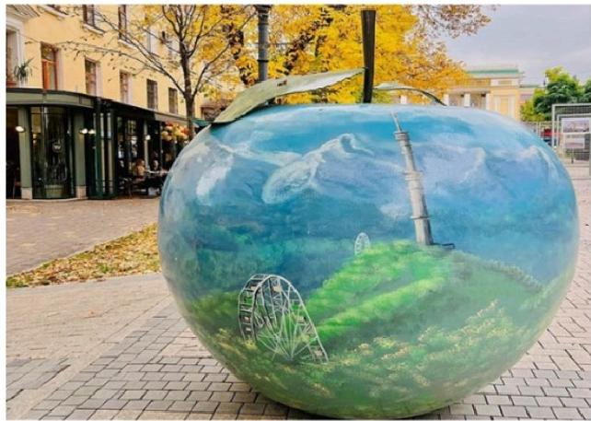
Apple art dotted allover Almaty

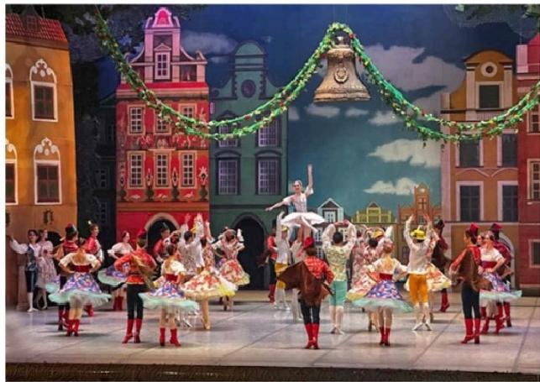
Abay Kazakh State Academic Opera and Ballet Theater

 Attractions none

 Transportation
tourist vehicle

 Dining None

 Accommodation Almaty

Day 2 Almaty City Tour|28 Panfilov Guardsmen Park(Ascension
Cathedral,Military History Museum),Museum of Folk Musical
Instruments,Green Bazaar,Kok-Tobe Hill (Cable Car),Welcome Dinner
Today,your group will enjoy a full-day tour of Almaty's essential city highlights.For first-time visitors,you will get perfect introduction to the city's "historical memory,ethnic culture,
vibrant local life,and panoramic city views”.
After breakfast,your tour begins at 28 Panfilov Guardsmen Park, a peaceful green oasis named after General Ivan Panfilov and his 28 soldiers who heroically defended Moscow during World War I.Their legendary last words-"Great Russia,but nowhere to retreat. Moscow is behind us."-echo through history.Stroll along the shaded paths,pause at the Memorial of Glory and Eternal Flame, and honor the bravery that symbolizes the
preciousness of peace.

Move to the center of the park,you will see Almaty's most iconic landmarks-the Ascension Cathedral (Zenkov Cathedral).Designed by architect Andrei Zenkov and completed in 1907, this 56-meter-tall architectural gem is the second-tallest wooden church in the world,built entirely without nails.Remarkably,it survived the devastating 1911 earthquake with almost no damage.Step inside to admire its colorful murals,gilded iconostasis,and serene
atmosphere-a memorable stop for reflection and photography.
After leaving the park,you will visit the Military History Museum, which presents the story of Kazakhstan's warriors-from the ancient Saka and Turkic nomads to the modern Kazakh
armed forces.Spend some time in the World War ll section,where precious photographs, letters,uniforms,and medals are displayed.Here,you will gain a deeper understanding of the 28 Panfilov Heroes and other Kazakh soldiers who showed extraordinary bravery during the war.
Next,take a short walk to the Kazakh Museum of Folk Musical Instruments,also designed by Zenkov.This charming wooden building houses more than 1,000 traditional instruments, including wooden harps,horns,bagpipes,the two-stringed dombra,and the bowed kobyz- each carrying the spirit of Kazakhstan's nomadic heritage.If timing allows,you may even enjoy a short live performance that brings the sounds of the steppe to life.
Later,your group will visit the lively Green Bazaar(Zeleny Bazar), a bustling marketplace that offers a true taste of local life.Browse colorful stalls filled with spices,dried fruits,and handmade crafts,or sample regional delicacies like juicy samsa(meat pies),tangy
kurt(dried cheese),kazy(horse sausage),and traditional dairy sweets.

In the afternoon,be transferred and ascend to Kok-Tobe Hill,a symbol of Almaty at 1,100 meters above sea level.Ride the scenic cable car for panoramic views of the city and the snow-capped Shymbulak Mountains. Visit the famous Beatles monument,admire the 372- meter TV Tower, and enjoy attractions like the Ferris wheel,mini-zoo,or cozy cafés.It's a
perfect spot for sunset photography and relaxation amidst nature.After your visit,get down the hill and get back to Almaty.

AOT Special Welcome Dinner:

In the evening,Asia Odyssey Travel will offer Special Welcome Dinner for your group.Enjoy authentic Kazakh-style cuisine accompanied by local dance or live music.It's the perfect way to relax,connect with fellow travelers.

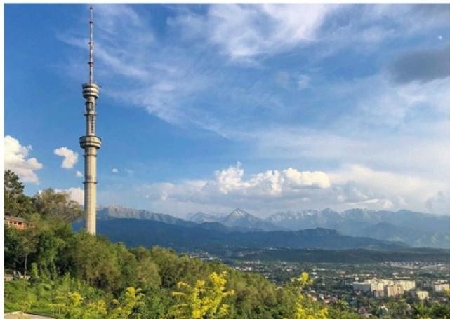
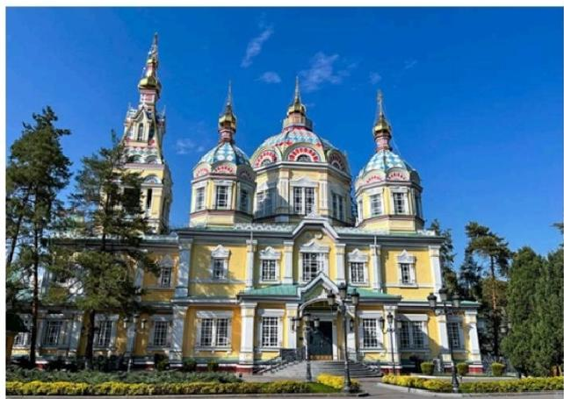

Ascension Cathedral,Almaty
Kok Tobe Hill,Almaty

 Attractions
5 sites

 Dining
Breakfast,Dinner
 Transportation tourist vehicle

 Accommodation Almaty

Day 3 Almaty -Charyn Canyon -Almaty |About 2-hour Hiking,
Picnic Lunch

This morning,leave Almaty behind and set off on a scenic drive to Charyn Canyon National Park (about 210 km,4-5 hours).Often called the “Grand Canyon of Central Asia,”this awe- inspiring natural wonder has been carved by wind and the Charyn River over the past 12
million years.Layers of colorful sedimentary rock reveal the Earth's deep geological history- from ancient lake beds to long-vanished river systems.

The highlight of the park is the Valley of Castles(Dolina Zamkov),a stunning section where wind-sculpted cliffs and pillars resemble ancient fortresses and magical towers.Enjoy

leisurely 2-3 km walk along the canyon floor,surrounded by glowing walls of red,orange, and gold.At the end of the trail,the path opens up to the Charyn River,where you can relax, enjoy your packed lunch,or simply take in the serenity of this incredible landscape.
Charyn Canyon stretches over 150 km along the river,featuring a surprising diversity of
terrain -from semi-desert cliffs to lush riverbanks dotted with small groves of ash trees,all framed by the distant,snow-capped Tian Shan Mountains. With a bit of luck,you may spot wildlife such as foxes,eagles,hares,or lizards along the way.

Travel Tips:

· Best Time to Visit:Spring(April-June)and autumn(September-October)offer the most pleasant weather.In summer (July-August),temperatures can exceed 40℃ at the canyon floor-avoid hiking at midday if possible.

· Hiking Advice:The trail is mostly flat but exposed;wear comfortable,non-slip hiking shoes and carry plenty of drinking water.

· Picnic Lunch:As there are no restaurants within the canyon,we will provide a picnic or simple lunch box foryour group,typically including sandwiches,fruit,and bottled
water.

After a day of exploring one of Kazakhstan's most spectacular natural sites,return to Almaty in the late afternoon.

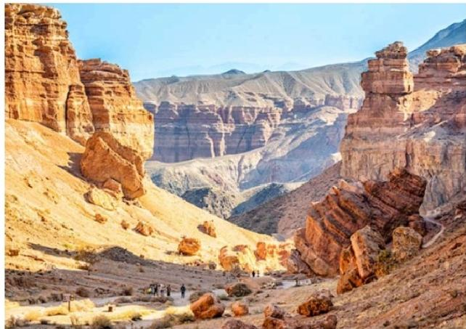
Charyn Canyon National Park

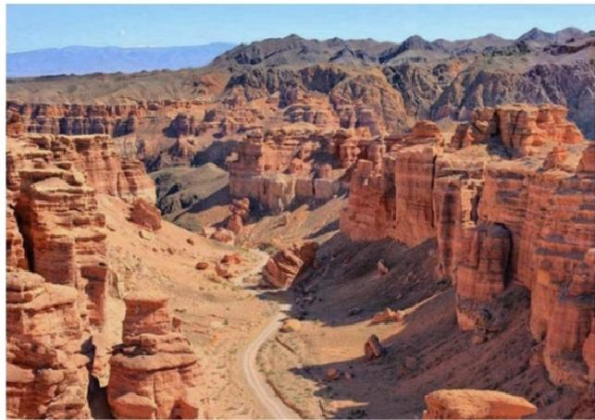
Charyn Canyon National Park

 Attractions
1 site

 Dining
Breakfast,Lunch

 Transportation tourist vehicle

 Accommodation Almaty

Day 4 Almaty Flight to Bishkek(Kyrgyzstan)|Airport Pick-up&
Hotel Check-in

Today,you will enjoy some free time in Almaty.You can either rest at your hotel or wander around the city at your leisure.Then,your group will be transferred to the airport in Almaty for your flight to Bishkek,Kyrgyzstan.(Note:There are typically one to two daily flights on this route. We will book the best available option based on the current schedule.)
Welcome to Kyrgyzstan! Often referred to as the"Switzerland of Central Asia,"this country is renowned for its breathtaking natural beauty and rich nomadic culture.Its capital,Bishkek, offers a unique blend of Soviet-era charm and lush,green parks.
Upon arrival at Manas International Airport(FRU),our local driver will greet you and provide a private transfer to your downtown hotel.(Note:The airport is located approximately 32 km from the city center;the drive takes 40 to 60 minutes.)
Check in to your hotel.The rest of the day is yours to explore the capital city.(Tip:If you arrive early,feel free to ask our travel advisors for "free-time suggestions.")
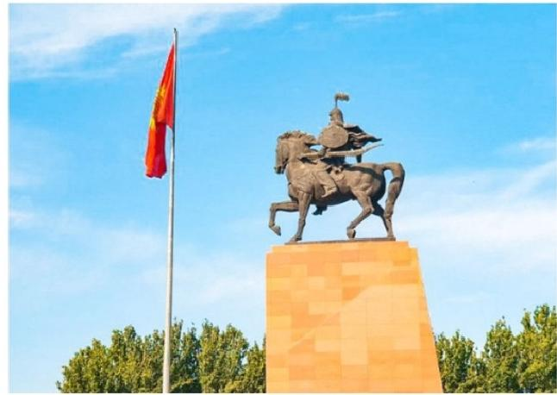  Ala Too Square |  | 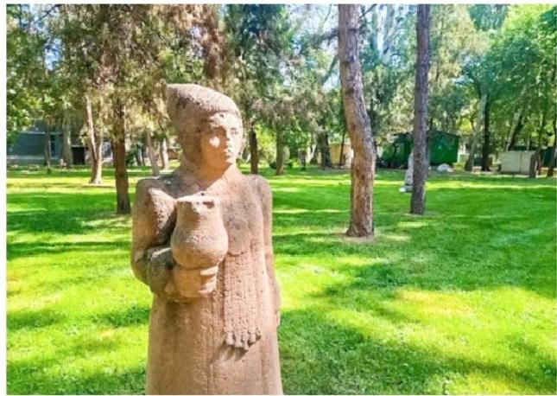  Oak Park
 Attractions none   Dining Breakfast |  Transportation tourist vehicle   Accommodation Bishkek

Day 5 Bishkek Tour|Ala-Archa National Park,Ala-Too Square
(Statue of Manas),Oak Park,State Historical Museum,Osh Bazaar, Featured Dinner

After breakfast,your local guide and driver will pick you up from your hotel.Your group will then head out of Bishkek for a hike in Ala-Archa National Park,located 30 km(about 40-60 minutes)southwest of the city.Known as Bishkek's "backyard park,"this alpine valley in the Tian Shan Mountains offers scenery reminiscent of Switzerland-majestic snow-capped
peaks,clear blue skies,dense pine forests,wildflower meadows,and scenic river valleys.It's ideal for light hiking.You can follow the riverside trail for a leisurely walk while enjoying the fresh mountain air.Keep an eye out for wildlife such as squirrels,red deer,wild goats,and even the elusive snow leopard(rare but possible!).(Route Tip:There are three hiking routes; we recommend the easy riverside path for the best views.)

In the afternoon,return to Bishkek for a city highlights tour.Begin at the main square,Ala- Too Square, where you'll see the impressive statue of Manas, the legendary national hero, along with the Government House and the national flagpole.At certain times,you may also catch the changing-of-the-guard ceremony.
From the square,take a pleasant walk to Oak Park,a peaceful spot filled with centuries-old oak trees and various sculptures.
Nearby,visit the State Historical Museum, an excellent introduction to Kyrgyzstan's rich
culture and heritage.Inside,you'l find more than 80,000 artifacts,including a full-scale
Kyrgyz yurt,traditional felt and leather crafts,embroidered clothing,horse gear,and exhibits covering the Russian Empire and Soviet eras.
Next,head to Osh Bazaar, one of the liveliest markets in the city.Explore stalls offering fresh produce,spices,nuts,dried fruits,local clothing,handicrafts,and beautifully woven carpets.

Special Welcome Dinner:

This evening,enjoy a welcome dinner hosted by Travel Agency at a renowned local restaurant.Experience a warm Kyrgyz atmosphere with modern comfort as you savor
authentic Kyrgyz dishes and Central Asian fusion cuisine.

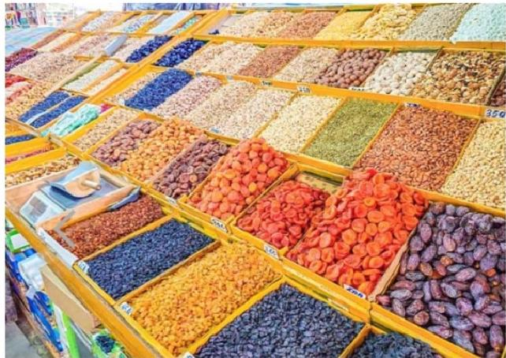

Osh Bazaar

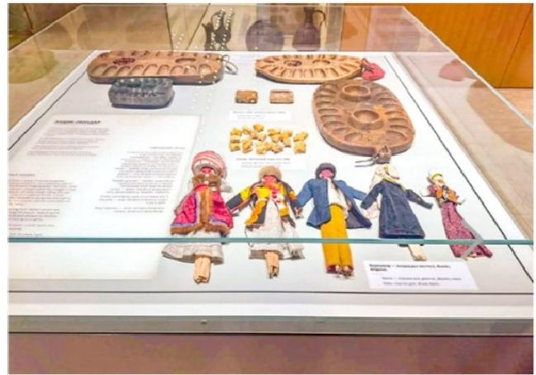
State Historical Museum

 Attractions

 Transportation

5 sites

 Dining
Breakfast,Dinner

tourist vehilce

 Accommodation
Bishkek

Day 6 Bishkek -Burana Tower -Cholpon-Ata|Issyk-Kul Lake
(Boating)

After breakfast,your guide and driver will take the group east from Bishkek toward Issyk- Kul,the world's second-largest high-altitude lake.
On the way,you'll stop at the Burana Tower, an 11th-century minaret that once marked the ancient city of Balasagun,capital of the Kara-Khanid Khanate.Climb to the top for sweeping views of the surrounding plains and distant snow-capped mountains.On the ground,stroll among the Balbals-medieval stone figures used as Turkic nomadic gravestones -offering a fascinating glimpse into the region's early history.
Continue driving to Cholpon-Ata(about 3 hours),located on the northern shore of Issyk-Kul. After checking in to your hotel,enjoy the rest of the afternoon relaxing by the lake.Known as the "Pearl of Central Asia,"Issyk-Kul Lake sits at an elevation of 1,607 meters.Its slightly
salty water keeps it from freezing in winter,and its clear blue surface gives the impression of a calm seaside.
Activities at Issyk-Kul Lake:
· Boat Trip:Head to the pier for a scenic boat ride and take in panoramic views of the lake and surrounding mountains.

· Relax or Swim:Enjoy the golden sandy beaches -sunbathe or take a refreshing swim in the warm,crystal-clear water.

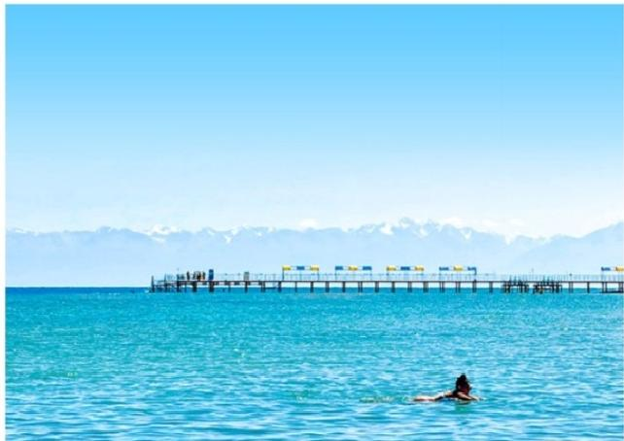
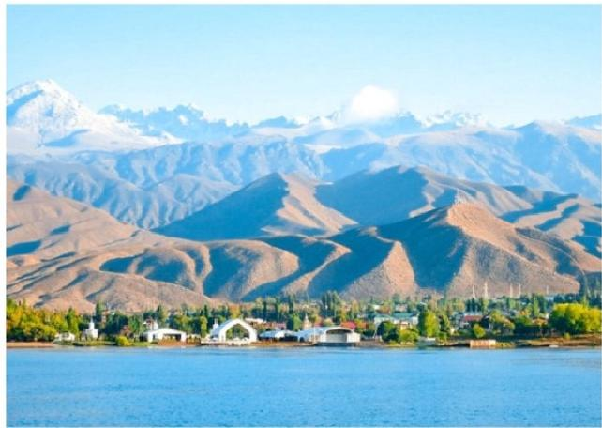
Issyk Kul Lake
Issyk Kul Lake

Day 7 Cholpon-Ata-Petroglyphs Museum -Bihskek

Enjoy breakfast at your hotel.After that,you'l visit the Petroglyphs Museum. This open-air museum(42 hectares)is set on vast land with the majestic Tianshan Mountain range as
backdrop.Here,you'll find ancient petroglyphs carved on massive black basalt stones,
which are dated from the 2nd millennium BC until the 4th century AD.These carvings depict animals like wolves and snow leopards,as well as hunting and sacrificial scenes.
After the visit,your group will be driven back to Bishkek (about 4 hours).
Upon arrival in Bishkek,you'l have some free time to visit a local market to buy souvenirs.Enjoy a relaxing evening in Bishkek.

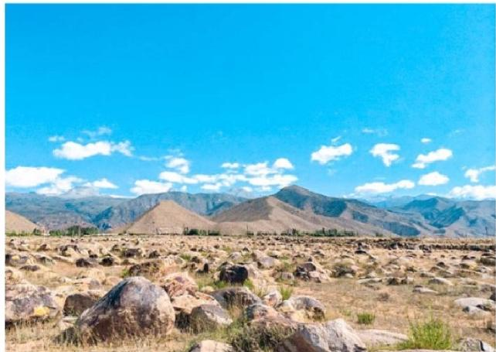
Petroglyphs Museum

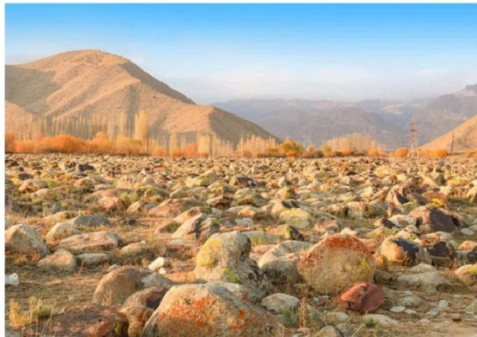
Petroglyphs Museum

 Attractions
1 site

 Dining Breakfast

 Transportation tourist vehicle

 Accommodation Bihskek

Day 8 Bishkek &Flight to Tashkent(Uzbekistan)|Free Time in Bishkek&Airport -Hotel Transfer Service

After breakfast,you'll have some free time to explore Bishkek.In the afternoon,your group will be transferred to the airport for your flight to Tashkent,the capital of Uzbekistan.The flight takes about 1 hour and 20 minutes.

Welcome to Tashkent! Uzbekistan's vibrant capital and largest city is the perfect gateway to the country's Silk Road treasures,blending Soviet-era grandeur with modern charm.In your Tashkent trip,you will explore its iconic metro stations,lively bazaars,historic mosques,and don't miss tasting Plov,the national dish.

Upon arrival at Tashkent International Airport,your guide will meet you at the arrivals gate. From there,it's about one-hour drive to the downtown area.You'l be transferred to your
hotel for check-in.Enjoy the rest of the day at leisure.
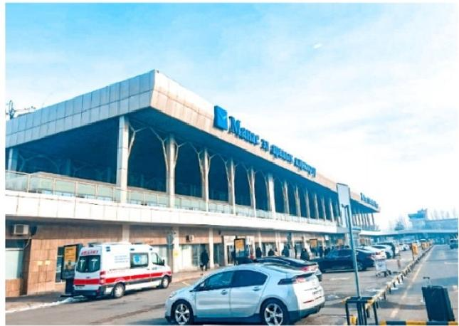  Bishkek Airport |  | 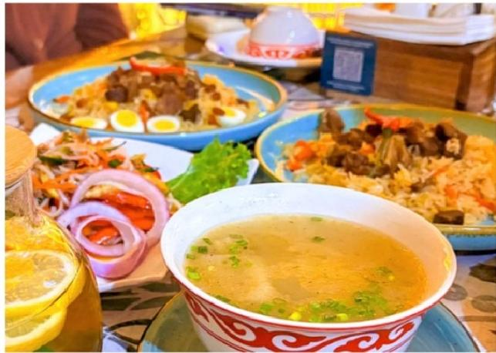  Kyrgyzstan Food
 Attractions none   Dining Breakfast |  Transportation tourist vehicle   Accommodation Tashkent

Day 9 Tashkent One Day Tour |Khast-Imam Complex(Hazrati
Imam Complex),Chorsu Bazaar,State Museum of Applied Arts,
Tashkent Metro (Soviet-era),Amir Timur Square,Featured Dinner

After breakfast,your group will have a full day to explore Tashkent,Uzbekistan's vibrant capital.You'l get a first impression of this country.

Begin your day in the Old City at the Khast-Imam Complex, the spiritual heart of Tashkent. This serene ensemble of blue-domed mosques, mausoleums, and madrasahs invites you to step back in time. Here you’ll find the elegant Hazrati Imam Mosque, whose twin 53-meter minarets and gold-leafed domes dominate the square, as well as the Tillya Sheikh Mosque, Barak Khan Madrasah, and the Mausoleum of Abu Bakr Kaffal Shashi, a 10th-century
scholar, poet, and locksmith-saint after whom the complex is named. Be sure to visit the Mui Muborak Library, home to the revered 7th-century Osman Qur’an - one of the world’s oldest copies.
After soaking up the complex’s peaceful atmosphere, stroll through Barak Khan Madrasah, now home to artisan workshops and boutiques. Watch local masters create ikat fabrics, woodcarvings, pottery, and jewelry, giving you a chance to bring home a unique handmade souvenir.
Continue your immersion in local culture with a visit to Chorsu Bazaar, Tashkent’s largest and most iconic marketplace. Beneath its turquoise dome, vendors sell colorful spices,
dried fruits, fresh bread still warm from the tandoor, and vibrant handicrafts. Sample street food, chat with friendly locals, and experience the daily rhythm of Tashkent life.
Next, explore the State Museum of Applied Arts, where more than 7,000 exhibits showcase Uzbekistan’s finest craftsmanship from the 19th century to today. Admire intricate gold
embroidery, suzani textiles, ceramics, jewelry, carpets, and woodcarvings, gaining a deeper appreciation for the country’s artistic traditions.
In the afternoon, descend underground for a ride on the Tashkent Metro - an experience in itself. As the first subway system in Central Asia, it is a living museum of Soviet architecture and Uzbek decorative art. Each station is uniquely designed, from Kosmonavtlar with its
cosmonaut-themed mosaics to Paxtakor with cotton motifs.
Emerge at Amir Timur Square, the heart of modern Tashkent. Surrounded by landmarks
such as Hotel Uzbekistan, the Palace of International Forums, and the University of Law, the square is anchored by a bronze equestrian statue of Amir Timur, the great Central Asian
conqueror and founder of the Timurid Empire. Take time to relax by the fountains, stroll through the green spaces, and - if time allows - visit the Amir Timur Museum (closed
Mondays), whose striking dome is depicted on the 1,000-som banknote. Inside, discover fascinating exhibits on Timur’s life and legacy.
After the tour, be escorted back to the hotel in Tashkent.

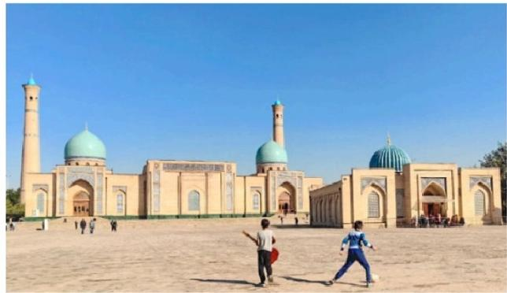

 Attractions
5 sites

 Dining
Breakfast,Dinner

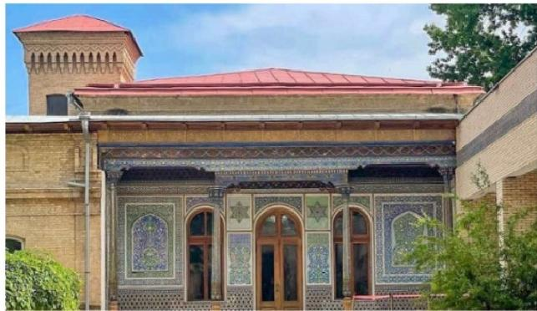

 Transportation tourist vehicle

 Accommodation Tashkent

Day 10 Tashkent to Urgench by Morning Flight,Transfer to Khiva
(World Heritage)|Ichan-kala (Kalta Minor Minaret,Pakhlavan
Makhmud Mausoleum,Islam Khoja Minaret,Juma Mosque,Tosh
Hovli Palace,Kuhna Ark)

On this day,your group will need to get up early and take your morning flight from Bishkek to Urgench International Airport,followed by short 36 km transfer to Khiva, a UNESCO
World Heritage Site.The contrast is striking:leaving behind modern Tashkent,the Silk
Road's gateway,you step into a city that feels frozen in time.Once a thriving Silk Road hub in the 16th century,Khiva blended Persian,Turkic,and Russian influences,becoming a safe haven for traders and scholars.
"I would offer a bag of gold merely to catch a glimpse of Khiva."This well-known Central Asian saying perfectly captures the city's legendary allure.Khiva is a living "open-air
museum,"a place where stepping through its gates feels like traveling back to the medieval era.
The highlight of Khiva is Itchan Kala, the perfectly preserved inner-walled city of the
Khwarezm Empire(10th-17th centuries).Enclosed by 10-meter-high mud-brick walls,this UNESCO World Heritage site covers just 26 hectares and is home to about 2,000 residents. All its treasures-palaces,mosques,madrasahs,minarets,and mausoleums-lie within a walkable 1-kilometer radius,making it easy to explore on foot in half a day.

After breakfast,follow your guide through the Ata Darvaza(West Gate) to begin your journey through Khiva's most iconic landmarks.Admire the turquoise-glazed Kalta Minor
Minaret (the"Short Minaret")and the nearby Muhammad Amin Khan Madrasah,the largest in Khiva.Continue to the peaceful Sayid Allauddin Mausoleum(14th century)and the
Pakhlavan Makhmud Mausoleum,the holiest site in Khiva with its striking turquoise domes.

Climb(optional,self-pay)the Islam Khoja Minaret-at 57 meters tall,it offers breathtaking panoramic views over the city.Step into the Juma Mosque(Friday Mosque) with its
mesmerizing forest of 218 wooden columns,and admire the intricate tilework at Allakuli Khan Madrasah. Explore the elegant Tosh Hovli Palace(Stone Palace)with its harem
quarters and mirrored halls,and visit the Mohammed Rakhim Khan Madrasa for a glimpse of Khiva's cultural history.
Also,explore Kuhna Ark(Old Fortress),a17th-century citadel where you can see the khans' harem,mint,stables,arsenal,mosque,and jail.If time permits,walk along the Itchan Kala walls (self-pay)for unforgettable panoramic views-a perfect spot to watch the sunset over Khiva's timeless skyline.(Fun fact:Itchan Kala is featured on the 100,000 Uzbekistani som banknote!)
This evening,you will stay in Khiva.

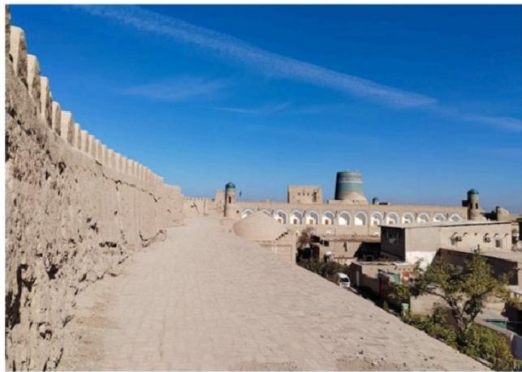
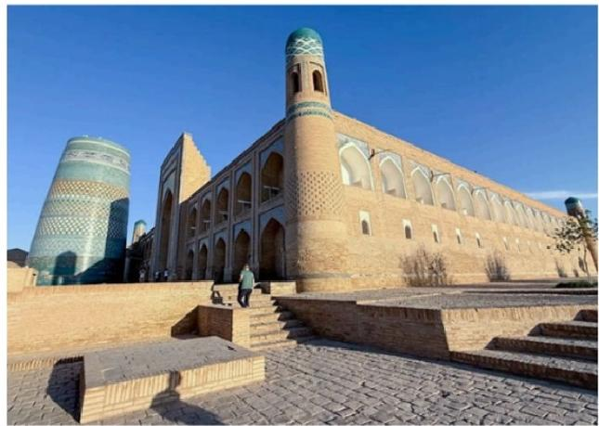
Muhammad Amin Khan Madrasah,Itchan Kala
Itchan Kala Walls,Khiva

 Attractions
1 site

 Dining
Breakfast,Dinner
 Transportation tourist vehicle

 Accommodation Khiva

Day 11 Khiva-Shavat Border Point -Darvaza Gas Crater (Turkmenistan)|Dinner,Camp at the Desert

After breakfast,you will be transferred from Khiva to the Uzbekistan-Turkmenistan border, which is about one-hour drive.
Your group will cross into Turkmenistan via the Shavat-Dashoguz border point. Our local Turkmen guide will be waiting foryou there to assist with customs formalities and
paperwork.

Border Crossing Tip:

The border connects Shavat (Khorezm region,Uzbekistan)with Dashoguz(Dashoguz
province,Turkmenistan),and is the main land route for travelers heading toward Darvaza. Customs and immigration procedures typically take about 1 hour(sometimes may last 2 hours)when entering Turkmenistan.
After passing the border,drive south through the vast Karakum Desert to Darvaza Gas Crater (276 km,about 5 hours).You've now arrived at the "Door to Hell"!
The crater was formed in 1971 when Soviet geologists were drilling for natural gas.The
ground beneath their rig collapsed,leaving a large hole with a diameter of 60 meters and a depth of 20 meters.To prevent the release of poisonous gas,they decided to light it on fire, hoping it would burn itself out in a few days.The gas,however,is still burning today.
At daylight,the crater may seem like an ordinary hole in the ground,with a slight haze of
smoke.We'l take a walk around the site while our barbecue dinner is being prepared.As
dusk falls,the simple hole transforms into a spectacular "fire temple,"creating an
otherworldly atmosphere that will ignite your imagination.We'll finish the day with a taste of delicious nomadic food,with the flickering lights of the "eternal"fire.

Stay overnight in a traditional yurt camp.(Note:Each yurt is a private unit within the camp. Restrooms are shared.As this is a desert environment,facilities are basic-there are no
showers,and water pressure is very limited.)

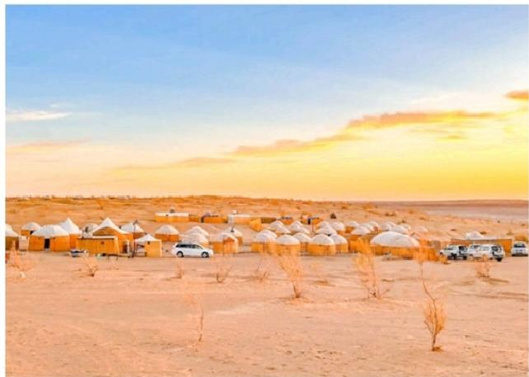

Darvaza Gas Crater

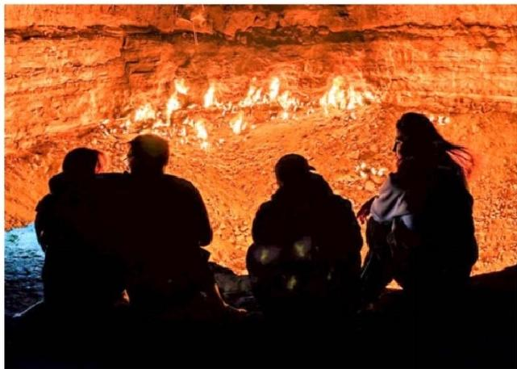

Darvaza Gas Crater

 Attractions
1 site

 Dining Breakfast

 Transportation tourist vehicle

 Accommodation Darvaza Gas Crater

Day 12 Darvaza Gas Crater - Ashgabat | Ashgabat City Tour:
Turkmenbashi Ruhy Mosque, Akhal-Teke Horse Stables, Gulistan Bazaar, City Night View

This morning, your group will enjoy picnic-style breakfast at Darvaza in the desert.
Afterward, drive back through the vast Karakum Desert and get back to Ashgabat (about 4-5 hours).
Ashgabat, the capital, is a pure white world, truly unique. It has been recognized by the
Guinness World Records as the city with the highest density of white marble buildings. More than 500 structures are decorated with shining marble. Your driver will take you on a ride
through these white giants, making you feel as if you’ve entered film-like world, similar to The Truman Show. Today, begin your adventure in Ashgabat.
In the afternoon, your group will explore this fascinating white-marble city. Your first stop is the Turkmenbashi Ruhy Mosque (also Gypjak Mosque). The first sight comes to eye will be the massive golden dome - shimmering under the desert sun. It is the largest mosque in
Central Asia, capable of accommodating 10,000 to 20,000 worshippers at a time. Built entirely from Turkmenistan’s signature white marble, the structure stands with four 91- meter minarets, symbolizing the country’s independence in 1991.
Its gleaming façade, grand golden dome, and towering minarets form a striking silhouette against the sky. Inside, you’ll find glittering chandeliers, intricate geometric designs, and
inscriptions from both the Quran and the Ruhnama (“Book of the Soul”), written by
Turkmenistan’s first president. (Dress Code Tips: (1) Men: Long trousers required; no shorts or sleeveless shirts. (2) Women: Headscarf required (to cover hair); long skirt or trousers
that cover the ankles; sleeves must cover the wrists.)
After that, you’ll visit the Horse Stables to see the national pride of Turkmenistan - the
Akhal-Teke horses, often celebrated as some of the most beautiful horses in the world.
Known as “heavenly horses,” they are famous for their distinctive metallic sheen. You can
gently touch their silky coats and observe their shimmering, golden glow up close. (Optional Horse Riding: There is an additional fee if you wish to ride the horses.)
You will also visit Gulistan Bazaar to experience vibrant local life. Wander through stalls filled with fresh fruits, vegetables, spices, daily essentials, and even traditional Turkmen carpets. If you’d like, feel free to sample some local snacks or street food here.
AOT Specially Arranged Dinner in Ashgabat:
This evening, Asia Odyssey Travel invites your group to enjoy a special dinner at the
symbolic Tower Restaurant. Savor authentic local flavors while taking in the stunning night views of Ashgabat.
After dinner, continue with a night city tour to admire the beautifully illuminated landmarks of Ashgabat as you drive along the main avenues. Transfer back to your hotel for a good rest.

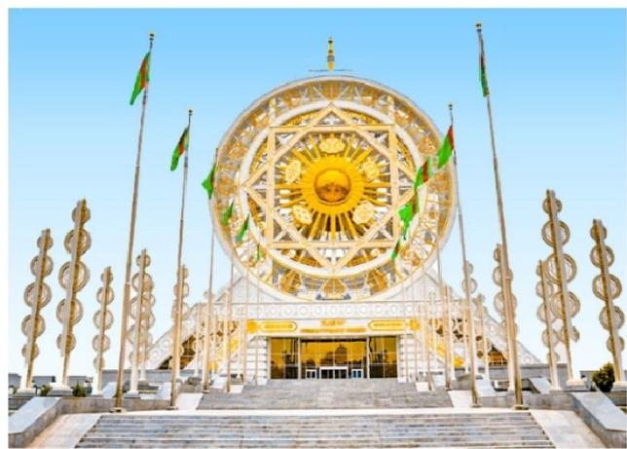
Ashgabat

 Attractions
4 sites

Dining

Breakfast,Dinner

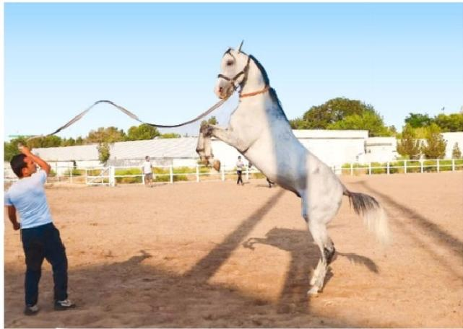

Ahal Teke Horse

 Transportation tourist vehicle

 Accommodation Ashgabat

Day 13 Ashgabat-Mary(by Drive)|Ashgabat City Tour:Neutrality
Monument,National Museum of Turkmenistan,Independence
Monument,Alem Cultural and Entertainment Center(outlook),
Palace of Happiness (outlook)

After breakfast,your group will embark on a city tour of Ashgabat, the dazzling capital often called the "White City" for its grand,marble-clad architecture.As you drive through the city, admire some of its most striking landmarks,including the Wedding Palace,the Wheel of
Fortune,and other impressive modern monuments.Make a brief stop at the Alem Cultural and Entertainment Center, home to the world's largest indoor Ferris wheel,and the Palace of Happiness,an iconic building designed as an eight-pointed star encircling a globe.
After seeing the architecture marvels,enjoy your city walk exploration.Begin at the
Neutrality Monument,a striking 75-meter-high,tripod-shaped arch built in 1998 to
symbolize Turkmenistan's permanent neutrality and its commitment to peace and goodwill. From its viewing platform,enjoy sweeping panoramas of the capital.
Continue to the National Museum of Turkmenistan,one of Central Asia's finest museums. Its white-marble exterior,crowned by a brilliant blue dome and golden statues,is as
impressive as the treasures inside.With over 500,000 artifacts on display,you'lldiscover
archaeological finds from legendary Silk Road sites like Nisa,Merv,and Gonur Depe.Admire coins,weapons,pottery,and exquisite gold jewelry,along with traditional clothing that tells the story of Turkmen heritage.Don't miss the museum's star exhibits-the ancient rhytons, ceremonial drinking vessels of extraordinary beauty.

Next,stroll through Independence Park,home to statues of poets,philosophers,and national heroes,and marvel at the soaring Independence Monument, a 118-meter masterpiece built to commemorate Turkmenistan's independence in 1991.
After the city tour,you'll set off on a scenic drive to Mary, located about 360 km southeast of Ashgabat(3.5-4 hours by road).The journey takes you along the edge of the vast
Karakum Desert,offering striking views of its rolling dunes and arid landscapes.As you
approach Mary,the scenery begins to change-the desert gradually gives way to the fertile Mary Oasis,a region known for its cotton fields and natural gas production.Along the way, you'llnotice more greenery and cultivated farmland.
Arrive in Mary and check into your hotel here.Your group will have a good rest tonight.

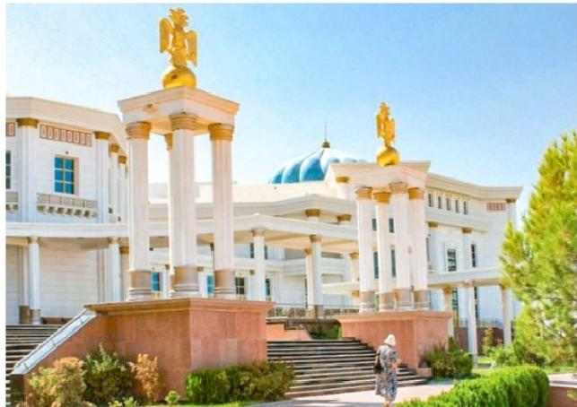
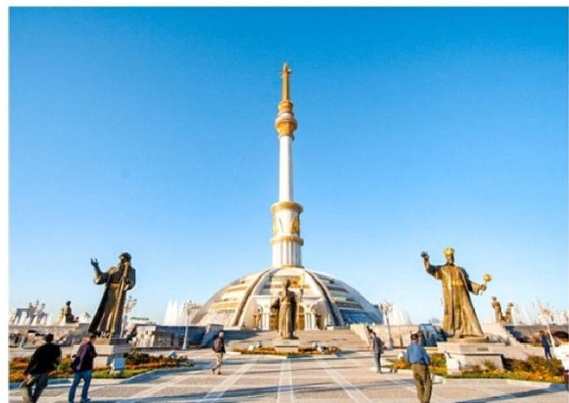
National Museum Of Turkmenistan
Ashgabat Independence Monument

 Attractions
5 sites

 Dining Breakfast
Transportation tourist vehicle

 Accommodation Mary

Day 14 Mary(Turkmenistan)-Ancient Merv(UNESCO Site)-
Farap Border-Bhuhara(Uzbekistan)

After breakfast,your group will be driven from Mary city to Ancient Merv,located 33km
northeast of Mary.This UNESCO World Heritage site is the oldest and best-preserved of the oasis-cities along the Silk Route in Central Asia.It has spanned over 4,000 years'history.
During the medieval period,its population exceeded one million,making it one of the largest cities in the world.It was known as the "Queen of the World"and the "Jewel of the Silk
Road."

Within the vast 1,200-hectare archaeological park,you'll have the chance to observe all the constituent parts of this "wandering city."The site consists of a series of adjacent cities,
roughly divided into the ancient(Erk Kala and Gyaur Kala),the medieval (Sultan Kala),and
the post-medieval(Abdulla-Khan Kala and Bayram-Ali-Khan Kala).Besides these remnants, you'll also visit the 6th-9th century AD forts of Big and Little Kyz-Kalas, which are excellent examples of the so-called "corrugated Koshks."You'll also explore the splendid 12th-century mausoleums of Sultan Sanjar and Muhammed ibn-Zeyd, which demonstrate exquisite
Seljuk-period brickwork and architectural décor.
This afternoon,depart Merv for the Farap border crossing on the Turkmenistan-Uzbekistan frontier,located northeast of Merv(about 239km,3 hours'drive).Note:This border
operates 24 hours a day and is convenient for travelers.
After completing customs and passport control on both sides of the border,proceed to the exit of the border control area,where your Uzbekistan guide/driver will be waiting to greet your group.
From here,continue your journey to Bukhara (about 123 km,2hours).Upon arrival in
Bukhara,check in to your hotel and enjoy good rest before tomorrow's exploration of this legendary Silk Road city.

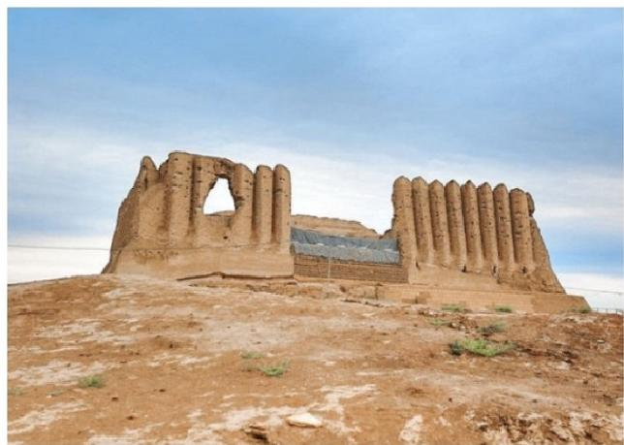

Turkmenistan Ancient Merv

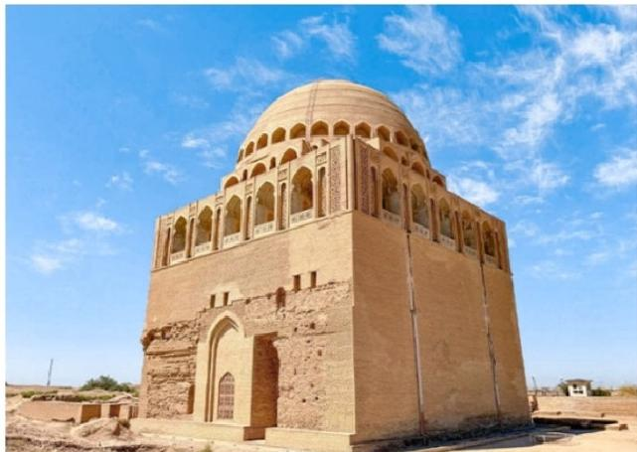

Turkmenistan Ancient Merv

 Attractions
1 site

 Dining Breakfast

 Transportation tourist vehicle

 Accommodation Bukhara

Day 15 Bukhara Tour |Chor Minor Madrasah (Four Minarets),
Lyabi Hauz Ensemble (Afandi Statue),Magoki Attori Mosque,

Trading Domes, Po-i-Kalyan Complex (Kalyan Minaret), Ark of Bukhara (Ark Fortress), Bolo Hauz Mosque

Today, follow our guide to fully explore Bukhara, a UNESCO World Heritage Site and one of the most atmospheric cities along the Silk Road. Often called the “Second Mecca,” Bukhara has been a center of Islamic learning for centuries and is famous for its 2,500-year-old
history as a Silk Road hub, from the era of the Samanids to the Timurids. This legendary city is also tied to the tales of One Thousand and One Nights and is the home of the beloved folk character Afandi.
Bukhara is wonderfully walkable - most of its landmarks are within a compact 6 km stretch - making it easy to immerse yourself in its living history, lively bazaars, and warm local
atmosphere.
Your exploration begins at Chor Minor Madrasah, the four-towered gem that once graced the cover of Lonely Planet Central Asia. Built in 1807 by the wealthy merchant Khalif
Niyazkul, its four unique minarets are believed to represent the four major religions of the world, with decorations that some interpret as Buddhist prayer wheels, Christian crosses, Zoroastrian motifs, and Islamic patterns. This charming structure is all that remains of a once-grand madrasa complex.
Continue to Lyabi Hauz Ensemble, the beating heart of Bukhara since the 17th century. Built around a peaceful pool shaded by mulberry trees, this square was once a lively Silk Road
trading hub. Its three surrounding monuments — the Nadir Divan-Beghi Madrasah, the Nadir Divan-Beghi Khanaka (Sufi hospice), and the Kukeldash Madrasah - are masterpieces of
Central Asian architecture. Today, Lyabi Hauz remains the social center of the city, lined with cafes where locals sip tea and travelers watch the world go by. Don’t miss the playful statue of Khodja Nasreddin (Afandi), the wise fool of Sufi legend, riding his donkey.
Nearby is the Magoki Attori Mosque, Bukhara’s oldest surviving mosque, dating back to the 9th–10th centuries. Situated 4.5 meters below ground level, this mosque is a true
archaeological wonder, displaying ancient brickwork and terracotta ornamentation. It now houses a small carpet museum (admission self-pay).
From there, stroll through Bukhara’s famous Trading Domes, a network of 16th-century domed bazaars - Toki-Zargaron, Toki-Sarrofon, Telpak-Furushon, and Tim Abdullah Khan. Once bustling hubs for jewelers, money changers, and silk merchants, they still sell
traditional crafts, carpets, and souvenirs, allowing you to experience Bukhara’s mercantile spirit firsthand.
Next, reach the Po-i-Kalyan Complex, the iconic centerpiece of Bukhara’s skyline. Here you will admire the 47-meter-high Kalyan Minaret - so magnificent that Genghis Khan spared it from destruction. The adjacent Kalyan Mosque, with its 288 domes and capacity for 10,000 worshippers, and the Mir-i-Arab Madrasah, with its turquoise domes and active Islamic
school, together form one of Central Asia’s most stunning architectural ensembles.

Your final stops are the Ark of Bukhara,the ancient fortress that served as the royal
residence for centuries,and the nearby Bolo Hauz Mosque,known as the “Mosque of Forty Columns”for its 20 exquisitely carved wooden pillars reflected in the pool in front.Inside the Ark,explore its throne room,coronation mosque,and museums,or climb to the top for
sweeping views over the city.
Optional sunset tip: For an unforgettable end to your day,watch the sunset from the Ark's walls or a rooftop near Po-i-Kalyan.As the minarets glow golden and the call to prayer
echoes across the old city,Bukhara feels truly timeless.

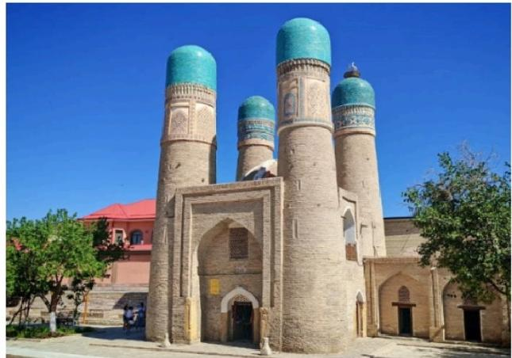
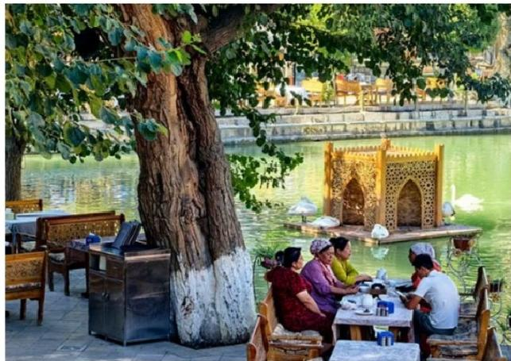
Lyabi Hauz Ensemble,Bukhara
Chor Minor Madrasah,Bukhara

 Attractions
7 sites

 Dining Breakfast

 Transportation tourist vehicle

 Accommodation Bukhara

Day 16 Bukhara -Samarkand |Scenery on the Way,Samarkand
Hotel Check-in

After breakfast,your group will leave Bukhara and drive toward Samarkand.The journey takes about 4.5-5 hours (about 278km).
Shortly after departing Bukhara,you'll enter a vast,flat landscape-a semi-desert steppe painted in soft gray-yellow tones,dotted with drought-tolerant shrubs and camel-thorn
bushes.Around the halfway point,the scenery shifts to endless cotton fields stretching to the horizon.In harvest season(September-October),you may see fluffy white cotton bolls
opening across the fields and local farmers hand-picking the crop-an iconic sight of Uzbekistan.

As you get closer to Samarkand,the land becomes greener and more fertile.Orchards of apricot and mulberry trees,vineyards,and wel-kept farmlands line the road,signaling your approach to one of the Silk Road's greatest cities.
Upon arrival in Samarkand, check in to your hotel and enjoy a comfortable stay in this legendary Silk Road destination.

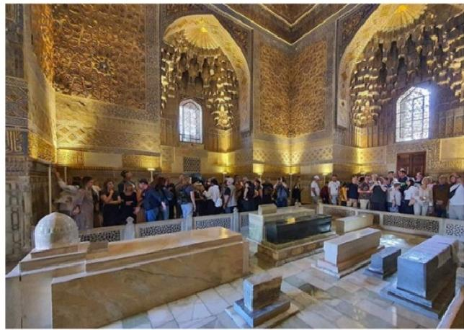
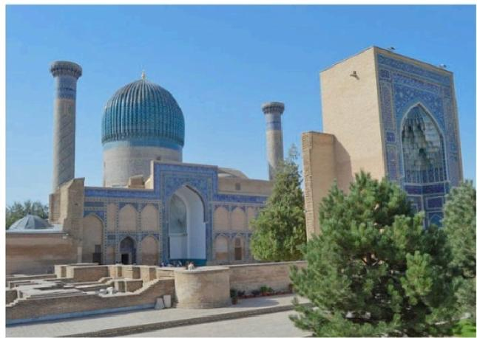
Gur-e Amir Mausoleum,Samarkand
Gur-e Amir Mausoleum,Samarkand

 Attractions
none

Dining

Breakfast

 Transportation tourist vehicle

 Accommodation Samarkand

Day 17 Samarkand Tour|Gur Emir Mausoleum(Timur's Tomb), Registan Square,Bibi Khanim Mosque,Siyab Bazaar,Shahi Zinda
Necropolis,Featured Dinner

Today,immerse yourself in Samarkand, a UNESCO World Heritage Site and the former
capital of the Timurid Empire(14th-15th centuries).Known as Uzbekistan's cultural heart and second-largest city,Samarkand dazzles visitors with its monumental architecture,Silk Road legends,and vibrant bazaars.From the majestic Gur-e Amir Mausoleum to the iconic Registan Square,the grand Bibi Khanim Mosque,the breathtaking Shahi Zinda Necropolis, and the lively Siyab Bazaar, you will discover a city that celebrates the glory and power of the Timurid dynasty.

Begin at Gur-e Amir Mausoleum,the final resting place of Amir Timur(Tamerlane),
completed in 1404.This striking monument,crowned with a ribbed azure dome,served as a prototype for later Mughal architecture,including India's Taj Mahal.Step inside to marvel at its gilded interior,intricate jade tombstones,and delicate calligraphy.Look for Timur's

legendary grave marker,said to carry a warning:"Whosoever disturbs my tomb willunleash an invader more terrible than I."When Soviet archaeologists opened the tomb in June 1941, Nazi Germany invaded the USSR days later-a story that adds an air of mystery to your visit.
Next,head to Registan Square,the heart of Samarkand and one of the Silk Road's most
magnificent sights.Once a sandy gathering place for royal decrees,military parades,and festivals,it is now flanked by three resplendent madrasahs: Ulugh Beg Madrasa(1420),with its starry celestial mosaics; Sher-Dor Madrasa (1619),famed for its unique lion mosaics; and Tilya-Kori Madrasa(1660),with a dazzling gold-leaf dome that graces the cover of
many guidebooks.By day,Registan is a masterpiece of symmetry and tilework;by night,it transforms under magicalilluminations -a perfect spot for photography.

Continue to the monumental Bibi Khanim Mosque, one of the largest in the Islamic world. Built in 1404 to honor Timur's wife,the mosque is steeped in legend-including the tale of the architect who dared to kiss Bibi Khanim and met Timur's wrath.Step inside to admire gilded decorations inspired by local embroidery traditions.

Right nearby lies Siyab Bazaar,where you can sample Samarkand's famous round bread, dried fruits,and spices while mingling with locals-a lively reminder that Samarkand was once a key Silk Road trading hub.

End your day with a stroll through Shahi Zinda Necropolis, an extraordinary“avenue of
mausoleums"climbing a hillside.This necropolis,dating from the 11th to 15th centuries,
contains some of the finest examples of Timurid-era tilework and the tombs of Timur's
female relatives and high-ranking nobles.The site is also believed to house the grave of
Qutham ibn Abbas,cousin of Prophet Muhammad,making it a revered pilgrimage site.With its brilliant turquoise domes and intricate mosaics,Shahi Zinda is not just a spiritual
landmark but also one of Samarkand's most photogenic spots.

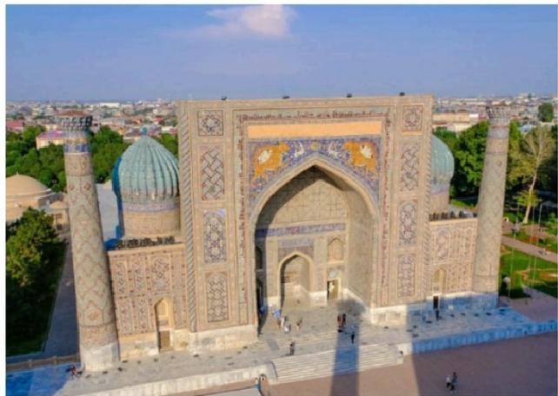
Registan Square,Samarkand

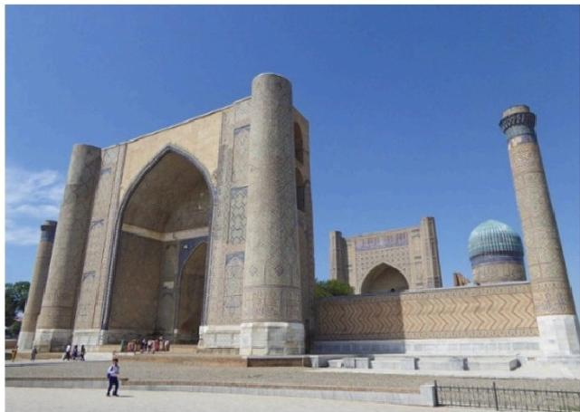
Bibi Khanim Mosque,Samarkand

 Attractions
5 sites

 Dining
Breakfast,Dinner

 Transportation tourist vehicle

 Accommodation Samarkand

Day 18 Samarkand (Uzbekistan)-Jartepa Border -Seven Lakes
(Tajikistan)-Penjikent |Short Hike between the Sixth and the
Seventh of the Seven Lakes,Picnic Lunch

This morning,your journey begins with a transfer from your hotel in Samarkand to the
Uzbekistan-Tajikistan border at Jartepa(50 km,about 1 hour).Upon arrival,you'll proceed through customs and passport control on both sides.Once formalities are complete,simply walk to the exit of the border control area,where your Tajik guide and driver will be waiting to warmly welcome you.
From here,a short drive will take you to the Penjikent area,the gateway to a realxing hiking adventure.Prepare to explore Tajikistan's legendary Seven Lakes,locally known as Haftkul or the Marguzor Lakes.These seven stunning,glacier-fed lakes cascade down the valley, connected by a single river,resembling a sparkling necklace draped across the landscape. Each lake boasts its own unique color and charm,offering breathtaking views and a serene escape into nature.
Your journey begins with a bumpy but scenic drive into the mountains.Though the Seven Lakes are not far from Penjikent,the rugged road makes this a full-day trip.As you travel deeper into the valley,you'll pass the first five lakes-Nejigon,Soya,Gushor,Nofin,and Khurdak -each with its own distinct color,ranging from pale green to vivid turquoise and deep blue.It's like nature's own painter's palette.

Light Hike from the Sixth to the Seventh of the Seven Lakes:
You'll reach Marguzor,the sixth and largest lake,a dazzling expanse of sapphire water
framed by dramatic peaks.From here,take an easy two-hour round-trip hike to
Hazorchashma, the seventh and highest lake,whose name means “A Thousand Springs.” The water here is crystal clear,and the surrounding atmosphere feels serene and
untouched.

Enjoy a picnic by the lakeshore,soak in the alpine views,and perhaps take a short stroll
through the nearby villages to experience the simple,authentic rhythm of Tajik mountain life.
After the tour,your group will be transferred to Penjikent for accommodation.
Travel Note: As you head deeper into the Fann Mountains,expect simpler tourist
infrastructure.Tonight,you will stay in the best available local hotel,but with more basic

amenities compared to the big cities.Consider this part of the adventure and a chance to experience authentic Tajik hospitality.

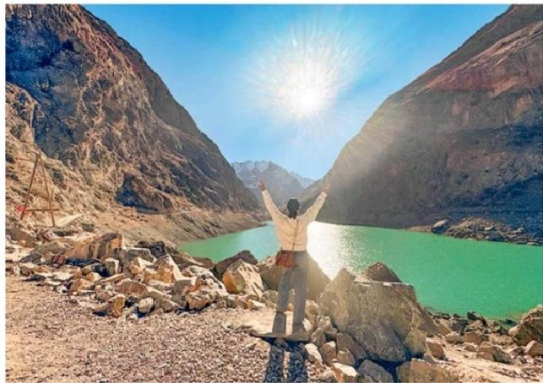
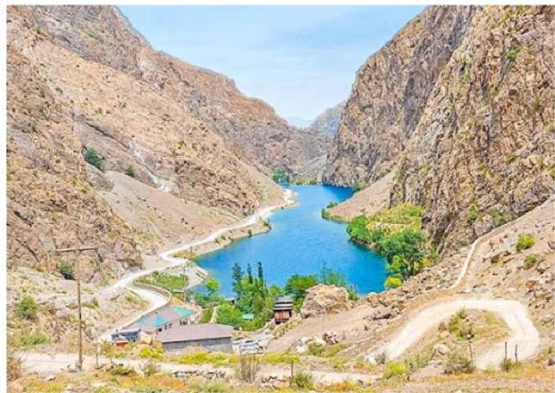

Seven Lakes
Seven Lakes

 Attractions
1 site

Dining

Breakfast,Lunch
 Transportation tourist vehicle

 Accommodation Penjikent

Day 19 Penjikent (Tajikistan)-Jartepa Border -Samarkand
(Uzbekistan)|Rudaki Museum,Ancient Penjikent Ruins

After breakfast,you will have enough time to explore Penjikent.Known as the “Pompeii of Central Asia,"Penjikent was once a major center of the ancient Sogdian civilization.
Between the 5th and 8th centuries,this city thrived as a cultural and commercial hub on the Silk Road.The Sogdians were known as the“soul of the Silk Road,dominating trade across Eurasia-from Chinese silk to Western glassware and Indian spices.
Start with the Rudaki Museum(closed on Sunday),home to thousands of artifacts
unearthed from local excavations -pottery,coins,sculptures,and tools-which vividly depict the Sogdian way of life.Here you'l discover their art,clothing,mythology,and even scenes of feasts and rituals.
Next,visit the Ancient Penjikent Ruins, the remarkably preserved remains of a complete 5th- 8th century Sogdian city.As you walk among the mud-brick foundations of palaces,
residential quarters,temples,and fortifications,you can clearly visualize the city's original layout and imagine the bustling life of the Silk Road era.
In the afternoon,your group will cross border into Uzbekistan and transfer to Samarkand for overnight.

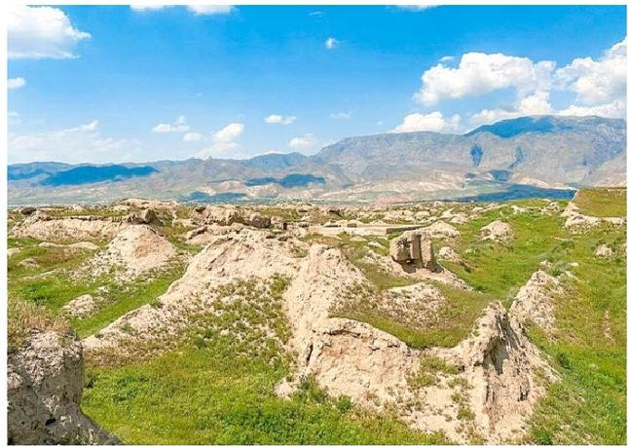
Penjikent Ancient Ruins

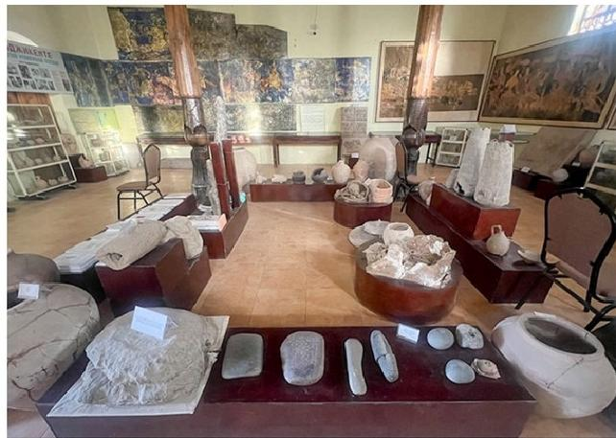
Rudaki Museum

 Attractions
2 sites

 Dining
Breakfast

 Transportation tourist vehicle

 Accommodation Samarkand

Day 20 Samarkand Departure |Hotel Check-out&See-off

After breakfast,it's time to conclude your 20-day Central Asia group tour.Our local driver in Samarkand willescort you to the airport or train station for your departure to your next
destination.
Travel Tip: Please share your flight or train details with us in advance so we can arrange your transfer smoothly.

Additional Transfer Service(Extra Fee Required):
If you need transfer service from Samarkand to Tashkent,please let us know in advance. While the tour officially ends in Samarkand (as it has its own airport and train station),we'll be happy to help you book train tickets to Tashkent and arrange transfers in Tashkent.

Transportation
Attractions

none
tourist vehicle

Dining None
Accommodation
/

Month  Mar | Available Date  Mar.31, 2026
Apr | Apr.07, 2026
Apr | Apr.18, 2026
Apr | Apr.22, 2026
Apr | Apr.29, 2026
May | May.10, 2026
May | May.14, 2026
May | May.21, 2026
Jun | Jun.01, 2026
Jun | Jun.05, 2026
Jun | Jun.12, 2026
Jun | Jun.23, 2026
Jun | Jun.27, 2026
Jul | Jul.04, 2026
Jul | Jul.15, 2026
Jul | Jul.19, 2026
Jul | Jul.26, 2026
Aug | Aug.06, 2026

 | Aug.10, 2026
 | Aug.17, 2026
 | Aug.28, 2026
Sep | Sep.01, 2026
Sep | Sep.08, 2026
Sep | Sep.19, 2026
Sep | Sep.23, 2026
Sep | Sep.30, 2026
Oct | Oct.11, 2026
Oct | Oct.15, 2026
Oct | Oct.22, 2026
Nov | Nov.02, 2026

Price: What’s Included & What’s Excluded

What's Included:
 Guide Service: Professional English-speaking tour guide.
 Attraction Tickets: Entrance fees for all sites listed in the itinerary.
Transportation:
- Airport transfers upon arrival and departure.
- Private tourist vehicle for all city sightseeing tours and overland travel.
- All flights and overland border crossings between countries, as well as all local transfers within the Five Stans.
Accommodation:
- Hotels as listed in the itinerary (primarily 4-star standard).

-In remote areas(e.g.,Darvaza Gas Crater),accommodation will be in traditional guesthouses or yurt camps.
 Meals:
-Daily breakfast at the hotel.
-Lunch and Dinner where specifically listed in the day-by-day itinerary.
-AOT Special Meal Arrangements(One featured dining experience per country):
-Tashkent:Dinner featuring traditional dance and live music.
-Darvaza(Turkmenistan):Desert Barbecue Dinner with views of the burning gas crater.
-Ashgabat:Dinner at the TV Tower restaurant with city night views.
-Bishkek or lssyk-Kul (Kyrgyzstan)dinner
-Charyn Canyon(Kazakhstan):Picnic Lunch after hiking.
-Almaty:Featured Dinner featuring Kazakh cuisine and music/dance. Logistics &Support:
-Cross-Border Assistance:Guide assistance for land border crossings.
-Turkmenistan LOl:Includes the fee for the Letter of Invitation required for the
Turkmenistan visa.
Service Fees: Allplanning,handling,operational,and communication charges.

What's Excluded:
× Visa Fees: Cost of tourist visas (if required),depending on the traveler's nationality.
× Travel Insurance: Comprehensive travel insurance is not included but is strongly recommended.
× Optional Tours:Costs for any optional activities or tours not explicitly listed in the itinerary.
× Unlisted Meals: Lunches and dinners not specified in the itinerary (your guide can provide recommendations for local restaurants).
× Single Supplement: Additional charge for travelers requesting a private room.
× Tips &Gratuities: Gratuities for tour guides and drivers are optional and at the traveler's discretion.
× Overtime Service Fees: Additional charges may apply for services requested beyond scheduled itinerary hours.
× Personal Expenses: Shopping,alcohol,snacks,laundry,and other beverages outside of those specified in the itinerary.


Your Central Asia Group Tour Experience: What You Need to Know

01 | Small Group Size (1–16 Pax)  Our small group tours welcome 1–16 travelers, ensuring comfort and a friendly atmosphere. Departures are guaranteed even with one traveler. The group size will not exceed 16.
02 | Solo Travelers Welcome  We accept individual bookings. One person can join freely—just confirm your date with our Central Asia travel experts.
03 | Rooming & Single Supplement  Prices are based on double occupancy. Solo travelers or guests requesting a private room must pay a single supplement.
04 | Booking & Payment  A deposit is required to secure your seat. The remaining balance is due no later than 30 days before departure.
05 | Best Travel Season  Tours operate from late March to early November. The ideal months to visit the Five Stans are spring and autumn.
06 | About Visa  - Visa required. We will need to apply for your Letter of Invitation (LOI) in  advance. The Turkmenistan visa can be obtained at the border upon arrival, based on the approved LOI. PCR test and Visa on arrival Fee need to pay on spot.  - If you need to obtain a Uzbekistan visa, it should be a multiple-entry e-visa.
07 | Accommodation Standards  Enjoy comfortable 4-star hotels in major cities.  Note: At the Darvaza Gas Crater, conditions are basic—private yurts, shared toilets, no showers, and limited water supply.
08 | Border Crossings  Usually require 1–2 hours. Your local guide will assist with forms and entry

 | procedures.
09 | Luggage Policy  Each traveler may bring 1 suitcase (max 26 inches) + 1 carry-on backpack. Excess luggage may affect comfort during transfers.
10 | Travel Insurance  Comprehensive insurance (medical, accident, cancellation, property) is strongly recommended.
11 | Non-Participation Policy  Skipping any activity is considered voluntary abandonment. No refunds will be provided for unused services.
12 | Amendments After Booking  Changes after confirmation may incur amendment fees and depend on availability and supplier conditions.
13 | Itinerary Integrity  For the safety and convenience of all travelers, deviations from the group itinerary cannot be accommodated during the tour.
14 | Cancellation & Rescheduling Policy  30–60 days before departure: 10% of the tour fee  15–29 days before departure: 30% of the tour fee  8–14 days before departure: 80% of the tour fee  0–7 days before departure: 100% of the tour fee

