8 Days Classic Yunnan Group Tour:

Kunming Dali Shangri-La Lijiang
https://www.asiaodysseytravel.com/china-group-tours/8-days-yunnan-group-tour.html
Tour Code: GT023
Travel Route: Kunming - Dali - Shangri-La - Lijiang
Features: World Heritages, Ethic Cultures, Ancient Town, Karst Landform, Monasteries & Temples, Gorge, Hiking, Nature, Mountains, Lakes, Parks; Yunnan Rice Noodles & Hot Pot
Tour Type: Small Group (maximum 16 travelers, guaranteed departures)
Guide & Driver: English-speaking guide, experienced driver with an air-conditioned vehicle
Accommodation: 7 nights at good 4-star hotels
Is Yunnan a COLORFUL dream for you? Are you captivated by its DIVERSE landscapes, rich ETHNIC cultures, and the vibrant life unfolding beneath the black-tiled rooftops of ancient towns?
Join our most classic Yunnan group tour to fully experience Yunnan’s diverse scenery and unique cultures. This intimate small-group tour, specially organized by Asia Odyssey Travel, takes you through the highlights of Kunming, Dali, Shangri-La, and Lijiang, blending must-see sights with thoughtfully curated experiences - connecting with locals and trying authentic Yunnan cuisine. All at affordable local prices!
Begin in Kunming, where you’ll explore the mesmerizing karst formations of the Stone Forest and soak up the “Spring City” sunshine. Continue to Dali for a relaxing tour around Erhai Lake, the iconic Three Pagodas, and Dali Old Town, with glimpses of Bai traditions in Xizhou Ancient Town and Zhoucheng’s tie-dye art. Discover Tibetan culture at Shangri-La’s Songzanlin Monastery, then head to Lijiang to wander its historic old town and marvel at the Jade Dragon Snow Mountain, all while immersing yourself in the vibrant Naxi culture.

Highlights:
Lowest Price Guarantee: Explore Yunnan Best Highlights with Asia Odyssey Travel at the lowest price. It can save up to 30% compared to a private tour.

100% No Shopping in Any Destinations: Go with Asia Odyssey Travel’s small group tour, and you’re guaranteed with “100% No Shopping Stops”.

Unforgettable Travel Experience: Travel with likeminded 1-16 travelers in the stunning destinations on our small group tour. You’ll get in-depth and intimate experience as a private tour.

Comfortable Pace for Classic Exploration: With ease and comfort, from big wows to hidden gems, our small group tour leaves you feeling that you’ve really explored. You won’t miss any highlights of Yunnan.

Tour Brief :
Kunming - Dali - Shangri-La - Lijiang

Day | Cities | Activities | Meals | Hotel
01 | Kunming | Airport Transfer | none | 4-star hotel
02 | Kunming | *Stone Forest  *Yuantong Temple  *Green Lake Park  *Yunnan Rice Noodles | B+D | 4-star hotel
03 | Kunming - Dali by High Speed Train | *Three Pagodas of  *Chongsheng Temple  *Erhai Lake  *Free Time in Dali Ancient Town | B | 4-star hotel
04 | Dali - Shangri-La by car | *Local Market  *Xizhou Ancient Town  *Zhoucheng Tie-dye | B | 4-star hotel
05 | Shangri-La | *Pudacuo National Park  *Songzanlin Monastery  *Dukezong Ancient Town  *Tibetan Family Visit | B | 4-star hotel
06 | Shangri-La - Lijiang by car | *Tiger Leaping Gorge  *First Bend of the Yangtze River  *Lijiang Old Town  *Black Dragon Pond Park | B | 4-star hotel
07 | Lijiang | *Jade Dragon Snow Mountain  *Blue Moon Valley  *Baisha Murals  *Shuhe Ancient Town (Optional) | B+L | 4-star hotel
08 | Lijiang | Airport Transfer | B

Itinerary Day by Day

Day 1 Kunming Arrival | Pick-up and Hotel Check-in
Welcome to Kunming (昆明), the capital of Yunnan Province! Upon arrival in Kunming, our local driver will meet you and your group at the airport at the appointed time and escort you to your hotel in the downtown area.
Known as the "Spring City" for its mild, year-round climate, Kunming is a popular destination for those escaping harsh winters or scorching summers. The pleasant weather also allows flowers to bloom throughout the year, giving Kunming the nickname "Flower City". Whether you seek a relaxing retreat, cultural immersion, or the chance to explore breathtaking landscapes and savor Yunnan's delicious cuisine, Kunming offers something for everyone.

Attractions : explore freely today
Transportation: arrive in Kunming by yourself
Dining: None
Accommodation: 4-star hotel in downtown Kunming
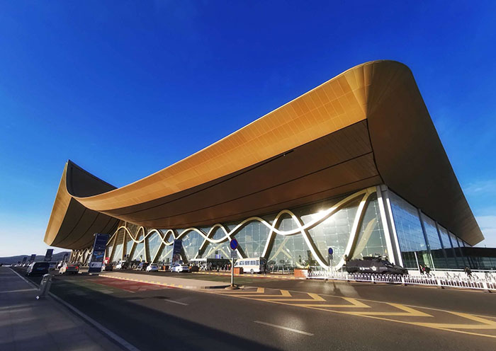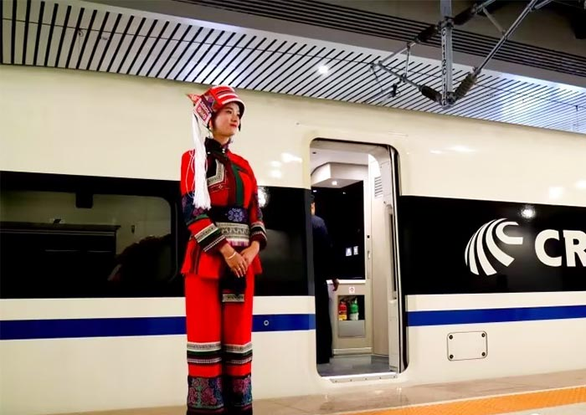
Kunming Airport Kunming Train Station

Day 2 Kunming Tour | Stone Forest, Yuantong Temple, Green Lake Park, Yunnan Rice Noodles
On this day, your whole group will be transferred to the Stone Forest, a World Heritage Site in South China Karst, for an unforgettable Kunming excursion. Afterward, return to downtown Kunming for a classic city tour, including Yuantong Temple, Green Lake Park (Cuihu Park), and other sites based on your interests and available time.
Start your day with a visit to the Stone Forest (石林, 80km from Kunming, about 1.5 hours’ drive) - a must-see natural wonder that was once submerged under an ancient sea. Known as Shilin in Chinese, this national geological park showcases remarkable stone formations that evolved over 270 million years through marine sedimentation, crustal uplift, volcanic lava coverage, erosion, and leveling. Within the Stone Forest, explore the Big and Small Stone Forests by sightseeing bus, marveling at the unique karst formations and traces of geological history. The site also highlights the Yi ethnic culture, and you can immerse yourself in the legend of Ashima (阿诗玛) and explore filming locations for the 1986 TV series Journey to the West.
After that, return to Kunming for a visit to Yuantong Temple (圆通寺), a tranquil oasis in the city center with a unique water courtyard layout and over 1,200 years of history. Yuantong Temple is China’s oldest Guanyin Temple and features a rare “Downhill Temple” design, where visitors descend rather than ascend upon entering. This sacred site houses Buddhist traditions from the Han, Southern, and Tibetan regions and includes the Bronze Buddha Hall, a Southeast Asian-style building that holds a Buddha statue gifted by Thailand’s Buddhist Association.
Afterward, enjoy a scenic walk at Green Lake Park (翠湖公园), just 700 meters from Yuantong Temple. Once a marshy bay of Dianchi Lake, Cuihu Park became a city lake during the Ming Dynasty and is often called the “jade within the city.” Divided by embankments reminiscent of West Lake’s Su Causeway, the park has historical buildings, famous residences, and a sculpture honoring Nie Er, the composer of China’s national anthem. Cuihu is beloved by locals for strolling, feeding fish, watching the seasonal migration of Black-headed Gulls from Siberia, and enjoying lotus blooms, flower lanterns, and the vibrant atmosphere.
Featured Dinner Arranged by Asia Odyssey Travel:
This evening, enjoy a special treat: authentic Yunnan Cross-bridge Rice Noodles (云南过桥米线), one of Yunnan’s signature dishes. Featuring delicate rice noodles in a rich broth with various toppings, this traditional dish offers a true taste of Yunnan’s flavors. Enjoy the rice noodles while listening to the story of why it is called the Cross-Bridge Rice Noodles.
After the tour, be escorted back to your hotel in Kunming.
Attractions : 3 iconic sites
Transportation: Vehicle
Dining: Breakfast,Dinner
Accommodation: 4-star hotel in downtown Kunming
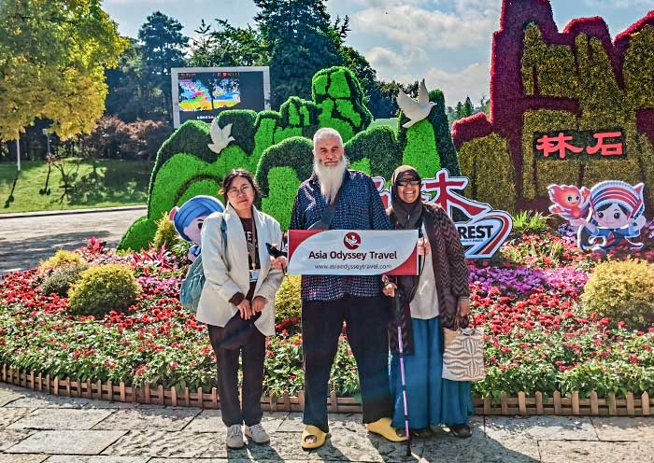
Kunming Stone Forest Visit Kunming Stone Forest with AOT
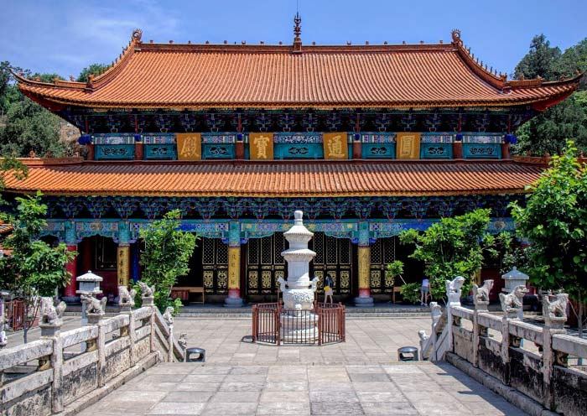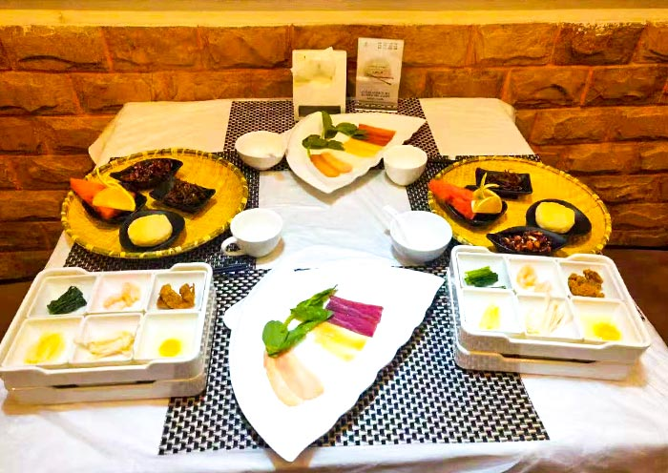
Buddha Hall of Yuantong Temple Yunnan Crossing-the-bridge Rice Noodles

Day 3 Kunming to Dali by High Speed Train | Three Pagodas of Chongsheng Temple, Erhai Lake, Free Time in Dali Ancient Town
In this morning, you will take the high speed train from Kunming to Dali. Upon arrival in Dali, pick you up at the train station. And our guide will take you and your group to visit the Three Pagodas of Chongsheng Temple, offering a deep dive into Dali's rich history and spiritual heritage.
The Three Pagodas of Chongsheng Temple (崇圣寺三塔景区), set against the stunning backdrop of the Cangshan Mountains and overlooking Erhai Lake, are an iconic symbol of Dali. These three pagodas consist of a central pagoda, Qianxun Pagoda, which stands at 69 meters, flanked by two smaller pagodas. According to local legend, the pagodas were constructed to deter dragons that once inhabited the swampy area of Dali. Take time to appreciate the intricate architectural details that have allowed these structures to withstand the centuries. Don’t miss the picturesque reflection pond in front of the pagodas, offering stunning mirror images perfect for photos.
Next, visit Chongsheng Temple (崇圣寺), located just behind the pagodas. Once the royal temple of the Dali Kingdom of Nanzhao and nicknamed “the Capital of Buddhism,” it is also known as Tianlong Temple from Jin Yong’s Demi-Gods and Semi-Devils. As you tour the temple grounds, explore worship halls such as the Mahavira Hall and enjoy the tranquil atmosphere. From higher points, you can take in sweeping panoramic views of the Cangshan Mountains and Erhai Lake.
After that, take an electric cart along the ecological corridor of the west side of Erhai Lake (洱海). Named "Ear-shaped Sea" due to its unique form, Erhai is the second-largest highland lake in China and a central feature of the Dali Bai Autonomous Prefecture. Along the way, you’ll enjoy breathtaking views of the expansive blue lake framed by the majestic Cangshan Mountains. And, you’ll pass through charming Bai villages, green fields, and vibrant flowers.
In this afternoon, explore the captivating Dali Ancient Town (大理古城) independently. At dusk, the town’s lively night markets begin to stir. Relax at one of the many cozy coffee shops or bars. Originally established during the Ming Dynasty over 600 years ago, Dali Old Town once served as the capital of the Nanzhao and Dali Kingdoms. Stroll along main streets like Renmin Road and Foreigner Street, which feature well-preserved traditional Bai architecture, alleyways, unique workshops, temples, and even antique-flavored schools and churches. The blend of history and culture creates a truly unique experience.
After the tour, return to your hotel in Dali.
Attractions : 3 sites
Transportation: Vehicle
Dining: Breakfast
Accommodation: 4-star hotel in Dali
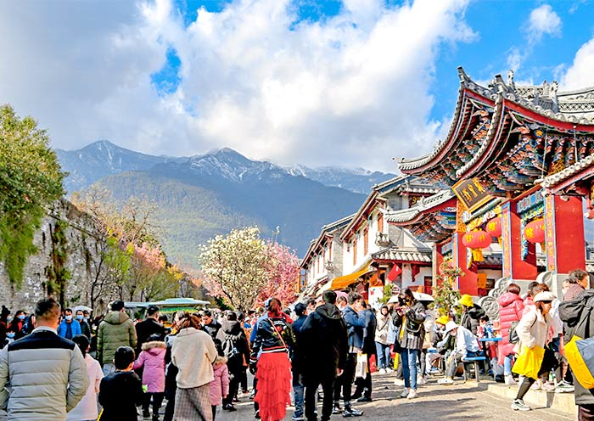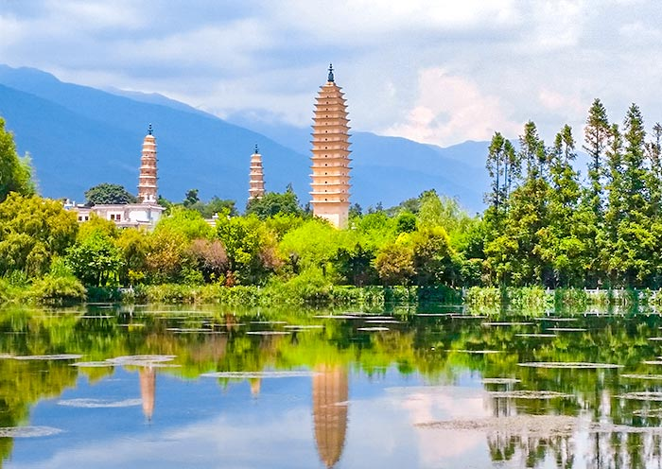
Strolling Through Dali Ancient Town Reflections of the Three Pagodas
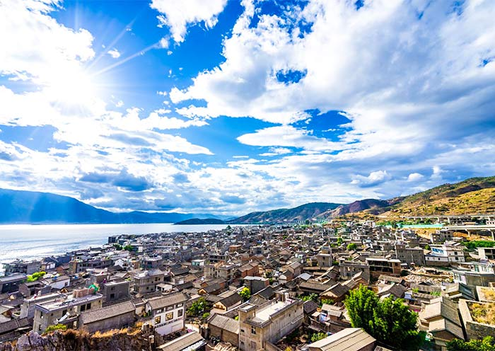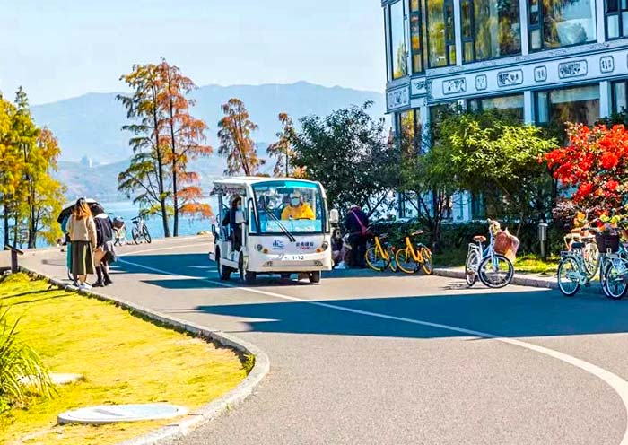
Dali Old Town Panorama Erhai Lake Electric Cart

Day 4 Dali to Shangri-La | Local Market, Xizhou Ancient Town, Zhoucheng Tie-dye
After breakfast, let's experience the lively atmosphere of Xizhou at the local market. There's no better way to get under the skin of a place than by exploring its local market, here you can witness firsthand the local customs and mouth-watering dietary habits. This market has been a gathering spot for over a century where locals trade a wide array of goods - from farm-fresh produce and unique handicrafts to tantalizing local snacks. Yunnan, fondly known as the "Kingdom of Flora and Fauna," is a place where flowers and insects find their way into the local cuisine! Don't be surprised if you come across unfamiliar vegetables, fruits, and wild mushrooms. While you're there, don't miss your chance to try local favorites like Xizhou baba (a tasty stuffed pancake, savory or sweet) and a cup of freshly brewed Yunnan coffee.
After exploring the market, take a walking tour of Xizhou Ancient Town (喜洲古镇), acclaimed as the "Premier Town of the Bai people" due to its exceptionally the largest and best-preserved cluster of Bai ethnic group's traditional dwellings. Xizhou Village is ideal for those seeking a more authentic and tranquil cultural experience of Bai life and traditions. As you wander through the village, visit some of the old mansions and Bai residences like Yan Family Compound (严家大院), you'll notice the most distinctive features of Bai architecture known as "Three-Room and One-Screen Wall (三房一照壁)" and "Siheyuan/Courtyard (四合院)”. These homes are adorned with exquisite details such as flying eaves, ornately carved wooden doors and beautifully painted walls typical of Bai aesthetics. Don't miss the "Three Courses of Tea" ceremony (三道茶), a Bai cultural practice you must experience. This tea ceremony, which transitions from bitter to sweet to an aftertaste, encapsulates the philosophy of "embraces hardship, values the sweetness that follows struggles, and reflects on the profound aftertastes that life experiences leave behind". In addition, Xizhou is surrounded by vast wheat fields, creating a striking contrast against the grey-and-white tones of the Bai minority dwellings. This harmonious coexistence with nature provides a healing, wonderful feeling. The beautiful scenery, especially in spring and autumn, draws tourists to appreciate Xizhou's charms.
Next, make your way to Zhoucheng Village, which is just a short drive from Xizhou. Zhoucheng Village (周城), is often referred to as the “Hometown of Bai Embroidery ”. It is Bai people village, famous for its traditional tie-dye art (扎染), which has been preserved and passed down through generations. The Bai tie-dye technique has been listed as a National Intangible Cultural Heritage. Explore workshops within the village that showcase exquisite Bai embroidery. These pieces often depict traditional motifs such as lotus flowers, fish, and birds, which carry significant cultural symbolism. Engage with the local craftsmen and women, many of whom have inherited their skills from generations. If you're lucky, you may witness live demonstrations of Bai embroidery and tie-dye techniques.
In this afternoon, your group will be transferred to Shangri-La (only with the driver), located in the northwest of Dali city, about 300km, 4-hours’ drive. Welcome to Shangri-La (香格里拉)! Nestled in the northwestern part of Yunnan Province in Diqing Tibetan Autonomous Prefecture, Shangri-La was formerly known as Zhongdian. This charming paradise is considered the real Shangri-La on earth. Inspired by the mythical paradise described in James Hilton's novel "Lost Horizon", Shangri-La lives up to its name. Hidden among majestic mountains, it beckons you with a landscape shrouded in mystery and legend, a place where fairytale scenery awaits.
Attractions : 3 sites
Transportation: Vehicle
Dining: Breakfast
Accommodation: 4-star hotel in Shangri-La
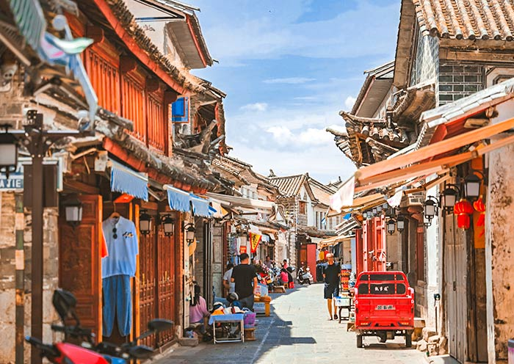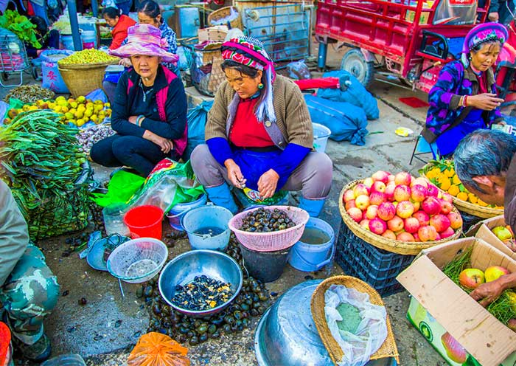
Charming Streets of Xizhou Village, Dali Fresh Finds at Xizhou Local Market
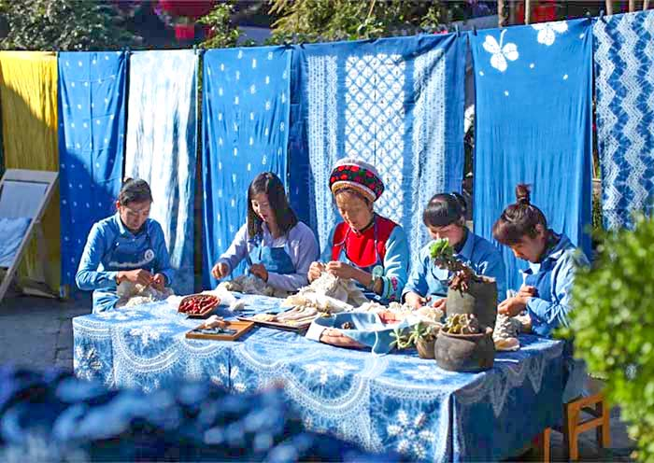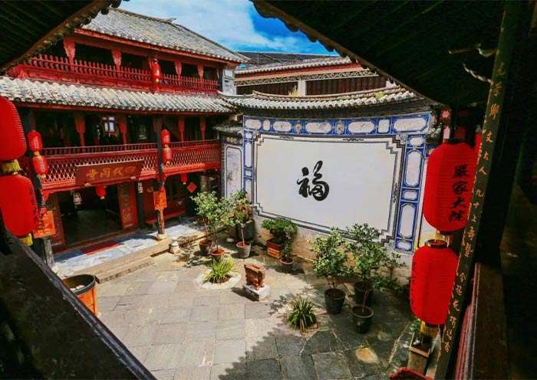
Tie-Dye Workshop in Zhoucheng Village, Dali Yan Family Compound at Xizhou Village, Dali

Day 5 Shangri-La Tour | Pudacuo National Park, Songzanlin Monastery, Dukezong Ancient Town, Tibetan Family Visit
In this morning, your group will enjoy a scenic drive (about 40 minutes) to Pudacuo National Park (普达措, also known as Potatso National Park), the first national park in China. Situated on the vast Tibetan Plateau and forming an important part of the "Three Parallel Rivers" scenic spot, the park is renowned for its pristine landscapes. Encompassing scenic hills, meadows, lakes, diverse plant life, and abundant bird species, the park is also home to over 100 endangered animals including leopards, cranes, macaques, and lynxes. Your journey begins with a sightseeing bus ride to Shudu Lake (altitude: 3,705 meters), the park's largest lake famed for its crystal-clear water and serene beauty. Take a leisurely hike around the well-maintained path suitable for most fitness levels. Afterwards, hop on a sightseeing bus to Bita Lake (altitude: 3,568 meters). A jewel nestled amidst the mountains and considered sacred by the local Tibetans, Bita Lake's turquoise waters and snow-capped backdrop create a picture-perfect scene. Take another short hike around the lake, a trail that leads you deeper into the heart of the park.
After that, our local guide will take your group to visit Songzanlin Monastery (松赞林寺, also known as Ganden Sumtsenling Monastery), a sprawling complex perched at an altitude of 3,380 meters. Founded in 1679 by the Fifth Dalai Lama, Songzanlin Monastery is the largest Tibetan Buddhist monastery in Yunnan Province. Inspired by the Potala Palace in Lhasa, it's often referred to as the "Little Potala Palace". The monastery's architecture is a fascinating fusion of Tibetan and Han Chinese styles. Currently, around 700 monks reside in its 200 associated houses. Ascend the steps and enter the monastery's three grand halls: Zhacang Hall (the central and highest hall), Jikang Hall (dedicated to Tsongkhapa), and Sakyamuni Hall (dedicated to Shakyamuni Buddha). Here, you'll witness Tibetan monks chanting and meditating, enveloped in the monastery's solemn atmosphere. The climb will be rewarded with a breathtaking panoramic view of the entire monastery complex and the beautiful Lamuyangcuo Lake.
In this afternoon, your group will visit Dukezong Ancient Town (独克宗古城), with over 1,300 years history, which is the best-preserved and largest Tibetan residential cluster in China. It holds the distinction of being the oldest castle along the Tea Horse Road. The name "Dukezong" translates to "Moonlight Castle built on a Stone" and it is also known as the City of Moonlight. Here, you will discover a world of traditional Tibetan houses, ancient temples, beautiful pagodas, and narrow, winding alleyways, all adorned with iconic Tibetan prayer flags of various colors. Take a hike up Guishan Hill and join the locals in turning the world's largest prayer wheel for good luck and happiness. From this vantage point, you can capture a breathtaking panoramic view of the entire town. Afterwards, wander through the distinctive alleys and immerse yourself in the rich tapestry of Tibetan culture.
Special Experience Arranged by Asia Odyssey Travel:
This evening, to connect closely with the local Tibetans, we will take your group to visit a Tibetan family to experience their authentic daily life and sample local snacks and yak butter tea in their welcoming home.
After the tour, be escorted to your hotel in Shangri-La.
Attractions : 4 sites
Transportation: Vehicle
Dining: Breakfast
Accommodation: 4-star hotel in Shangri-La
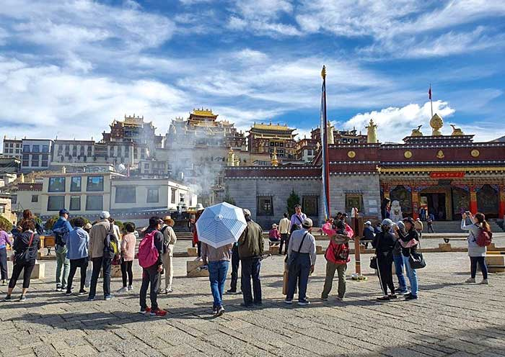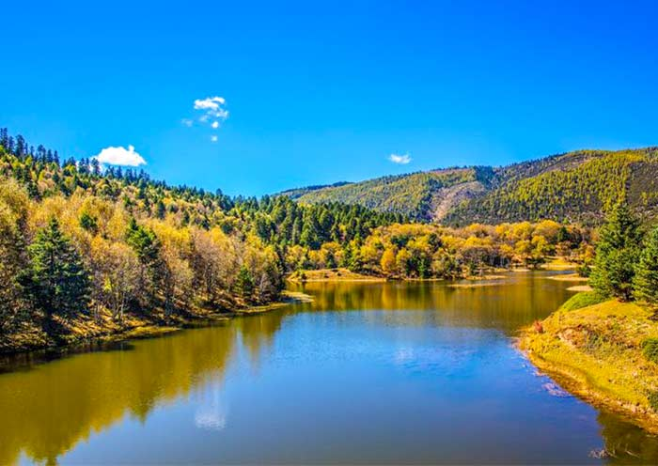
Pay a visit to Songzanlin Monastery Shangri-La Pudacuo National Park
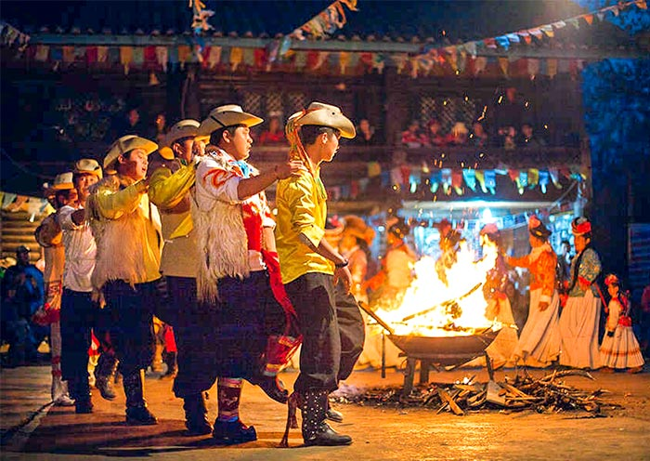
Ganden Sumtsenling Monastery, Shangri-La Visit a local Tibetan family in Shangri-La

Day 6 Shangri-La to Lijiang | Tiger Leaping Gorge, First Bend of the Yangtze River, Lijiang Old Town, Black Dragon Pond Park
This morning, your group will be escorted from Shangri-La to Lijiang, with opportunities to explore breathtaking natural landscapes along the way.
During the drive, you'll stop to visit the Upper Section of Tiger Leaping Gorge (上虎跳, altitude: 1,800 meters). According to legend, this spot earned its name when a tiger, chased by a hunter, made a legendary leap across the narrowest point of the gorge, cornered by the rushing Jinsha River (part of the Yangtze River) below. One of the deepest gorges in the world, Tiger Leaping Gorge offers a stunning view of the roaring Jinsha River and the natural power of its waters. With Jade Dragon Snow Mountain (5,596m) and Haba Snow Mountain (5,386m) towering on either side, you’ll be immersed in the beautiful and diverse landscapes. You'll walk along the plank road, which has both ascending and descending sections (Optional: For a fee, you can take the lift to conserve energy).
Later, make a stop at the First Bend of the Yangtze River (长江第一湾), where you’ll witness the majestic river making a dramatic 90-degree turn from south to east in just 1 kilometer. Climb up to the observation deck for panoramic views of the Yangtze River.
Afterward, your group will proceed to Lijiang. Upon arrival, you’ll have some time to explore Lijiang Old Town (丽江古城), also known as Dayan Old Town. With over 800 years of history, Lijiang Old Town was once a bustling trade center on the famous "Old Tea Horse Caravan Trail." Its labyrinthine layout features cobbled streets, traditional wooden houses with upturned eaves, ancient bridges, and an intricate network of waterways. Afterward, head to a higher vantage point for a breathtaking panoramic view of the old town, with snow-capped mountains forming a stunning backdrop. Take a short walk to Sifang Street (四方街), the town’s most famous square, where you can explore Naxi handicrafts, souvenirs, local specialties, and enjoy the lively atmosphere of bustling bars with music filling the streets.
Later, visit Black Dragon Pond Park (黑龙潭公园), located at the northern edge of Lijiang Old Town. This scenic spot offers stunning views of the surrounding landscape, with the majestic Jade Dragon Snow Mountain in the background. On clear days, the reflection of the snow-capped peak on the tranquil Black Dragon Pool creates a breathtaking sight.
Stay overnight in Lijiang Old Town.
Attractions : 4 sites
Transportation: Vehicle
Dining: Breakfast
Accommodation: 4-star hotel in Lijiang
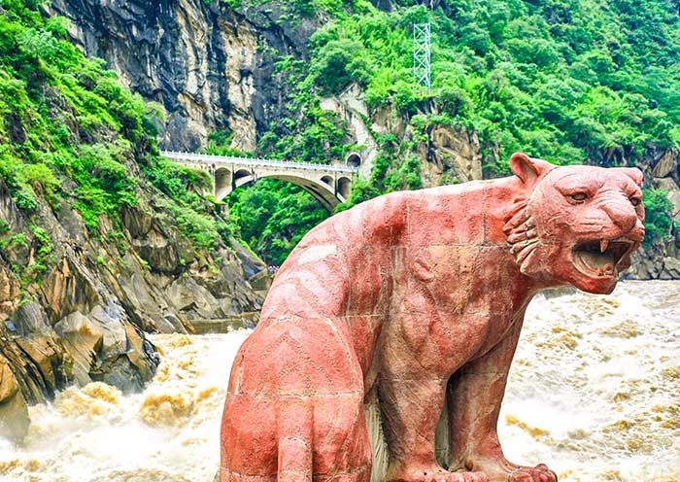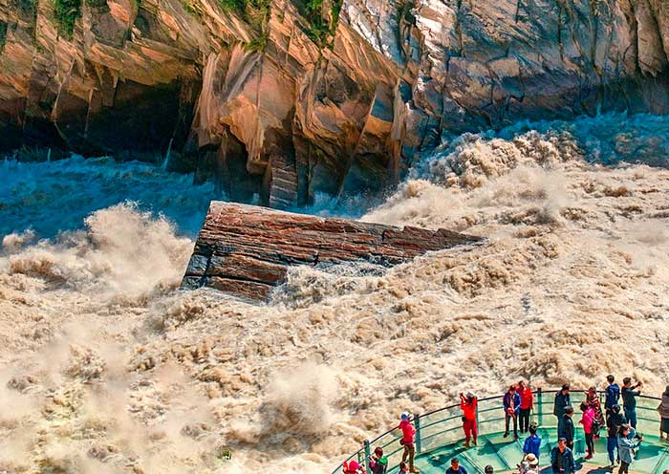
Lijiang Tiger Leaping Gorge (Upper Gorge) Marvel at Tiger Leaping Gorge
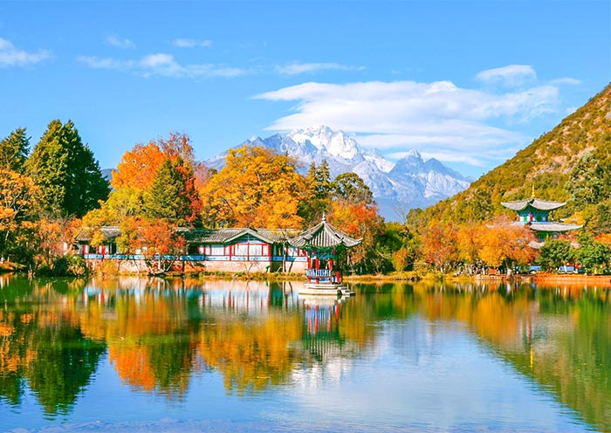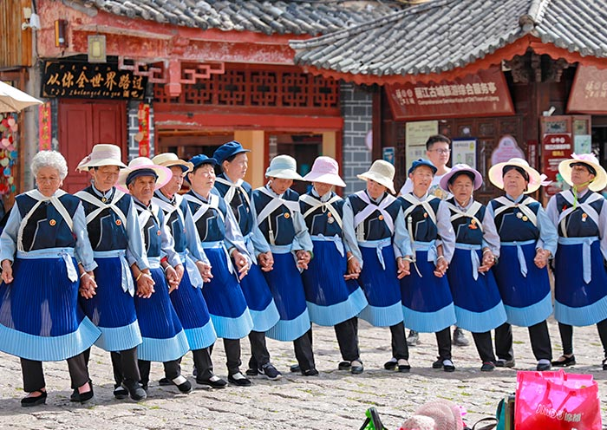
Black Dragon Pool Park, Lijiang Sifang Square, Lijiang Old Town

Day 7 Lijiang Tour | Jade Dragon Snow Mountain, Blue Moon Valley, Baisha Murals, Shuhe Ancient Town (Optional)
After breakfast, it's time to venture beyond Lijiang Old Town and explore the renowned Jade Dragon Snow Mountain (玉龙雪山). This majestic mountain is famous for its towering peaks, stunning scenery, and abundant biodiversity. It was designated as a UNESCO World Heritage site in 2003. The mountain gets its name from its resemblance to a stainless jade dragon, especially during winter when its peaks are covered in thick snow.
The crown jewel of the region is the sight of 13 snow-capped peaks, with the highest peak named Shanzidou, reaching an impressive elevation of 5,596 meters (18,360 ft). To fully experience the mountain, it is recommended to take a 10-minute cable car ride up to Spruce Meadow (云杉坪), situated at 3,240 meters. The cable car ride itself is a remarkable experience, offering breathtaking views of the surrounding mountains and valleys. Once you reach the top, you'll be greeted by awe-inspiring panoramic views and have the opportunity to explore meadows and pristine forests. After the tour, take cable down the mountain.
Afterward, take a sightseeing bus to Blue Moon Valley (蓝月谷). The valley is a breathtaking sight, with its almost surreal turquoise blue water, reflecting the majestic Jade Dragon Snow Mountain in the background. This valley boasts four lakes and a White Water Terrace. Each lake presents unique scenery, but the most beautiful one is the Jade Liquid Lake. The best time to admire the splendor of Blue Moon Valley is during a sunny midday when the lake's water, under the radiant sunlight, becomes as clear and blue as a mirror. You can capture many awesome photos here.
Special Hot Pot Experience at Jade Dragon Snow Mountain:
Asia Odyssey Travel specially arranges for your group to enjoy a hearty HOT POT after the mountain trip. Relax in the pleasant environment and enjoy the snow mountain view while savoring lunch with your friends.
Leaving the Jade Dragon Snow Mountain, you'll continue your journey to Baisha Village (白沙村), the birthplace of the Mu chieftaincy and the ancient capital of the Naxi ethnic group. Part of the UNESCO World Heritage Site "Old Town of Lijiang", Baisha Village offers a unique glimpse into the Naxi group’s rich history and culture. Here, you can visit the Baisha Murals (白沙壁画), showcasing a unique fusion of Buddhist, Taoist, and local Naxi religious elements, reflecting the diverse spiritual beliefs of the region. These murals are found within several temples, including the Dabaoji Palace, the Liuli Temple, and the Wenchang Palace.
Then, if your energy permits (optional), on the way back to Lijiang, you can make a stop at Shuhe Ancient Town (束河古镇). It is an important stop along the legendary Tea Horse Ancient Road. Unlike the bustling Lijiang Old Town, Shuhe offers a tranquil escape, with charming shops selling locally-made crafts lining the narrow cobbled streets. The gentle murmur of water flowing through canals and the aroma of Naxi cuisine wafting from cozy teahouses create a peaceful atmosphere where time seems to slow down. (Note: You can try local snacks like Chicken Bean Cold Noodles, Grilled Milk Fan, Fresh Flower Cake, Yunnan Ham Mooncake, and Jar-Roasted Rose Milk.)
After the tour, head back to Lijiang.
Attractions : 4 sites
Transportation: Vehicle
Dining: Breakfast,Lunch
Accommodation: 4-star hotel in Lijiang
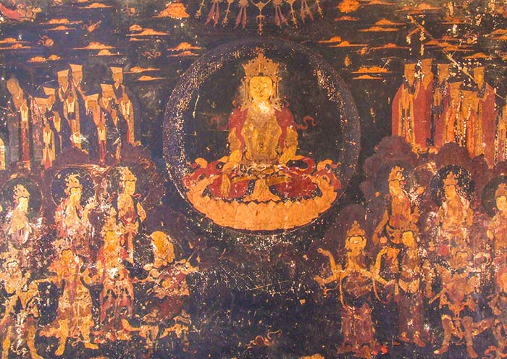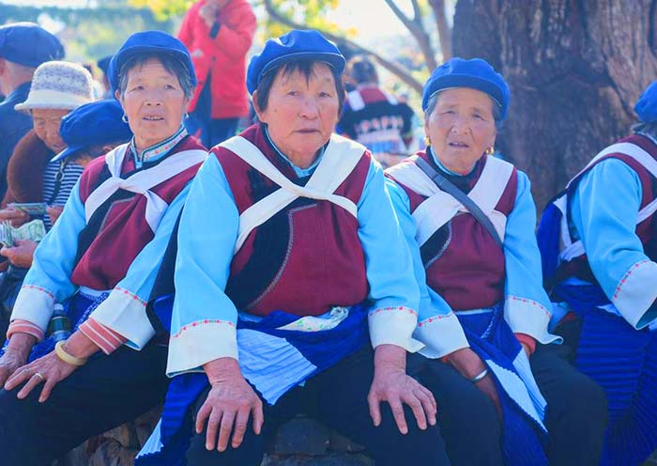
Baisha Mural at Baisha Ancient Town, Lijiang Baisha Village, the original capital of the Naxi Kingdom

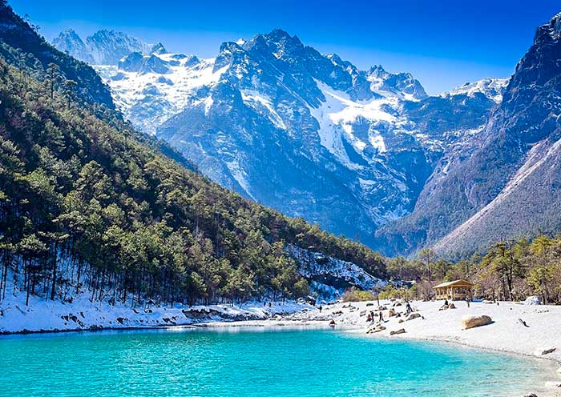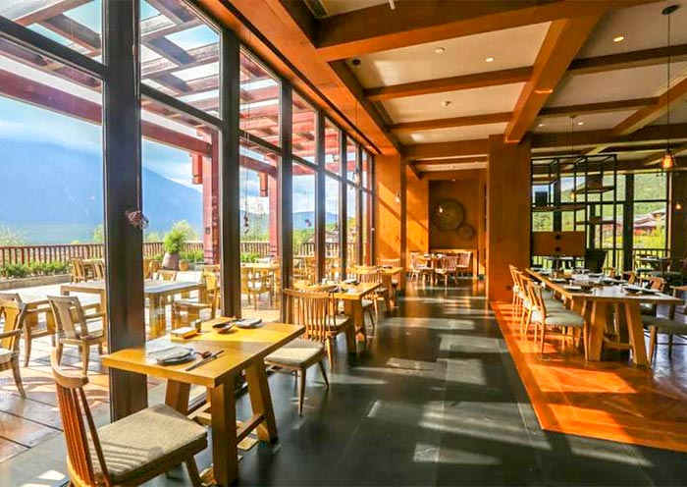
Blue Moon Valley, Lijiang Enjoy Yunnan-style Hot Pot after Exploring Yulong Snow Mountain

Day 8 Lijiang Departure | Check-out & Transfer Service
On this day, it marks the end of your 8-Day Yunnan Group Tour in Lijiang. Enjoy some time to explore on your own until our local driver picks you up at your hotel and escorts you to the airport or the train station in Lijiang at the appointed time.
Thank you for choosing Asia Odyssey Travel for your Yunnan tour. We are always here to serve you and look forward to seeing you again on your next trip to China/Asia. Safe travels!
Attractions : /
Transportation: Vehicle
Dining: Breakfast
Accommodation: /
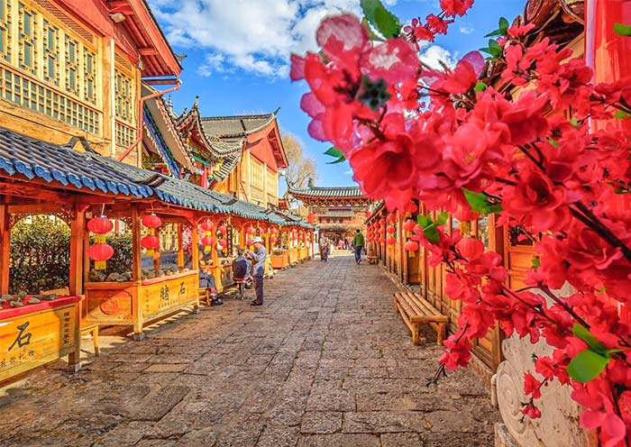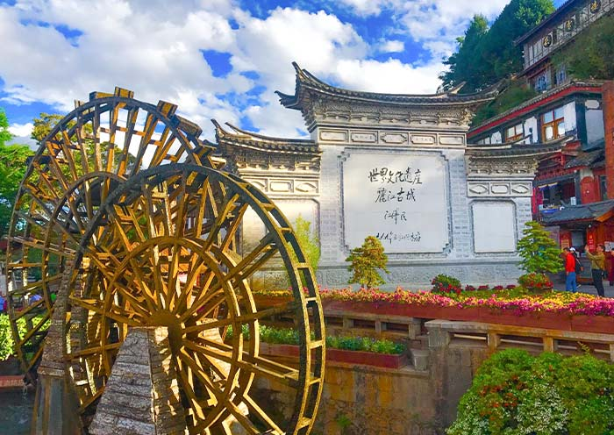
Lijiang Old Town Beautiful Alley Large Water Wheel in Lijiang Old Town

Price: What’s Included & What’s Excluded
GT023: Classic Yunnan 8-Day Tour - Kunming, Dali, Shangri-La,Lijiang
 | Tour Fee  Per person | Single Room Supplement  per person
March~June & September~December | $1,000 USD | $ 226 USD
July and August | $1,162 USD | $ 329 USD

The above price is based on a group tour for 2 people sharing one standard twin-bed room in 4-star hotels.
Price varies depending on travel date, group size, hotel class, program in your itinerary and possible fluctuation of currency exchange rate.
What’s Included:
Drivers & air-conditioned vehicles
Professional licensed English-speaking local guide
Hotel accommodation with breakfasts (4-star standard)
Transportation listed in the itinerary
Admission tickets, activities, meals listed in the itinerary
Accident insurance
Our service from tour planning, handling, operational and finishing your trip
What’s Excluded:
International airfares
Entry Visa fees
Personal expenses
Single Room Supplement
Recommended optional activities
Arrival/departure flights or train on the first and last day
Tips or gratuities for guides and drivers

Hotel Selections in Yunnan for Group Tour
On a Yunnan Group Tour, enjoy a stay in good condition hotels like no other! Typically, your accommodation will include 2 nights in Kunming, 1 night in Dali, 2 nights in Lijiang, and 2 nights in Shangri-La. All hotels are carefully selected 4-star types conveniently located in each destination. You’ll stay in the downtown area or near major attractions. The hotels feature unique characteristics, ensuring a clean, comfortable environment with good service.
During your group tour, you will share a standard twin room with your travel partner. If you are traveling as a family of two, this arrangement is perfect for sharing the same room. If you prefer a room to yourself, a single room supplement will apply.
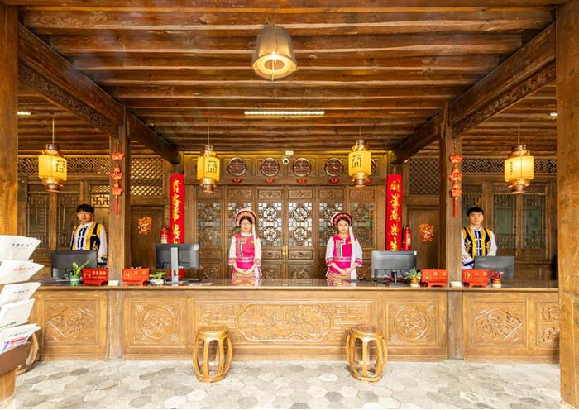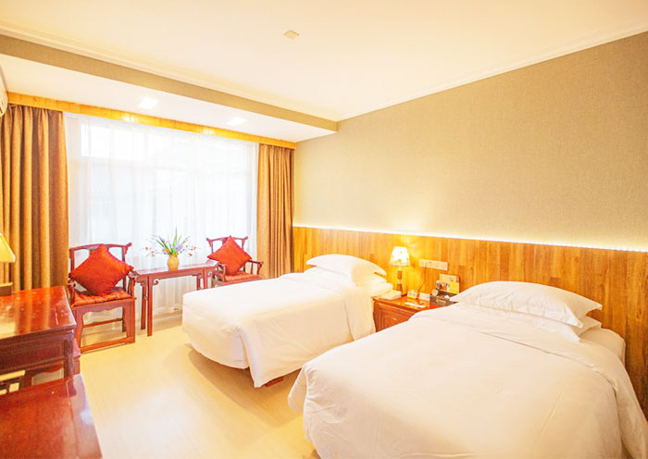

Important Trip Notes for Booking a China Group Tour

How do I book a Yunnan group tour?
Select your travel dates and choose the travel style “join-in a tour”. You will get free enquiry and don’t need to pay immediately. After sending us your requirements, one of our professional travel experts will get back to you within 0.5 to 24 hours and we guarantee to reserve a place for you first. When all the information have confirmed, then you make the payment. Please feel free to contact the travel expert directly if you have any questions prior to booking.
Deadline for Booking a Yunnan Group Tour:
The deadline for receiving guests is tentatively 7 days before departure; in the peak season, bookings close 15 days before departure.
Transportation
In a group tour, it means you will transfer to the tourist attractions in one city by vehicle. The maximum group size will be 16 people. It will be a small group size traveling at comfortable pace. We will select a suitable vehicle based on the actual group size.
Meals
* “B” stands for breakfast. You will have it at your hotel in the morning.
* “L” stands for lunch. The restaurants we will arrange for you are all designated tourist restaurants approved by local tourist administration bureau. All are in good sanitary conditions. Lunches are usually included if you have a full day tour in one destination. Your guide will assist you with ordering the dishes. If you will travel from one city to another, lunches are excluded and you can ask the guide for some suggestions about where and what to eat.
* “D” means dinner. All dinners are excluded in the itinerary. You have the chance to taste some authentic Chinese food and local snacks.
* If you have special dietary requirements (vegetarian, halal, kosher, Indian, or gluten-free), please let us know before your booking. We will try our best to take care of you.
Regarding Children's Fees:
(1) Occupying a bed: Children will be charged the adult rate.
(2) Not occupying a bed: Children will be charged the group tour fee minus the single room difference. Any ticket discounts will be refunded.
Single Room Supplement:
If you are traveling alone and prefer a private room, a single room supplement will apply. Please contact our travel experts for the exact fee.
Free Transfer Time Periods:
Free Pickup: For flights/trains arriving between 08:00 and 22:00.
Free Drop-off: For flights departing between 09:00 and 23:00. For early morning flights, no extra charge will apply if you are willing to be dropped off earlier.
Cancellation Policy
In the event that you need to cancel your trip, please ensure that you submit a written cancellation request. The calculation of cancellation fees will begin from the date we receive your written request.
The cancellation fees will be calculated as follows:
*If the cancellation is made between 45 days and 30 days before the scheduled departure date, a fee of 10% of the full payment per person will apply.
*If the cancellation is made between 29 and 15 days before the scheduled departure date, a fee of 30% of the full payment per person will apply.
*If the cancellation is made between 14 and 7 days before the scheduled departure date, a fee of 50% of the full payment per person will apply.
*If the cancellation is made between 6 and 0 days before the scheduled departure date, a fee of 100% of the full payment per person will apply.

