Japan Cherry Blossom Tour: 7 Days Tokyo, Kyoto & Mount Fuji Sakura Tour

Tour Code: AOT-JPN-F
Travel Route: Tokyo - Mount Fuji - Kyoto
Features: Cherry Blossom/Sakura, Temples, Shrines, World Heritage, Modern Cityscape, Cultural Experience, Japanese Cuisine, Natural Scenery, High Speed Train
Tour Type: Small Group of maximum 16 travelers, guaranteed departures;
Guide & Driver: English-speaking guide, experienced driver with regular tourist vehicle
Accommodation: 6 Nights at 4-Star Hotel

Itinerary Day by Day

Day 1 Tokyo, Japan Arrival | Head to your hotel in Tokyo on your own
Konnichiwa (こんにち は)！Welcome to Tokyo, the capital city of Japan!
On this day, based on your flight schedule, you will arrive in Tokyo by plane. Upon arriving at the airport, you will transfer to the designated hotel in Tokyo on your own. The accommodation in Tokyo will be a 4-star hotel in a convenient location.
Tokyo, the capital of Japan, is one of Japan and Asia's largest economic centers. Tokyo is a hub for Japanese culture and art, with numerous museums, art galleries, theaters, and
cultural venues, serving as a vital platform for artistic activities and cultural exchanges. Tokyo stands as a significant base for technological advancement, nurturing numerous high-tech companies and innovative talents, holding leading positions globally in areas like electronics, automotive, and robotics technology.

Situated at the southern end of the Kanto Plain, Tokyo is surrounded by diverse natural landscapes including Mount Fuji, providing residents with leisure and outdoor activity spaces. At one point, the population of the Tokyo metropolitan area reached 36 million,
accounting for one-third of Japan's total population. Despite the high cost of living, Tokyo
provides residents with convenient living conditions, offering a plethora of shopping centers, entertainment facilities, and a rich culinary culture ranging from fine dining to street food.
Arrival Ideas:
Japan has two commonly used international airports. Narita International Airport, located 63.5 kilometers from the center of Tokyo, is the primary international air
hub for Tokyo, where flights from China to Tokyo usually land. Tokyo International
Airport (Haneda Airport), is situated 17 kilometers from the center of Tokyo and mainly serves domestic flights within Japan and some international flights,
including flights to South Korea and other East Asian regions.
Cities that have direct flights to Tokyoinclude, but are not limited to: Beijing, Shanghai, Guangzhou, Shenzhen, Hangzhou, Xi'an, Chengdu, Chongqing, Hong Kong, Taipei, Kaohsiung, Seoul, Singapore, Bangkok, Kuala Lumpur, Jakarta, Bali, Manila, Ho Chi Minh City, Hanoi, and more. Please note that flight information is subject to changes based on time and market demand. Contact us to obtain the latest flight information and prices.
In Japan, using public transportation such as the subway & JR trains is recommended to save costs, avoid traffic congestion, and help reduce carbon emissions. Taxi fares in Japan are relatively high, with a starting fare of around 660 Japanese yen and 140 yen per kilometer. Waiting time is also charged. Surcharges are applicable during nighttime and peak hours (+20%), and expressway tolls are additional. Extra fees are levied for large luggage. For instance, a taxi ride from Tokyo Tower to Narita Airport, covering about 60-70 km, might cost around 25,000-35,000 Japanese yen (roughly 170-237 USD).
Tips for a Japan Sakura Tour:
Choose the Right Time: Sakura season typically runs from late March to early April.
Research the specific bloom dates for the regions you plan to visit.
Book Accommodation Early: Popular cherry blossom destinations can get crowded during peak season. Book your accommodations well in advance to secure the best options.
Check Weather Forecasts: Be prepared for potential rain showers, especially during the cherry blossom season.
Picnic Etiquette: Respect local customs and etiquette when picnicking under the cherry blossoms.

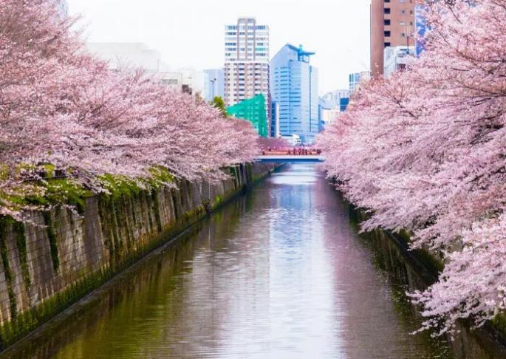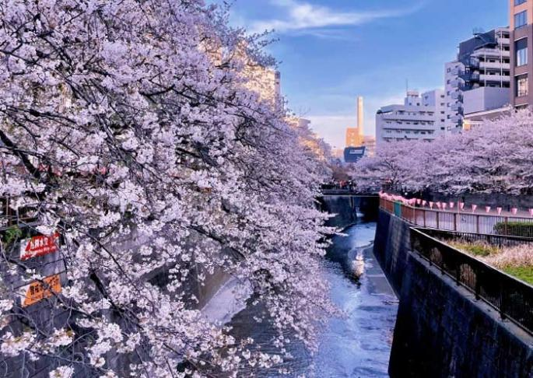

Meguro River Cherry Blossoms along the river
Meguro River Cherry Blossoms Promenade
Attractions
/
Transportation
/
Dining
None
Accommodation
4-star hotel in Tokyo

Day 2 Tokyo Tour | Ueno Park (Sakura), Senso-ji Temple (Sakura), Meiji Jingu Shrine, Shibuya Crossing
Full day explore Tokyo & Sakura (Cherry Blossom). In the morning head to Ueno Park. It is one of the city's largest parks and one of Japan's most famous cherry blossom viewing
spots, boasting over 1,300 cherry trees. The cherry blossoms bloom every spring, especially in early April, creating a breathtaking spectacle of falling cherry petals carried by the wind. The park is home to numerous museums and art galleries, including the Tokyo National Museum (Closed on Mondays) and the National Museum of Western Art (a World Heritage Site). In Ueno Park, you can also hear the calls of Japan's national bird, the crow, as they fly and search for food.
After that, head to Senso-ji Temple (Asakusa Kannon Temple), a must-visit for anyone traveling to Tokyo. Here, you can experience the heart of old Tokyo and its vibrant
atmosphere. You can take photos that frame Senso-ji Temple and the Tokyo Skytree (Japan's Tallest Tower; 634 meters) together. Senso-ji Temple is a great place to view cherry blossoms in Tokyo! The temple is located in Asakusa, a popular neighborhood known for its cherry blossoms. There are several cherry trees in the temple grounds, as well as in the
surrounding area.
Senso-ji Temple was built in 628 AD and has a history of over 1300 years, making it one of Japan's oldest temples. It not only witnesses Japan's historical changes but also carries a rich Buddhist culture. The architectural style of Senso-ji Temple blends Japanese traditional culture and art, with rich colors and exquisite carvings. The main buildings include the main

gate (Kaminarimon; a landmark of Tokyo), the bell tower, the five-story pagoda (a landmark of Tokyo), and the main hall, all reflecting ancient Japanese architectural style and religious beliefs.
Kaminarimon is the iconic structure of Senso-ji Temple, towering at 11.7 meters high and
21.7 meters wide, truly spectacular. Giant red lanterns hang in front of the gate, with the
words "Kaminarimon" prominently displayed. Kaminarimon is not only a symbol of Senso-ji Temple but also one of Tokyo's most famous landmarks. You may have seen the work of Utagawa Hiroshige, one of the "Three Greats of Ukiyo-e," in his piece "One Hundred Famous Views of Edo: Asakusa Kaminarimon," depicting a snowy scene of the Kaminarimon gate,
celebrated for its delicate portrayal and profound imagery, becoming a masterpiece of Ukiyo-e art. The area is bustling, and crowded with people coming to pray and seek blessings for health, peace, and happiness. Around Senso-ji Temple, you can taste various Japanese cuisines, purchase unique souvenirs, and participate in various celebratory activities.
In this afternoon, visit Meiji Jingu Shrine (Meiji Shrine), a Shinto Shrine dedicated to
Emperor Meiji (1852-1912) and Empress Shoken (1849-1914), who played a crucial role in modernizing Japan while excelled in writing Waka (traditional Japanese poems of 31 syllables in the pattern 5-7-5-7-7). Meiji Shrine is also a popular venue for traditional weddings, where you will have the opportunity to witness a Japanese wedding procession and experience the charm of Japanese traditional culture.
The Meiji Shrine is nestled within a tranquil forest that covers an area of 70 hectares,
providing a peaceful escape from the bustling city. This forest is home to over 100,000 trees that were donated from regions across Japan during the shrine's construction, in honor of
their beloved Emperor Meiji (who established Shinto as the state religion) and Empress Shoken.
Take a stroll along the paths and enjoy the fresh air and natural beauty. You will walk
through Japan's largest wooden Torii gate, standing in its natural wooden hue and weighing up to 13 tons. The Torii gate serves as the Symbol of Shinto Shrines, marking the transition from the worldly to the sacred. Then, you will notice the impressive Sake Barrel Wall along
the South Approach, which features offerings from sake breweries and believers across Japan, including barrels of sake and Western liquor, reflecting Emperor Meiji's fondness for Western culture.
At the main hall of Meiji Shrine, you can witness locals washing their hands and rinsing their mouths at Purification Font before worship as a sign of respect. You can offer a 5-yen coin
(symbolizing a connection) like locals and pray for blessings. In the eyes of the Japanese, Meiji Shrine is considered to have such boundless capabilities, from naming ceremonies for newborns, to coming-of-age ceremonies, graduation ceremonies, seeking marriage partners, praying for world peace, family well-being, safe travels, good health, warding off calamity, etc.
In addition to immersing yourself in Japanese Shinto traditions and architecture, revel in the enchanting surroundings filled with lush trees, serene ponds, graceful bridges, and stone

pathways that epitomize the essence of traditional Japanese garden art. You should visit
here to enjoy the vibrant bloom of cherry blossoms in spring, the verdant beauty of summer, the fiery hues of autumn leaves, and the serene snowy landscapes of winter.
Tips for Visiting Meiji Jingu Shrine:
Wear modest clothing: Respect the sacred nature of the shrine by dressing appropriately.
Be mindful of noise levels: Maintain a quiet and respectful atmosphere.
Inner Garden (Optional; self-pay; once Imperial Property), and Meiji Jingu Museum (Optional; self-pay; items used by the imperial couple).
Then, move to visit Shibuya Crossing, one of the busiest intersections in the world,
accommodating approximately 3,000 people per minute. As one of Tokyo's iconic locations, Shibuya attracts tourists and photographers from around the globe who come to observe and capture its essence. Numerous movies, TV shows, commercials, and music videos are filmed at this location, such as "The Fast and the Furious: Tokyo Drift." Additionally, if you're interested in the story of Hachiko, the loyal dog, you can also visit his bronze statue. This
Hachiko Statue is located outside Shibuya Station and was erected to commemorate Hachiko's loyalty. Not only is it a popular meeting spot, but it's also a must-visit attraction for tourists. The statue symbolizes the power of loyalty and love, serving as a touching tribute.
Stay overnight in Tokyo.

Sakura Season at Ueno Park Sakura & Five-story Pagoda


Attractions
4 Sites

Transportation
Vehicle

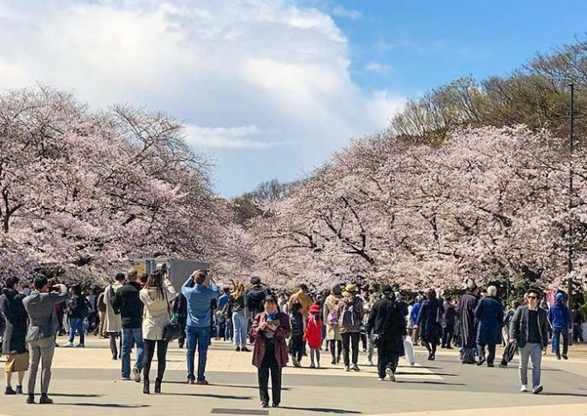
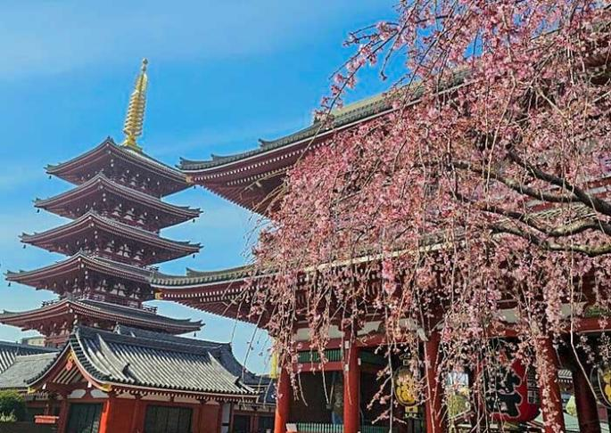
Dining
Breakfast

Accommodation
4-star hotel in Tokyo

Day 3 Tokyo - Lake Kawaguchi (View Mt. Fuji) - Tokyo | Arakurayama Sengen Park, Lake Kawaguchi (with Cruise)
Today, it will be a full-day round trip to admire the breathtaking views of Mount Fuji from Lake Kawaguchi,
Mount Fuji is the tallest mountain in Japan. It's a famous volcano with a perfectly symmetrical cone shape. Visiting Mount Fuji is essential for any traveler in Japan. As a UNESCO World Heritage Site, Mount Fuji (3,776m) stands as an iconic symbol of Japan, a cultural and spiritual landmark (recognized as a holy mountain in Shintoism), and a natural
marvel. When picturing Mount Fuji, its distinctive perfect cone shape and snow-capped peak likely come to mind. Among the most renowned depictions is Katsushika Hokusai's 'Thirty-Six Views of Mount Fuji'. Hokusai, one of the "Three Greats of Ukiyo-e", is best known for his masterpiece "The Great Wave off Kanagawa" which can be seen on the 1,000 Japanese yen bill.
Start your journey to Arakurayama Sengen Park on the way to Lake Kawaguchi.
Arakurayama Sengen Park is a popular destination for viewing cherry blossoms, renowned for its early blooming sakura trees. The park features Kawazu zakura, a unique variety of
cherry trees known for its large, pink blossoms. The park's cherry trees typically bloom
earlier than those in other regions of Japan, making it a great choice for those who want to experience the beauty of Sakura in February or early March. The park offers breathtaking views of the Kawazu River and surrounding mountains (framing Mt. Fuji, Sakura & Five-story pagoda together), providing a picturesque backdrop for your cherry blossom experience.
During the peak cherry blossom season, the park hosts a lively festival with food stalls,
traditional performances, and other festivities. Hike about 15-20 minutes up to Arakurayama Sengen Shrine, dedicated to the mountain god. The shrine is surrounded by beautiful
gardens and offers a peaceful atmosphere. Enjoy the gorgeous scenery and capture iconic photos at the famous Red Fuji Observation Deck.
Next, head to Lake Kawaguchi, another excellent location to leisurely view Mount Fuji. The lake boasts crystal-clear waters, providing breathtaking views of the iconic mountain and a serene atmosphere. Enjoy a cruise on the tranquil waters to marvel at the stunning reflection of Mt. Fuji in Lake Kawaguchi. Additionally, take a leisurely stroll around the lake and explore the nearby parks, galleries, and museums based on your interests.
After that, head back to Tokyo overnight and have a good rest.

Notes:

It is a long day trip, and there will be a surcharge if the tour exceeds 8 hours (For Guide, driver & vehicle).
If the weather is clear, you can enjoy a good view of Mt. Fuji. However, if the weather is not favorable, Mt. Fuji may not be visible.

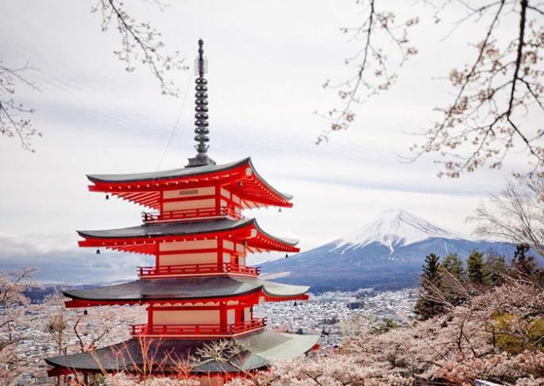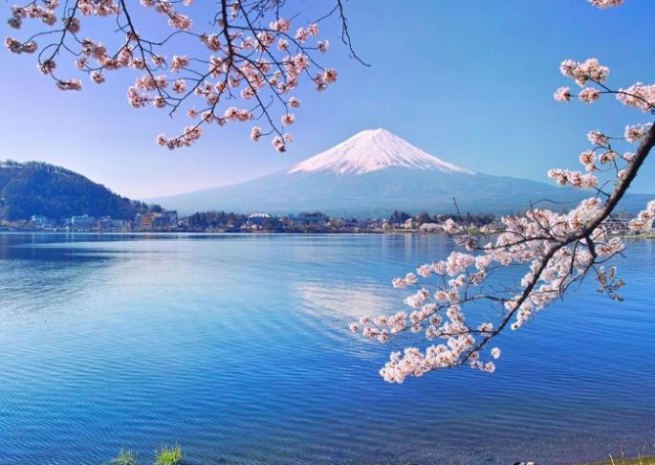

The best time to view Mount Fuji is generally from December to February when skies are clearer and the peak is snow-capped. And also, April to May (for blooming cherry blossoms) and October to November (for the autumn foliage) are good times.
Early mornings often provide the best visibility before clouds obscure the view. Different locations around Mount Fuji offer varying perspectives, with some spots known for their clear views.
Cherry Blossom in Mount Fuji Arakurayama Sengen Park
Mount Fuji and Cherry Blossom
Attractions
Transportation
2 Sites
Vehicle, Cruise
Dining
Accommodation
Breakfast
4-star hotel in Tokyo
Day 4 Tokyo to Kyoto by Shinkansen (Bullet Train) | Free Exploration in Kyoto
On this day, your driver in Tokyo will take you to the train station, where your group will
board the Shinkansen (bullet train) to Kyoto. Shinkansen Ride Experience: At Tokyo Station, board the Shinkansen bound for Kyoto Station (about 2.5 hours). This fast and comfortable journey offers an opportunity to enjoy the changing landscapes of urban and rural Japan.
Upon arrival in Kyoto, your driver will greet you and transfer you to your hotel. Check in, take some time to settle in, and rest.
Kyoto, located in the Kansai region of the country, was once the capital of Japan. It
epitomizes ancient Japan and is famous for tranquil temples, exquisite gardens, colorful shrines, grand imperial palaces, and ornate castles. Boasting 17 UNESCO World Heritage Sites, over 1,000 Buddhist temples, and more than 400 Shinto shrines, Kyoto is among the
world's most culturally rich cities. It's also known for traditional Japanese arts and practices,

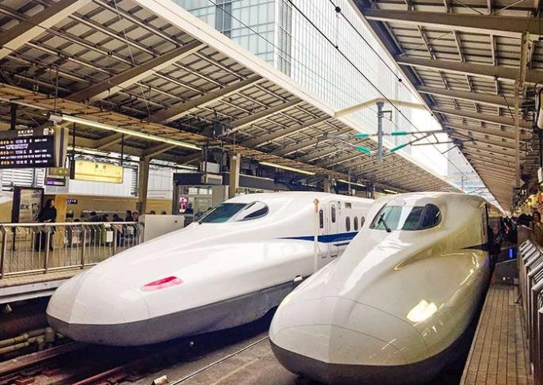
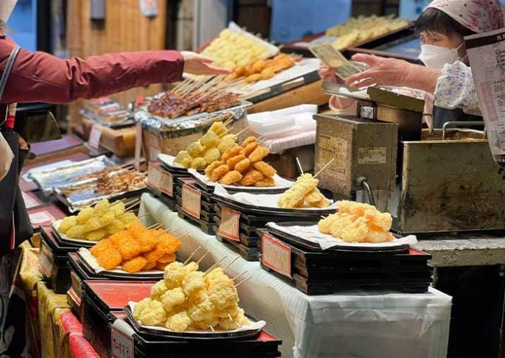
such as tea ceremonies, kaiseki dining (a traditional multi-course meal), and ikebana (flower arranging). It remains one of the best places to see geishas, who are traditional Japanese
female entertainers known for their refined skills in arts, music, dance, and conversation.

Free Time Ideas in Kyoto:

Evening Stroll Along the Kamo River: This river flows through the city and provides walking paths with beautiful views. Many cafes and restaurants along the river have terraces, perfect for a relaxing end to your day.
Walk the Philosopher's Path: Enjoy a peaceful walk along the Philosopher’s Path, a stone path lined with cherry trees that follows a canal in northeastern Kyoto. This path is especially beautiful during cherry blossom season but offers a serene experience year-round.

Japan Bullet Train Nishiki Market, Kyoto


Attractions
/

Transportation
Shinkansen, Vehicle

Dining
Breakfast

Accommodation
4-star hotel in Kyoto

Day 5 Kyoto Tour | Kiyomizudera Temple (Sakura), Ninenzaka & Sannenzaka, Maruyama Park (Sakura), Gion, Tea Ceremony
In the morning, visit Kiyomizudera Temple, a UNESCO World Heritage Site. Perched on the hillside of Eastern Kyoto, this temple is renowned for its wooden stage that juts out over the hill, providing stunning views of the city and the surrounding nature. The temple's main hall, constructed entirely without the use of nails, is an architectural marvel. Kiyomizu-dera is also celebrated for its sacred waters, which are believed to have wish-granting powers that draw countless visitors who come to drink from its stream. Don’t miss the Hondo (Main

Hall), Jishu Shrine, the Otowa Waterfall, and the spiritual experience of the Tainai-Meguri room.

Tips: The scenery at Kiyomizu-dera Temple is distinctively beautiful in each season, offering a unique charm year-round. In spring, the mountains are adorned with charming cherry
blossoms; in summer, they are lush with vibrant greenery; in autumn, they are decorated with brilliantly colored leaves; and in winter, they are filled with enchanting trees. You will enjoy
the soft pink sakura ice cream (specially prepared for free by Asia Odyssey Travel) while having a wonderful time here.
Then, walk up the well-preserved streets of Ninenzaka and Sannenzaka. These charming, sloping streets are lined with traditional shops and quaint tea houses, offering a nostalgic
glimpse into Kyoto's past. As you stroll through these areas, you can shop for unique crafts, sample local snacks, and perhaps stop at a café to relax and soak in the atmosphere of old Kyoto.
Continue to Maruyama Park for viewing Sakura. Located near Kiyomizu-dera Temple and Gion District, Maruyama Park is renowned for its stunning display of sakura, particularly the iconic weeping cherry tree (shidarezakura) near the shrine. The park is home to Yamataka-no-Otoko Shrine, a popular Shinto shrine that attracts many visitors throughout the year.
Next, move to Gion which is Kyoto's famous geisha district. Here, you might catch a glimpse of Geisha (Geiko) in their elaborate kimonos and traditional makeup. As you wander through the cobblestone streets of Gion, take a moment to appreciate the beautifully preserved machiya (wooden townhouses), ochaya (teahouses), and exclusive ryotei (traditional
Japanese restaurants). Gion is particularly enchanting at dusk when the lanterns are lit and geishas and maiko (apprentice geishas) make their way to evening appointments, making
the narrow lanes come alive.
The final activity today is to experience a traditional tea ceremony in an authentic setting, following the artful rituals and savoring the tea. Immerse yourself in the philosophy behind the ceremony.
After the tour, your group will be escorted to your hotel in Kyoto.

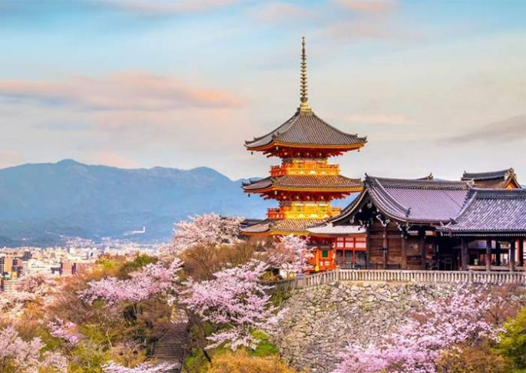
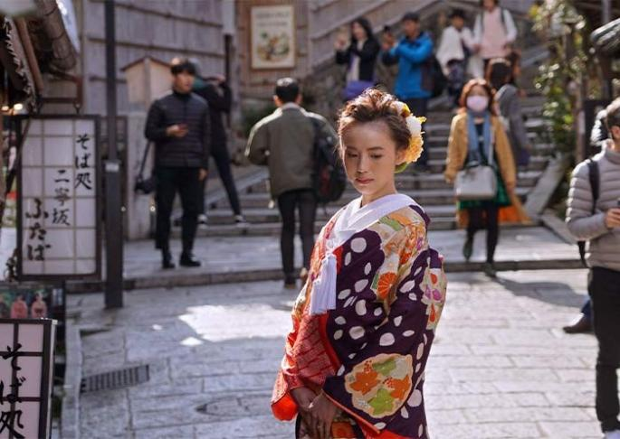
Kiyomizudera Temple, Kyoto
Ninenzaka & Sannenzaka Streets, Kyoto

Attractions
5 Sites
Transportation
Vehicle
Dining
Breakfast
Accommodation
4-star hotel in Kyoto

Day 6 Kyoto Tour | Kinkakuji Temple (Sakura), Nijo Castle, Sagano Scenic Railway or Yakatabune Boat (Sakura), Arashiyama Bamboo Grove, Tenryuji Temple, Togetsukyo Bridge
Today, you'll be visiting some of Kyoto's most iconic spots, then head to the Arashiyama and Sagano areas located in the northwest of Kyoto. This itinerary will not only allow you to deeply experience Kyoto's culture and history but also bring you closer to nature, letting you feel the changes of the seasons.
Start your day with a visit to one of Kyoto's most iconic sights, Kinkakuji Temple (Golden Pavilion) - a UNESCO World Heritage site. This Zen Buddhist temple is famous for its
stunning golden exterior. The temple's stunning visual appeal comes from its top two floors, which are completely covered in gold leaf. The reflection of the golden structure shimmering in the pond in front of it, makes it perfect for photos and quiet reflection. It was originally
built in 1397 as a retirement villa for Shogun Ashikaga Yoshimitsu. After Yoshimitsu's death, as per his will, the villa was converted into a Zen temple by his son.
Next, head to Nijo Castle, another UNESCO World Heritage site, to delve deeper into Japan’s feudal history. Constructed in 1603 as the Kyoto residence of Tokugawa Ieyasu, the first shogun of the Edo period, its expansive grounds and ornate architecture highlight the power and wealth of the dominant samurai clans during the Edo period (1603-1867).
The castle features two concentric rings of fortifications, each consisting of a wall and a wide moat. After passing through the grand Kara-mon (gate), you will enter Ninomaru Palace, which is divided into five buildings with numerous chambers. The interiors are adorned with masterful paintings by the Kano school, reflecting the cultural and artistic
heritage of the era. The castle is renowned for its "nightingale floors," (that sing and squeak at every move, making it difficult for intruders to move about quietly), designed as a security measure against intruders. Don’t miss the excellent Ninomaru Palace Garden, which was designed by the tea master and landscape architect, Kobori Enshu. Nijo Castle holds a
significant place in Japanese history. It was at Nijo Castle in 1867 that Tokugawa Yoshinobu, the 15th and last shogun of the Tokugawa dynasty, declared the restoration of imperial rule, leading to the Meiji Restoration. This event marked the end of the shogunate system in Japan and the beginning of modern Japan as a nation-state.

This afternoon, you will fully explore the Arashiyama area in the western part of Kyoto. Based on Sakura season ticket availability, take one of the following two experiences:


Option 1: Sagano Scenic Railway Experience (25-30 minutes)
The Sagano Scenic Railway is a sightseeing train line running between Arashiyama and Kameoka. The train travels along the Hozugawa River gorge, offering breathtaking views of the surrounding forests and mountains. During spring, the old-fashioned train moves at a
leisurely pace, allowing you to marvel at the stunning sight of pink cherry blossoms blanketing the forests and hillsides.

Option 2: Yakatabune (Houseboat Pleasure Boat, 30 minutes)
Enjoy a tranquil ride on traditional Yakatabune. As you glide along the Hozugawa River, take in the enchanting views of cherry blossoms lining both sides of the river. The serene scene of pink petals drifting on the water creates a poetic and picturesque atmosphere - truly an idyllic experience.
And then, walk to the nearby Arashiyama Bamboo Grove. The famous pathway is
surrounded by towering bamboo, which creates an otherworldly atmosphere. This path leads you through one of Kyoto's most photographed landscapes.
After a short walk, explore Tenryuji Temple which is designated as a UNESCO World
Heritage Site and is one of the so-called Kyoto Gozan or "five great Zen temples of Kyoto". Don't miss the garden, designed by the famous Zen master Muso Soseki, which reflects the concept of shakkei ("borrowed landscape"). Tips: The temple and its gardens are
particularly beautiful during the cherry blossom season in spring and the colorful foliage season in autumn.
Conclude your visit to Arashiyama by walking to the Togetsukyo Bridge, an iconic historical wooden bridge offering picturesque views of the surrounding mountains and river,
encapsulating the tranquil beauty of the area.
After the tour, drive back to Kyoto downtown. Stay overnight in Kyoto.

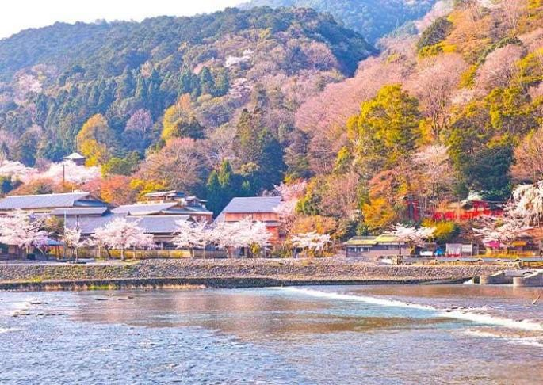
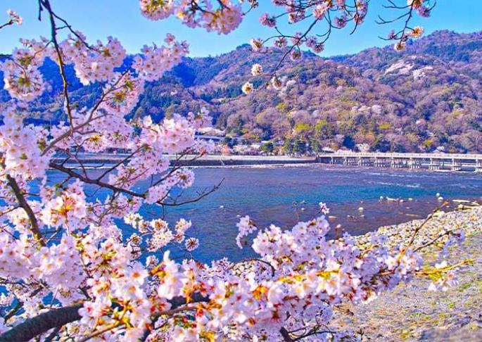
Arashiyama Area
Togetsukyo Bridge, Kyoto

Attractions
5 Sites
Transportation
Vehicle
Dining
Breakfast
Accommodation
4-star hotel in Kyoto

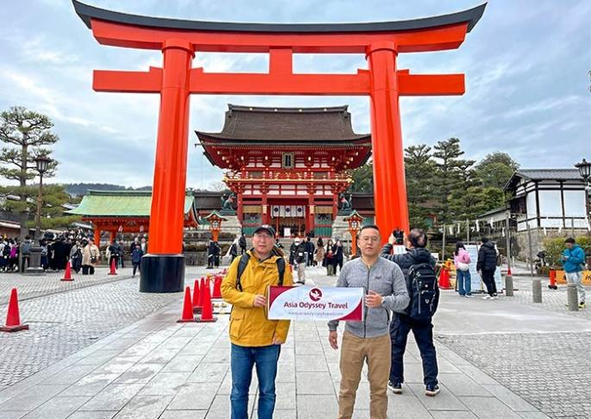
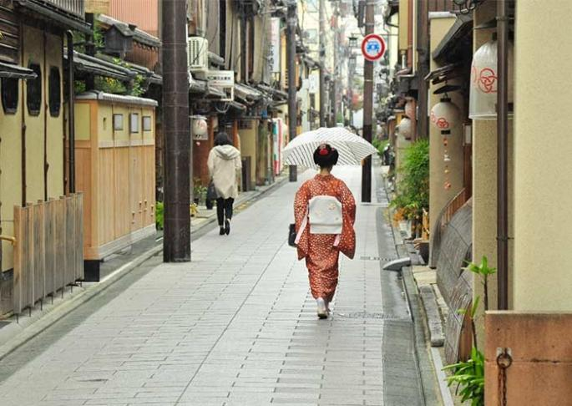
Day 7 Kyoto Departure | Hotel Check-out & Transfer to Airport on your own
After breakfast, it’s time to conclude your 7 Days Japan Sakura (Cherry Blossom) Essence Tour.

Departure Options from Kyoto:
If you choose to extend your journey, continue Japan group tour with visits to Nara and Osaka for additional 2 days.
Or, on this day, you need to be transferred from your hotel to the Osaka airport (on your own) for your departure.
Thank you for choosing Asia Odyssey Travel (AOT) for your Japan Tour. We are always committed to providing you with exceptional experiences and look forward to welcoming you again on your next trip to Asia.

Fushimi Inari Taisha Shrine, Kyoto Gion (Kyoto's famous geisha district)


Attractions
/

Transportation
/

Dining
Accommodation
Breakfast
/

Month | Available Date
Mar | Mar.15, 2026
Mar | Mar.22, 2026
Mar | Mar.29, 2026
Apr | Apr.05, 2026
Apr | Apr.12, 2026
Apr | Apr.19, 2026

Price: What’s Included & What’s Excluded
The above price is based on a group tour for 2 people sharing one standard double-bed room in 4-star hotels in Japan.
Price varies depending on travel date, group size, hotel class, program in your itinerary and possible fluctuation of currency exchange rate.

What’s Included:
 Accommodation: Throughout the trip, stay in 4 star hotels in each city of Japan.
Meals: Breakfasts are included in itinerary. Please refer to the itinerary for the details of the meals provided.
Attraction Tickets: Entrance tickets for all listed attractions are included, guaranteeing full visits. In case of unexpected circumstances, alternative arrangements will be discussed with the tourists.
Transportation Arrangement: Air-conditioned vehicles.

Operation Service: Our service from tour planning, handling, operational and finishing your trip

What’s Excluded:
 Visa: Travelers are typically responsible for obtaining their own visas and paying any associated fees.
Airfare: International round-trip tickets and Domestic air tickets (Flight ticket booking service and instant quotes are available upon request.)
Airport Pick-up & Drop-off Service: No transfer service is provided on the first and last days for departure.
Travel Insurance: Travel insurance is usually not included and should be purchased separately.
Single Room Supplement: The default accommodation is based on two people
sharing a room. If you require a single room, an additional single room supplement must be paid.
Personal Expenses: Other personal expenses such as laundry, telephone, internet, fax, etc., within the hotel.
Tipping: Tips for drivers and guides (Tipping practices may vary depending on the region and nature of service; it is recommended to consult the guide's opinion in advance).
Unexpected Circumstances: In case of uncontrollable and non-agency-related factors (such as natural disasters, war, strikes), flight delays or cancellations, delayed visa processing at embassies.

Important Information for Joining Japan Group Tours

01 | Our Japan small group tours typically include 1–16 travelers, giving you the  opportunity to meet and explore with people from around the world. To ensure comfort, the group size will not exceed 16 travelers.
02 | Solo travelers are welcome! We accept individual bookings, and only one  traveler can book per reservation. Simply confirm your departure with our Japan travel experts.

03 | The tour price is based on double occupancy, with two travelers sharing a room. Solo travelers or those requesting a single room for personal reasons will need to pay an additional single supplement fee.
04 | A deposit is required at the time of booking to secure your place on the tour. The remaining balance is due no later than 30 days prior to the departure date.
05 | Cancellation and Rescheduling Policy for AOT-JPN-A, B, C, and D: 30 to 60 days before departure: 10% of the tour fee.  15 to 29 days before departure: 30% of the tour fee. 8 to 14 days before departure: 80% of the tour fee. 0 to 7 days before departure: 100% of the tour fee.
06 | Cancellation and Rescheduling Policy for AOT-JPN-E and F (Cherry Blossom Tour):  31 to 60 days before departure: 30% of the tour fee. 16 to 30 days before departure: 80% of the tour fee. 0 to 15 days before departure: 100% of the tour fee.
07 | Child Pricing Policy (For children 12 years old and under): If a child requires a separate bed, the price will be the same as the adult rate. If you are traveling with children, please contact us in advance.
08 | Luggage Policy (Excess luggage may affect passenger comfort):  Each traveler is allowed 1 suitcase (maximum 26 inches) and 1 carry-on backpack.
09 | Participants are strongly advised to purchase comprehensive travel insurance covering medical expenses, personal accident, cancellation, and personal  property.
10 | Please note that any non-participation in the itinerary will be considered as voluntary abandonment, and no refund will be provided for those activities or locations.
11 | Any changes to the booking after confirmation may incur amendment fees, subject to availability and any additional costs imposed by suppliers.
12 | For the safety and convenience of all travelers, it is not possible to

accommodate requests to deviate from the tour itinerary during the trip.

