12 Days Ultimate Palawan Group Tour: Puerto Princesa, Port Barton, El Nido, Coron
Route: Puerto Princesa - Port Barton - El Nido - Coron

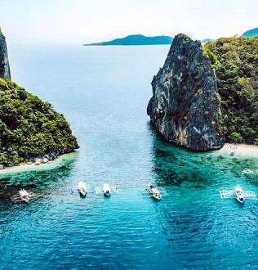
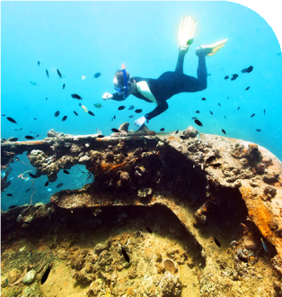
Tour Code: AOT-PHG-001 Group Tour Lowest Price Guarantee Recommended Rating: 5 Star

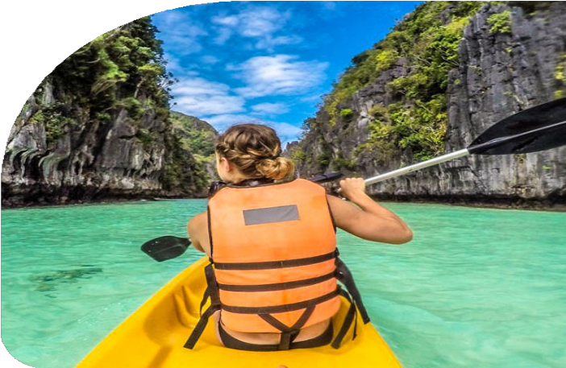
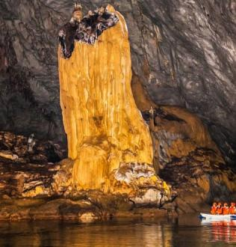
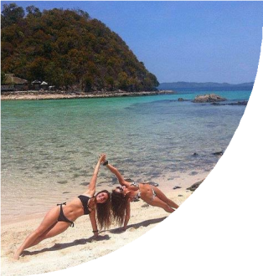
Ultimate Palawan Adventure: Explore All Island’s Top Destinations
Looking for the ultimate Palawan adventure? Our 12-day Palawan Group Tour has got you covered! From Puerto Princesa to Port Barton, El Nido, and Coron, this trip packs in all the highlights of Palawan's most stunning spots.

You’ll get to check off bucket-list experiences like the UNESCO-listed Underground River, snorkeling in Port Barton’s vibrant reefs, and exploring El Nido’s hidden lagoons

and beaches. In Coron, dive into the past with WWII shipwrecks and swim in the pristine waters of Kayangan Lake, one of the cleanest lakes in Asia. Want to take it all in from above? A hike up Mt. Tapyas offers a jaw-dropping view of Coron that you won’t forge

Enjoy the benefits of traveling in a small group where logistics are handled efficiently, allowing you more time to enjoy the experiences and less time worrying about the details. Ready to explore Palawan like never before? Join us for this unforgettable
journey!

Group Information

Available: All year
Languages: English

Difficulty: Easy
Duration 12 days


Features:
Nature, Islands, Beaches, Caves, Lagoons, Island Hopping, Swimming, Snorkeling, Underground River, Wold Heritage Site, Culture

You Can Experience “Must-see & Must-do” with This Tour

- Explore the UNESCO-listed Underground River. Glide through mystical
stalactite-filled caves in one of the New 7 Wonders of Nature, immersing
yourself in the awe-inspiring beauty of this underground world.

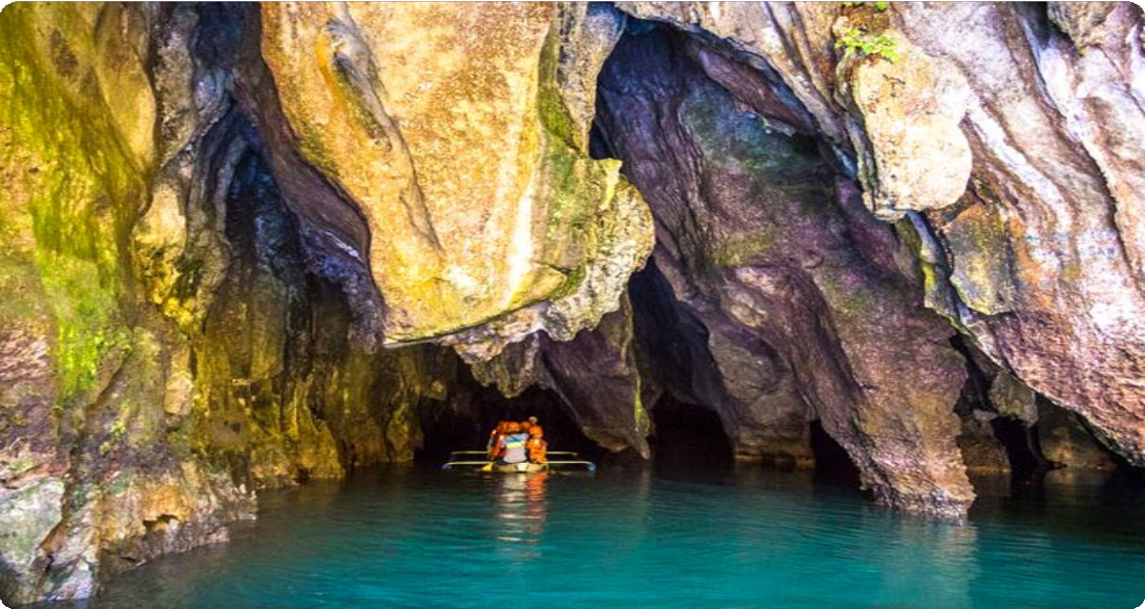
- Island Hop Across Honda Bay. Visit Starfish Island, Cowrie Island, and Luli
Island for a day of snorkeling, sunbathing, and indulging in fresh seafood on
the beach.


Day by Day Itinerary

 Day 1 Arrival in Puerto Princesa | Airport Pick-up and Hotel Check-in Welcome to Palawan Islands, Philippines! Upon arrival at Puerto Princesa
International Airport, you will be greeted by your driver, who will assist you with your transfer to your hotel. After checking in, you can take the rest of the day to relax,
explore the local area, or enjoy a leisurely dinner at a nearby restaurant.

Palawan, an archipelago in the western Philippines, is often called the country's "last ecological frontier" due to its stunning natural beauty. Home to wonders like the

UNESCO-listed Puerto Princesa Underground River, El Nido's majestic karst cliffs, and Coron's pristine dive sites, it offers a paradise for nature lovers and adventurers.

At the heart of this tropical haven is Puerto Princesa, the provincial capital and gateway to Palawan's treasures, including the world-famous Underground River and exciting island-hopping adventures in Honda Bay and Port Barton.

Arrival Ideas:

By Air: The fastest way to reach Puerto Princesa is via direct flights from major cities including Manila (MNL), Cebu (CEB), Clark (CRK), and Caticlan (MPH, Boracay). Cebu Pacific, AirAsia, and Philippine Airlines operate daily flights to the destination.
Main Airport: Puerto Princesa International Airport (PPS) is the main gateway to Palawan. It is about 1.5 kilometers (about 10 minutes by car) from the city center.
If you need help with Philippines flight ticket booking, feel free to contact us.

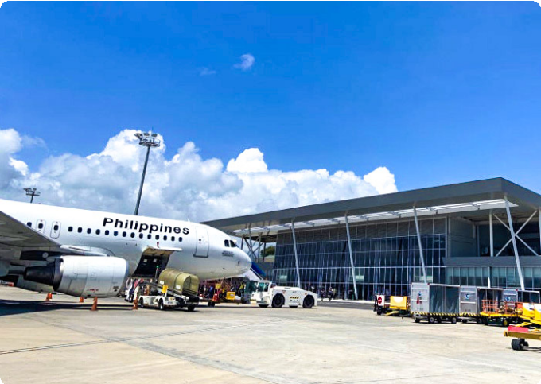
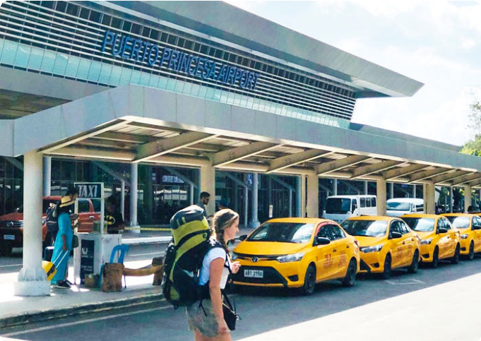
Dining：None Accommodation：Puerto Princesa
Puerto Princesa International Airport
(PPS)
Puerto Princesa International Airport
(PPS)

 Day 2 Puerto Princesa | Honda Bay Island Hopping to Starfish Island, Cowrie Island, Luli Island

Get ready for a day filled with sun, sand, and sea as you embark on a full-day Honda Bay Island Hopping Tour. Today, you’ll explore three of the most beautiful islands in Puerto Princesa: Starfish Island, Cowrie Island, and Luli Island.
After breakfast, your guide will pick you up and take you to Santa Lourdes Pier to board your boat and start the adventure.

Your first stop is Starfish Island, where you’ll find loads of starfish dotting the shallow waters. Immerse yourself in the crystal-clear waters, where vibrant marine life swims beneath the surface. You might even spot some colorful clownfish (Nemo!) and other marine life. you’ ll be enchanted by the colorful coral reefs and curious fish- an

underwater playground just waiting to be explored.

Next, head to Cowrie Island, the biggest island of the day. Named after the brightly-shelled mollusks (local sea snail), the island is all about relaxation and fun. You can
grab a drink at the bar, unwind with a massage, or just enjoy the beautiful beach under
the coconut trees. Or explore the island on foot, feel the soft sand beneath your feet, or simply take in the panoramic views of the bay.
But the real treat? A delicious beachside buffet featuring local delicacies, giving you a true taste of Palawan.
Finally, you’ll visit Luli Island - a magical place that disappears and reappears with the tide! When the water’s low, you’ll see its sandbars stretching out; when it’s high, only
the houses are visible. Feel free to jump off the diving board, go cliff jumping, or swim
in the clear emerald waters. Luli Island is also a great spot for sunbathing, strolling along the sandbars, and feeding the fish.
After a day full of island fun, you’ll head back to your hotel.

Dining：Breakfast, Lunch
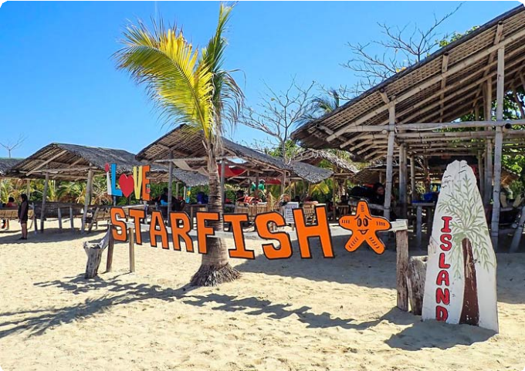
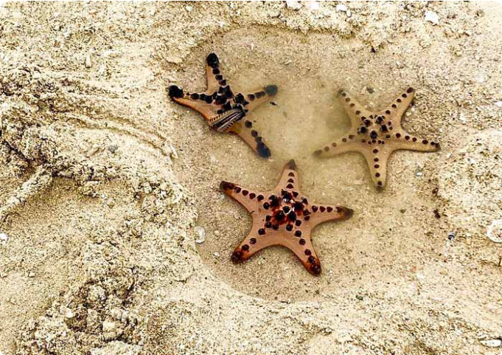
Accommodation：Puerto Princesa
Starfish Island
Starfish Island

 Day 3 Puerto Princesa - Sabang - Puerto Princesa | Underground River National Park

Today, prepare for a fascinating journey into one of the New 7 Wonders of Nature - the

Puerto Princesa Underground River. A UNESCO World Heritage Site, this
extraordinary river flows through a vast cave system, offering an unforgettable adventure beneath the Earth’s surface.
After breakfast, you will depart from Puerto Princesa City and head to Sabang which is about 75km (2 hours drive). Upon arrival at the Sabang Boat Terminal, you’ll board a boat that will take you to the entrance of Underground River National
Park (Subterranean River National Park).

After a short walk through the park, you’ll transfer to a park-operated paddleboat and glide into the Underground River. As you move deeper into the cave, towering stalactites and stalagmites rise from the dark waters, formed over thousands of years. Let your imagination run wild as you identify the shapes and patterns in the rock formations. The eerie silence and the cave’s darkness - broken only by the soft sound of your boat moving through the water- will make you feel as if you've stepped into another world.
Listen to your guide share fascinating insights about the unique ecosystem and the geological history of this natural wonder. Some sections of the river are illuminated by the boat's lights, revealing stunning formations that will leave you in awe. It's not just a tour - it's a vivid environmental education lesson.
Aside from its geological wonders, the park is home to diverse wildlife. While exploring the river, keep an eye out for monkeys, lizards, bats, and even the
endangered Philippine eagle, which can sometimes be spotted near the cave’s
entrance.

After your underground adventure, enjoy a delicious lunch in Sabang before heading back to Puerto Princesa.

Dining：Breakfast, Lunch
Accommodation：Puerto Princesa

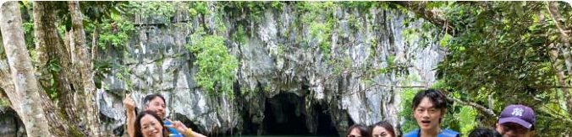

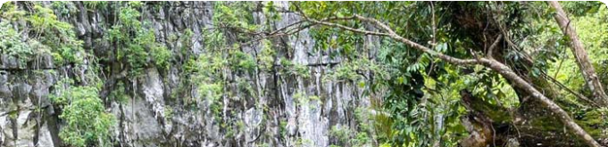
 Day 4 Puerto Princesa to Port Barton | Half Day Whaleshark Tour or City Tour, Transfer to Port Barton

This morning, you'll either swim with whale sharks (April to September) or explore Puerto Princesa's city highlights (October - March). It depends on the season. After your half-day activity, you'll drive you to Port Barton (about 3 hours).

Morning: Whale Shark Half-Day Tour (Seasonal: April - September)

Your guide will pick you up from your hotel in Puerto Princesa and drive you to
Baywalk Park, where you’ll board a boat for your exciting whale shark adventure.

As you sail toward the open waters, your guide will provide important safety instructions for swimming with the whale sharks. Be mindful not to feed or disturb the marine life, as this can negatively impact the ecosystem.
Once you arrive at the whale shark spotting area, you’ll have the incredible opportunity to snorkel and swim alongside these gentle giants, known locally as "butanding."
Marvel at their massive size and peaceful nature as you experience this once-in-a-
lifetime encounter up close.

Please note: Swimming with whale sharks is a seasonal activity, available only from
April to September, and is subject to favorable weather conditions.

Morning: Puerto Princesa City Half Day Tour ( Seasonal: October - March)

Start your day with a half-day exploration of Puerto Princesa's cultural highlights.
Begin by visiting Mitra House, where you can enjoy panoramic views of the city and
the surrounding landscapes. Afterward, head to Baker’s Hill, a local favorite known for its freshly baked treats and charming gardens filled with whimsical sculptures.
Next, you’ll visit the Palawan Butterfly Ecological Garden and Tribal Village. Here, you’ll encounter a vibrant array of butterflies fluttering amidst lush greenery and learn about the rich biodiversity of Palawan. The visit also includes an immersive
experience with the indigenous Palawan tribe, offering a glimpse into their traditional lifestyle, crafts, and survival skills.
Finally, the tour will take you to the Crocodile Farm, where you'll learn about Palawan’s native crocodiles and the important wildlife conservation efforts taking place in the region.

Afternoon: Drive to Port Barton


In the afternoon, drive to Port Barton. Port Barton is just 3 hours away from Puerto Princesa City and is one of its up and coming beach destinations.

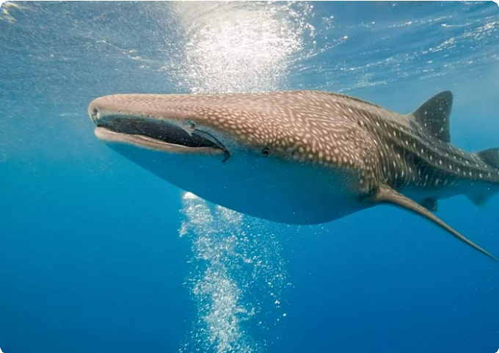
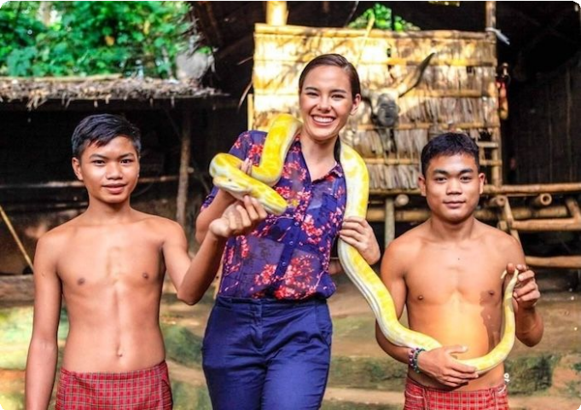
Dining：Breakfast Accommodation：Port Barton
Swimming with Whale Sharks in Puerto
Princesa
Palawan Butterfly Ecological Garden and
Tribal Village

 Day 5 Port Barton | Island Hopping A to Twin Reef, Exotic Island, Turtle Spot, Paradise Island, Fantastic Reef, Sand Bar

Port Barton is unlike any other destination - a place where the natural world feels
untouched, and the serenity of its beauty wraps around you like a gentle hug. Today, you’ll embark on a thrilling island-hopping adventure through pristine waters, secret beaches, and vibrant coral reefs, making it a day of discovery you’ll never forget.
After breakfast, your guide will greet you for a thrilling boat ride to Twin Reef - a true underwater paradise. As you plunge into the crystal-clear waters, you’ll be surrounded by a vibrant world of coral gardens and colorful fish. Swim through the living tapestry of the ocean, where each reef is an exciting discovery waiting to unfold.
Next, you set course for Exotic Island. Feel the soft sand beneath your feet as you
step onto this secluded gem. The calm waters invite you for a refreshing dip, or simply lie back, basking in the peaceful ambiance of this hidden retreat.
Our next stop is Turtle Spot, a magical place where you can swim alongside the
gentle sea turtles in their natural habitat. Afterward, you’ll visit Paradise Island, an idyllic escape with a tranquil beach, perfect for lounging and soaking in the peaceful surroundings.

In the afternoon, you’ll venture to Fantastic Reef, where you’ll be captivated by the colorful coral formations and thriving marine life. Snorkel through this underwater

wonderland for an unforgettable experience. Then, you’ll head to Sand Bar, a stretch
of sand that emerges at low tide. It’s a perfect spot to cool off, enjoy the sun, and take in the stunning views.
After tour, you will be transferred back to your hotel.

Dining：Breakfast, Lunch
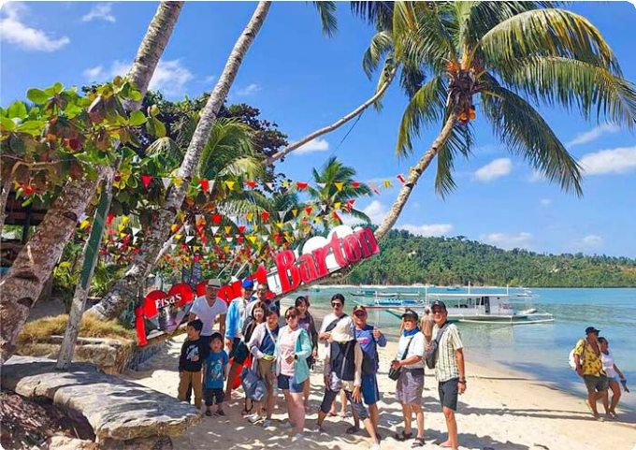
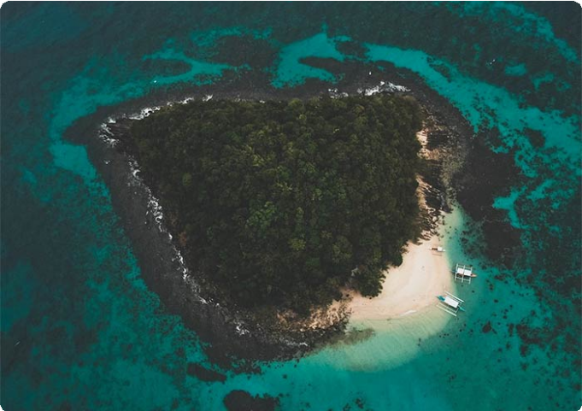
Accommodation：Port Barton
Our guests at Port Barton Island Hopping
Exotic Island at Port Barton, Palawan

 Day 6 Port Barton to El Nido (about 3-4 hrs’ drive)

Today, you will depart from Port Barton and drive to El Nido (180km, 3-4 hours). Upon arrival, check into your hotel and take a moment to soak in the picturesque
surroundings of this incredible destination.

El Nido, located at the northern tip of Palawan, is world-renowned for its stunning limestone cliffs, crystal-clear lagoons, turquoise waters, and pristine beaches. The
name El Nido translates to "the nest" in Spanish, as the bay and its surrounding cliffs were home to numerous bird nests. Serving as the gateway to the Bacuit Archipelago, El Nido is home to a collection of over 40 islands and islets, each offering hidden beaches, dramatic caves, and unforgettable natural wonders, all waiting for you to discover.

Dining：Breakfast Accommodation：El Nido



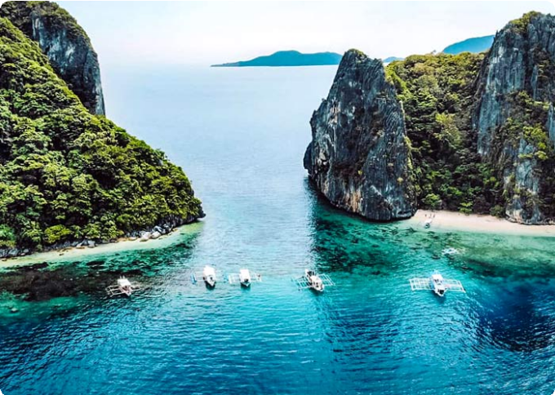
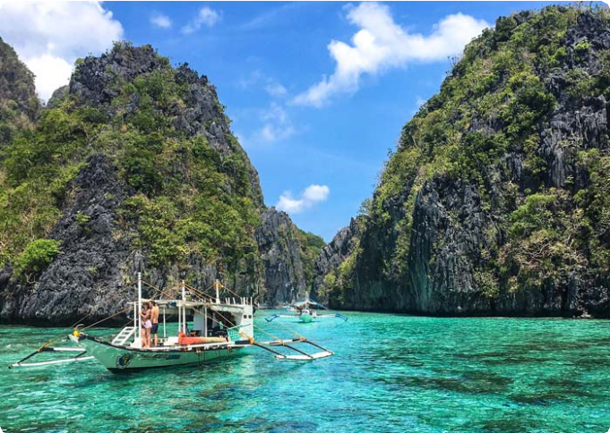
 Day 7 El Nido Island Hopping Tour A | Big Lagoon, Secret Lagoon, 7 Commando Beach, Shimizu Island, Payong-Payong Beach
Shimizu Island, El Nido
Big Lagoon, El Nido

Get ready for an exciting day of island hopping as you explore the stunning Bacuit Archipelago on Island Hopping Tour A. This tour takes you to iconic lagoons and beaches - perfect for kayaking and snorkeling enthusiasts.
After breakfast, your guide will meet you for an exhilarating boat ride to the Big
Lagoon, one of El Nido’s most famous gems. Surrounded by towering limestone cliffs, this serene lagoon invites you to kayak through its crystal-clear waters, with the cliffs rising dramatically around you. As your boat glides across the water, the vibrant
turquoise sea contrasts with the rugged rock formations, creating a striking visual
spectacle.

Next, you’ll head to the Secret Lagoon, a hidden paradise tucked behind towering
limestone formations. A short swim through a narrow entrance reveals a beautiful, secluded cove with turquoise waters and a pristine beach - an enchanting place to explore and unwind.
The adventure continues with a visit to 7 Commando Beach, a tropical haven known for its soft white sand and crystal-clear waters. Take a refreshing dip or relax under the shade of palm trees while enjoying the breathtaking surroundings.
From there, you’ll set sail to Shimizu Island, named after the Japanese diver who discovered its incredible marine life. This island offers exceptional snorkeling
opportunities, where you can explore vibrant coral reefs teeming with fish, making it a perfect spot for underwater exploration.
Our final stop of the day is Payong-Payong Beach, a serene and peaceful beach that offers an idyllic setting for relaxation. Spend time swimming, sunbathing, or simply

enjoying the natural beauty of the island before you return to El Nido.


Dining：Breakfast, Lunch
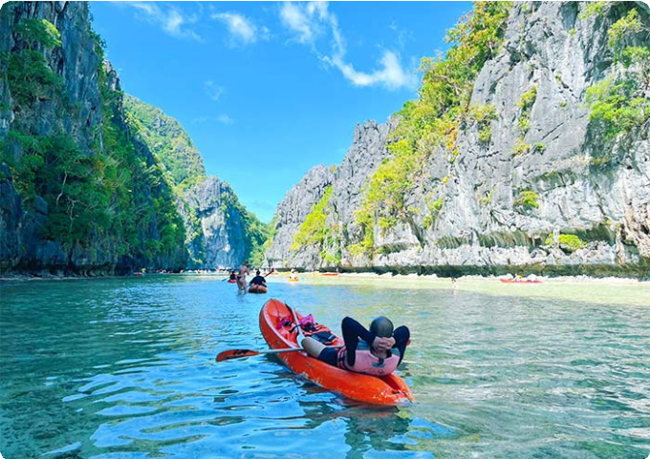
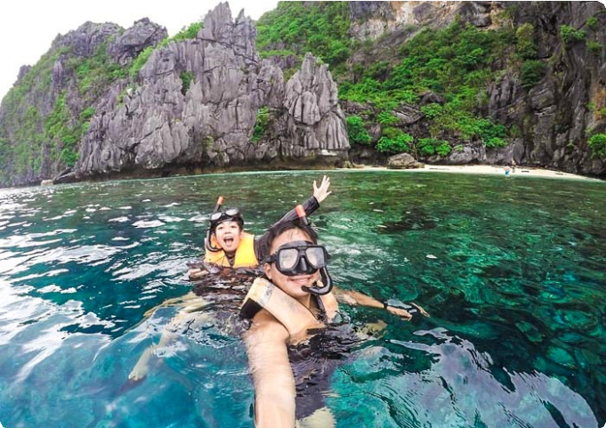
Accommodation：El Nido
Big Lagoon, El Nido
Shimizu Island, El Nido

 Day 8 El Nido Island Hopping Tour C | Helicopter Island, Tapiutan Island, Hidden Beach, Secret Beach

Today, you’re diving deeper into the enchanting Bacuit Archipelago with Island Hopping Tour C. Get ready to explore some of El Nido’s most secluded beaches and stunning underwater landscapes where natural wonders await at every turn.
After breakfast, your guide will greet you for an exciting boat ride to Helicopter Island (Dilumacad Island), named for its rock formations that resemble a helicopter from a distance. Here you you can snorkel in the crystal-clear waters, explore vibrant coral reefs, and if you’re lucky, you might spot a sea turtle gliding by. Whether you're soaking up the sun or floating in the warm water, it’s impossible not to be amazed by the scenery.
Next, you’ll visit Tapiutan Island, a stunning island marked by dramatic cliffs and calm waters. The natural beauty here is mesmerizing, with rich marine life waiting to be
explored just below the surface. Whether you want to snorkel or simply bask on the
golden sands, Tapiutan offers a perfect slice of paradise.

Continue your journey to Secret Beach, hidden behind a wall of towering cliffs. To get there, you’ll swim through a narrow opening in the rock - sounds adventurous, right? Once inside, you’ll discover a secluded cove where soft white sand meets calm, clear

waters. It’s said that this beach inspired parts of the novel The Beach - and standing there, you’ll understand why.

Your last stop is Hidden Beach, another gem concealed behind limestone formations. From the open sea, you wouldn’t even know it’s there until you swim around the rocks and suddenly, you’re in a peaceful lagoon-like haven. The water is a stunning shade of turquoise, the sand is soft beneath your feet, and you’ll find yourself wanting to stay
forever.

After a full day of exploring hidden treasures, you'll head back to your hotel.

Dining：Breakfast, Lunch
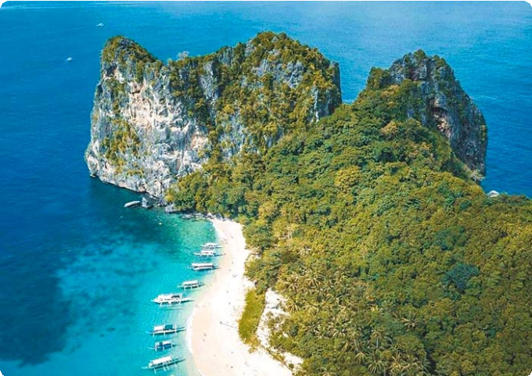
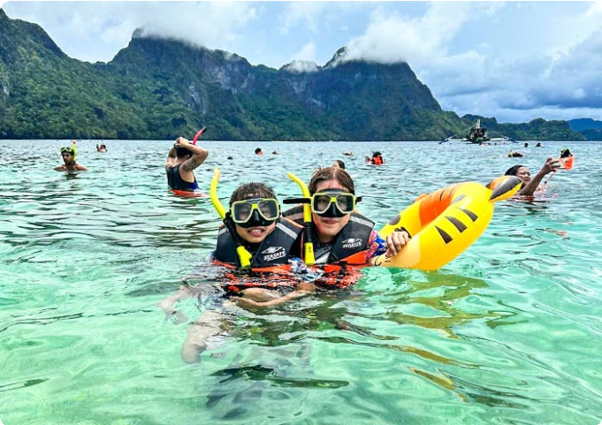
Accommodation：El Nido
Helicopter Island, El Nido
Helicopter Island, El Nido

 Day 9 El Nido to Coron by Ferry | Mt. Tapyas or Maquinit Hot Spring

After breakfast, you will say goodbye to El Nido and take a ferry to Coron. The typical travel time for the ferry from El Nido to Coron is around 4-5 hours (127km), but it can take more depending on the weather and sea conditions. Upon arrival in Coron, you’ll check into your hotel and have some time to settle in.
Coron, nestled on Busuanga Island at Palawan's northernmost reaches, is a true paradise for adventure seekers. It’s renowned for its world-class diving spots,
including the famous Coron Wrecks, a collection of sunken WWII Japanese warships
now home to vibrant marine life.

In the afternoon, we will arrange your tour based on your ferry departure time. Note: Ship time subject to seasonal change.

If your ferry is at 08:00 AM → Mt. Tapyas Tour


Mt. Tapyas: You will enjoy a short trek to the summit of Mt. Tapyas, the second tallest mountain and the most iconic landmark in Coron on Busuanga Island. The hike up involves 724 steps, but the panoramic views of the town, surrounding islands, and
crystal-clear waters make every step worthwhile. At the top, you’ll be treated to
breathtaking vistas that are perfect for photography, so don’t forget your camera!

If your ferry is at 12:30 PM → Maquinit Hot Spring Tour

Maquinit Hot Spring: Take a 30-minute tricycle ride to this rare saltwater hot spring along Busuanga’s southern coast. The 40°C waters, said to be heated by volcanic activity, are perfect for soothing your muscles (optional plunge).

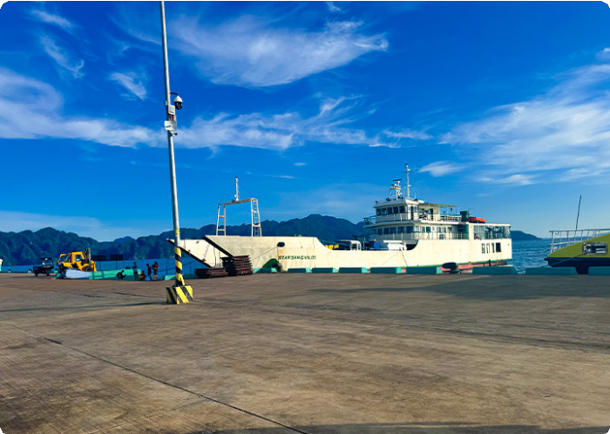
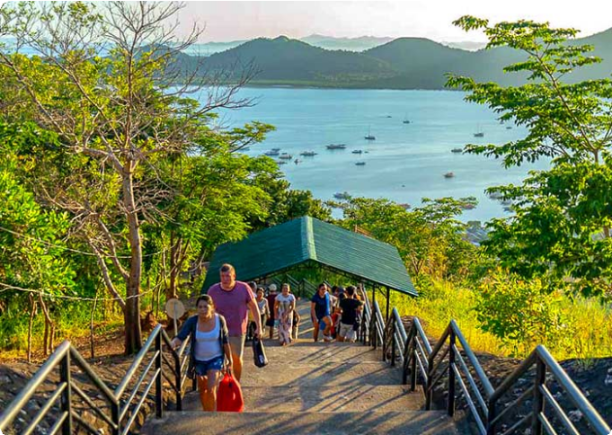
Dining：Breakfast Accommodation：Coron
Coron Port
Mt. Tapyas, Coron

 Day 10 Coron Island Hopping Tour A | Kayangan Lake, Green Lagoon, Quin Reef, Atwayan Beach, CYC Beach, Las Isla De Coral

Get ready for an exhilarating day of island hopping in Coron, where you’ll discover crystal-clear lagoons, breathtaking beaches, and hidden gems.
After breakfast, your guide will pick you and head straight to iconic Kayangan
Lake, often referred to as the “cleanest lake in Asia.” Nestled in the heart of Coron, this crystal-clear freshwater lake is encircled by towering limestone cliffs, offering a
picturesque setting for your photos. As you approach, the natural beauty will take your breath away. Beneath the surface, you’ll find vibrant aquatic life swimming around
intricate rock formations and caves, making it a snorkeler's and diver’s paradise.

Next, head to the Green Lagoon, an equally breathtaking spot with emerald waters that shimmer under the sun. The calm, clear water, surrounded by lush cliffs, is

perfect for swimming and enjoying the serene beauty of the lagoon.

Continue your adventure at Quin Reef (also known as Malwawey Coral Garden), where the underwater world comes alive. As you snorkel through the vibrant coral gardens, you’ll be surrounded by schools of colorful fish, all dancing beneath the crystal-clear water.
From the reef, you’ll sail to Atwayan Beach, a hidden gem with pristine white sand,
crystal-clear waters, and small bamboo huts offering a touch of rustic charm. Take a
leisurely swim in the calm waters, or just relax under the swaying palm trees while you take in the beauty of this idyllic, peaceful beach.
Next, you’ll head to CYC Beach, named after the Coron Youth Club. This tranquil beach is a great spot for swimming, sunbathing, or simply relaxing under the shade of
mangrove trees. With its white sand and clear waters, the beach offers a picture-perfect escape.
Finally, you’ll wrap up the tour at Las Islas de Coral, a famous snorkeling spot. Dive
into its warm waters and swim alongside a rainbow of colorful coral and tropical fish, experiencing the natural world in its full glory. The coral gardens here are vibrant and alive, offering a breathtaking end to your island-hopping adventure.
After the tour, you will be escorted to your hotel in Coron Town.

Dining：Breakfast, Lunch
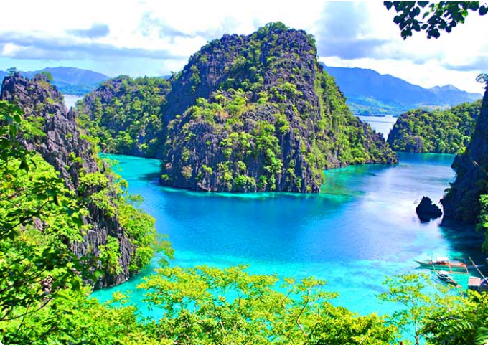
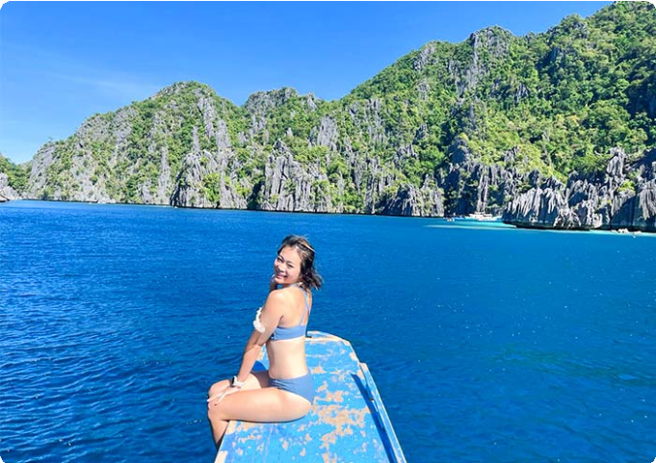
Accommodation：Coron
Kayangan Lake, Coron
Kayangan Lake, Coron

Day 11 Coron Reef and Wrecks Tour | Pass Island, Lusong Coral Garden, Lusong Gunboat, Eact Tangat Wreck

Today, get ready to dive into Coron's rich history and vibrant marine life with the Reef and Wrecks Tour. This thrilling adventure combines stunning natural wonders with the eerie beauty of two sunken WWII shipwrecks, offering a truly unforgettable day on the water.
After breakfast, you’ll set off on a 2-hour boat ride to Pass Island, a small slice of paradise off the coast of Busuanga, Palawan. Picture soft white sand stretching
endlessly, coconut trees swaying in the breeze, and a sense of calm that makes it feel like your own private oasis. Take a moment to relax, swim, or snorkel in the clear waters before you continue your journey.
Next, you’ll head to Lusong Coral Garden, the largest and most vibrant coral garden in Coron. Here, the water shimmers in every shade of blue and green, while beneath the surface, a breathtaking tapestry of colorful corals and marine life unfolds. The diversity of coral species here is staggering, offering a perfect underwater paradise
for snorkelers.

From there, you’ll visit the Lusong Gunboat, a sunken WWII vessel that’s become a
must-see for divers and snorkelers alike. Resting at a shallow depth of 10 meters, this gunboat wreck lies on its side, its rugged structure home to thriving marine life. As you explore, you’ll marvel at the contrast of history and nature - where the wreck’s worn edges meet the vibrancy of the ocean’s new inhabitants.
The adventure continues with the East Tangat Wreck is one of the most impressive. A 40-meter-long vessel that sunk on September 24, 1944, it’s believed to have been
either a tugboat or anti-submarine craft. Resting on a sandy slope, its stern is visible
at 22 meters (72 feet) during low tide, offering a glimpse into both the past and the ocean’s vibrant present. You’ll have the chance to snorkel around the ship, marveling at the eerie beauty of this submerged piece of history.
After the tour, you will be escorted to your hotel in Coron Town.

Dining：Breakfast, Lunch
Accommodation：Coron



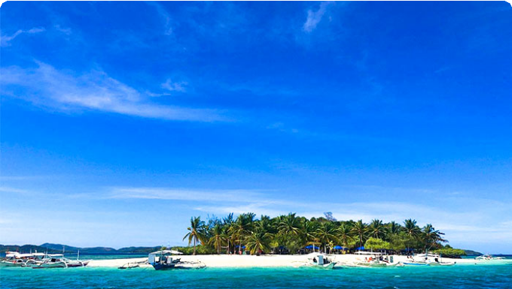
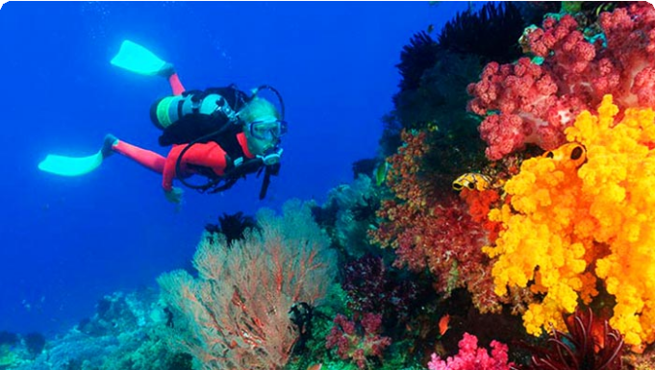
 Day 12 Coron Departure | Hotel Check-out and See-off

It’s time to say goodbye to Palawan and end to 12-days Philippines Palawan Group Tour. Your driver will transfer you to the airport and you will continue on your next destination.
Thank you for choosing us for your Philippines tour, and you are always here working for you and hope to see you again for your next trip to Philippines. Safe journey!

Dining：Breakfast Accommodation：None

Month | Available Date
Apr | Apr.02, 2025
Apr | Apr.10, 2025
Apr | Apr.22, 2025
May | May.07, 2025
Jun | Jun.11, 2025
Jul | Jul.09, 2025
Aug | Aug.13, 2025
Aug | Aug.20, 2025
Sep | Sep.10, 2025

Oct | Oct.08, 2025
Oct | Oct.22, 2025
Nov | Nov.06, 2025
Nov | Nov.18, 2025
Nov | Nov.26, 2025
Dec | Dec.04, 2025
Dec | Dec.16, 2025
Dec | Dec.24, 2025

Price: What’s Included & What’s Excluded

What's included?

English-speaking guide;
Ferries as listed in the itinerary;
Admission tickets for all attractions listed in the itinerary; Accommodation as listed in the itinerary;
All ground transportation during sightseeing; Airport Transfers: complimentary at fixed times;
Meals listed in “breakfast” or “lunch” in the above day to day itinerary; 24/7 customer support

What's excluded?
Travel Insurance Entry visa fees
International Flights Personal expenses
Single room supplement
Recommended optional activities: It may offer optional activities that are not included in the tour price, such as scuba diving, hot spring, etc.

Tips or gratuities for guides and drivers

Important Trip Notes for Booking This Tour

A Philippine Group Tour: Land Tours and Island Hopping
Our group tours in the Philippines consist of two types: land tours and island-hopping adventures.
Land Tours: We intentionally keep our land tours small, with a maximum of 8
travelers per group. If your group exceeds this number, don't worry! For groups of 9 or more, we’ll seamlessly divide you into two smaller groups, each with dedicated guides and vehicles. This ensures personalized attention and a
comfortable travel experience for everyone.
Island Hopping: For island-hopping adventures, the seating capacity of boats and transfer vehicles depends on the actual number of travelers on the day of the tour, ensuring flexibility and convenience for all participants.

Scheduled Airport Transfers
Our complimentary airport transfer service is available at fixed times. Please
ensure your arrival aligns with these scheduled transfers. If your flight does not
coincide with the scheduled times, alternative transfer arrangements can be made at an additional cost.

Transportation
For land transportation, we will use comfortable vehicles with a seating capacity of 9 to 12 passengers during the tour. For sea transportation, we will arrange ferry services according to the schedules provided by the shipping companies.

Special Conditions for Attractions
Depending on the policies and conditions of each attraction, different
arrangements will be in place. For example, at the Underground River National Park, the park administration will organize boat tours. According to these
arrangements, you will share a boat with other guests to enter the cave.

Changes to Itinerary
While we strive to adhere to the planned itinerary, we may need to make adjustments due to weather conditions, safety concerns, or other unforeseen circumstances. We reserve the right to make adjustments as needed.

By booking a tour with us, you agree to these terms and conditions. We look
forward to providing you with an unforgettable travel experience in the Philippines.

What to Bring for the Philippines Tour

Passport (Valid for 6 months from date of departure)
Visa if required

Cash and Credit/Debit Cards Lightweight and Breathable Clothing Hat, Sunglasses, and Sunscreen Swimwear, Wetsuit, Water Shoes

Camera, phone, charger, and power bank
Insect Repellent to protect against mosquitoes

Personal Hygiene Products Personal Snorkeling Gear

Cancellation Policy

Thank you for choosing our services. We understand that sometimes plans change and adjustments are necessary. Below is our cancellation policy applicable to all our bookings:

Tours/Activities:
More than 9 days before the service date: No penalties.
Less than 9 days before the service date: Tours are non-refundable, except in cases of force majeure.

Hotels:
Cancel more than 61 days in advance: Free cancellation.
Cancel 31-60 days in advance: 50% of the room rate will be charged. Cancel 0-30 days in advance: 100% of the room rate will be charged.

Transfers:
More than 72 hours before the service date: No penalty.

Less than 72 hours before the service date: Non-refundable, except in cases of force majeure.
We kindly ask for your understanding that these policies are in place to ensure that we can manage our bookings and resources effectively while continuing to offer quality
services to all our guests.

