4 Days Puerto Princesa Group Tour: Underground River, Honda Bay Island Hopping
Route: Puerto Princesa

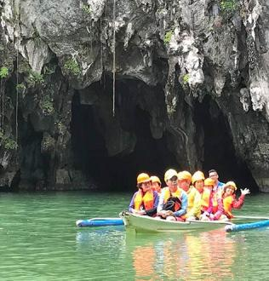
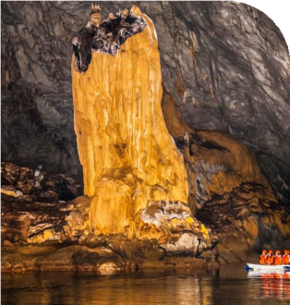
Tour Code: AOT-PHG-002 Group Tour Lowest Price Guarantee Recommended Rating: 5 Star

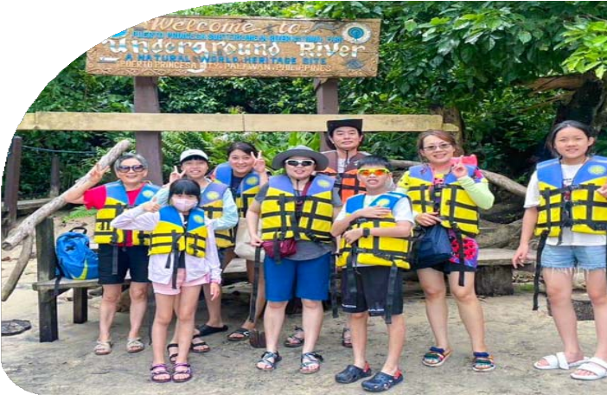
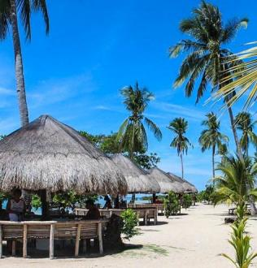

Explore Puerto Princesa’s Top Attractions in Small Group Adventure
Get ready for the adventure of a lifetime! This 4-day Puerto Princesa Group Tour packs in the very best of Puerto Princesa, from the breathtaking Underground River to the
idyllic islands of Honda Bay. Journey through this UNESCO World Heritage Site, gliding through a majestic cave system adorned with towering stalactites and stalagmites,
offering a truly magical experience. Set sail to Starfish Island, Cowrie Island, and Luli Island, where crystal-clear waters, vibrant marine life, and pristine beaches await.

With expert guides leading the way, you’ll experience Palawan's wonders in a small, fun group, all at an unbeatable price. Say goodbye to worries - transport, tickets, and details are all taken care of, so you can focus on the adventure ahead. Don’t miss out on this
unforgettable journey to one of the world’s most stunning destinations!

Group Information

Available: All year
Languages: English

Difficulty: Easy
Duration 4 days


Features:
Underground River, Wold Heritage Site, Nature, Islands, Beaches, Island Hopping, Swimming, Snorkeling

You Can Experience “Must-see & Must-do” with This Tour

- Explore the Puerto Princesa Underground River. Embark on a boat journey through one of the New 7 Wonders of Nature, gliding beneath towering
stalactites and stalagmites in this UNESCO World Heritage Site.

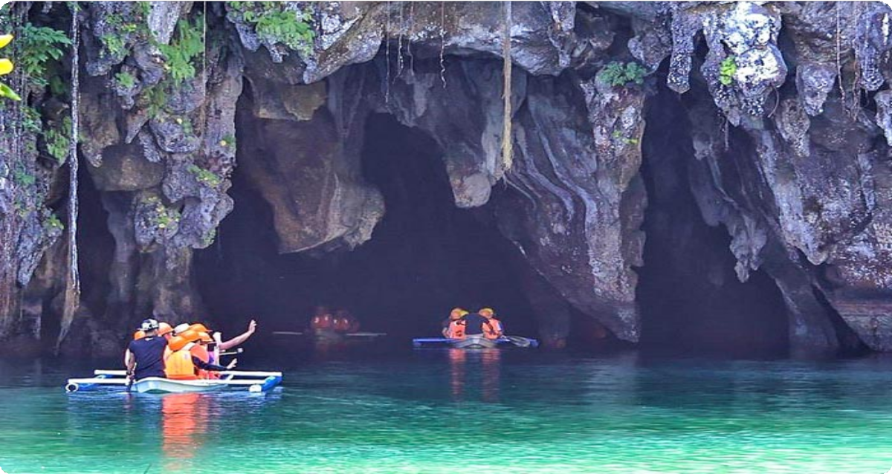
- Island Hop Across Honda Bay. Visit Starfish Island, Cowrie Island, and Luli Island for a day of snorkeling, sunbathing, and indulging in fresh seafood on
the beach.

Day by Day Itinerary
 Day 1 Arrival in Puerto Princesa | Airport Pick-up and Hotel Check-in Welcome to Palawan Islands, Philippines! Upon arrival at Puerto Princesa
International Airport, you will be greeted by your driver, who will assist you with your transfer to your hotel. After checking in, you can take the rest of the day to relax,
explore the local area, or enjoy a leisurely dinner at a nearby restaurant.

Puerto Princesa, the capital city of Palawan in the Philippines, is home to the Puerto Princesa Subterranean River National Park - a UNESCO World Heritage Site and one of the New 7 Wonders of Nature. Beyond the Underground River, Puerto Princesa offers diverse attractions, including Honda Bay with its pristine islands and vibrant
snorkeling spots.

Arrival Ideas:


By Air: The fastest way to reach Puerto Princesa is via direct flights from major cities including Manila (MNL), Cebu (CEB), Clark (CRK), and Caticlan (MPH, Boracay). Cebu Pacific, AirAsia, and Philippine Airlines operate daily flights to the destination.
Main Airport: Puerto Princesa International Airport (PPS) is the main gateway to Palawan. It is about 1.5 kilometers (about 10 minutes by car) from the city center.
If you need help with Philippines flight ticket booking, feel free to contact us.

Dining：None
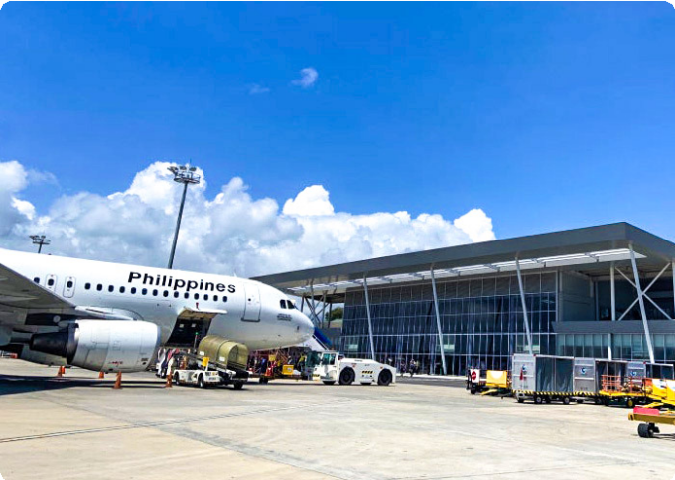
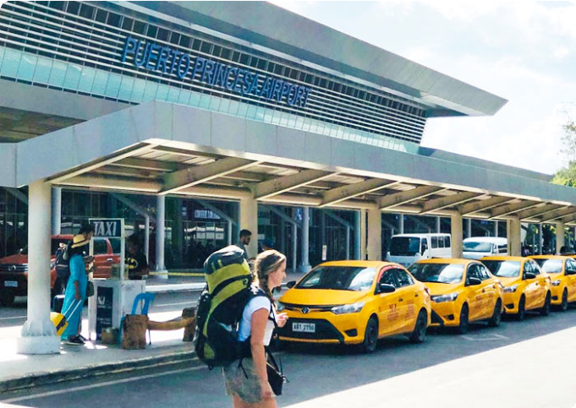
Accommodation：Puerto Princesa
Puerto Princesa International Airport
(PPS)
Puerto Princesa International Airport
(PPS)

 Day 2 Puerto Princesa | Honda Bay Island Hopping to Starfish Island, Cowrie Island, Luli Island

Get ready for a day filled with sun, sand, and sea as you embark on a full-day Honda Bay Island Hopping Tour. Today, you’ll explore three of the most beautiful islands in Puerto Princesa: Starfish Island, Cowrie Island, and Luli Island.
After breakfast, your guide will pick you up and take you to Santa Lourdes Pier to board your boat and start the adventure.
Your first stop is Starfish Island, where you’ll find loads of starfish dotting the shallow waters. Immerse yourself in the crystal-clear waters, where vibrant marine life swims beneath the surface. You might even spot some colorful clownfish (Nemo!) and other marine life. you’ ll be enchanted by the colorful coral reefs and curious fish- an
underwater playground just waiting to be explored.

Next, head to Cowrie Island, the biggest island of the day. Named after the brightly-shelled mollusks (local sea snail), the island is all about relaxation and fun. You can

grab a drink at the bar, unwind with a massage, or just enjoy the beautiful beach under
the coconut trees. Or explore the island on foot, feel the soft sand beneath your feet, or simply take in the panoramic views of the bay.
But the real treat? A delicious beachside buffet featuring local delicacies, giving you a true taste of Palawan.
Finally, you’ll visit Luli Island - a magical place that disappears and reappears with the tide! When the water’s low, you’ll see its sandbars stretching out; when it’s high, only the houses are visible. Feel free to jump off the diving board, go cliff jumping, or swim in the clear emerald waters. Luli Island is also a great spot for sunbathing, strolling along the sandbars, and feeding the fish.
After a day full of island fun, you’ll head back to your hotel.

Dining：Breakfast, Lunch
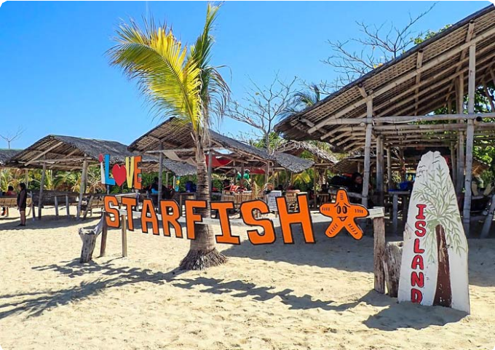
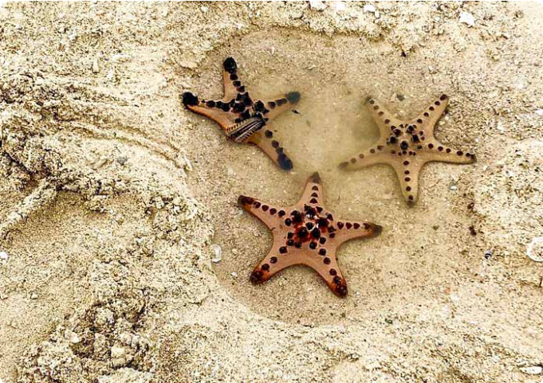
Accommodation：Puerto Princesa
Starfish Island
Starfish Island

 Day 3 Puerto Princesa - Sabang - Puerto Princesa | Underground River National Park

Today, prepare for a fascinating journey into one of the New 7 Wonders of Nature - the
Puerto Princesa Underground River. A UNESCO World Heritage Site, this
extraordinary river flows through a vast cave system, offering an unforgettable adventure beneath the Earth’s surface.

After breakfast, you will depart from Puerto Princesa City and head to Sabang which is about 75km (2 hours drive). Upon arrival at the Sabang Boat Terminal, you’ll board a boat that will take you to the entrance of Underground River National

Park (Subterranean River National Park).

After a short walk through the park, you’ll transfer to a park-operated paddleboat and glide into the Underground River. As you move deeper into the cave, towering stalactites and stalagmites rise from the dark waters, formed over thousands of
years. Let your imagination run wild as you identify the shapes and patterns in the
rock formations. The eerie silence and the cave’s darkness - broken only by the soft sound of your boat moving through the water- will make you feel as if you've stepped into another world.
Listen to your guide share fascinating insights about the unique ecosystem and the
geological history of this natural wonder. Some sections of the river are illuminated by the boat's lights, revealing stunning formations that will leave you in awe. It's not just a tour - it's a vivid environmental education lesson.
Aside from its geological wonders, the park is home to diverse wildlife. While exploring the river, keep an eye out for monkeys, lizards, bats, and even the
endangered Philippine eagle, which can sometimes be spotted near the cave’s
entrance.

After your underground adventure, enjoy a delicious lunch in Sabang before heading back to Puerto Princesa.

Dining：Breakfast, Lunch
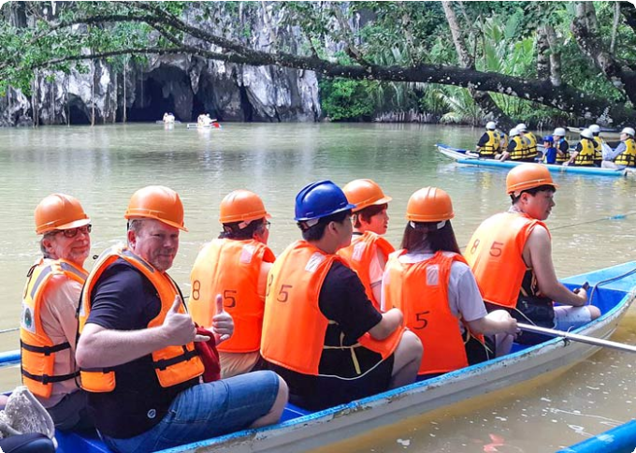
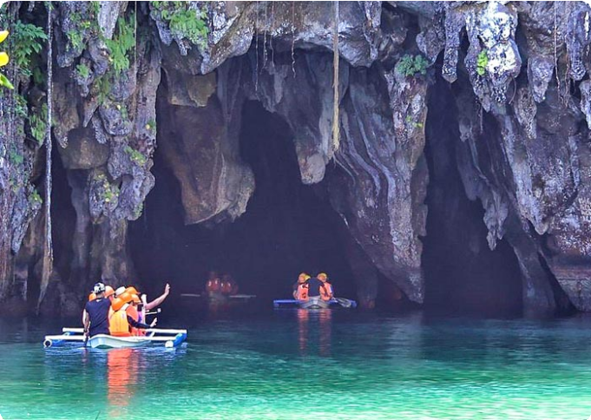
Accommodation：Puerto Princesa
Puerto Princesa Subterranean River
National Park
Puerto Princesa Subterranean River
National Park

 Day 4 Puerto Princesa Departure | Hotel Check-out and See-off

It’s time to end 4-days Puerto Princesa Group Tour. Your driver will transfer you to the airport and you will continue on your next destination.
Thank you for choosing Asia Odyssey Travel (AOT) for your Philippines tour, and you are always here working for you and hope to see you again for your next trip to Philippines. Safe journey!

Dining：Breakfast Accommodation：/

Month | Available Date
Apr | Apr.02, 2025
Apr | Apr.10, 2025
Apr | Apr.22, 2025
May | May.07, 2025
Jun | Jun.11, 2025
Jul | Jul.09, 2025
Aug | Aug.13, 2025
Aug | Aug.20, 2025
Sep | Sep.10, 2025
Oct | Oct.08, 2025
Oct | Oct.22, 2025
Nov | Nov.06, 2025
Nov | Nov.18, 2025
Nov | Nov.26, 2025

Dec | Dec.04, 2025
Dec | Dec.16, 2025
Dec | Dec.24, 2025

Price: What’s Included & What’s Excluded

What's included?
English-speaking guide;
Ferries as listed in the itinerary;
Admission tickets for all attractions listed in the itinerary; Accommodation as listed in the itinerary;
All ground transportation during sightseeing; Airport Transfers: complimentary at fixed times;
Meals listed in “breakfast” or “lunch” in the above day to day itinerary; 24/7 customer support

What's excluded?

Travel Insurance Entry visa fees
International Flights Personal expenses
Single room supplement
Recommended optional activities: It may offer optional activities that are not included in the tour price, such as scuba diving, hot spring, etc.
Tips or gratuities for guides and drivers

Important Trip Notes for Booking This Tour

A Philippine Group Tour: Land Tours and Island Hopping

Our group tours in the Philippines consist of two types: land tours and island-hopping adventures.
Land Tours: We intentionally keep our land tours small, with a maximum of 8
travelers per group. If your group exceeds this number, don't worry! For groups of 9 or more, we’ll seamlessly divide you into two smaller groups, each with
dedicated guides and vehicles. This ensures personalized attention and a comfortable travel experience for everyone.
Island Hopping: For island-hopping adventures, the seating capacity of boats and transfer vehicles depends on the actual number of travelers on the day of the tour, ensuring flexibility and convenience for all participants.

Scheduled Airport Transfers
Our complimentary airport transfer service is available at fixed times. Please
ensure your arrival aligns with these scheduled transfers. If your flight does not coincide with the scheduled times, alternative transfer arrangements can be made at an additional cost.

Transportation
For land transportation, we will use comfortable vehicles with a seating capacity of 9 to 12 passengers during the tour. For sea transportation, we will arrange ferry services according to the schedules provided by the shipping companies.

Special Conditions for Attractions
Depending on the policies and conditions of each attraction, different
arrangements will be in place. For example, at the Underground River National Park, the park administration will organize boat tours. According to these
arrangements, you will share a boat with other guests to enter the cave.

Changes to Itinerary
While we strive to adhere to the planned itinerary, we may need to make adjustments due to weather conditions, safety concerns, or other unforeseen circumstances. We reserve the right to make adjustments as needed.
By booking a tour with us, you agree to these terms and conditions. We look
forward to providing you with an unforgettable travel experience in the Philippines.

What to Bring for the Philippines Tour

Passport (Valid for 6 months from date of departure)
Visa if required

Cash and Credit/Debit Cards Lightweight and Breathable Clothing Hat, Sunglasses, and Sunscreen Swimwear, Wetsuit, Water Shoes

Camera, phone, charger, and power bank
Insect Repellent to protect against mosquitoes

Personal Hygiene Products Personal Snorkeling Gear

Cancellation Policy

Thank you for choosing our services. We understand that sometimes plans change and adjustments are necessary. Below is our cancellation policy applicable to all our
bookings:

Tours/Activities:
More than 9 days before the service date: No penalties.
Less than 9 days before the service date: Tours are non-refundable, except in cases of force majeure.

Hotels:
Cancel more than 61 days in advance: Free cancellation.
Cancel 31-60 days in advance: 50% of the room rate will be charged. Cancel 0-30 days in advance: 100% of the room rate will be charged.

Transfers:
More than 72 hours before the service date: No penalty.
Less than 72 hours before the service date: Non-refundable, except in cases of force majeure.
We kindly ask for your understanding that these policies are in place to ensure that we can manage our bookings and resources effectively while continuing to offer quality
services to all our guests.

