7 Days El Nido Coron Group Tour: Best of Palawan
Route: El Nido - Coron

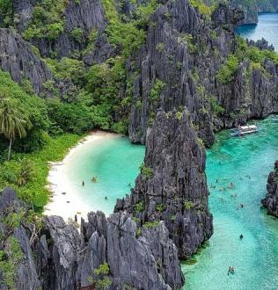
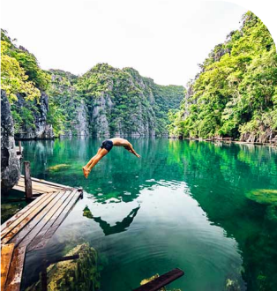
Tour Code: AOT-PHG-004 Group Tour Lowest Price Guarantee Recommended Rating: 5 Star

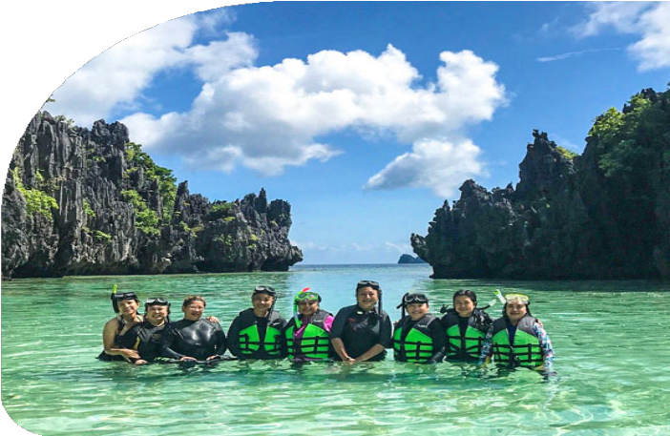
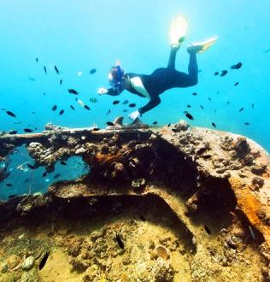
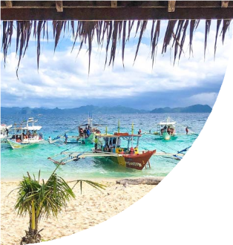
Experience Best of Palawan: El Nido and Coron in 7 Days
Palawan, the "Last Frontier" of the Philippines, is a paradise for nature lovers and
adventure seekers. Our 7 Days El Nido Coron Group Tour brings you to two of its most sought-after destinations: El Nido and Coron.

In El Nido, experience the spectacular limestone cliffs, secret lagoons, and secluded beaches - a true haven for island-hopping enthusiasts. You’ll explore Big Lagoon, Secret

Lagoon, and Hidden Beach, each offering unique experiences of seclusion, crystal-clear waters, and rich marine life
Coron, on the other hand, is a diver's paradise, known for its World War II wreck sites and vibrant coral reefs. Dive into history as you snorkel through the Lusong
Gunboat and the East Tangat Wreck. And a visit to Kayangan Lake, Asia’s cleanest lake, and the opportunity to hike Mt. Tapyas for panoramic views of this beautiful island
cluster.

This tour perfectly combines El Nido's dramatic island landscapes with Coron's historic dive sites - the best experience of Palawan. Join us for an unforgettable small-group
experience at an unbeatable price!

Group Information

Available: All year
Languages: English

Difficulty: Moderate
Duration 7 days


Features:
Nature, Islands, Beaches, Caves, Lagoons, Lakes, Shipwrecks Diving, Island Hopping, Swimming, Snorkeling, Marine Life, Seafood

You Can Experience “Must-see & Must-do” with This Tour

- Discover the stunning lagoons of El Nido. Cruise through dramatic limestone cliffs and the crystal-clear Big Lagoon, and find Secret Lagoon's secluded cove
- accessible only through a narrow rock opening.

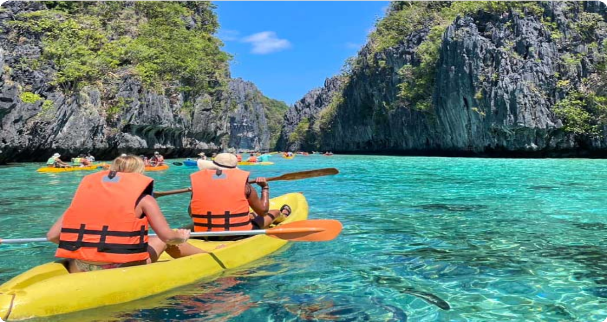
- Venture into El Nido's hidden treasures - Hidden Beach and Secret Beach, where pristine coves nestle behind majestic limestone cliffs, beckoning
adventurous swimmers to explore their secluded waters.
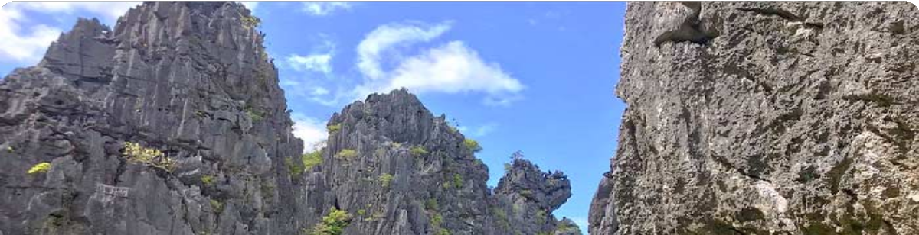

Show More

Day by Day Itinerary


Day 1 Arrival in El Nido | Airport Pick-up and Hotel Check-in

Welcome to El Nido, Palawan! Upon arrival at El Nido Lio Airport, you will be greeted by your driver, who will assist you with your transfer to your hotel. After checking in, you can take the rest of the day to relax, explore the local area, or enjoy a leisurely

dinner at a nearby restaurant.

El Nido, located at the northern tip of Palawan, is world-renowned for its stunning limestone cliffs, crystal-clear lagoons, turquoise waters, and pristine beaches. The
name El Nido translates to "the nest" in Spanish, as the bay and its surrounding cliffs were home to numerous bird nests. Serving as the gateway to the Bacuit Archipelago, El Nido is home to a collection of over 40 islands and islets, each offering hidden beaches, dramatic caves, and unforgettable natural wonders, all waiting for you to discover.

Arrival Ideas:

From Manila: You can fly directly to El Nido's Lio Airport with airlines like AirSWIFT. The flight is about 1.5 hours.
From Puerto Princes: You can take a van or bus to El Nido. The journey typically takes 5 to 7 hours, depending on traffic and road conditions.
Main Airport: El Nido Airport (IATA: ENI), also known as Lio Airport, is a private airport located approximately 4 kilometers northeast of El Nido town in Palawan, Philippines.
If you need help with flight ticket and private transfer bookings, feel free to contact us.

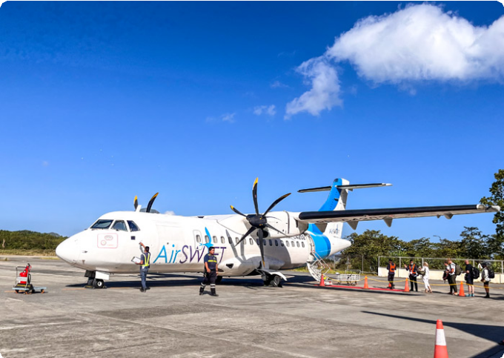
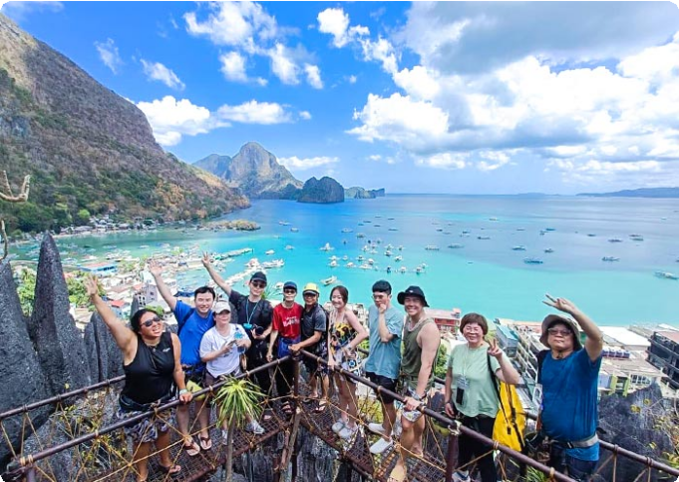
Dining：None Accommodation：El Nido
El Nido's Lio Airport
Our Guests in El Nido, Palawan



Day 2 El Nido Island Hopping Tour A | Big Lagoon, Secret Lagoon, 7 Commando Beach, Shimizu Island, Payong-Payong Beach


Get ready for an exciting day of island hopping as you explore the stunning Bacuit Archipelago on Island Hopping Tour A. This tour takes you to iconic lagoons and beaches - perfect for kayaking and snorkeling enthusiasts.
After breakfast, your guide will meet you for an exhilarating boat ride to the Big
Lagoon, one of El Nido’s most famous gems. Surrounded by towering limestone cliffs, this serene lagoon invites you to kayak through its crystal-clear waters, with the cliffs rising dramatically around you. As your boat glides across the water, the vibrant
turquoise sea contrasts with the rugged rock formations, creating a striking visual
spectacle. Tip: You can rent a kayak for 450 PHP (for 2 pax) to fully experience the lagoon from a closer perspective.
Next, you’ll head to the Secret Lagoon, a hidden paradise tucked behind towering
limestone formations. A short swim through a narrow entrance reveals a beautiful, secluded cove with turquoise waters and a pristine beach - an enchanting place to explore and unwind.
The adventure continues with a visit to 7 Commando Beach, a tropical haven known for its soft white sand and crystal-clear waters. Take a refreshing dip or relax under the shade of palm trees while enjoying the breathtaking surroundings.
From there, you’ll set sail to Shimizu Island, named after the Japanese diver who discovered its incredible marine life. This island offers exceptional snorkeling
opportunities, where you can explore vibrant coral reefs teeming with fish, making it a
perfect spot for underwater exploration.

Our final stop of the day is Payong-Payong Beach, a serene and peaceful beach that offers an idyllic setting for relaxation. Spend time swimming, sunbathing, or simply enjoying the natural beauty of the island before you return to El Nido.

Dining：Breakfast, Lunch
Accommodation：El Nido

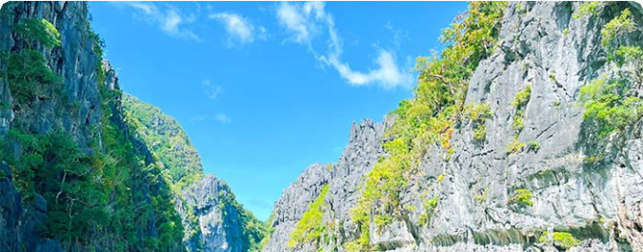

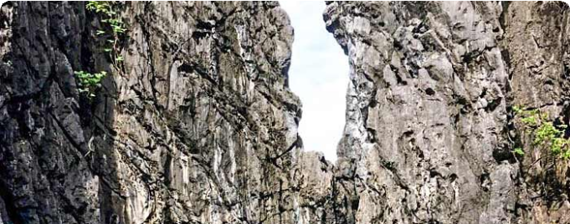
 Day 3 El Nido Island Hopping Tour C | Helicopter Island, Tapiutan Island, Hidden Beach, Secret Beach

Today, you’re diving deeper into the enchanting Bacuit Archipelago with Island Hopping Tour C. Get ready to explore some of El Nido’s most secluded beaches and stunning underwater landscapes where natural wonders await at every turn.
After breakfast, your guide will greet you for an exciting boat ride to Helicopter Island (Dilumacad Island), named for its rock formations that resemble a helicopter from a distance. Here you you can snorkel in the crystal-clear waters, explore vibrant coral reefs, and if you’re lucky, you might spot a sea turtle gliding by. Whether you're soaking up the sun or floating in the warm water, it’s impossible not to be amazed by the scenery.
Next, you’ll visit Tapiutan Island, a stunning island marked by dramatic cliffs and calm waters. The natural beauty here is mesmerizing, with rich marine life waiting to be
explored just below the surface. Whether you want to snorkel or simply bask on the golden sands, Tapiutan offers a perfect slice of paradise.
Continue your journey to Secret Beach, hidden behind a wall of towering cliffs. To get there, you’ll swim through a narrow opening in the rock - sounds adventurous, right? Once inside, you’ll discover a secluded cove where soft white sand meets calm, clear waters. It’s said that this beach inspired parts of the novel The Beach - and standing
there, you’ll understand why.

Your last stop is Hidden Beach, another gem concealed behind limestone formations. From the open sea, you wouldn’t even know it’s there until you swim around the rocks and suddenly, you’re in a peaceful lagoon-like haven. The water is a stunning shade of turquoise, the sand is soft beneath your feet, and you’ll find yourself wanting to stay
forever.

After a full day of exploring hidden treasures, you'll head back to your hotel.

Dining：Breakfast, Lunch
Accommodation：El Nido



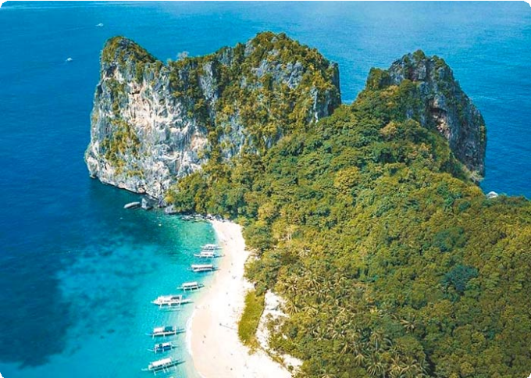
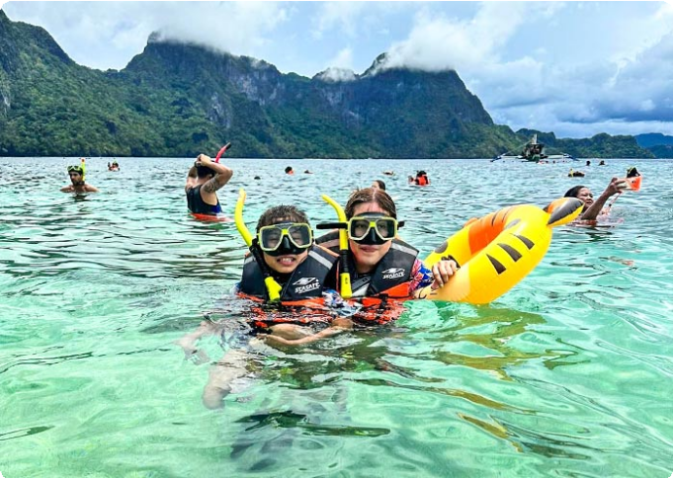
 Day 4 El Nido to Coron by Ferry | Mt. Tapyas or Maquinit Hot Spring
Helicopter Island, El Nido
Helicopter Island, El Nido

After breakfast, you will say goodbye to El Nido and take a ferry to Coron. The typical travel time for the ferry from El Nido to Coron is around 4-5 hours (127km), but it can take more depending on the weather and sea conditions. Upon arrival in Coron, you’ll check into your hotel and have some time to settle in.
Coron, nestled on Busuanga Island at Palawan's northernmost reaches, is a true paradise for adventure seekers. It’s renowned for its world-class diving spots,
including the famous Coron Wrecks, a collection of sunken WWII Japanese warships now home to vibrant marine life.
In the afternoon, we will arrange your tour based on your ferry departure time. Note: Ship time subject to seasonal change.

If your ferry is at 08:00 AM → Mt. Tapyas Tour

Mt. Tapyas: You will enjoy a short trek to the summit of Mt. Tapyas, the second tallest mountain and the most iconic landmark in Coron on Busuanga Island. The hike up involves 724 steps, but the panoramic views of the town, surrounding islands, and
crystal-clear waters make every step worthwhile. At the top, you’ll be treated to
breathtaking vistas that are perfect for photography, so don’t forget your camera!

If your ferry is at 12:30 PM → Maquinit Hot Spring Tour

Maquinit Hot Spring: Take a 30-minute tricycle ride to this rare saltwater hot spring along Busuanga’s southern coast. The 40°C waters, said to be heated by volcanic activity, are perfect for soothing your muscles (optional plunge).

Dining：Breakfast

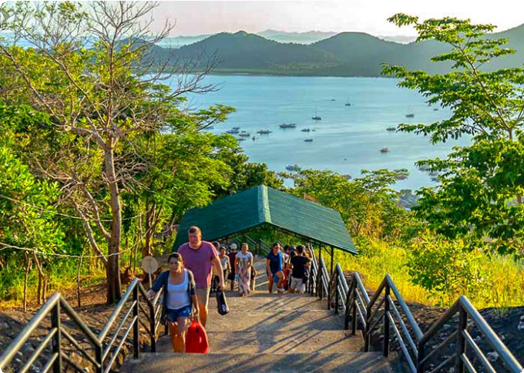
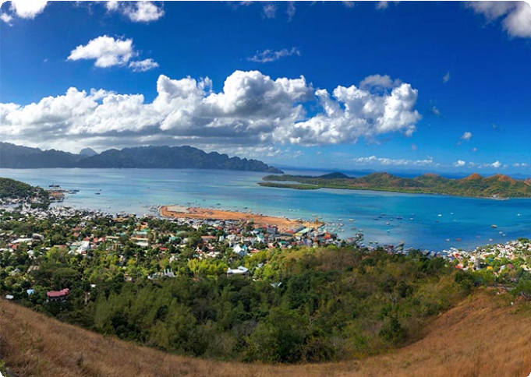
Accommodation：Coron

Mt. Tapyas, Coron
Mt. Tapyas, Coron

 Day 5 Coron Island Hopping Tour A | Kayangan Lake, Green Lagoon, Quin Reef, Atwayan Beach, CYC Beach, Las Isla De Coral

Get ready for an exhilarating day of island hopping in Coron, where you’ll discover crystal-clear lagoons, breathtaking beaches, and hidden gems.
After breakfast, your guide will pick you and head straight to iconic Kayangan
Lake, often referred to as the “cleanest lake in Asia.” Nestled in the heart of Coron, this crystal-clear freshwater lake is encircled by towering limestone cliffs, offering a
picturesque setting for your photos. As you approach, the natural beauty will take your breath away. Beneath the surface, you’ll find vibrant aquatic life swimming around
intricate rock formations and caves, making it a snorkeler's and diver’s paradise.

Next, head to the Green Lagoon, an equally breathtaking spot with emerald waters that shimmer under the sun. The calm, clear water, surrounded by lush cliffs, is
perfect for swimming and enjoying the serene beauty of the lagoon.

Continue your adventure at Quin Reef (also known as Malwawey Coral Garden), where the underwater world comes alive. As you snorkel through the vibrant coral gardens, you’ll be surrounded by schools of colorful fish, all dancing beneath the crystal-clear water.
From the reef, you’ll sail to Atwayan Beach, a hidden gem with pristine white sand,
crystal-clear waters, and small bamboo huts offering a touch of rustic charm. Take a
leisurely swim in the calm waters, or just relax under the swaying palm trees while you take in the beauty of this idyllic, peaceful beach.

Next, you’ll head to CYC Beach, named after the Coron Youth Club. This tranquil beach is a great spot for swimming, sunbathing, or simply relaxing under the shade of

mangrove trees. With its white sand and clear waters, the beach offers a picture-
perfect escape.

Finally, you’ll wrap up the tour at Las Islas de Coral, a famous snorkeling spot. Dive
into its warm waters and swim alongside a rainbow of colorful coral and tropical fish, experiencing the natural world in its full glory. The coral gardens here are vibrant and alive, offering a breathtaking end to your island-hopping adventure.
After the tour, you will be escorted to your hotel in Coron Town.

Dining：Breakfast, Lunch
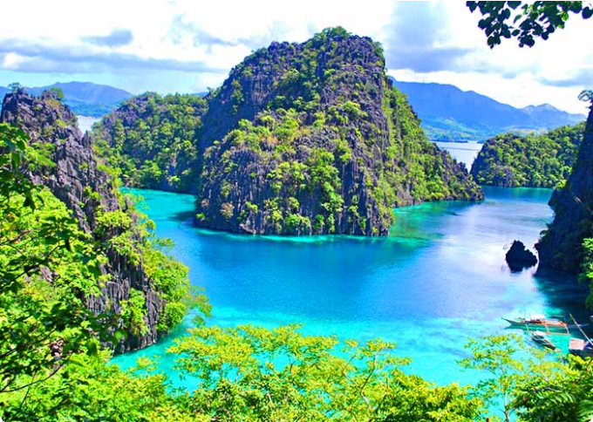
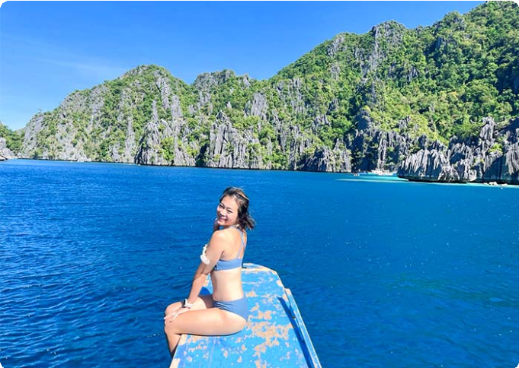
Accommodation：Coron
Kayangan Lake, Coron
Kayangan Lake, Coron

 Day 6 Coron Reef and Wrecks Tour | Pass Island, Lusong Coral Garden, Lusong Gunboat, East Tangat Wreck

Today, get ready to dive into Coron's rich history and vibrant marine life with the Reef and Wrecks Tour. This thrilling adventure combines stunning natural wonders with the eerie beauty of two sunken WWII shipwrecks, offering a truly unforgettable day on the water.
After breakfast, you’ll set off on a 2-hour boat ride to Pass Island, a small slice of paradise off the coast of Busuanga, Palawan. Picture soft white sand stretching
endlessly, coconut trees swaying in the breeze, and a sense of calm that makes it feel like your own private oasis. Take a moment to relax, swim, or snorkel in the clear waters before you continue your journey.

Next, you’ll head to Lusong Coral Garden, the largest and most vibrant coral garden in Coron. Here, the water shimmers in every shade of blue and green, while beneath the surface, a breathtaking tapestry of colorful corals and marine life unfolds. The diversity of coral species here is staggering, offering a perfect underwater paradise

for snorkelers.

From there, you’ll visit the Lusong Gunboat, a sunken WWII vessel that’s become a
must-see for divers and snorkelers alike. Resting at a shallow depth of 10 meters, this gunboat wreck lies on its side, its rugged structure home to thriving marine life. As you explore, you’ll marvel at the contrast of history and nature - where the wreck’s worn edges meet the vibrancy of the ocean’s new inhabitants.
The adventure continues with the East Tangat Wreck is one of the most impressive. A 40-meter-long vessel that sunk on September 24, 1944, it’s believed to have been
either a tugboat or anti-submarine craft. Resting on a sandy slope, its stern is visible
at 22 meters (72 feet) during low tide, offering a glimpse into both the past and the ocean’s vibrant present. You’ll have the chance to snorkel around the ship, marveling at the eerie beauty of this submerged piece of history.
After the tour, you will be escorted to your hotel in Coron Town.

Dining：Breakfast, Lunch
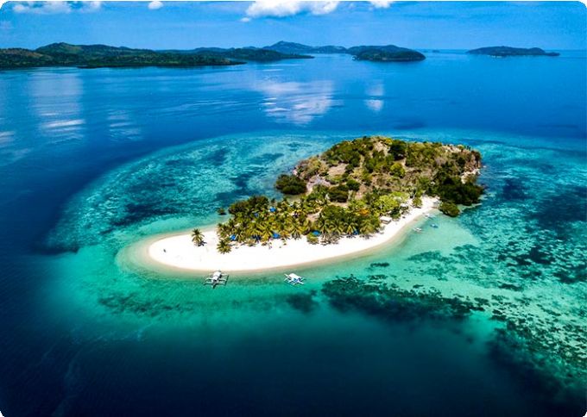
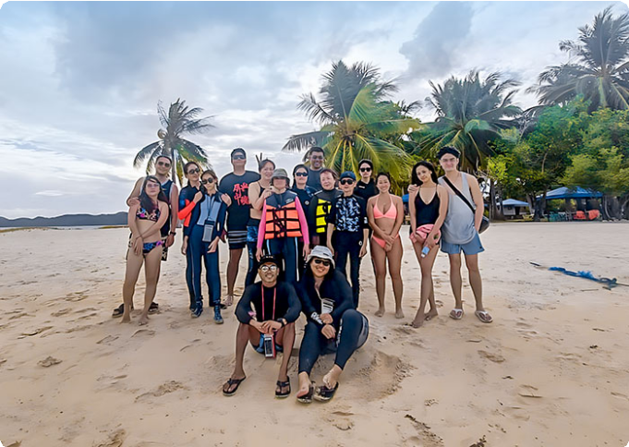
Accommodation：Coron
Pass Island, Coron
Pass Island, Coron

 Day 7 Coron Departure | Hotel Check-out and See-off

It’s time to say goodbye to Palawan and end to 7-days El Nido Coron Group Tour. Your driver will transfer you to the airport and you will continue on your next destination.

Thank you for choosing us for your Philippines tour, and you are always here working for you and hope to see you again for your next trip to Philippines. Safe journey!

Dining：Breakfast Accommodation：

Month | Available Date
Apr | Apr.07, 2025
Apr | Apr.15, 2025
Apr | Apr.27, 2025
May | May.12, 2025
Jun | Jun.16, 2025
Jul | Jul.14, 2025
Aug | Aug.18, 2025
Aug | Aug.25, 2025
Sep | Sep.15, 2025
Oct | Oct.13, 2025
Oct | Oct.27, 2025
Nov | Nov.11, 2025
Nov | Nov.23, 2025
Dec | Dec.01, 2025
Dec | Dec.09, 2025
Dec | Dec.21, 2025

Dec.29, 2025

Price: What’s Included & What’s Excluded

What's included?
English-speaking guide;
Ferries as listed in the itinerary;
Admission tickets for all attractions listed in the itinerary; Accommodation as listed in the itinerary;
All ground transportation during sightseeing; Airport Transfers: complimentary at fixed times;
Meals listed in “breakfast” or “lunch” in the above day to day itinerary; 24/7 customer support

What's excluded?

Travel Insurance Entry visa fees
International Flights Personal expenses
Single room supplement
Recommended optional activities: It may offer optional activities that are not included in the tour price, such as scuba diving, hot spring, etc.
Tips or gratuities for guides and drivers

Important Trip Notes for Booking This Tour

A Philippine Group Tour: Land Tours and Island Hopping
Our group tours in the Philippines consist of two types: land tours and island-hopping adventures.
Land Tours: We intentionally keep our land tours small, with a maximum of 8
travelers per group. If your group exceeds this number, don't worry! For groups of

9 or more, we’ll seamlessly divide you into two smaller groups, each with dedicated guides and vehicles. This ensures personalized attention and a comfortable travel experience for everyone.
Island Hopping: For island-hopping adventures, the seating capacity of boats and transfer vehicles depends on the actual number of travelers on the day of the tour, ensuring flexibility and convenience for all participants.

Scheduled Airport Transfers
Our complimentary airport transfer service is available at fixed times. Please
ensure your arrival aligns with these scheduled transfers. If your flight does not
coincide with the scheduled times, alternative transfer arrangements can be made at an additional cost.

Transportation
For land transportation, we will use comfortable vehicles with a seating capacity of 9 to 12 passengers during the tour. For sea transportation, we will arrange ferry services according to the schedules provided by the shipping companies.

Special Conditions for Attractions
Depending on the policies and conditions of each attraction, different
arrangements will be in place. For example, at the Underground River National Park, the park administration will organize boat tours. According to these
arrangements, you will share a boat with other guests to enter the cave.

Changes to Itinerary
While we strive to adhere to the planned itinerary, we may need to make adjustments due to weather conditions, safety concerns, or other unforeseen circumstances. We reserve the right to make adjustments as needed.
By booking a tour with us, you agree to these terms and conditions. We look
forward to providing you with an unforgettable travel experience in the Philippines.

What to Bring for the Philippines Tour

Passport (Valid for 6 months from date of departure)
Visa if required

Cash and Credit/Debit Cards Lightweight and Breathable Clothing Hat, Sunglasses, and Sunscreen Swimwear, Wetsuit, Water Shoes

Camera, phone, charger, and power bank
Insect Repellent to protect against mosquitoes

Personal Hygiene Products Personal Snorkeling Gear

Cancellation Policy

Thank you for choosing our services. We understand that sometimes plans change and adjustments are necessary. Below is our cancellation policy applicable to all our bookings:

Tours/Activities:
More than 9 days before the service date: No penalties.
Less than 9 days before the service date: Tours are non-refundable, except in cases of force majeure.

Hotels:
Cancel more than 61 days in advance: Free cancellation.
Cancel 31-60 days in advance: 50% of the room rate will be charged. Cancel 0-30 days in advance: 100% of the room rate will be charged.

Transfers:
More than 72 hours before the service date: No penalty.
Less than 72 hours before the service date: Non-refundable, except in cases of force majeure.
We kindly ask for your understanding that these policies are in place to ensure that we can manage our bookings and resources effectively while continuing to offer quality
services to all our guests.

