4 Days El Nido Group Tour: Island Hopping Tour A&C,Transfers, Hotels
Route: El Nido

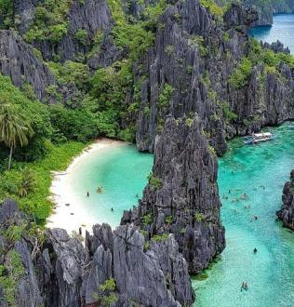
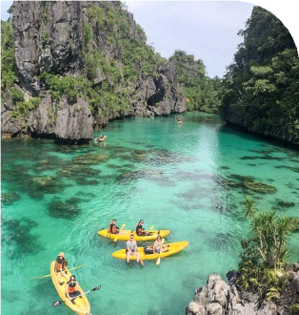
Tour Code: AOT-PHG-005 Group Tour Lowest Price Guarantee Recommended Rating: 5 Star

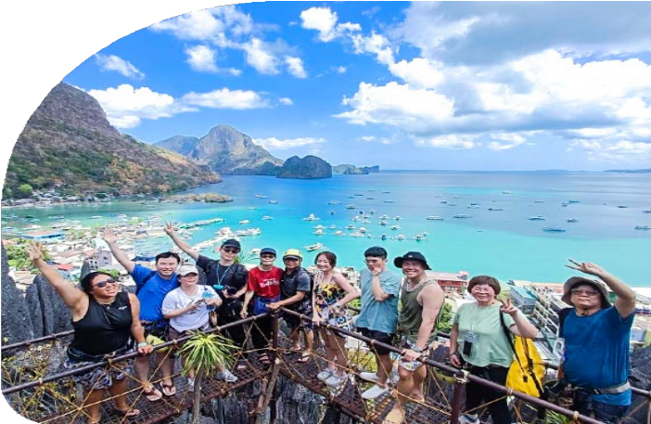

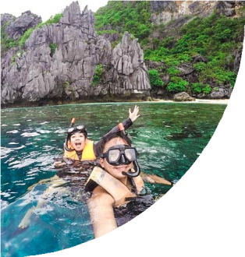
Affordable Island Escapes: El Nido Group Tour Deals Await!
Discover the best of El Nido with our 4-Day El Nido Group Tour that offers a complete and hassle-free travel experience. Unlike other tours, we combine the two most popular Island Hopping Tours (Tour A & Tour C), taking you to El Nido's most iconic lagoons,
hidden beaches, and vibrant coral reefs. But that’s not all – our package includes transfers, comfortable accommodation, delicious meals, and, most importantly, a local guide who will accompany you throughout the sightseeing, ensuring every detail is
taken care of.

This 4-Day El Nido Tour is designed to maximize your travel experience with a small-group tour. By sharing group costs, you can explore El Nido’s stunning islands without

the hefty price tag. Get More for Less by exploring El Nido’s beautiful islands comfortably and effortlessly, with the guidance of professionals.

Group Information

Available: All year
Languages: English

Difficulty: Easy
Duration 4 days


Features:
Nature, Islands, Beaches, Caves, Lagoons, Lakes, Shipwrecks Diving, Island Hopping, Swimming, Snorkeling, Marine Life, Seafood

You Can Experience “Must-see & Must-do” with This Tour

- Discover the stunning lagoons of El Nido. Glide through the dramatic limestone cliffs of the Big Lagoon, swim in the crystal-clear waters of the Secret Lagoon.
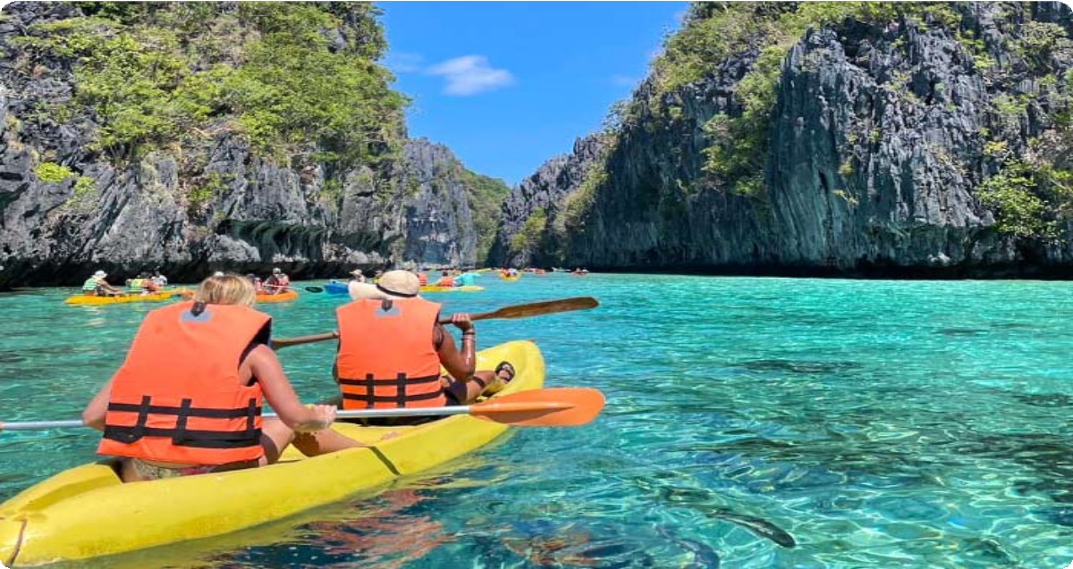

- Venture into El Nido's hidden treasures - Hidden Beach and Secret Beach, where pristine coves nestle behind majestic limestone cliffs, beckoning
adventurous swimmers to explore their secluded waters.
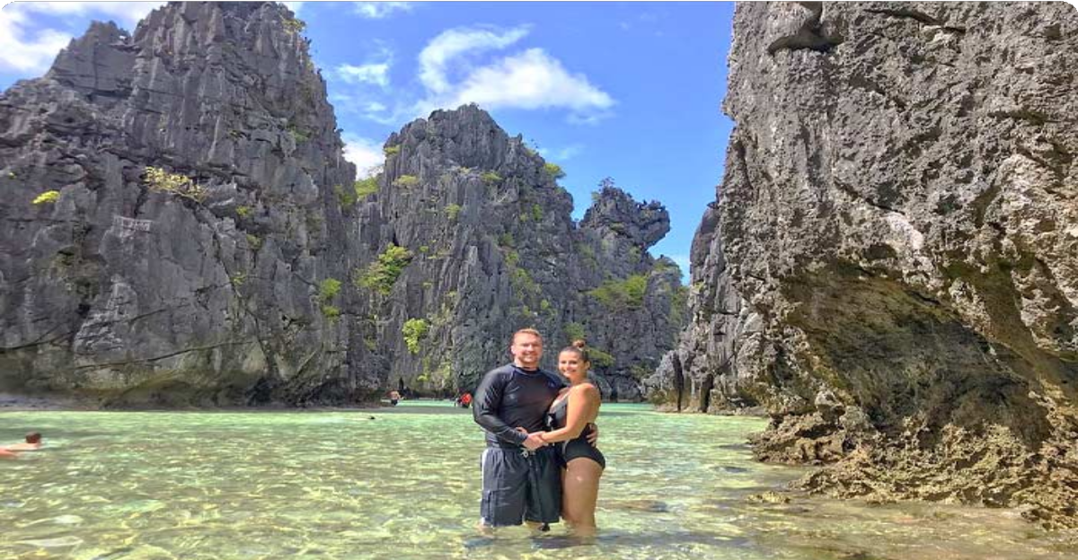

Show More

Day by Day Itinerary

 Day 1 Arrival in El Nido | Airport Pick-up and Hotel Check-in

Welcome to El Nido, Palawan! Upon arrival at El Nido Lio Airport, you will be greeted by your driver, who will assist you with your transfer to your hotel. After checking in, you can take the rest of the day to relax, explore the local area, or enjoy a leisurely
dinner at a nearby restaurant.

El Nido, located at the northern tip of Palawan, is world-renowned for its stunning limestone cliffs, crystal-clear lagoons, turquoise waters, and pristine beaches. The name El Nido translates to "the nest" in Spanish, as the bay and its surrounding cliffs were home to numerous bird nests. Serving as the gateway to the Bacuit Archipelago, El Nido is home to a collection of over 40 islands and islets, each offering hidden

beaches, dramatic caves, and unforgettable natural wonders, all waiting for you to discover.


Arrival Ideas:

From Manila: You can fly directly to El Nido's Lio Airport with airlines like AirSWIFT. The flight is about 1.5 hours.
From Puerto Princes: You can take a van or bus to El Nido. The journey typically takes 5 to 7 hours, depending on traffic and road conditions.
Main Airport: El Nido Airport (IATA: ENI), also known as Lio Airport, is a private airport located approximately 4 kilometers northeast of El Nido town in Palawan, Philippines.
If you need help with flight ticket and private transfer bookings, feel free to contact us.

Dining：None
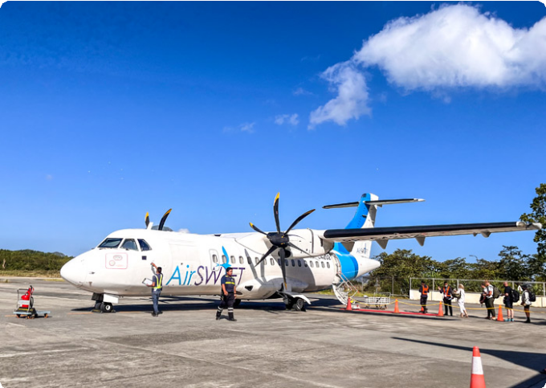
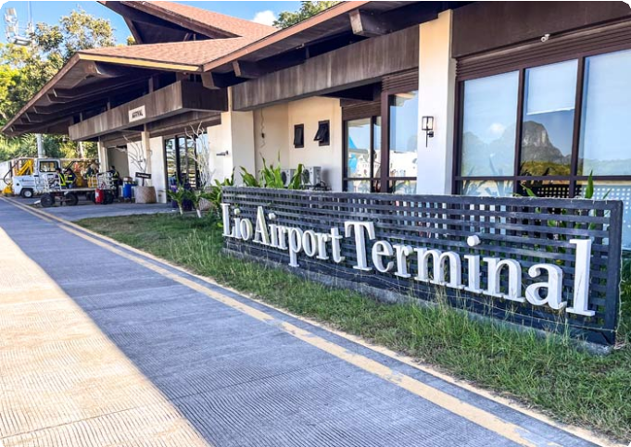
Accommodation：El Nido
El Nido's Lio Airport
El Nido's Lio Airport

 Day 2 El Nido Island Hopping Tour A | Big Lagoon, Secret Lagoon, 7 Commando Beach, Shimizu Island, Payong-Payong Beach

Get ready for an exciting day of island hopping as you explore the stunning Bacuit Archipelago on Island Hopping Tour A. This tour takes you to iconic lagoons and beaches - perfect for kayaking and snorkeling enthusiasts.
After breakfast, your guide will meet you for an exhilarating boat ride to the Big
Lagoon, one of El Nido’s most famous gems. Surrounded by towering limestone cliffs, this serene lagoon invites you to kayak through its crystal-clear waters, with the cliffs

rising dramatically around you. As your boat glides across the water, the vibrant

turquoise sea contrasts with the rugged rock formations, creating a striking visual spectacle. Tip: You can rent a kayak for 450 PHP (for 2 pax) to fully experience the lagoon from a closer perspective.
Next, you’ll head to the Secret Lagoon, a hidden paradise tucked behind towering limestone formations. A short swim through a narrow entrance reveals a beautiful, secluded cove with turquoise waters and a pristine beach - an enchanting place to explore and unwind.
The adventure continues with a visit to 7 Commando Beach, a tropical haven known for its soft white sand and crystal-clear waters. Take a refreshing dip or relax under the shade of palm trees while enjoying the breathtaking surroundings.
From there, you’ll set sail to Shimizu Island, named after the Japanese diver who discovered its incredible marine life. This island offers exceptional snorkeling
opportunities, where you can explore vibrant coral reefs teeming with fish, making it a perfect spot for underwater exploration.
Our final stop of the day is Payong-Payong Beach, a serene and peaceful beach that offers an idyllic setting for relaxation. Spend time swimming, sunbathing, or simply enjoying the natural beauty of the island before you return to El Nido.

Dining：Breakfast, Lunch
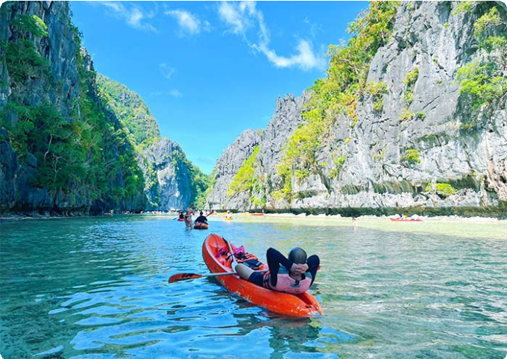
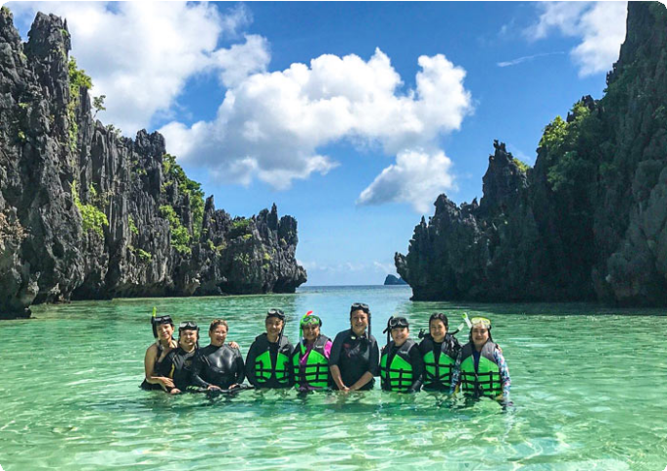
Accommodation：El Nido
Big Lagoon, El Nido
Secret Lagoon, El Nido

 Day 3 El Nido Island Hopping Tour C | Helicopter Island, Tapiutan Island, Hidden Beach, Secret Beach

Today, you’re diving deeper into the enchanting Bacuit Archipelago with Island
Hopping Tour C. Get ready to explore some of El Nido’s most secluded beaches and stunning underwater landscapes where natural wonders await at every turn.
After breakfast, your guide will greet you for an exciting boat ride to Helicopter
Island (Dilumacad Island), named for its rock formations that resemble a helicopter from a distance. Here you you can snorkel in the crystal-clear waters, explore vibrant coral reefs, and if you’re lucky, you might spot a sea turtle gliding by. Whether you're soaking up the sun or floating in the warm water, it’s impossible not to be amazed by the scenery.
Next, you’ll visit Tapiutan Island, a stunning island marked by dramatic cliffs and calm waters. The natural beauty here is mesmerizing, with rich marine life waiting to be
explored just below the surface. Whether you want to snorkel or simply bask on the golden sands, Tapiutan offers a perfect slice of paradise.
Continue your journey to Secret Beach, hidden behind a wall of towering cliffs. To get there, you’ll swim through a narrow opening in the rock - sounds adventurous, right? Once inside, you’ll discover a secluded cove where soft white sand meets calm, clear waters. It’s said that this beach inspired parts of the novel The Beach - and standing
there, you’ll understand why.

Your last stop is Hidden Beach, another gem concealed behind limestone formations. From the open sea, you wouldn’t even know it’s there until you swim around the rocks and suddenly, you’re in a peaceful lagoon-like haven. The water is a stunning shade of turquoise, the sand is soft beneath your feet, and you’ll find yourself wanting to stay
forever.

After a full day of exploring hidden treasures, you'll head back to your hotel.

Dining：Breakfast, Lunch
Accommodation：El Nido

 


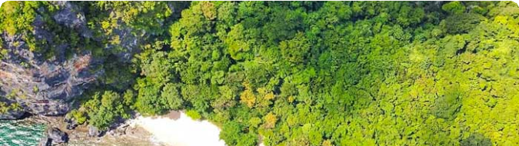

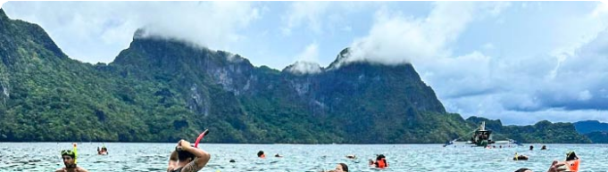
 Day 4 El Nido Departure | Hotel Check-out and See-off

It’s time to say goodbye to El Nido and end to 4-days El Nido Group Tour. Your driver will transfer you to the airport and you will continue on your next destination.
Thank you for choosing us for your Philippines tour, and you are always here working for you and hope to see you again for your next trip to Philippines. Safe journey!

Dining：Breakfast Accommodation：/

Month | Available Date
Apr | Apr.07, 2025
Apr | Apr.15, 2025
Apr | Apr.27, 2025
May | May.12, 2025
Jun | Jun.16, 2025
Jul | Jul.14, 2025
Aug | Aug.18, 2025
Aug | Aug.25, 2025
Sep | Sep.15, 2025
Oct | Oct.27, 2025
Nov | Nov.11, 2025

 | Nov.23, 2025
Dec | Dec.01, 2025
Dec | Dec.09, 2025
Dec | Dec.21, 2025
Dec | Dec.29, 2025

Price: What’s Included & What’s Excluded

What's included?
English-speaking guide;
Ferries as listed in the itinerary;
Admission tickets for all attractions listed in the itinerary; Accommodation as listed in the itinerary;
All ground transportation during sightseeing; Airport Transfers: complimentary at fixed times;
Meals listed in “breakfast” or “lunch” in the above day to day itinerary; 24/7 customer support

What's excluded?

Travel Insurance Entry visa fees
International Flights Personal expenses
Single room supplement
Recommended optional activities: It may offer optional activities that are not included in the tour price, such as scuba diving, hot spring, etc.
Tips or gratuities for guides and drivers

Important Trip Notes for Booking This Tour

A Philippine Group Tour: Land Tours and Island Hopping
Our group tours in the Philippines consist of two types: land tours and island-hopping adventures.
Land Tours: We intentionally keep our land tours small, with a maximum of 8
travelers per group. If your group exceeds this number, don't worry! For groups of 9 or more, we’ll seamlessly divide you into two smaller groups, each with
dedicated guides and vehicles. This ensures personalized attention and a comfortable travel experience for everyone.
Island Hopping: For island-hopping adventures, the seating capacity of boats and transfer vehicles depends on the actual number of travelers on the day of the tour, ensuring flexibility and convenience for all participants.

Scheduled Airport Transfers
Our complimentary airport transfer service is available at fixed times. Please
ensure your arrival aligns with these scheduled transfers. If your flight does not coincide with the scheduled times, alternative transfer arrangements can be made at an additional cost.

Transportation
For land transportation, we will use comfortable vehicles with a seating capacity of 9 to 12 passengers during the tour. For sea transportation, we will arrange ferry services according to the schedules provided by the shipping companies.

Special Conditions for Attractions
Depending on the policies and conditions of each attraction, different
arrangements will be in place. For example, at the Underground River National Park, the park administration will organize boat tours. According to these
arrangements, you will share a boat with other guests to enter the cave.

Changes to Itinerary
While we strive to adhere to the planned itinerary, we may need to make adjustments due to weather conditions, safety concerns, or other unforeseen circumstances. We reserve the right to make adjustments as needed.
By booking a tour with us, you agree to these terms and conditions. We look
forward to providing you with an unforgettable travel experience in the Philippines.

What to Bring for the Philippines Tour

Passport (Valid for 6 months from date of departure)
Visa if required

Cash and Credit/Debit Cards Lightweight and Breathable Clothing Hat, Sunglasses, and Sunscreen Swimwear, Wetsuit, Water Shoes

Camera, phone, charger, and power bank
Insect Repellent to protect against mosquitoes

Personal Hygiene Products Personal Snorkeling Gear

Cancellation Policy

Thank you for choosing our services. We understand that sometimes plans change and adjustments are necessary. Below is our cancellation policy applicable to all our
bookings:

Tours/Activities:
More than 9 days before the service date: No penalties.
Less than 9 days before the service date: Tours are non-refundable, except in cases of force majeure.

Hotels:
Cancel more than 61 days in advance: Free cancellation.
Cancel 31-60 days in advance: 50% of the room rate will be charged. Cancel 0-30 days in advance: 100% of the room rate will be charged.

Transfers:
More than 72 hours before the service date: No penalty.
Less than 72 hours before the service date: Non-refundable, except in cases of force majeure.
We kindly ask for your understanding that these policies are in place to ensure that we can manage our bookings and resources effectively while continuing to offer quality
services to all our guests.

