4 Days Coron Group Tour in Palawan: Kayangan Lake, Shipwrecks, Mt. Tapyas
Route: Coron

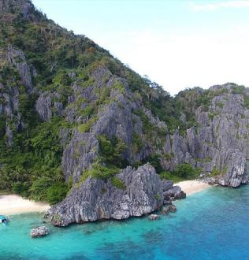
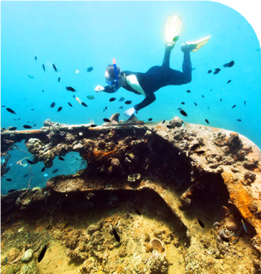
Tour Code: AOT-PHG-006 Group Tour Lowest Price Guarantee Recommended Rating: 5 Star

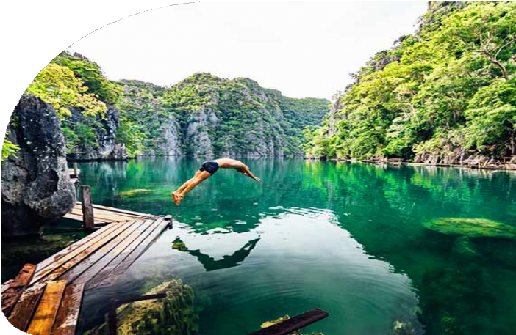
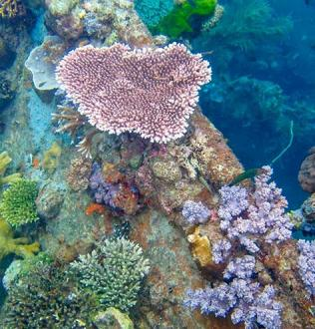
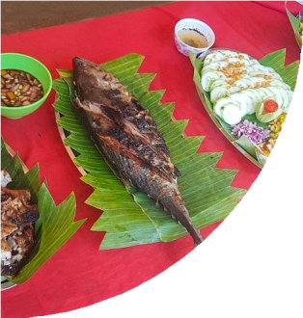
Coron Island Hopping Tour A and Reef & Wrecks Tour
Experience the essence of Coron with our 4-Day Coron Group Tour. This exciting tour combines the highlights of Coron Island Hopping Tour A, a favorite for first-time
visitors. Discover the crystal-clear waters of Kayangan Lake - Asia’s cleanest lake Green Lagoon, Quin Reef, CYC Beach, offering a mix of swimming, snorkeling, and relaxation.
For diving enthusiasts, the Reef & Wrecks Tour takes you to WWII shipwrecks like the Lusong Gunboat and East Tangat Wreck, surrounded by vibrant coral gardens,

making it a must for underwater explorers. Besides, you will hike up to the summit of
Mt. Tapyas and get a panoramic view of Coron.

But that’s not all – our Coron group tour package includes transfers, comfortable accommodation, delicious meals, and, most importantly, a local guide who will accompany you throughout the sightseeing, ensuring every detail is taken care of. By sharing group costs, you can explore Coron’s stunning islands at an affordable price.

Group Information

Available: All year
Languages: English

Difficulty: Moderate
Duration 4 days


Features:
Nature, Islands, Beaches, Caves, Lagoons, Lakes, Shipwrecks Diving, Island Hopping, Swimming, Snorkeling, Marine Life, Hiking

You Can Experience “Must-see & Must-do” with This Tour

- Dive into history with a snorkeling adventure through Coron’s famous WWII shipwrecks, like the Lusong Gunboat and East Tangat Wreck. Swim through
crystal-clear waters surrounded by vibrant coral reefs and abundant marine life.

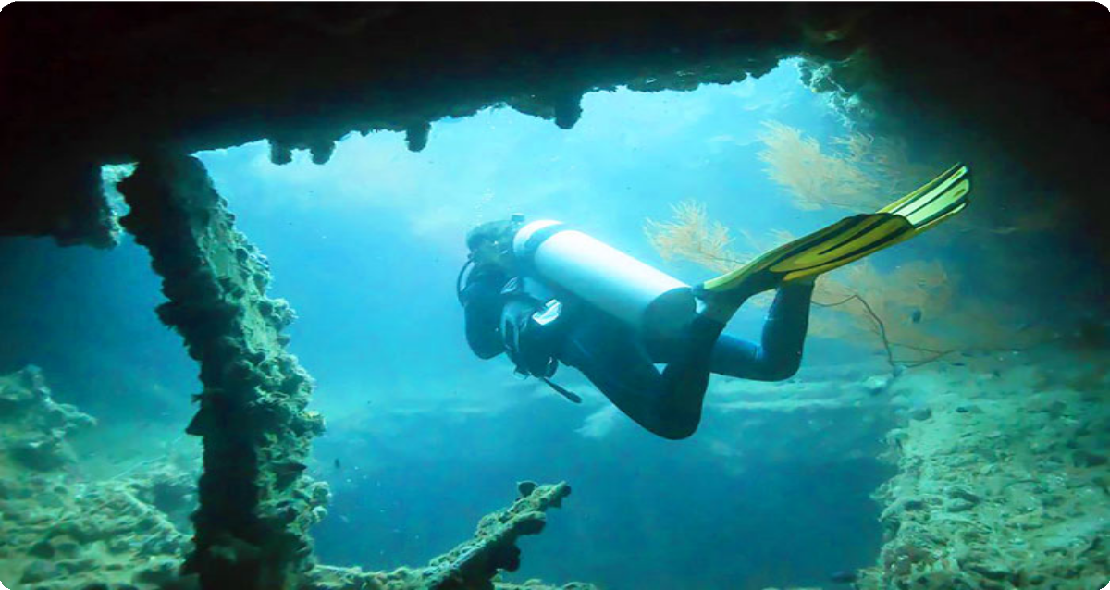
- Marvel at the breathtaking beauty of Kayangan Lake in Coron, renowned as Asia’s cleanest lake. Capture the panoramic view of this jewel-like lake
surrounded by towering limestone cliffs.


Day by Day Itinerary

 Day 1 Arrival in Coron | Transfers & Hotel Check-in, Mt. Tapyas

Welcome to Coron, Palawan! Upon arrival, our driver will greet you at the airport or
port based on your schedule and transfer you to your hotel in Coron Town. Take some time to rest and refresh at your hotel.
This afternoon, you will enjoy a short trek to the summit of Mt. Tapyas, the second-
tallest mountain and the most iconic landmark in Coron on Busuanga Island. The hike, Located in the northern part of Palawan, is worthwhile. At the top, you’ll be treated to breathtaking vistas that are perfect for photography, so don’t forget your camera!

Coron, situated in the northern part of Palawan, is a true paradise for adventure

seekers and diving enthusiasts. It’s famous for its world-class diving spots, including the renowned Coron Wrecks, a collection of sunken WWII Japanese warships that now serve as a habitat for vibrant marine life. Coron is also celebrated for its crystal-clear Kayangan Lake, often considered the cleanest lake in Asia.

Arrival Ideas:

By Air: Francisco B. Reyes Airport, also known as Busuanga Airport, is the main
airport serving Coron. It is located approximately 25 kilometers from the town center. Several airlines operate regular flights to Coron from major cities such as Manila, Cebu, and Clark, etc.
By Sea: If you are already in El Nido, you can take a ferry to Coron, with the journey lasting approximately 3.5 hours.
If you need help with flight ticket or ferry ticket bookings, feel free to contact us.

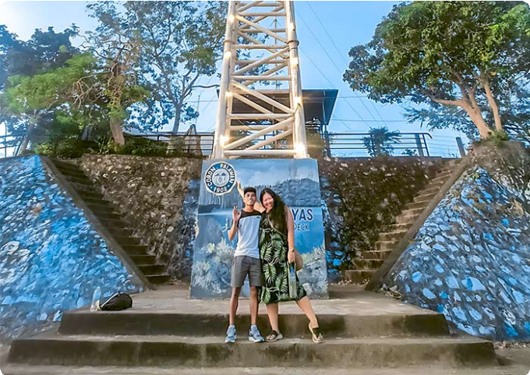
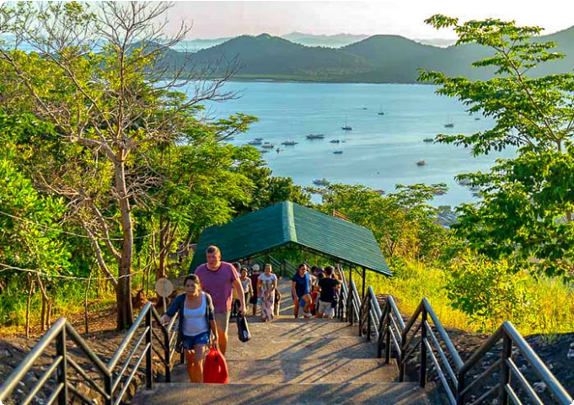
Dining：None Accommodation：Coron
Mt. Tapyas, Coron
Mt. Tapyas, Coron

 Day 2 Coron Island Hopping Tour A | Kayangan Lake, Green Lagoon, Quin Reef, Atwayan Beach, CYC Beach, Las Isla De Coral

Get ready for an exhilarating day of island hopping in Coron, where you’ll discover crystal-clear lagoons, breathtaking beaches, and hidden gems.
After breakfast, your guide will pick you and head straight to iconic Kayangan
Lake, often referred to as the “cleanest lake in Asia.” Nestled in the heart of Coron, this

crystal-clear freshwater lake is encircled by towering limestone cliffs, offering a

picturesque setting for your photos. As you approach, the natural beauty will take your breath away. Beneath the surface, you’ll find vibrant aquatic life swimming around
intricate rock formations and caves, making it a snorkeler's and diver’s paradise.

Next, head to the Green Lagoon, an equally breathtaking spot with emerald waters that shimmer under the sun. The calm, clear water, surrounded by lush cliffs, is
perfect for swimming and enjoying the serene beauty of the lagoon.

Continue your adventure at Quin Reef (also known as Malwawey Coral Garden), where the underwater world comes alive. As you snorkel through the vibrant coral gardens, you’ll be surrounded by schools of colorful fish, all dancing beneath the crystal-clear water.
From the reef, you’ll sail to Atwayan Beach, a hidden gem with pristine white sand,
crystal-clear waters, and small bamboo huts offering a touch of rustic charm. Take a
leisurely swim in the calm waters or just relax under the swaying palm trees while you take in the beauty of this idyllic, peaceful beach.
Next, you’ll head to CYC Beach, named after the Coron Youth Club. This tranquil beach is a great spot for swimming, sunbathing, or simply relaxing under the shade of
mangrove trees. With its white sand and clear waters, the beach offers a picture-
perfect escape.

Finally, you’ll wrap up the tour at Las Islas de Coral, a famous snorkeling spot. Dive
into its warm waters and swim alongside a rainbow of colorful coral and tropical fish, experiencing the natural world in its full glory. The coral gardens here are vibrant and alive, offering a breathtaking end to your island-hopping adventure.
After the tour, you will be escorted to your hotel in Coron Town.

Dining：Breakfast, Lunch
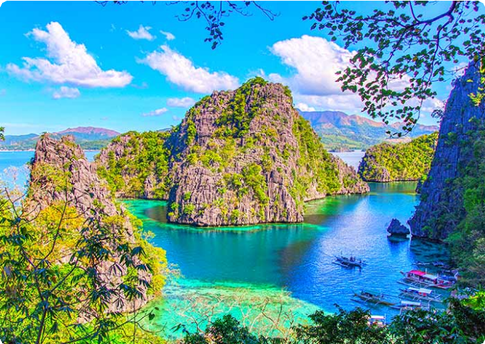
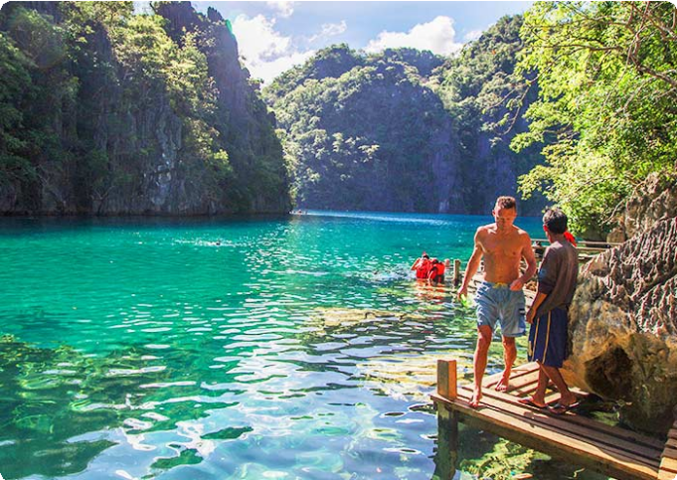
Accommodation：Coron

Kayangan Lake, Coron Kayangan Lake, Coron

 Day 3 Coron Reef and Wrecks Tour | Pass Island, Lusong Coral Garden, Lusong Gunboat, East Tangat Wreck

Today, get ready to dive into Coron's rich history and vibrant marine life with the Reef and Wrecks Tour. This thrilling adventure combines stunning natural wonders with the eerie beauty of two sunken WWII shipwrecks, offering a truly unforgettable day on the water.
After breakfast, you’ll set off on a 2-hour boat ride to Pass Island, a small slice of paradise off the coast of Busuanga, Palawan. Picture soft white sand stretching
endlessly, coconut trees swaying in the breeze, and a sense of calm that makes it feel like your own private oasis. Take a moment to relax, swim, or snorkel in the clear waters before you continue your journey.
Next, you’ll head to Lusong Coral Garden, the largest and most vibrant coral garden in Coron. Here, the water shimmers in every shade of blue and green, while beneath the surface, a breathtaking tapestry of colorful corals and marine life unfolds. The diversity of coral species here is staggering, offering a perfect underwater paradise
for snorkelers.

From there, you’ll visit the Lusong Gunboat, a sunken WWII vessel that’s become a
must-see for divers and snorkelers alike. Resting at a shallow depth of 10 meters, this gunboat wreck lies on its side, its rugged structure home to thriving marine life. As you explore, you’ll marvel at the contrast of history and nature - where the wreck’s worn edges meet the vibrancy of the ocean’s new inhabitants.
The adventure continues with the East Tangat Wreck is one of the most impressive. A 40-meter-long vessel that sunk on September 24, 1944, it’s believed to have been
either a tugboat or anti-submarine craft. Resting on a sandy slope, its stern is visible at 22 meters (72 feet) during low tide, offering a glimpse into both the past and the ocean’s vibrant present. You’ll have the chance to snorkel around the ship, marveling at the eerie beauty of this submerged piece of history.
After the tour, you will be escorted to your hotel in Coron Town.

Dining：Breakfast, Lunch
Accommodation：Coron



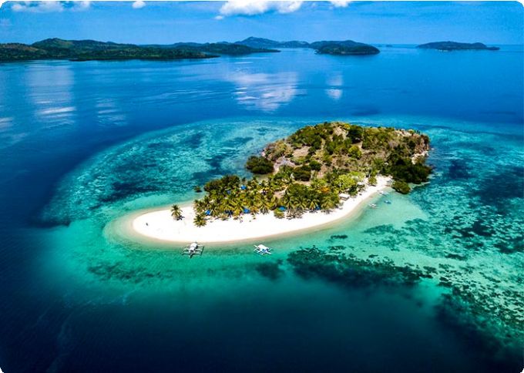
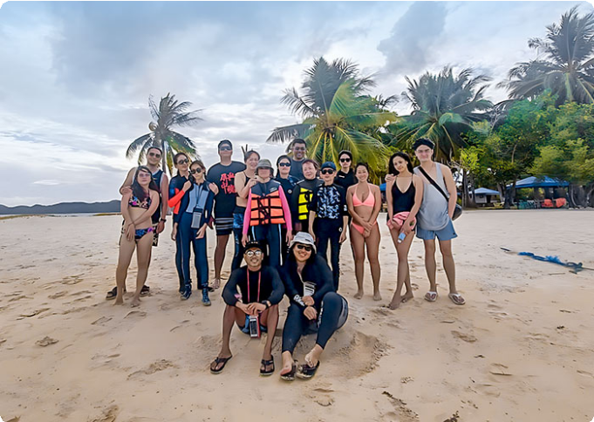
 Day 4 Coron Departure | Hotel Check-out and See-off
Pass Island, Coron
Pass Island, Coron

It’s time to say goodbye to Coron and end to 4-days Coron Group Tour. Your driver will transfer you to the airport and you will continue to your next destination.
Thank you for choosing us for your Philippines tour, and you are always here working for you, and hope to see you again for your next trip to the Philippines. Safe journey!

Dining：Breakfast Accommodation：/

Month | Available Date
Apr | Apr.02, 2025
Apr | Apr.10, 2025
Apr | Apr.18, 2025
Apr | Apr.30, 2025
May | May.15, 2025
Jun | Jun.19, 2025
Jul | Jul.17, 2025

Aug | Aug.21, 2025
Aug | Aug.28, 2025
Sep | Sep.18, 2025
Oct | Oct.16, 2025
Oct | Oct.30, 2025
Nov | Nov.14, 2025
Nov | Nov.26, 2025
Dec | Dec.04, 2025
Dec | Dec.12, 2025
Dec | Dec.24, 2025
Jan | Jan.01, 2026

Price: What’s Included & What’s Excluded

What's included?
English-speaking guide;
Ferries as listed in the itinerary;
Admission tickets for all attractions listed in the itinerary; Accommodation as listed in the itinerary;
All ground transportation during sightseeing; Airport Transfers: complimentary at fixed times;
Meals listed in “breakfast” or “lunch” in the above day to day itinerary; 24/7 customer support

What's excluded?

Travel Insurance Entry visa fees

International Flights Personal expenses
Single room supplement
Recommended optional activities: It may offer optional activities that are not included in the tour price, such as scuba diving, hot spring, etc.
Tips or gratuities for guides and drivers

Important Trip Notes for Booking This Tour

A Philippine Group Tour: Land Tours and Island Hopping
Our group tours in the Philippines consist of two types: land tours and island-hopping adventures.
Land Tours: We intentionally keep our land tours small, with a maximum of 8
travelers per group. If your group exceeds this number, don't worry! For groups of 9 or more, we’ll seamlessly divide you into two smaller groups, each with dedicated guides and vehicles. This ensures personalized attention and a
comfortable travel experience for everyone.
Island Hopping: For island-hopping adventures, the seating capacity of boats and transfer vehicles depends on the actual number of travelers on the day of the tour, ensuring flexibility and convenience for all participants.

Scheduled Airport Transfers
Our complimentary airport transfer service is available at fixed times. Please
ensure your arrival aligns with these scheduled transfers. If your flight does not
coincide with the scheduled times, alternative transfer arrangements can be made at an additional cost.

Transportation
For land transportation, we will use comfortable vehicles with a seating capacity of 9 to 12 passengers during the tour. For sea transportation, we will arrange ferry services according to the schedules provided by the shipping companies.

Special Conditions for Attractions
Depending on the policies and conditions of each attraction, different
arrangements will be in place. For example, at the Underground River National Park, the park administration will organize boat tours. According to these
arrangements, you will share a boat with other guests to enter the cave.

Changes to Itinerary
While we strive to adhere to the planned itinerary, we may need to make adjustments due to weather conditions, safety concerns, or other unforeseen circumstances. We reserve the right to make adjustments as needed.
By booking a tour with us, you agree to these terms and conditions. We look
forward to providing you with an unforgettable travel experience in the Philippines.

What to Bring for the Philippines Tour

Passport (Valid for 6 months from date of departure)
Visa if required

Cash and Credit/Debit Cards Lightweight and Breathable Clothing Hat, Sunglasses, and Sunscreen Swimwear, Wetsuit, Water Shoes

Camera, phone, charger, and power bank
Insect Repellent to protect against mosquitoes

Personal Hygiene Products Personal Snorkeling Gear

Cancellation Policy

Thank you for choosing our services. We understand that sometimes plans change and adjustments are necessary. Below is our cancellation policy applicable to all our bookings:

Tours/Activities:
More than 9 days before the service date: No penalties.
Less than 9 days before the service date: Tours are non-refundable, except in cases of force majeure.

Hotels:
Cancel more than 61 days in advance: Free cancellation.
Cancel 31-60 days in advance: 50% of the room rate will be charged.

Cancel 0-30 days in advance: 100% of the room rate will be charged.

Transfers:
More than 72 hours before the service date: No penalty.
Less than 72 hours before the service date: Non-refundable, except in cases of force majeure.
We kindly ask for your understanding that these policies are in place to ensure that we can manage our bookings and resources effectively while continuing to offer quality
services to all our guests.

