12 Days Philippines Group Tour: El Nido, Coron, Bohol, Siquijor & Dumaguete
Route: El Nido - Coron - Cebu - Bohol - Siquijor - Dumaguete

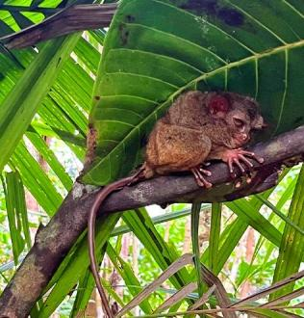
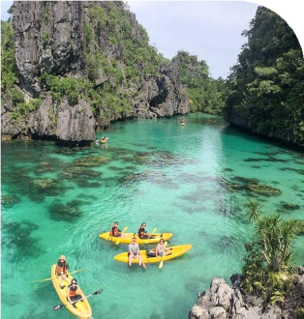
Tour Code: AOT-PHG-007 Group Tour Lowest Price Guarantee Recommended Rating: 5 Star

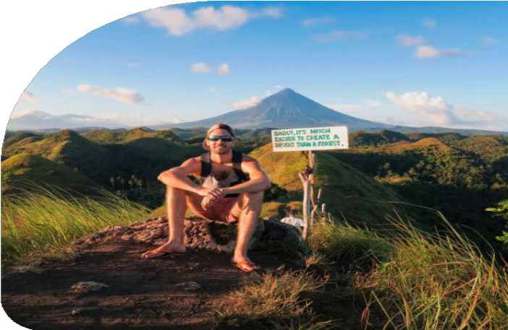
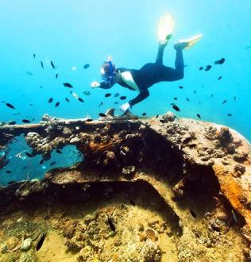
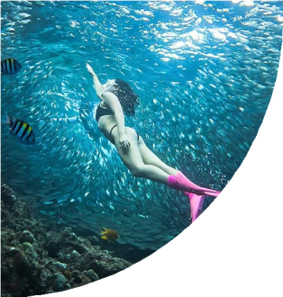
Explore the Best of Palawan & Visayas in One Epic Adventure
Experience the best of Palawan and the Visayas on this 12 Days Philippines Group Tour. From island-hopping in El Nido and Coron to cultural explorations in Cebu, natural wonders in Bohol, adrenaline-pumping activities in Siquijor, and marine life encounters in Dumaguete, this well-crafted itinerary is perfect for affordable travel seekers eager to experience it all.

Begin your adventure in Palawan, where El Nido & Coron welcome you with hidden
lagoons, dramatic limestone cliffs, and vibrant coral reefs. Snorkel, swim, and even
dive among historic WWII shipwrecks in one of the world’s most stunning seascapes.

Next, step into the heart of the Visayas as you explore Cebu & Bohol. In Cebu, discover iconic landmarks like Magellan’s Cross. Then immerse yourself in Bohol’s natural

wonders: Chocolate Hills, the mesmerizing Sardine Run at Napaling Reef, and close encounters with Philippine tarsiers. At Balicasag Island, spot dolphins and swim with sea turtles.

In Siquijor, uncover the island’s mystical charm with its enchanted Balete tree,
waterfalls, and secret beaches, before heading to Apo Island near Dumaguete, one of the world’s top snorkeling destinations, to swim alongside gentle sea turtles and vibrant marine life.

Group Information

Available: All year
Languages: English

Difficulty: Moderate
Duration 12 days


Features:
Nature, Islands, Beaches, Caves, Lagoons, Lakes, Shipwrecks Diving, Island Hopping, Swimming, Snorkeling, Marine Life, Wildlife

You Can Experience “Must-see & Must-do” with This Tour

- Discover the stunning lagoons of El Nido. Cruise through dramatic limestone cliffs and the crystal-clear Big Lagoon, and find Secret Lagoon's secluded cove
- accessible only through a narrow rock opening.

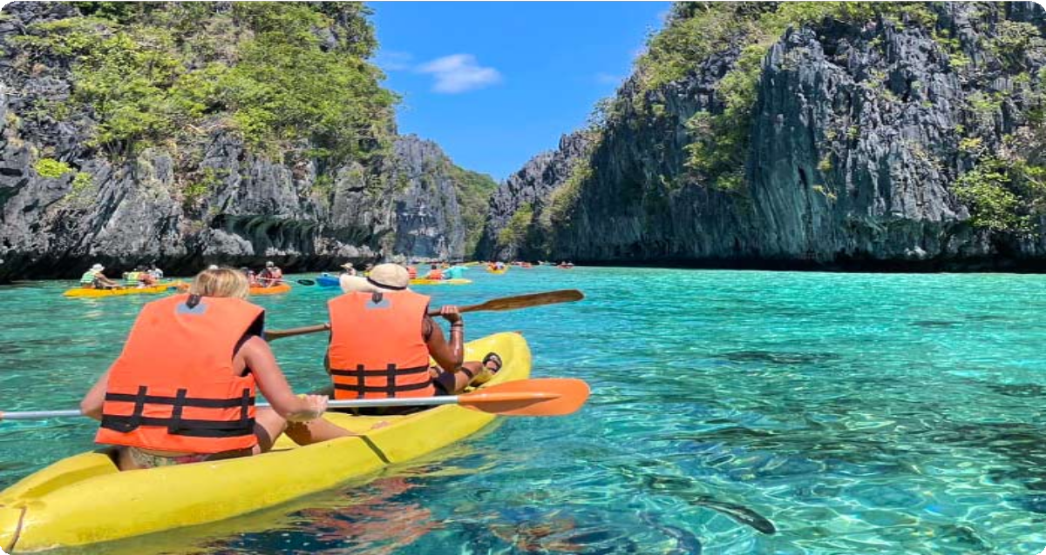
- Venture into El Nido's hidden treasures - Hidden Beach and Secret Beach, where pristine coves nestle behind majestic limestone cliffs, beckoning
adventurous swimmers to explore their secluded waters.
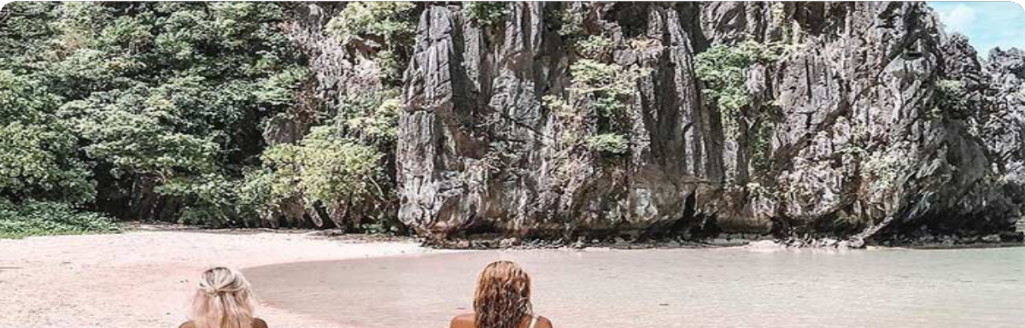

El Nido (3 Days)
El Nido Island Hopping Tour A: Big Lagoon, Secret Lagoon, 7 Commando Beach, Shimizu Island, Payong-Payong Beach; El Nido Island Hopping Tour C: Helicopter Island, Tapiutan Island, Hidden Beach, Secret Beach

Coron (3 Days)

Mt. Tapyas or Maquinit Hot Spring, Island-Hoppig A: Kayangan Lake, Green Lagoon, Quin Reef, Atwayan Beach, CYC Beach, Las Isla De Coral; Coron Reef and Wrecks Tour: Pass Island, Lusong Coral Garden, Lusong Gunboat, East Tangat Wreck

Cebu (0.5 Day)
Magellan's Cross, Basilica Minore del Santo Nino, Fort San Pedro

Bohol (2.5 Days)
Napaling Reef (Sardine Run Experience), Loboc River Cruise, Philippine Tarsier
Sanctuary, Chocolate Hills, Balicasag Island (Dolphin Watching, Turtle Watching)

Siquijor Island (1 Day)
Capilay Spring Park, Tubo Beach, Lugnason Falls, Old Enchanted Balete Tree, Lazi Convent, Kagusuan Beach, Cambugahay Falls

Dumaguete (2 Days)
Apo Island Hopping (Coral Garden Snorkeling, Sea Turtles)

Day by Day Itinerary

 Day 1 Arrival in El Nido | Airport Pick-up and Hotel Check-in

Welcome to El Nido, Palawan! Upon arrival at El Nido Lio Airport, you will be greeted by your driver, who will assist you with your transfer to your hotel. After checking in, you can take the rest of the day to relax, explore the local area, or enjoy a leisurely
dinner at a nearby restaurant.

El Nido, located at the northern tip of Palawan, is world-renowned for its stunning limestone cliffs, crystal-clear lagoons, turquoise waters, and pristine beaches. The
name El Nido translates to "the nest" in Spanish, as the bay and its surrounding cliffs were home to numerous bird nests. Serving as the gateway to the Bacuit Archipelago, El Nido is home to a collection of over 40 islands and islets, each offering hidden beaches, dramatic caves, and unforgettable natural wonders, all waiting for you to discover.

Arrival Ideas:

From Manila: You can fly directly to El Nido's Lio Airport with airlines like AirSWIFT. The flight is about 1.5 hours.

From Puerto Princes: You can take a van or bus to El Nido. The journey typically takes 5 to 7 hours, depending on traffic and road conditions.

Main Airport: El Nido Airport (IATA: ENI), also known as Lio Airport, is a private airport located approximately 4 kilometers northeast of El Nido town in Palawan, Philippines.
If you need help with flight ticket and private transfer bookings, feel free to contact us.

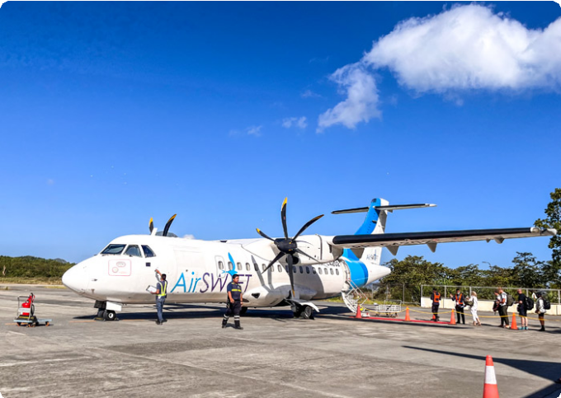
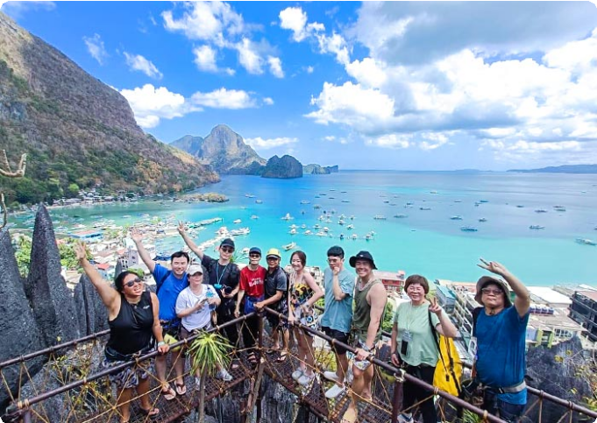
Dining：None Accommodation：El Nido
El Nido's Lio Airport
Our Guests in El Nido, Palawan

 Day 2 El Nido Island Hopping Tour A | Big Lagoon, Secret Lagoon, 7 Commando Beach, Shimizu Island, Payong-Payong Beach

Get ready for an exciting day of island hopping as you explore the stunning Bacuit Archipelago on Island Hopping Tour A. This tour takes you to iconic lagoons and beaches - perfect for kayaking and snorkeling enthusiasts.
After breakfast, your guide will meet you for an exhilarating boat ride to the Big
Lagoon, one of El Nido’s most famous gems. Surrounded by towering limestone cliffs, this serene lagoon invites you to kayak through its crystal-clear waters, with the cliffs rising dramatically around you. As your boat glides across the water, the vibrant
turquoise sea contrasts with the rugged rock formations, creating a striking visual
spectacle. Tip: You can rent a kayak for 450 PHP (for 2 pax) to fully experience the lagoon from a closer perspective.
Next, you’ll head to the Secret Lagoon, a hidden paradise tucked behind towering
limestone formations. A short swim through a narrow entrance reveals a beautiful,

secluded cove with turquoise waters and a pristine beach - an enchanting place to explore and unwind.

The adventure continues with a visit to 7 Commando Beach, a tropical haven known for its soft white sand and crystal-clear waters. Take a refreshing dip or relax under the shade of palm trees while enjoying the breathtaking surroundings.
From there, you’ll set sail to Shimizu Island, named after the Japanese diver who discovered its incredible marine life. This island offers exceptional snorkeling
opportunities, where you can explore vibrant coral reefs teeming with fish, making it a
perfect spot for underwater exploration.

Our final stop of the day is Payong-Payong Beach, a serene and peaceful beach that offers an idyllic setting for relaxation. Spend time swimming, sunbathing, or simply enjoying the natural beauty of the island before you return to El Nido.

Dining：Breakfast, Lunch
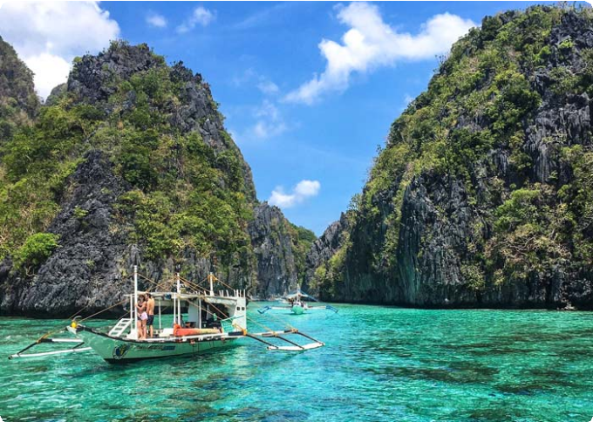
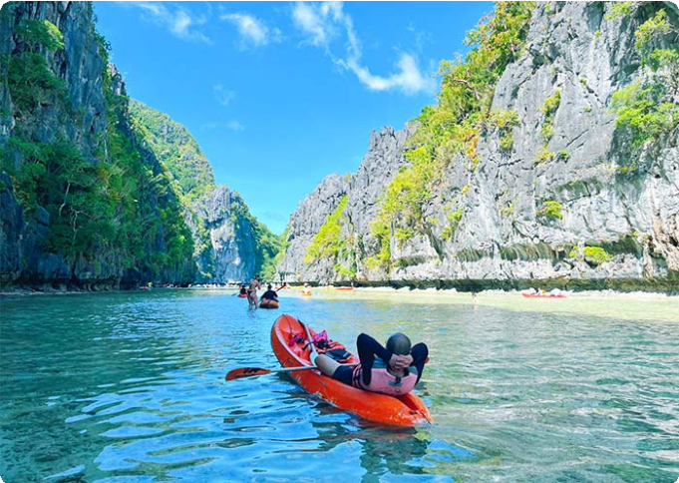
Accommodation：El Nido
Big Lagoon, El Nido
Big Lagoon, El Nido

 Day 3 El Nido Island Hopping Tour C | Helicopter Island, Tapiutan Island, Hidden Beach, Secret Beach

Today, you’re diving deeper into the enchanting Bacuit Archipelago with Island Hopping Tour C. Get ready to explore some of El Nido’s most secluded beaches and stunning underwater landscapes where natural wonders await at every turn.
After breakfast, your guide will greet you for an exciting boat ride to Helicopter Island (Dilumacad Island), named for its rock formations that resemble a helicopter from a distance. Here you you can snorkel in the crystal-clear waters, explore vibrant

coral reefs, and if you’re lucky, you might spot a sea turtle gliding by. Whether you're soaking up the sun or floating in the warm water, it’s impossible not to be amazed by the scenery.

Next, you’ll visit Tapiutan Island, a stunning island marked by dramatic cliffs and calm waters. The natural beauty here is mesmerizing, with rich marine life waiting to be
explored just below the surface. Whether you want to snorkel or simply bask on the golden sands, Tapiutan offers a perfect slice of paradise.
Continue your journey to Secret Beach, hidden behind a wall of towering cliffs. To get there, you’ll swim through a narrow opening in the rock - sounds adventurous, right? Once inside, you’ll discover a secluded cove where soft white sand meets calm, clear waters. It’s said that this beach inspired parts of the novel The Beach - and standing
there, you’ll understand why.

Your last stop is Hidden Beach, another gem concealed behind limestone formations. From the open sea, you wouldn’t even know it’s there until you swim around the rocks and suddenly, you’re in a peaceful lagoon-like haven. The water is a stunning shade of turquoise, the sand is soft beneath your feet, and you’ll find yourself wanting to stay
forever.

After a full day of exploring hidden treasures, you'll head back to your hotel.

Dining：Breakfast, Lunch
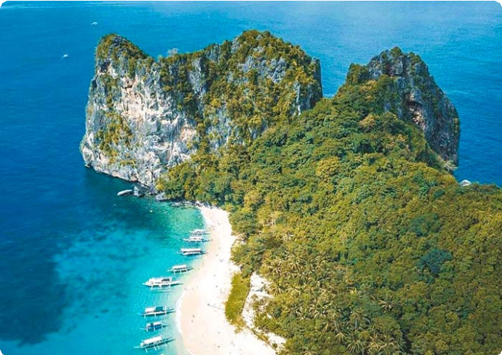
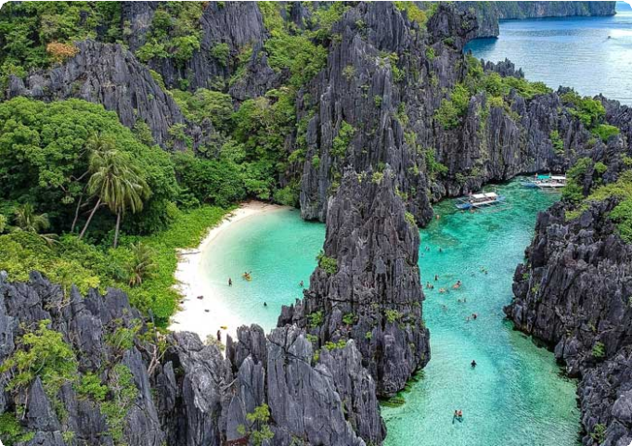
Accommodation：El Nido
Helicopter Island, El Nido
Hidden Beach, El Nido


Day 4 El Nido to Coron by Ferry | Mt. Tapyas or Maquinit Hot Spring

After breakfast, you will say goodbye to El Nido and take a ferry to Coron. The typical travel time for the ferry from El Nido to Coron is around 4-5 hours (127km), but it can take more depending on the weather and sea conditions. Upon arrival in Coron, you’ll check into your hotel and have some time to settle in.

Coron, nestled on Busuanga Island at Palawan's northernmost reaches, is a true paradise for adventure seekers. It’s renowned for its world-class diving spots,
including the famous Coron Wrecks, a collection of sunken WWII Japanese warships now home to vibrant marine life.
In the afternoon, we will arrange your tour based on your ferry departure time. Note: Ship time subject to seasonal change.

If your ferry is at 08:00 AM → Mt. Tapyas Tour

Mt. Tapyas: You will enjoy a short trek to the summit of Mt. Tapyas, the second tallest mountain and the most iconic landmark in Coron on Busuanga Island. The hike up involves 724 steps, but the panoramic views of the town, surrounding islands, and
crystal-clear waters make every step worthwhile. At the top, you’ll be treated to
breathtaking vistas that are perfect for photography, so don’t forget your camera!

If your ferry is at 12:30 PM → Maquinit Hot Spring Tour

Maquinit Hot Spring: Take a 30-minute tricycle ride to this rare saltwater hot spring along Busuanga’s southern coast. The 40°C waters, said to be heated by volcanic activity, are perfect for soothing your muscles (optional plunge).

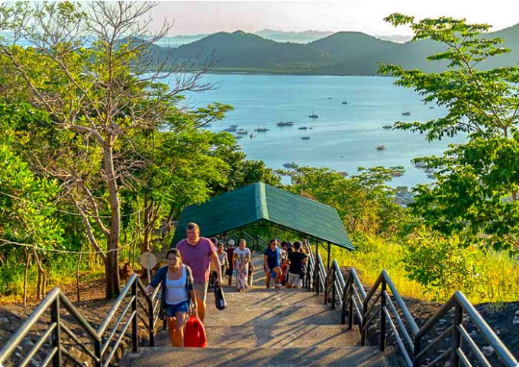
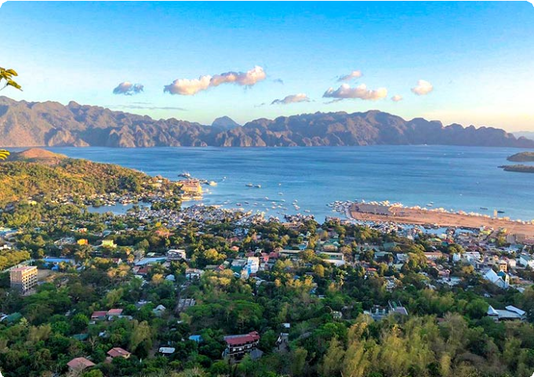
Dining：Breakfast Accommodation：El Nido
Mt. Tapyas, Coron
Mt. Tapyas, Coron

 Day 5 Coron Island Hopping Tour A | Kayangan Lake, Green Lagoon, Quin Reef, Atwayan Beach, CYC Beach, Las Isla De Coral

Get ready for an exhilarating day of island hopping in Coron, where you’ll discover crystal-clear lagoons, breathtaking beaches, and hidden gems.
After breakfast, your guide will pick you and head straight to iconic Kayangan
Lake, often referred to as the “cleanest lake in Asia.” Nestled in the heart of Coron, this crystal-clear freshwater lake is encircled by towering limestone cliffs, offering a
picturesque setting for your photos. As you approach, the natural beauty will take your breath away. Beneath the surface, you’ll find vibrant aquatic life swimming around
intricate rock formations and caves, making it a snorkeler's and diver’s paradise.

Next, head to the Green Lagoon, an equally breathtaking spot with emerald waters that shimmer under the sun. The calm, clear water, surrounded by lush cliffs, is
perfect for swimming and enjoying the serene beauty of the lagoon.

Continue your adventure at Quin Reef (also known as Malwawey Coral Garden), where the underwater world comes alive. As you snorkel through the vibrant coral gardens, you’ll be surrounded by schools of colorful fish, all dancing beneath the crystal-clear water.
From the reef, you’ll sail to Atwayan Beach, a hidden gem with pristine white sand,
crystal-clear waters, and small bamboo huts offering a touch of rustic charm. Take a
leisurely swim in the calm waters, or just relax under the swaying palm trees while you take in the beauty of this idyllic, peaceful beach.
Next, you’ll head to CYC Beach, named after the Coron Youth Club. This tranquil beach is a great spot for swimming, sunbathing, or simply relaxing under the shade of
mangrove trees. With its white sand and clear waters, the beach offers a picture-
perfect escape.

Finally, you’ll wrap up the tour at Las Islas de Coral, a famous snorkeling spot. Dive
into its warm waters and swim alongside a rainbow of colorful coral and tropical fish, experiencing the natural world in its full glory. The coral gardens here are vibrant and alive, offering a breathtaking end to your island-hopping adventure.
After the tour, you will be escorted to your hotel in Coron Town.

Dining：Breakfast, Lunch
Accommodation：Coron



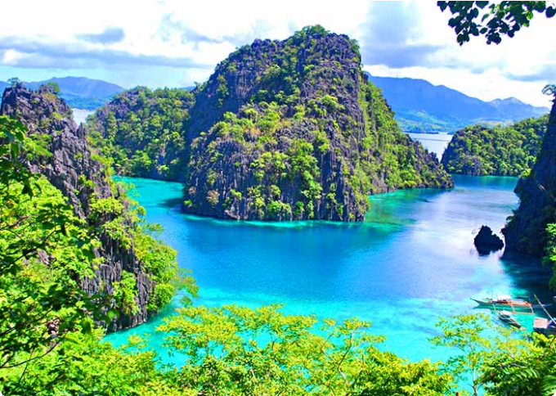
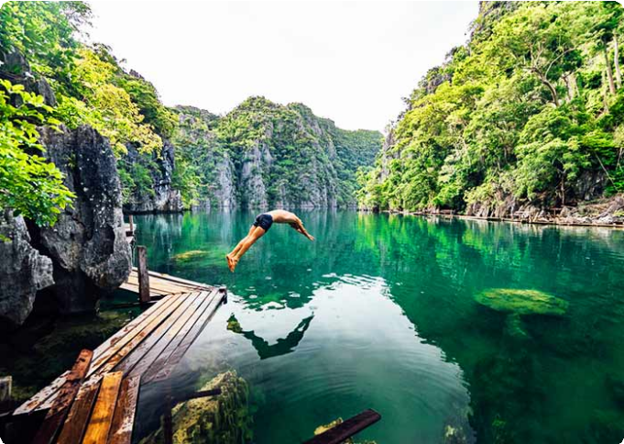
 Day 6 Coron Reef and Wrecks Tour | Pass Island, Lusong Coral Garden, Lusong Gunboat, East Tangat Wreck
Kayangan Lake, Coron
Kayangan Lake, Coron

Today, get ready to dive into Coron's rich history and vibrant marine life with the Reef and Wrecks Tour. This thrilling adventure combines stunning natural wonders with the eerie beauty of two sunken WWII shipwrecks, offering a truly unforgettable day on the water.
After breakfast, you’ll set off on a 2-hour boat ride to Pass Island, a small slice of paradise off the coast of Busuanga, Palawan. Picture soft white sand stretching
endlessly, coconut trees swaying in the breeze, and a sense of calm that makes it feel
like your own private oasis. Take a moment to relax, swim, or snorkel in the clear waters before you continue your journey.
Next, you’ll head to Lusong Coral Garden, the largest and most vibrant coral garden in Coron. Here, the water shimmers in every shade of blue and green, while beneath the surface, a breathtaking tapestry of colorful corals and marine life unfolds. The diversity of coral species here is staggering, offering a perfect underwater paradise
for snorkelers.

From there, you’ll visit the Lusong Gunboat, a sunken WWII vessel that’s become a
must-see for divers and snorkelers alike. Resting at a shallow depth of 10 meters, this gunboat wreck lies on its side, its rugged structure home to thriving marine life. As you explore, you’ll marvel at the contrast of history and nature - where the wreck’s worn edges meet the vibrancy of the ocean’s new inhabitants.
The adventure continues with the East Tangat Wreck is one of the most impressive. A 40-meter-long vessel that sunk on September 24, 1944, it’s believed to have been
either a tugboat or anti-submarine craft. Resting on a sandy slope, its stern is visible
at 22 meters (72 feet) during low tide, offering a glimpse into both the past and the

ocean’s vibrant present. You’ll have the chance to snorkel around the ship, marveling at the eerie beauty of this submerged piece of history.

After the tour, you will be escorted to your hotel in Coron Town.

Dining：Breakfast, Lunch
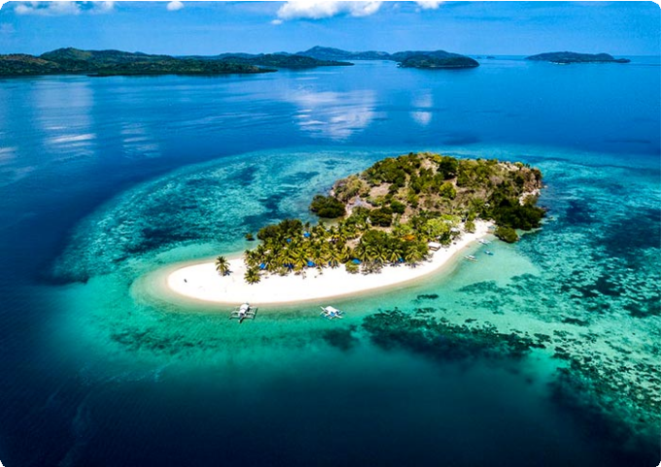
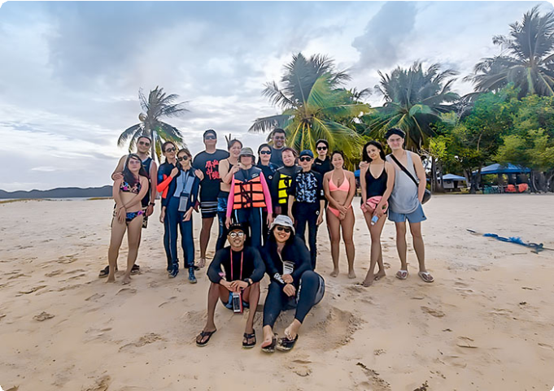
Accommodation：Coron
Pass Island, Coron
Pass Island, Coron

 Day 7 Coron - Cebu - Bohol | Magellan's Cross, Basilica Minore del Santo Nino, Fort San Pedro

In this morning, your group will be escorted to the Coron Airport (Busuanga Island Airport in Palawan), to take your flight to Cebu. Upon arrival in Cebu, you will enjoy a half-day tour of Cebu.
Start your time in Cebu with a visit to Magellan's Cross, a significant symbol of the arrival of Christianity in the Philippines. This iconic landmark marks the spot where Ferdinand Magellan planted a cross in 1521.
Next, head to the Basilica Minore del Santo Niño, a beautiful and historical church
that houses the revered statue of the Santo Niño, a symbol of faith and devotion for Filipinos.
Then, pay a visit to Fort San Pedro which is a Spanish colonial fort that was built in 1738 to defend the island from pirates and invaders. The fort's walls, cannons, and exhibits showcase the history of Bohol.
After the tour, you'll board a ferry to Bohol (about 2 hours), where you can enjoy a scenic journey across the Visayan Sea. Upon arrival at Bohol port, your driver will

transfer you to your hotel in Bohol.


Bohol is the heart of the Central Visayas island group. This unique destination offers travelers a rare opportunity to explore the 1,200 cone-shaped Chocolate Hills and get up close with the Tarsier, one of the smallest primates in the world, known for its distinctive large eyes. Enjoy exciting activities such as exploring nearby islands with coral reefs, sea turtles, dolphin watching, whale sharks, and the Sardine Run. It's a
place of natural wonders and thrilling adventures.

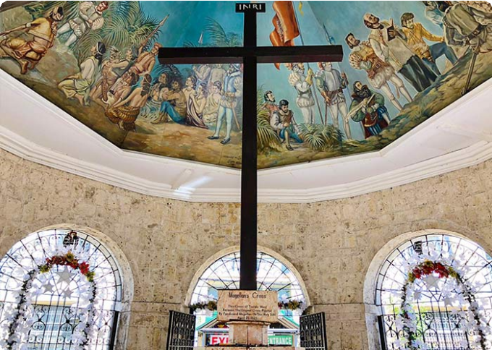
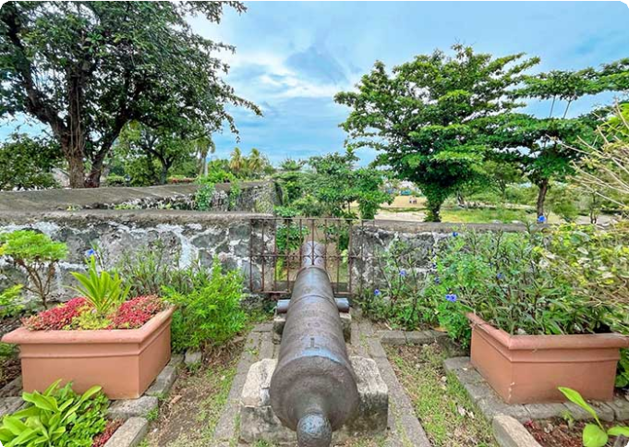
Dining：Breakfast Accommodation：Bohol
Magellan's Cross, Cebu
Fort San Pedro, Cebu

 Day 8 Bohol Tour | Napaling Reef (Sardine Run Experience), Loboc River Cruise, Philippine Tarsier Sanctuary, Chocolate Hills

After breakfast, your local guide and driver will pick up your group from the hotel. Your first stop is Napaling Reef, located on the northern side of Panglao Island. Here, you’ll have the opportunity to experience the breathtaking sardine run. Dive into the water and witness thousands of sardines swimming in mesmerizing, synchronized patterns.
You’ll swim among them and capture stunning photos and videos. (Tip: 1. The best time to visit is between 6:00 AM and 10:00 AM. 2. Our team will provide a GoPro for your group to capture amazing underwater footage of the sardine run. You’re free to keep all the unedited photos and videos.)
After that, enjoy a Bohol countryside tour and board a traditionally decorated cruise floating on the Loboc River. You will enjoy a buffet lunch onboard. The Loboc River flows through the town of Loboc, 24 kilometers east of Tagbilaran City. Relax on the leisure boat as it glides through calm, green waters, surrounded by dense tropical

forests, coconut palms, and mangroves. Experience local life and cultural performances along the riverbanks.

Later, you'll visit the Bohol Tarsier Conservation Area to see Philippine Tarsier. It is a protected area for the Philippine tarsier (Carlito syrichta), one of the smallest primates in the world. Get up close to these adorable creatures, known for their small size, large eyes, and long tails. You'll be amazed at how tiny and delicate the tarsiers are as you
observe their unique behaviors, such as clinging to branches or tree trunks and rotating their heads almost 180 degrees. Our guide will provide more information
about the tarsiers' unique behaviors and biology. (Please remember: no touching, no loud noises, and no flash photography.)
The last stop is the iconic Chocolate Hills in Bohol. During the dry season, the grass covering these hills turns brown, giving them the appearance of chocolate mounds -hence the name "Chocolate Hills." To reach the viewing decks at the Chocolate Hills
Complex, you’ll need to climb a few stairs. From here, you’ll enjoy a panoramic view of the entire Chocolate Hills. There are between 1,268 and 1,776 hills in total. Let the beauty of the Chocolate Hills embrace you as you take in the symmetrical, cone-shaped formations, each ranging in height from 30 to 50 meters. Enjoy your time here and capture stunning panoramic photos.
After the tour, you and your group will be escorted back to your hotel. Enjoy a good rest tonight!

Dining：Breakfast, Lunch
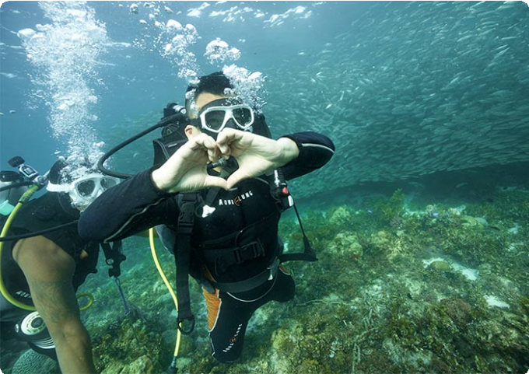
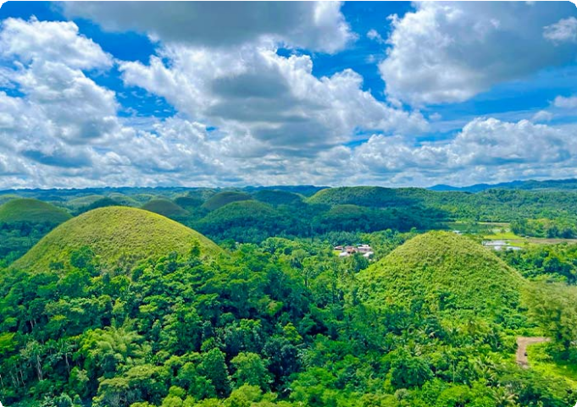
Accommodation：Bohol
Sardine Run Experience at Napaling Reef
Chocolate Hills, Bohol


Day 9 Bohol to Siquijor via Ferry | Balicasag Islands ( Dolphin Watching)

This morning, your guide will pick you up from your hotel to begin an exciting island-hopping tour focused on dolphin watching. You'll be transferred to the boat docking area and board a boat bound for Balicasag Island. En route, you'll have a fantastic
opportunity to observe dolphins in their natural habitat. This area is teeming with diverse marine wildlife, including at least seven different species of wild whales and
countless wild dolphins. With patience, you might witness a group of dolphins leaping gracefully from the water, their shiny, gray bodies glistening in the sunlight as they
twist and spin before diving back into the clear sea.

Dolphin Watching Tips:

It's advisable to start early in the morning, just after sunrise, as dolphins are most active during this time
Keep in mind that dolphins are wild animals, so sightings are not guaranteed. Enjoy the boat ride and the beauty of the sea while waiting for them to appear.
After that, you'll stop at Balicasag Island for further exploration. Located about 6 km from Panglao Island, Balicasag is easily accessible by boat. The island features a
stunning 3,000-foot-deep fault, known as the deepest and most beautiful underwater cliff in Asia. It's a marine paradise renowned for its thriving coral reefs and vibrant
marine life, and is part of a protected marine sanctuary. Here, you can see vibrant
coral reefs and a variety of tropical fish species, such as clownfish, parrotfish, lionfish, butterflyfish, and schools of jackfish. On the southeast side, you can visit the turtle point, where there's a high chance of seeing sea turtles grazing on seagrass or swimming gracefully. Alternatively, relax on the white sand beaches for some peaceful time.
Subject to Change: Please note that some activities may be subject to change due to weather conditions. Your safety is our top priority, and we may need to reschedule or cancel activities in case of unfavorable weather, such as strong winds. We appreciate your understanding and cooperation as we ensure a safe and enjoyable island-
hopping experience.

After the tour, you will be transferred to the port in Tagbilaran City, Bohol. Here, you will board an OceanJet ferry to Siquijor (about 2 hours). Upon arrival at the port in
Siquijor Island, you will be escorted to your hotel for check-in. Enjoy the rest of the day at your leisure.

Dining：Breakfast Accommodation：Siquijor



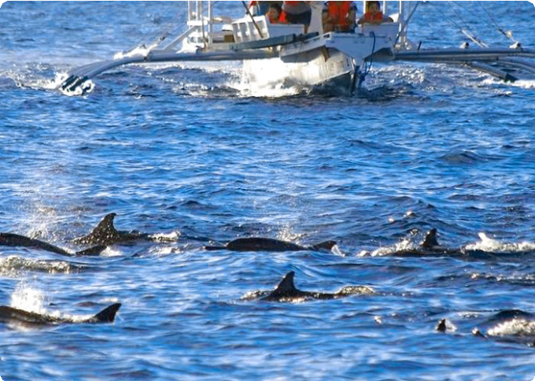
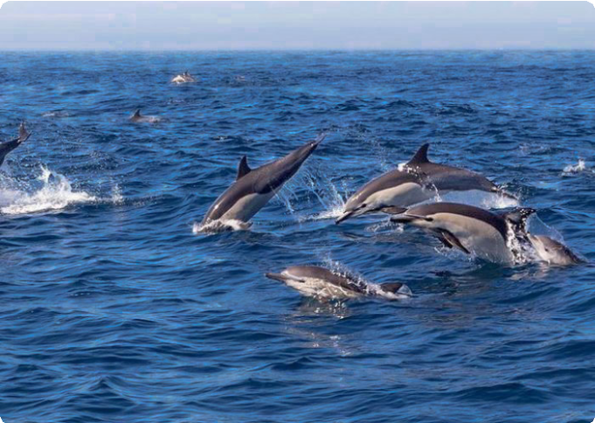
 Day 10 Siquijor to Dumaguete via Ferry | Capilay Spring Park, Tubod Beach, Lugnason Falls, Old Enchanted Balete Tree, Lazi Convent, Kagusuan Beach, Cambugahay Falls
Dolphin Watching at Balicasag Islands
Dolphin Watching at Balicasag Islands

On this day, your group will fully explore Siquijor, often referred to as the "Island of Fire." You will visit 7 small spots on this mystical island. This peaceful and less-
crowded island is known for its natural beauty, pristine beaches, waterfalls, and
mystical healing traditions. It's also renowned for its faith healers, herbal medicines, and rich folklore. Enjoy swimming, diving, and leisurely strolls here.
Capilay Spring Park: Start your day with a visit to this natural spring-fed pool. The cool, clean water flows directly from an underground spring, making it ideal for a refreshing morning swim.
Tubod Beach: Next, take a relaxing stroll along Tubod Beach, home to the famous Coco Grove Beach Resort. Enjoy the gentle breeze and the view of the turquoise waters.
Lugnason Falls: Continue to Lugnason Falls, a tranquil and lesser-known waterfall
surrounded by dense jungle. The single cascade flows into a natural pool, perfect for swimming in the cool, clear water beneath the falls.
Old Enchanted Balete Tree: Visit the 400+-year-old Balete tree, surrounded by myths and legends. At its base, a natural spring has been developed into a small fish spa pool. Sit on the edge and let the tiny fish gently nibble away dead skin.
Lazi Convent: Explore Lazi Convent, one of the most significant historical landmarks on the island. This two-story Spanish colonial architecture is considered one of the
largest and oldest convents in Asia. The lower floor is made of coral stones, while the

upper floor is built from hardwood. Walk through the museum for a glimpse into Siquijor’s history and religious traditions.

Kagusuan Beach: Head to Kagusuan Beach on the southeastern coast of Siquijor Island. Enjoy the secluded and peaceful atmosphere, the sound of the waves, and a walk on the soft sand.
Cambugahay Falls: The highlight of your day is a visit to Cambugahay Falls. This
three-tiered waterfall is known for its crystal-clear turquoise waters, surrounded by lush greenery. It's perfect for swimming and adventurous activities like rope swinging.
Descend approximately 135 steps to reach the waterfalls, where you can swim in the pools or try the rope swing, plunging into the water below. For thrill-seekers, some
areas of the falls are suitable for cliff jumping. Tip: Ensure the water depth is safe and seek guidance from your guide before jumping.
After the tour, you'll be transferred to the ferry port to take the OceanJet Ferry to
Dumaguete (about 40 min). Stay overnight in Dumaguete.

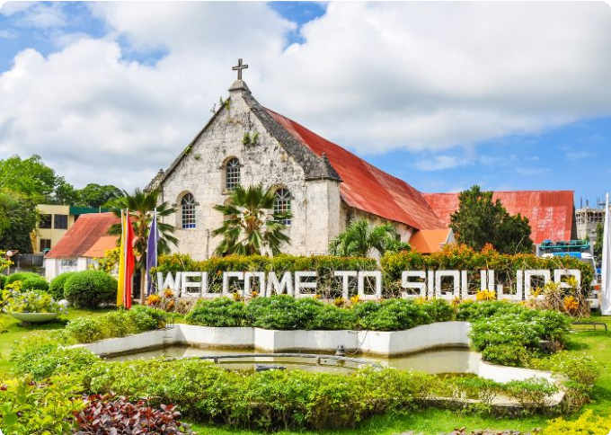
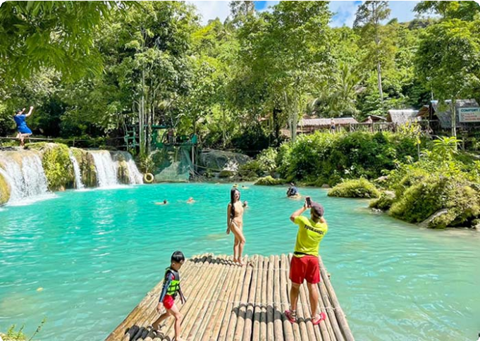
Dining：Breakfast Accommodation：Dumaguete
Siquijor Island
Cambugahay Falls, Siquijor Island

 Day 11 Dumaguete Island Hopping Tour | Apo Island (Sea Turtles)

In the early morning, your group will be picked up from your hotel in Dumaguete and transferred to the Dauin Jetty Port to board a boat to Apo Island (about 30 minutes).
Apo Island is a small volcanic island renowned for its thriving coral reefs and diverse marine life, making it one of the world's premier snorkeling and diving destinations.

The island is home to over 650 species of fish and 400 species of coral.


Apo Island is also a haven for sea turtles. The island's shallow waters provide an ideal environment for snorkeling with these gentle creatures. Green sea turtles and hawksbill turtles are frequently spotted, often grazing on seagrass in the shallow waters. (Tip: Do not touch or disturb the turtles. Maintain a distance of at least 3 meters when observing them.) Also, you'll explore the Coral Garden, a snorkeler's
paradise known for its lush coral formations and an array of vibrant sea life, including turtles, clownfish, and perhaps even a passing manta ray.
After your snorkeling adventure, enjoy lunch on the beach. Following lunch, take some leisure time to walk around the island at your own pace. You'll be greeted by the warm local residents and have the opportunity to learn about their simple way of life. There's also a viewing deck at the southern tip where you can enjoy a beautiful sea view.
After the tour, you'll be escorted back by ferry to Dumaguete. Stay overnight in Dumaguete.

Dining：Breakfast, Lunch
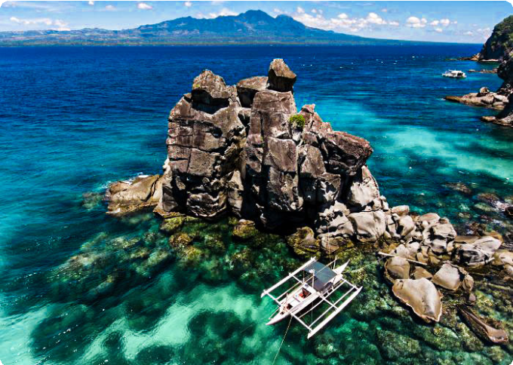
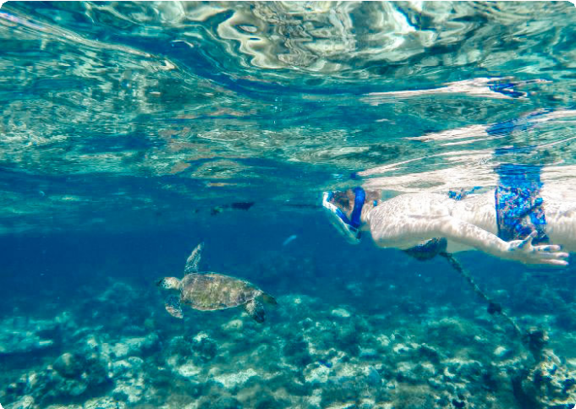
Accommodation：Dumaguete
Apo Island, Dumaguete
Apo Island, Dumaguete

 Day 12 Dumaguete Departure | Hotel Check-out and Airport/Port See-off

Enjoy your breakfast at your hotel in Dumaguete. Afterward, you'll have some free
time to explore the city at your own pace. Later, your group will be escorted to Sibulan Airport (also known as Dumaguete Airport) for your flight to your next destination. (Tips: Flights are available from Dumaguete to Manila, with a flight duration of about 1 hour and 30 minutes.)

Thank you for choosing us for your journey through Asia. We are committed to enhancing your travel experiences and look forward to welcoming you on your next adventure in Asia. Have a safe and pleasant journey home!

Dining：Breakfast Accommodation：None

Month | Available Date
Apr | Apr.07, 2025
Apr | Apr.15, 2025
Apr | Apr.27, 2025
May | May.12, 2025
Jun | Jun.16, 2025
Jul | Jul.14, 2025
Aug | Aug.18, 2025
Aug | Aug.25, 2025
Sep | Sep.15, 2025
Oct | Oct.13, 2025
Oct | Oct.27, 2025
Nov | Nov.11, 2025
Nov | Nov.23, 2025
Dec | Dec.01, 2025
Dec | Dec.09, 2025
Dec | Dec.21, 2025

Dec.29, 2025

Price: What’s Included & What’s Excluded

What's included?
English-speaking guide;
Ferries as listed in the itinerary;
Admission tickets for all attractions listed in the itinerary; Accommodation as listed in the itinerary;
All ground transportation during sightseeing; Airport Transfers: complimentary at fixed times;
Meals listed in “breakfast” or “lunch” in the above day to day itinerary; 24/7 customer support

What's excluded?

Travel Insurance Entry visa fees
International Flights Personal expenses
Single room supplement
Recommended optional activities: It may offer optional activities that are not included in the tour price, such as scuba diving, hot spring, etc.
Tips or gratuities for guides and drivers

Important Trip Notes for Booking This Tour

A Philippine Group Tour: Land Tours and Island Hopping
Our group tours in the Philippines consist of two types: land tours and island-hopping adventures.
Land Tours: We intentionally keep our land tours small, with a maximum of 8
travelers per group. If your group exceeds this number, don't worry! For groups of

9 or more, we’ll seamlessly divide you into two smaller groups, each with dedicated guides and vehicles. This ensures personalized attention and a comfortable travel experience for everyone.
Island Hopping: For island-hopping adventures, the seating capacity of boats and transfer vehicles depends on the actual number of travelers on the day of the tour, ensuring flexibility and convenience for all participants.

Scheduled Airport Transfers
Our complimentary airport transfer service is available at fixed times. Please
ensure your arrival aligns with these scheduled transfers. If your flight does not
coincide with the scheduled times, alternative transfer arrangements can be made at an additional cost.

Transportation
For land transportation, we will use comfortable vehicles with a seating capacity of 9 to 12 passengers during the tour. For sea transportation, we will arrange ferry services according to the schedules provided by the shipping companies.

Special Conditions for Attractions
Depending on the policies and conditions of each attraction, different
arrangements will be in place. For example, at the Underground River National Park, the park administration will organize boat tours. According to these
arrangements, you will share a boat with other guests to enter the cave.

Changes to Itinerary
While we strive to adhere to the planned itinerary, we may need to make adjustments due to weather conditions, safety concerns, or other unforeseen circumstances. We reserve the right to make adjustments as needed.
By booking a tour with us, you agree to these terms and conditions. We look
forward to providing you with an unforgettable travel experience in the Philippines.

What to Bring for the Philippines Tour

Passport (Valid for 6 months from date of departure)
Visa if required

Cash and Credit/Debit Cards Lightweight and Breathable Clothing Hat, Sunglasses, and Sunscreen Swimwear, Wetsuit, Water Shoes

Camera, phone, charger, and power bank
Insect Repellent to protect against mosquitoes

Personal Hygiene Products Personal Snorkeling Gear

Cancellation Policy

Thank you for choosing our services. We understand that sometimes plans change and adjustments are necessary. Below is our cancellation policy applicable to all our bookings:

Tours/Activities:
More than 9 days before the service date: No penalties.
Less than 9 days before the service date: Tours are non-refundable, except in cases of force majeure.

Hotels:
Cancel more than 61 days in advance: Free cancellation.
Cancel 31-60 days in advance: 50% of the room rate will be charged. Cancel 0-30 days in advance: 100% of the room rate will be charged.

Transfers:
More than 72 hours before the service date: No penalty.
Less than 72 hours before the service date: Non-refundable, except in cases of force majeure.
We kindly ask for your understanding that these policies are in place to ensure that we can manage our bookings and resources effectively while continuing to offer quality
services to all our guests.

