6 Days Philippines Group Tour: Bohol Siquijor Dumaguete
Route: Bohol - Siquijor - Dumaguete

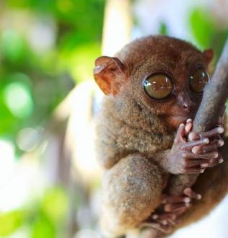
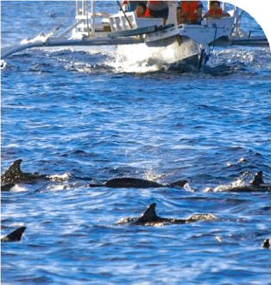
Tour Code: AOT-PHG-009 Group Tour Lowest Price Guarantee Recommended Rating: 5 Star

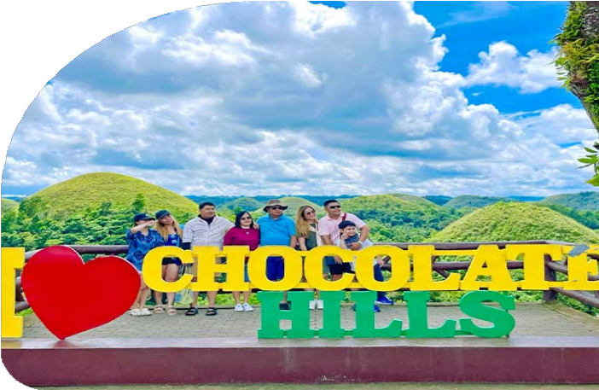
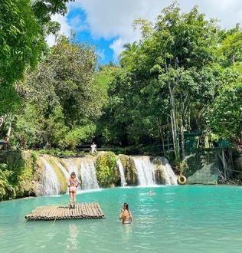
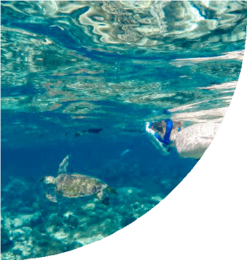
3 Famous Destinations in the Central Visayas: Diverse Experience
If you're seeking a brief yet exciting adventure in the Philippines, our 6-day
Philippines group tour is perfect for you! Explore the top three renowned destinations in Central Visayas: Bohol, Siquijor, and Dumaguete.

This tour combines land exploration with island-hopping excitement. In Bohol, marvel at the iconic Chocolate Hills and encounter the charming Philippine tarsiers. Enjoy a

leisurely cruise along the Loboc River, immersing yourself in local life. Discover mystical traditions and experience a fish spa on Siquijor Island.
You'll take three thrilling island-hopping adventures and enjoy an amazing experience:
(1) Sardine Run at Napaling Reef, (2) Sea Turtle Watching at Apo Island, (3) Dolphin Watching at Balicasag Island, and (4) Rope Swing at Cambugahay Falls. Dare to try these exhilarating activities? Join us on this small group tour for the ultimate sea adventure!

Group Information

Available: All year
Languages: English

Difficulty: Easy
Duration 6 days


Features:
Nature, Islands, Beaches, Wildlife, Marine Life, Sardine Runs, Dolphins, Tarsiers, Turtles, Island Hopping, Swimming, Snorkeling, Hills, Rivers, Waterfalls

You Can Experience “Must-see & Must-do” with This Tour

- Prepare to be amazed on Panglao Island! Dive into the mesmerizing spectacle of thousands of sardines moving in unison, creating a shimmering underwater
dance at Napaling Reef.

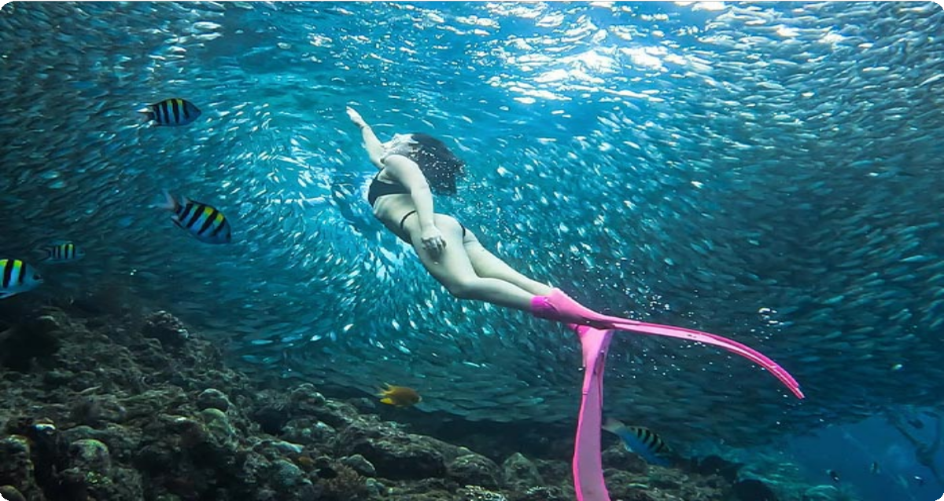
- Enjoy panoramic views of the Chocolate Hills and marvel at the surreal landscape of over 1,200 perfectly cone-shaped hills - a geological wonder that
turns brown during the dry season, resembling chocolate mounds.


Day by Day Itinerary

 Day 1 Bohol Arrival | Pick-up Service & Hotel Check-in, Free Time Explore

Welcome to Bohol, home of the famous Chocolate Hills and the Philippine Tarsier. Upon arrival, our driver will meet you and your group at the airport and take you to your hotel on Panglao Island. Enjoy the rest of the day at your leisure.

Bohol Arrival Options (by Flight):

Bohol is served by the Bohol-Panglao International Airport (TAG) on Panglao Island. Travelers can fly to Bohol from Manila (1.5 hours), Coron (1h 40m), Boracay (1h 15m), and Clark (1h 25m).

Bohol is the heart of the Central Visayas island group. This unique destination offers travelers a rare opportunity to explore the 1,200 cone-shaped Chocolate Hills and get up close with the Tarsier, one of the smallest primates in the world, known for its distinctive large eyes. Enjoy exciting activities such as exploring nearby islands with coral reefs, sea turtles, dolphin watching, whale sharks, and the Sardine Run. It's a
place of natural wonders and thrilling adventures. On Day 1, during your free time, you can relax on the stunning beaches or explore the island at your own pace.

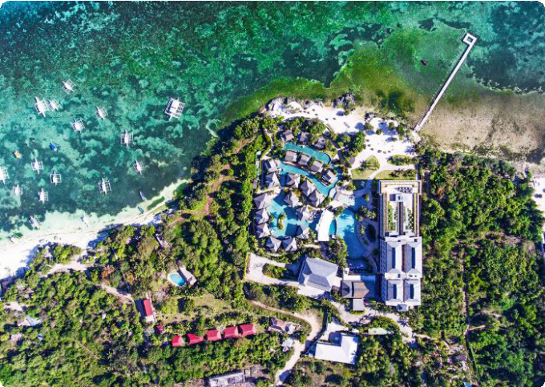
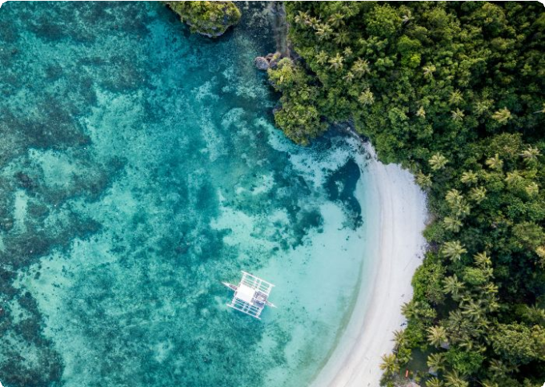
Dining：None Accommodation：Bohol
Bohol Island, Philippines
Bohol Island, Philippines

 Day 2 Bohol Tour | Napaling Reef (Sardine Run Experience), Loboc River Cruise, Philippine Tarsier Sanctuary, Chocolate Hills

After breakfast, your local guide and driver will pick up your group from the hotel. Your first stop is Napaling Reef, located on the northern side of Panglao Island. Here, you’ll have the opportunity to experience the breathtaking sardine run. Dive into the water and witness thousands of sardines swimming in mesmerizing, synchronized patterns.
You’ll swim among them and capture stunning photos and videos. (Tip: 1. The best time to visit is between 6:00 AM and 10:00 AM. 2. Our team will provide a GoPro for your group to capture amazing underwater footage of the sardine run. You’re free to keep all the unedited photos and videos.)

After that, enjoy a Bohol countryside tour and board a traditionally decorated cruise floating on the Loboc River. You will enjoy a buffet lunch onboard. The Loboc River flows through the town of Loboc, 24 kilometers east of Tagbilaran City. Relax on the leisure boat as it glides through calm, green waters, surrounded by dense tropical

forests, coconut palms, and mangroves. Experience local life and cultural performances along the riverbanks.
Later, you'll visit the Bohol Tarsier Conservation Area to see Philippine Tarsier. It is a protected area for the Philippine tarsier (Carlito syrichta), one of the smallest primates in the world. Get up close to these adorable creatures, known for their small size, large eyes, and long tails. You'll be amazed at how tiny and delicate the tarsiers are as you
observe their unique behaviors, such as clinging to branches or tree trunks and rotating their heads almost 180 degrees. Our guide will provide more information
about the tarsiers' unique behaviors and biology. (Please remember: no touching, no
loud noises, and no flash photography.)

The last stop is the iconic Chocolate Hills in Bohol. During the dry season, the grass covering these hills turns brown, giving them the appearance of chocolate mounds -hence the name "Chocolate Hills." To reach the viewing decks at the Chocolate Hills
Complex, you’ll need to climb a few stairs. From here, you’ll enjoy a panoramic view of
the entire Chocolate Hills. There are between 1,268 and 1,776 hills in total. Let the beauty of the Chocolate Hills embrace you as you take in the symmetrical, cone-shaped formations, each ranging in height from 30 to 50 meters. Enjoy your time here and capture stunning panoramic photos.
After the tour, you and your group will be escorted back to your hotel. Enjoy a good rest tonight!

Dining：Breakfast, Lunch
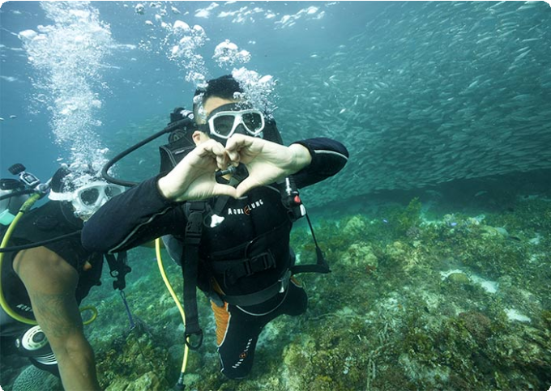
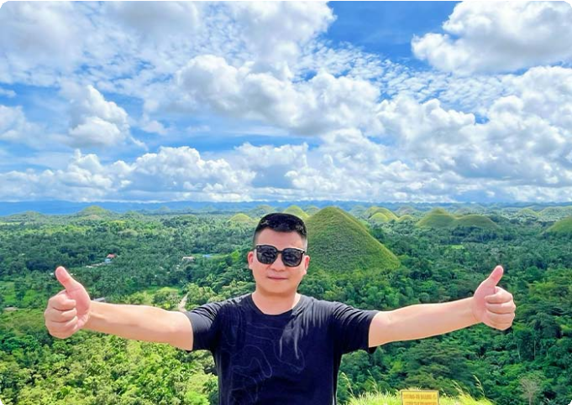
Accommodation：Bohol
Sardine Run Experience at Napaling Reef
Chocolate Hills, Bohol

 Day 3 Bohol to Siquijor via Ferry | Dolphin Watching, Balicasag Islands

This morning, your guide will pick you up from your hotel to begin an exciting island-hopping tour focused on dolphin watching. You'll be transferred to the boat docking area and board a boat bound for Balicasag Island. En route, you'll have a fantastic
opportunity to observe dolphins in their natural habitat. This area is teeming with diverse marine wildlife, including at least seven different species of wild whales and
countless wild dolphins. With patience, you might witness a group of dolphins leaping
gracefully from the water, their shiny, gray bodies glistening in the sunlight as they twist and spin before diving back into the clear sea.

Dolphin Watching Tips:

It's advisable to start early in the morning, just after sunrise, as dolphins are most active during this time
Keep in mind that dolphins are wild animals, so sightings are not guaranteed. Enjoy the boat ride and the beauty of the sea while waiting for them to appear.
After that, you'll stop at Balicasag Island for further exploration. Located about 6 km from Panglao Island, Balicasag is easily accessible by boat. The island features a
stunning 3,000-foot-deep fault, known as the deepest and most beautiful underwater
cliff in Asia. It's a marine paradise renowned for its thriving coral reefs and vibrant marine life, and is part of a protected marine sanctuary. Here, you can see vibrant coral reefs and a variety of tropical fish species, such as clownfish, parrotfish,
lionfish, butterflyfish, and schools of jackfish. On the southeast side, you can visit the turtle point, where there's a high chance of seeing sea turtles grazing on seagrass or swimming gracefully. Alternatively, relax on the white sand beaches for some peaceful time.
Subject to Change: Please note that some activities may be subject to change due to weather conditions. Your safety is our top priority, and we may need to reschedule or cancel activities in case of unfavorable weather, such as strong winds. We appreciate your understanding and cooperation as we ensure a safe and enjoyable island-
hopping experience.

After the tour, you will be transferred to the port in Tagbilaran City, Bohol. Here, you will board an OceanJet ferry to Siquijor (about 2 hours). Upon arrival at the port in
Siquijor Island, you will be escorted to your hotel for check-in. Enjoy the rest of the day at your leisure.

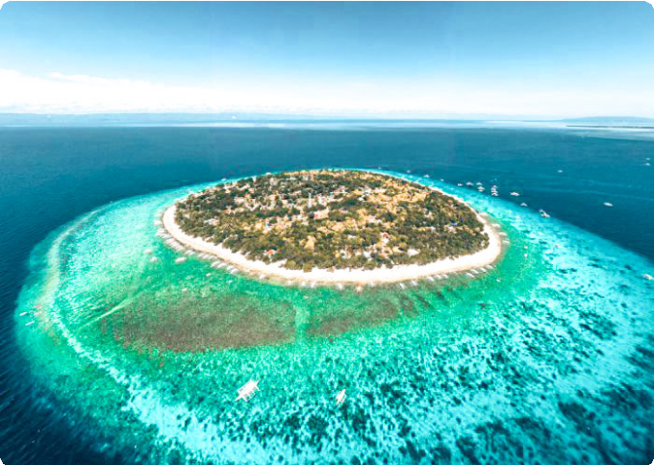
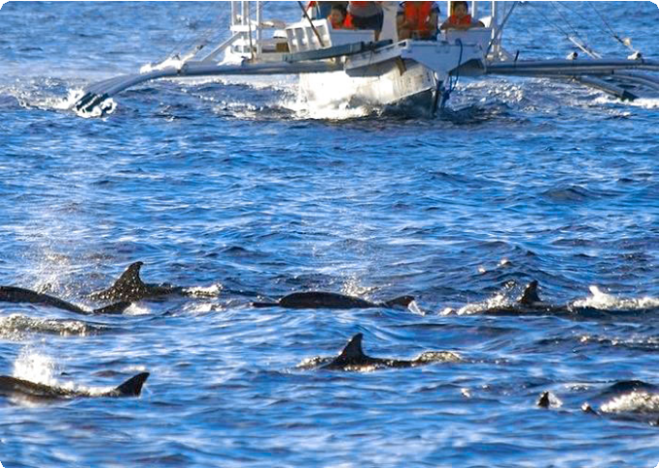
Dining：Breakfast Accommodation：Siquijor

Balicasag Islands
Dolphin Watching at Balicasag Islands

 Day 4 Siquijor to Dumaguete via Ferry | Capilay Spring Park, Tubod Beach, Lugnason Falls, Old Enchanted Balete Tree, Lazi Convent, Kagusuan Beach, Cambugahay Falls

On this day, your group will fully explore Siquijor, often referred to as the "Island of Fire." You will visit 7 small spots on this mystical island. This peaceful and less-
crowded island is known for its natural beauty, pristine beaches, waterfalls, and
mystical healing traditions. It's also renowned for its faith healers, herbal medicines, and rich folklore. Enjoy swimming, diving, and leisurely strolls here.
Capilay Spring Park: Start your day with a visit to this natural spring-fed pool. The cool, clean water flows directly from an underground spring, making it ideal for a refreshing morning swim.
Tubod Beach: Next, take a relaxing stroll along Tubod Beach, home to the famous Coco Grove Beach Resort. Enjoy the gentle breeze and the view of the turquoise waters.
Lugnason Falls: Continue to Lugnason Falls, a tranquil and lesser-known waterfall
surrounded by dense jungle. The single cascade flows into a natural pool, perfect for swimming in the cool, clear water beneath the falls.
Old Enchanted Balete Tree: Visit the 400+-year-old Balete tree, surrounded by myths and legends. At its base, a natural spring has been developed into a small fish spa pool. Sit on the edge and let the tiny fish gently nibble away dead skin.

Lazi Convent: Explore Lazi Convent, one of the most significant historical landmarks on the island. This two-story Spanish colonial architecture is considered one of the

largest and oldest convents in Asia. The lower floor is made of coral stones, while the
upper floor is built from hardwood. Walk through the museum for a glimpse into Siquijor’s history and religious traditions.
Kagusuan Beach: Head to Kagusuan Beach on the southeastern coast of Siquijor Island. Enjoy the secluded and peaceful atmosphere, the sound of the waves, and a walk on the soft sand.
Cambugahay Falls: The highlight of your day is a visit to Cambugahay Falls. This
three-tiered waterfall is known for its crystal-clear turquoise waters, surrounded by lush greenery. It's perfect for swimming and adventurous activities like rope swinging. Descend approximately 135 steps to reach the waterfalls, where you can swim in the pools or try the rope swing, plunging into the water below. For thrill-seekers, some
areas of the falls are suitable for cliff jumping. Tip: Ensure the water depth is safe and seek guidance from your guide before jumping.
After the tour, you'll be transferred to the ferry port to take the OceanJet Ferry to
Dumaguete (about 40 min). Stay overnight in Dumaguete.

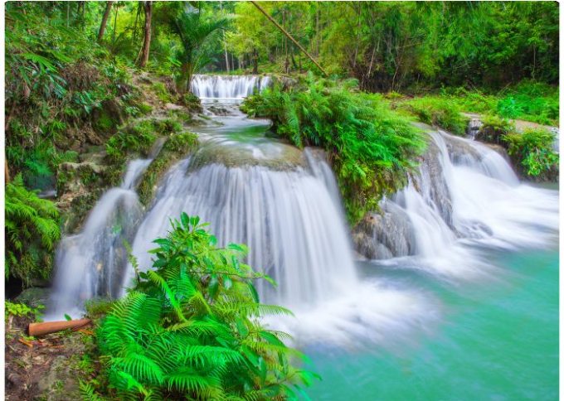
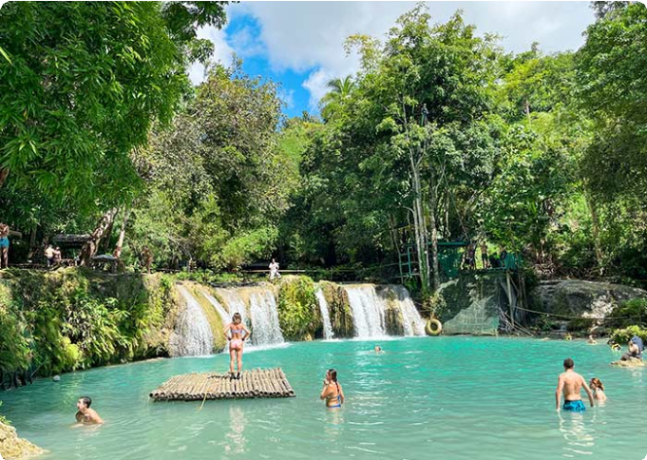
Dining：Breakfast Accommodation：Dumaguete


Siquijor Watefalls
Cambugahay Falls, Siquijor Island

 Day 5 Dumaguete Island Hopping Tour | Apo Island (Sea Turtles)

In the early morning, your group will be picked up from your hotel in Dumaguete and transferred to the Dauin Jetty Port to board a boat to Apo Island (about 30 minutes).

Apo Island is a small volcanic island renowned for its thriving coral reefs and diverse marine life, making it one of the world's premier snorkeling and diving destinations. The island is home to over 650 species of fish and 400 species of coral.

Apo Island is also a haven for sea turtles. The island's shallow waters provide an ideal environment for snorkeling with these gentle creatures. Green sea turtles and hawksbill turtles are frequently spotted, often grazing on seagrass in the shallow waters. (Tip: Do not touch or disturb the turtles. Maintain a distance of at least 3 meters when observing them.) Also, you'll explore the Coral Garden, a snorkeler's
paradise known for its lush coral formations and an array of vibrant sea life, including turtles, clownfish, and perhaps even a passing manta ray.
After your snorkeling adventure, enjoy lunch on the beach. Following lunch, take some leisure time to walk around the island at your own pace. You'll be greeted by the warm local residents and have the opportunity to learn about their simple way of life. There's also a viewing deck at the southern tip where you can enjoy a beautiful sea view.
After the tour, you'll be escorted back by ferry to Dumaguete. Enjoy your leisure time in this "City of Gentle People." Dumaguete City, the capital of Negros Oriental, is known
for the warm and welcoming nature of its residents. Stay overnight in Dumaguete.

Dining：Breakfast, Lunch
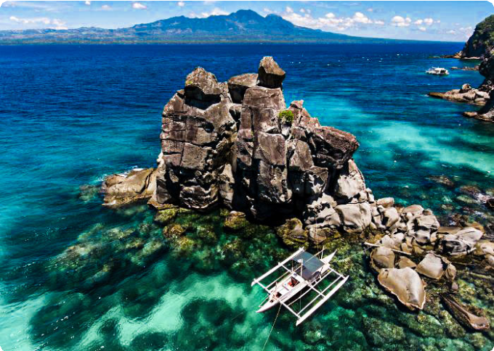
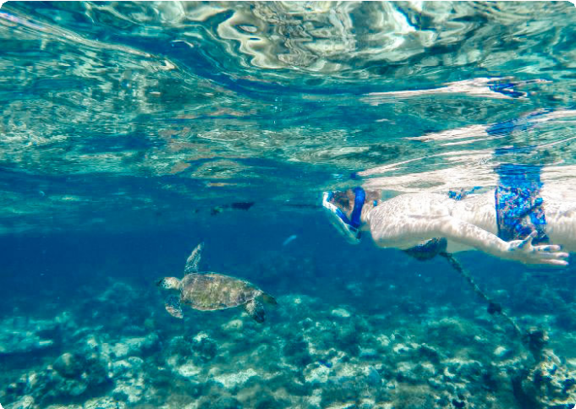
Accommodation：Dumaguete
Apo Island, Dumaguete
Apo Island, Dumaguete

 Day 6 Dumaguete Departure | Hotel Check-out and Airport/Port See-off

Enjoy your breakfast at your hotel in Dumaguete. Afterward, you'll have some free
time to explore the city at your own pace. Later, your group will be escorted to Sibulan

Airport (also known as Dumaguete Airport) for your flight to your next destination. (Tips: Flights are available from Dumaguete to Manila, with a flight duration of about 1 hour and 30 minutes.)

Thank you for choosing us for your journey through Asia. We are committed to enhancing your travel experiences and look forward to welcoming you on your next adventure in Asia. Have a safe and pleasant journey home!

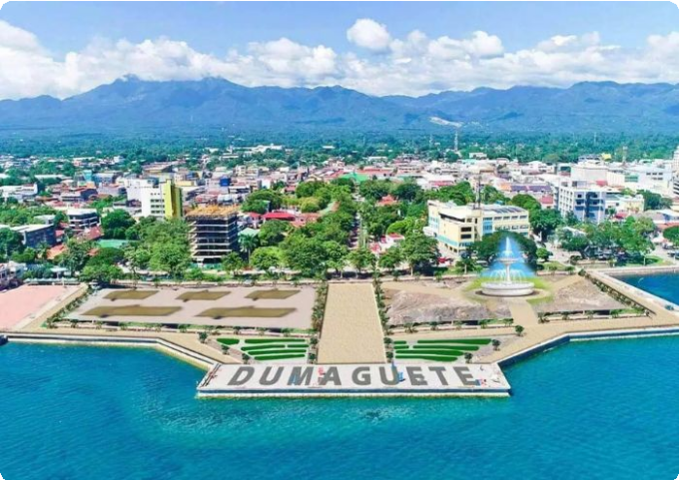
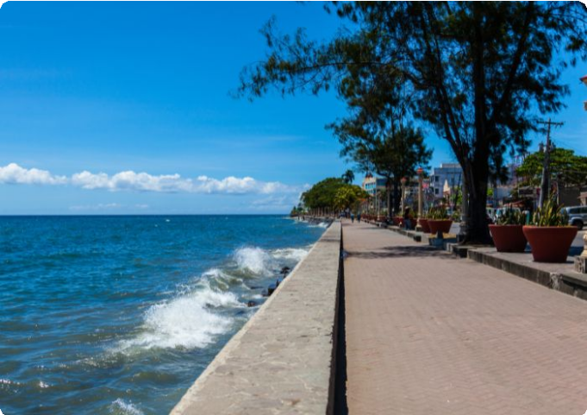
Dining：Breakfast Accommodation：None
Dumaguete City
Dumaguete City

Month | Available Date
Apr | Apr.05, 2025
Apr | Apr.13, 2025
Apr | Apr.21, 2025
May | May.03, 2025
May | May.18, 2025
Jun | Jun.22, 2025
Jul | Jul.20, 2025
Aug | Aug.24, 2025

Sep | Sep.21, 2025
Oct | Oct.19, 2025
Nov | Nov.02, 2025
Nov | Nov.17, 2025
Nov | Nov.29, 2025
Dec | Dec.07, 2025
Dec | Dec.15, 2025
Dec | Dec.27, 2025
Jan | Jan.04, 2026

Price: What’s Included & What’s Excluded

What's included?
English-speaking guide;
Ferries as listed in the itinerary;
Admission tickets for all attractions listed in the itinerary; Accommodation as listed in the itinerary;
All ground transportation during sightseeing; Airport Transfers: complimentary at fixed times;
Meals listed in “breakfast” or “lunch” in the above day to day itinerary; 24/7 customer support

What's excluded?

Travel Insurance Entry visa fees
International Flights Personal expenses
Single room supplement

Recommended optional activities: It may offer optional activities that are not included in the tour price, such as scuba diving, hot spring, etc.
Tips or gratuities for guides and drivers

Important Trip Notes for Booking This Tour

A Philippine Group Tour: Land Tours and Island Hopping
Our group tours in the Philippines consist of two types: land tours and island-hopping adventures.
Land Tours: We intentionally keep our land tours small, with a maximum of 8
travelers per group. If your group exceeds this number, don't worry! For groups of 9 or more, we’ll seamlessly divide you into two smaller groups, each with dedicated guides and vehicles. This ensures personalized attention and a
comfortable travel experience for everyone.
Island Hopping: For island-hopping adventures, the seating capacity of boats and transfer vehicles depends on the actual number of travelers on the day of the tour, ensuring flexibility and convenience for all participants.

Scheduled Airport Transfers
Our complimentary airport transfer service is available at fixed times. Please
ensure your arrival aligns with these scheduled transfers. If your flight does not
coincide with the scheduled times, alternative transfer arrangements can be made at an additional cost.

Transportation
For land transportation, we will use comfortable vehicles with a seating capacity of 9 to 12 passengers during the tour. For sea transportation, we will arrange ferry services according to the schedules provided by the shipping companies.

Special Conditions for Attractions
Depending on the policies and conditions of each attraction, different
arrangements will be in place. For example, at the Underground River National Park, the park administration will organize boat tours. According to these
arrangements, you will share a boat with other guests to enter the cave.

Changes to Itinerary
While we strive to adhere to the planned itinerary, we may need to make adjustments due to weather conditions, safety concerns, or other unforeseen

circumstances. We reserve the right to make adjustments as needed.
By booking a tour with us, you agree to these terms and conditions. We look
forward to providing you with an unforgettable travel experience in the Philippines.

What to Bring for the Philippines Tour

Passport (Valid for 6 months from date of departure)
Visa if required

Cash and Credit/Debit Cards Lightweight and Breathable Clothing Hat, Sunglasses, and Sunscreen Swimwear, Wetsuit, Water Shoes

Camera, phone, charger, and power bank
Insect Repellent to protect against mosquitoes

Personal Hygiene Products Personal Snorkeling Gear

Cancellation Policy

Thank you for choosing our services. We understand that sometimes plans change and adjustments are necessary. Below is our cancellation policy applicable to all our bookings:

Tours/Activities:
More than 9 days before the service date: No penalties.
Less than 9 days before the service date: Tours are non-refundable, except in cases of force majeure.

Hotels:
Cancel more than 61 days in advance: Free cancellation.
Cancel 31-60 days in advance: 50% of the room rate will be charged. Cancel 0-30 days in advance: 100% of the room rate will be charged.

Transfers:

More than 72 hours before the service date: No penalty.
Less than 72 hours before the service date: Non-refundable, except in cases of force majeure.

We kindly ask for your understanding that these policies are in place to ensure that we can manage our bookings and resources effectively while continuing to offer quality
services to all our guests.

