7 Days Visayas Group Tour: Boracay, Cebu, Bohol in Philippines
Route: Boracay - Cebu - Bohol

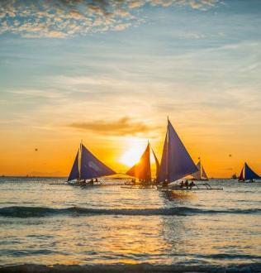
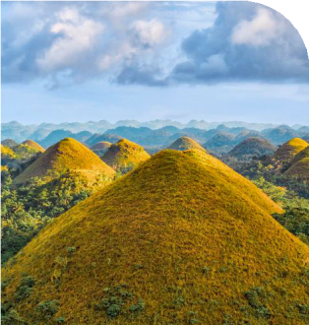
Tour Code: AOT-PHG-010 Group Tour Lowest Price Guarantee Recommended Rating: 5 Star

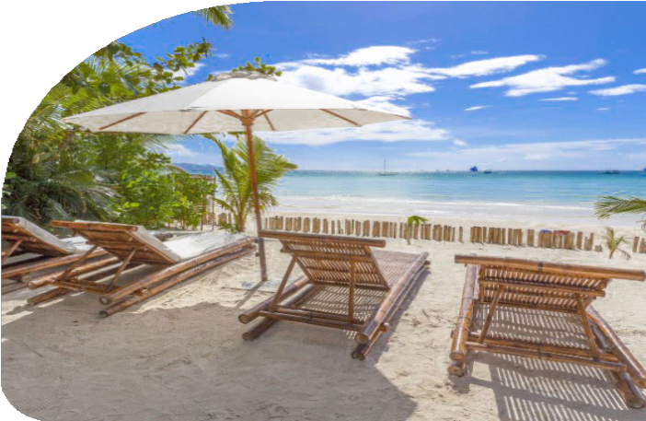
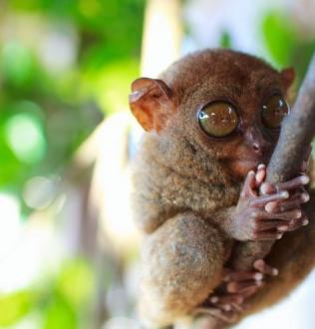
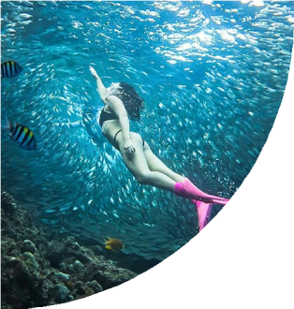
Beaches, History, Wildlife, Natural Wonders - All in One Trip
If you’re dreaming of a vacation that has it all - pristine beaches, rich history, wildlife encounters, and natural wonders - this Visayas Group Tour is your perfect match. Our journey will take you through the heart of the Philippines’ Visayas region: Boracay,

Cebu, and Bohol.

Picture yourself stepping onto the powdery white sands of Boracay, the island that feels like it was plucked straight from a postcard. Then, immerse yourself in the rich history

of Cebu, where iconic landmarks like Magellan’s Cross and the Basilica Minore del Santo Niño offer a slice of the past.
Wrap up your journey in Bohol, a nature lover's dream with its famous Chocolate Hills, a peaceful Loboc River cruise, and the chance to meet the adorable tarsiers. Plus,
Balicasag Island offers one of the best dolphin-watching experiences in the country.

Group Information

Available: All year
Languages: English

Difficulty: Easy
Duration 7 days


Features:
Nature, Islands, Beaches, Island Hopping, Swimming, Snorkeling, Marine Life, Seafood, Wildlife, Historical Site

You Can Experience “Must-see & Must-do” with This Tour

- Exlpore famous beach paradise - Boracay, strolling on powdery white sand shores, relaxing under the coconut palm trees. Revel in the limitless expanse of
sea and sky, and bask in the breathtaking spectacle of the sunset.

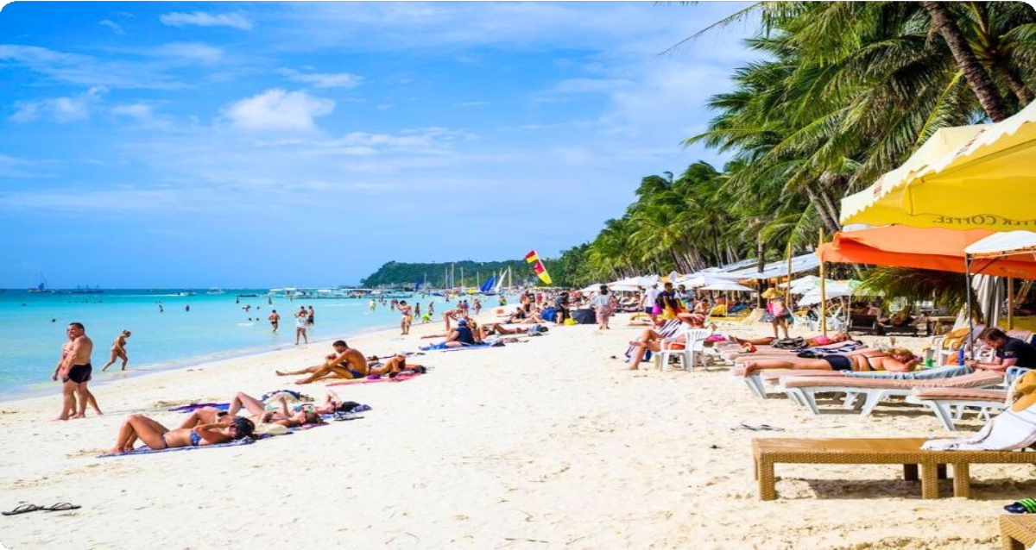
- Discover Boracay's natural treasures with a thrilling Island Hopping Adventure.
From snorkeling in the vibrant waters of Coral Garden to cliff diving at Magic
Island, each stop is filled with excitement and beauty.


Day by Day Itinerary

 Day 1 Boracay Arrival | Pick-up Service & Hotel Check-in

Welcome to Boracay Island, Philippines! Upon arrival at the Godofredo P. Ramos Airport (MPH), you can can enjoy the pre-arranged transfers to Caticlan Jetty Port, followed by a boat ride to Boracay Island. The boat ride typically takes around 15 minutes. And then you will be transported from port to your hotel for check-in. After settling in, you're free to explore the famous White Beach of Boracay.
Boracay Island, located in the Western Visayas region of the Philippines, is one of the country's most famous tourist destinations. Despite being only 7 kilometers long and shaped like a dumbbell, it’s home to the world-famous 4-kilometer stretch of White

Beach, often hailed as the ‘best beaches in the world” with its powdery sand and crystal-clear waters.


Arrival Ideas:

Godofredo P. Ramos Airport (MPH), commonly known as Caticlan Airport, is the
closest gateway to Boracay Island, located just 6.7 kilometers from Boracay's famous White Beach.
MPH primarily serves domestic flights from Manila, Cebu, and in recent years, it has expanded to handle international flights, including routes to Taipei, Taiwan.

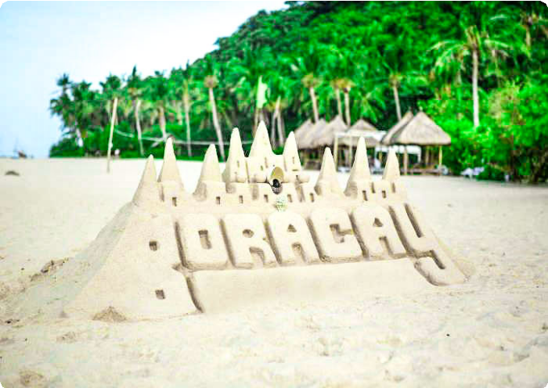
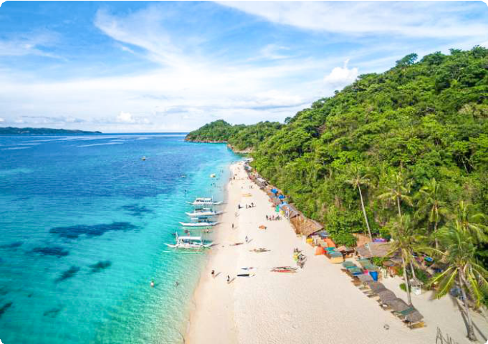
Dining：None Accommodation：Boracay
Boracay Island, Philippines
Boracay Island, Philippines

 Day 2 Boracay Island Hopping | Coral Garden Snorkeling, Magic Island, Angol Point Snorkeling, Sunset Sail

No trip to Boracay is complete without an unforgettable island-hopping experience, and today promises just that! Get ready for a day filled with adventure, natural beauty, and unforgettable memories.
Kick off your day with a visit to Coral Garden, one of Boracay’s most famous
snorkeling spots. Dive into its crystal-clear, shallow waters and discover a vibrant underwater world teeming with colorful corals and a diverse array of marine life.
Whether you’re a beginner or an experienced snorkeler, this spot offers an enchanting
experience for everyone.

Next, head to Magic Island, a thrilling destination famous for its cliff diving platforms. Feel the adrenaline surge as you take the leap from heights ranging from 3 to 10 meters, or simply enjoy the excitement as others make the plunge. If diving isn’t your style, soak up the stunning panoramic views, take a refreshing swim in the pristine waters, or unwind on the island’s tranquil shore

Continue your adventure at Angol Point, a quieter and more secluded snorkeling spot. This hidden gem is perfect for those seeking a peaceful escape from the crowds.
Immerse yourself in the tranquil waters and explore the rich marine biodiversity that
makes Boracay a snorkeler’s paradise.

As dusk approaches, you'll experience an exciting activity - Sunset Paraw Sailing. Hop on a traditional paraw boat and glide across the calm waters as the sun dips below
the horizon, painting the sky in hues of orange, pink, and purple.

Dining：Breakfast, Lunch
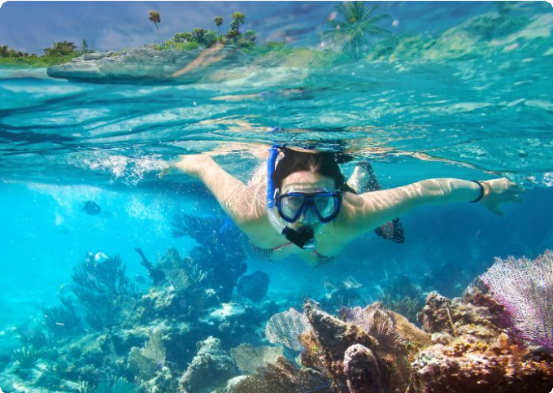
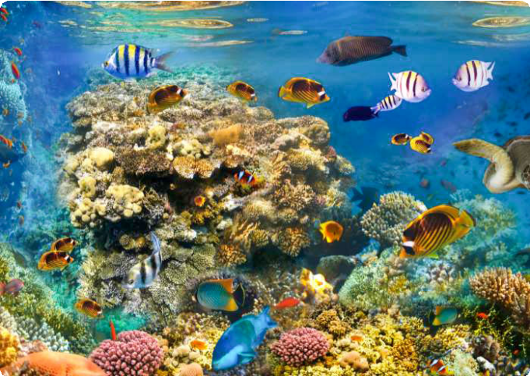
Accommodation：Boracay
Snorkeling on Boracay Island
Coral Garden, Boracay Island

 Day 3 Boracay Flight to Cebu | Port & Airport Transfers

Today, you’ll fly from Boracay to Cebu, with your flight arranged in advance. Upon arrival at Cebu Airport, your driver will be waiting to take you to your hotel. Once you've checked in and settled, the rest of the day is yours to enjoy at your own pace.

Dining：Breakfast Accommodation：Cebu



 Day 4 Cebu to Bohol via Ferry | Magellan's Cross, Basilica Minore del Santo Nino, Fort San Pedro

Start your day with a visit to Magellan's Cross, a significant symbol of the arrival of Christianity in the Philippines. This iconic landmark marks the spot where Ferdinand Magellan planted a cross in 1521.
Next, head to the Basilica Minore del Santo Niño, a beautiful and historical church
that houses the revered statue of the Santo Niño, a symbol of faith and devotion for Filipinos.
Then, pay a visit to Fort San Pedro which is a Spanish colonial fort that was built in 1738 to defend the island from pirates and invaders. The fort's walls, cannons, and exhibits showcase the history of Bohol.
After the tour, you'll board a ferry to Bohol (about 2 hours), where you can enjoy a scenic journey across the Visayan Sea. Upon arrival at Bohol port, your driver will transfer you to your hotel in Bohol.

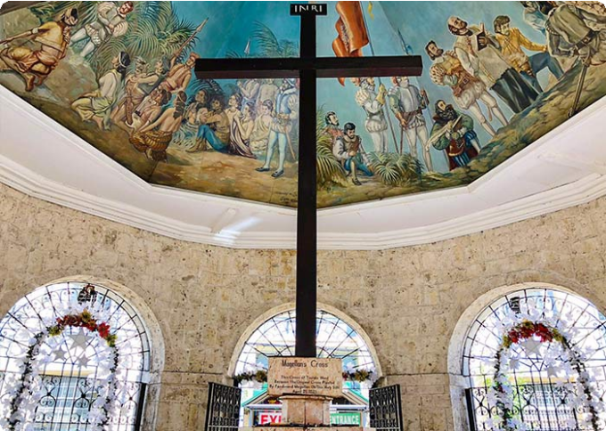
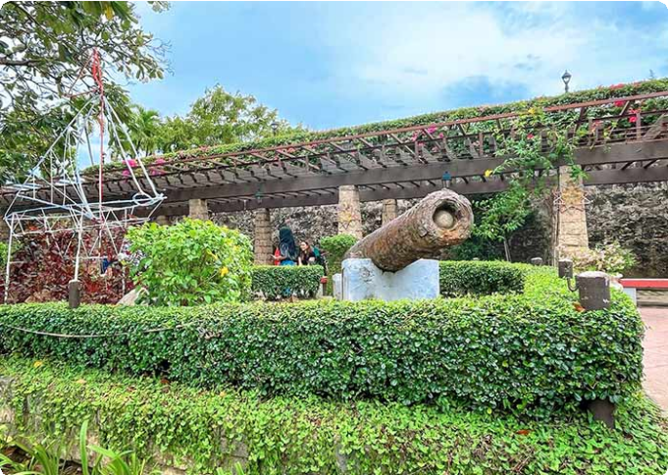
Dining：Breakfast Accommodation：Bohol
Magellan's Cross, Cebu
Fort San Pedro, Cebu

 Day 5 Bohol Tour | Napaling Reef (Sardine Run Experience), Loboc River Cruise, Philippine Tarsier Sanctuary, Chocolate Hills

After breakfast, your local guide and driver will pick up your group from the hotel. Your first stop is Napaling Reef, located on the northern side of Panglao Island. Here, you’ll have the opportunity to experience the breathtaking sardine run. Dive into the water

and witness thousands of sardines swimming in mesmerizing, synchronized patterns.
You’ll swim among them and capture stunning photos and videos. (Tip: 1. The best time to visit is between 6:00 AM and 10:00 AM. 2. Our team will provide a GoPro for your group to capture amazing underwater footage of the sardine run. You’re free to keep all the unedited photos and videos.)
After that, enjoy a Bohol countryside tour and board a traditionally decorated cruise floating on the Loboc River. You will enjoy a buffet lunch onboard. The Loboc River flows through the town of Loboc, 24 kilometers east of Tagbilaran City. Relax on the leisure boat as it glides through calm, green waters, surrounded by dense tropical
forests, coconut palms, and mangroves. Experience local life and cultural performances along the riverbanks.
Later, you'll visit the Bohol Tarsier Conservation Area to see Philippine Tarsier. It is a protected area for the Philippine tarsier (Carlito syrichta), one of the smallest primates in the world. Get up close to these adorable creatures, known for their small size, large eyes, and long tails. You'll be amazed at how tiny and delicate the tarsiers are as you
observe their unique behaviors, such as clinging to branches or tree trunks and rotating their heads almost 180 degrees. Our guide will provide more information
about the tarsiers' unique behaviors and biology. (Please remember: no touching, no
loud noises, and no flash photography.)

The last stop is the iconic Chocolate Hills in Bohol. During the dry season, the grass covering these hills turns brown, giving them the appearance of chocolate mounds -hence the name "Chocolate Hills." To reach the viewing decks at the Chocolate Hills
Complex, you’ll need to climb a few stairs. From here, you’ll enjoy a panoramic view of the entire Chocolate Hills. There are between 1,268 and 1,776 hills in total. Let the beauty of the Chocolate Hills embrace you as you take in the symmetrical, cone-shaped formations, each ranging in height from 30 to 50 meters. Enjoy your time here and capture stunning panoramic photos.
After the tour, you and your group will be escorted back to your hotel. Enjoy a good rest tonight!

Dining：Breakfast, Lunch
Accommodation：Bohol



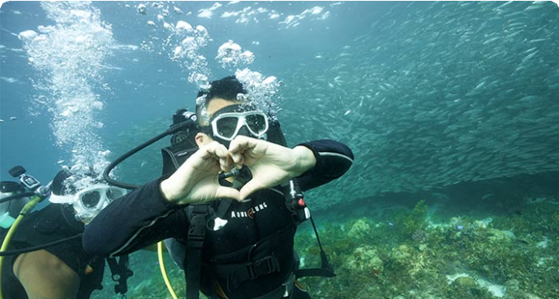
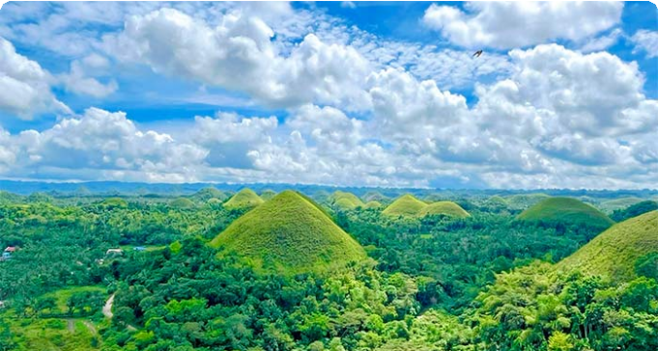
 Day 6 Bohol Tour | Dolphin Watching, Balicasag Islands

This morning, your guide will pick you up from your hotel to begin an exciting island-hopping tour focused on dolphin watching. You'll be transferred to the boat docking area and board a boat bound for Balicasag Island. En route, you'll have a fantastic
opportunity to observe dolphins in their natural habitat. This area is teeming with diverse marine wildlife, including at least seven different species of wild whales and
countless wild dolphins. With patience, you might witness a group of dolphins leaping
gracefully from the water, their shiny, gray bodies glistening in the sunlight as they twist and spin before diving back into the clear sea.

Dolphin Watching Tips:

It's advisable to start early in the morning, just after sunrise, as dolphins are most active during this time
Keep in mind that dolphins are wild animals, so sightings are not guaranteed. Enjoy the boat ride and the beauty of the sea while waiting for them to appear.
After that, you'll stop at Balicasag Island for further exploration. Located about 6 km from Panglao Island, Balicasag is easily accessible by boat. The island features a
stunning 3,000-foot-deep fault, known as the deepest and most beautiful underwater
cliff in Asia. It's a marine paradise renowned for its thriving coral reefs and vibrant marine life, and is part of a protected marine sanctuary. Here, you can see vibrant coral reefs and a variety of tropical fish species, such as clownfish, parrotfish,
lionfish, butterflyfish, and schools of jackfish. On the southeast side, you can visit the turtle point, where there's a high chance of seeing sea turtles grazing on seagrass or swimming gracefully. Alternatively, relax on the white sand beaches for some peaceful time.
Subject to Change: Please note that some activities may be subject to change due to weather conditions. Your safety is our top priority, and we may need to reschedule or cancel activities in case of unfavorable weather, such as strong winds. We appreciate your understanding and cooperation as we ensure a safe and enjoyable island-
hopping experience.

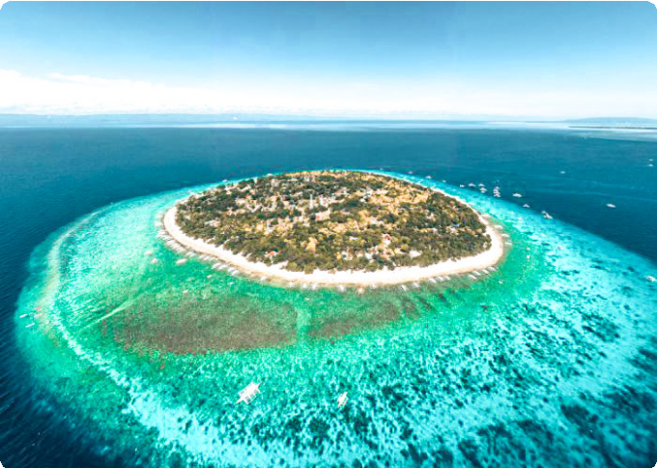
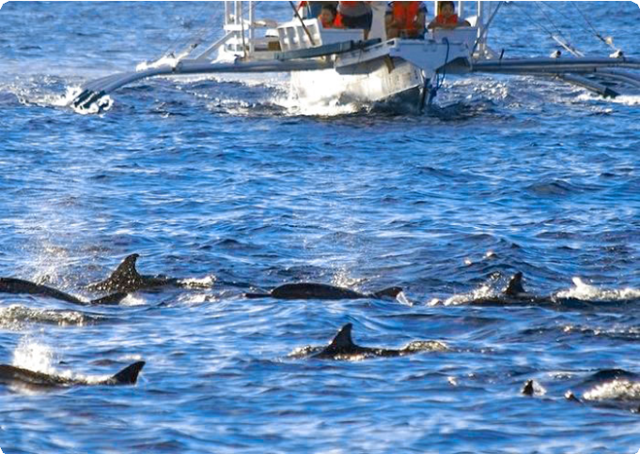
Dining：Breakfast Accommodation：Bohol

Balicasag Islands
Dolphin Watching at Balicasag Islands

 Day 7 Bohol Departure | Hotel Check-out and See-off

Time to say goodbye to Bohol, the fantastic base for adventure. It is time to end your
7-day Visayas Group Tour. Your driver will transfer you to the airport and you will continue on your next destination.
Thank you for choosing us for your Philippines tour, and you are always here working for you and hope to see you again for your next trip to Philippines. Safe journey!

Dining：Breakfast Accommodation：None

Month | Available Date
Apr | Apr.02, 2025
Apr | Apr.10, 2025
Apr | Apr.18, 2025
Apr | Apr.30, 2025

May | May.15, 2025
Jun | Jun.19, 2025
Jul | Jul.17, 2025
Aug | Aug.21, 2025
Sep | Sep.18, 2025
Oct | Oct.16, 2025
Oct | Oct.30, 2025
Nov | Nov.14, 2025
Nov | Nov.26, 2025
Dec | Dec.04, 2025
Dec | Dec.12, 2025
Dec | Dec.24, 2025
Jan | Jan.01, 2026

Price: What’s Included & What’s Excluded

What's included?
English-speaking guide;
Ferries as listed in the itinerary;
Admission tickets for all attractions listed in the itinerary; Accommodation as listed in the itinerary;
All ground transportation during sightseeing; Airport Transfers: complimentary at fixed times;
Meals listed in “breakfast” or “lunch” in the above day to day itinerary; 24/7 customer support

What's excluded?

Travel Insurance Entry visa fees
International Flights Personal expenses
Single room supplement
Recommended optional activities: It may offer optional activities that are not included in the tour price, such as scuba diving, hot spring, etc.
Tips or gratuities for guides and drivers

Important Trip Notes for Booking This Tour

A Philippine Group Tour: Land Tours and Island Hopping
Our group tours in the Philippines consist of two types: land tours and island-hopping adventures.
Land Tours: We intentionally keep our land tours small, with a maximum of 8
travelers per group. If your group exceeds this number, don't worry! For groups of 9 or more, we’ll seamlessly divide you into two smaller groups, each with dedicated guides and vehicles. This ensures personalized attention and a
comfortable travel experience for everyone.
Island Hopping: For island-hopping adventures, the seating capacity of boats and transfer vehicles depends on the actual number of travelers on the day of the tour, ensuring flexibility and convenience for all participants.

Scheduled Airport Transfers
Our complimentary airport transfer service is available at fixed times. Please
ensure your arrival aligns with these scheduled transfers. If your flight does not
coincide with the scheduled times, alternative transfer arrangements can be made at an additional cost.

Transportation
For land transportation, we will use comfortable vehicles with a seating capacity of 9 to 12 passengers during the tour. For sea transportation, we will arrange ferry services according to the schedules provided by the shipping companies.

Special Conditions for Attractions
Depending on the policies and conditions of each attraction, different
arrangements will be in place. For example, at the Underground River National

Park, the park administration will organize boat tours. According to these arrangements, you will share a boat with other guests to enter the cave.

Changes to Itinerary
While we strive to adhere to the planned itinerary, we may need to make adjustments due to weather conditions, safety concerns, or other unforeseen circumstances. We reserve the right to make adjustments as needed.
By booking a tour with us, you agree to these terms and conditions. We look
forward to providing you with an unforgettable travel experience in the Philippines.

What to Bring for the Philippines Tour

Passport (Valid for 6 months from date of departure)
Visa if required

Cash and Credit/Debit Cards Lightweight and Breathable Clothing Hat, Sunglasses, and Sunscreen Swimwear, Wetsuit, Water Shoes

Camera, phone, charger, and power bank
Insect Repellent to protect against mosquitoes

Personal Hygiene Products Personal Snorkeling Gear

Cancellation Policy

Thank you for choosing our services. We understand that sometimes plans change and adjustments are necessary. Below is our cancellation policy applicable to all our bookings:

Tours/Activities:
More than 9 days before the service date: No penalties.
Less than 9 days before the service date: Tours are non-refundable, except in cases of force majeure.

Hotels:

Cancel more than 61 days in advance: Free cancellation.
Cancel 31-60 days in advance: 50% of the room rate will be charged. Cancel 0-30 days in advance: 100% of the room rate will be charged.

Transfers:
More than 72 hours before the service date: No penalty.
Less than 72 hours before the service date: Non-refundable, except in cases of force majeure.
We kindly ask for your understanding that these policies are in place to ensure that we can manage our bookings and resources effectively while continuing to offer quality
services to all our guests.

